**Comparative Study on the Breeding of *Bufo calamita* in the Present Day Compared with the 1988/1989 Breeding Seasons**

**By Josh Latham**

**Student ID: 20477585**

**School of Built and Natural Environment**

***I declare that the main text of this dissertation is all my own work.***

**Abstract**

An investigation into the breeding successes of *Bufo calamita* in 2013 was carried out to be compared to past data in the form of a study carried out by P. H. Smith in 1988/1989 breeding season. This would determine whether the breeding was more successful in the modern day compared to 25 years ago. This was done by measuring snout-vent lengths of the Natterjacks which would give an indication into the previous breeding seasons successes with the shorter the average snout-vent length the more successful the breeding season. The investigation found that the Natterjacks had still not emerged from hibernation a month later than expected which lead to other data being sought to explain why this problem has occurred. The

data showed that the temperature had not been high enough for a suitable period of time to bring the toads out. Dip-well data also showed that water table levels were not satisfactory and this could mean that the breeding ponds dry up before the season finishes which could cause a high mortality of tadpoles and toadlets. The low rainfall levels could further the problem as the breeding ponds could dry up due to the lack of rainfall which could increase the mortality rate of tadpoles and toadlets further.

**Acknowledgements**

I would like to thank John Gramauskas, head ranger at Sefton Coast and Countryside for the help and assistance he gave towards this project. I would also like to thank all the other employees at Sefton Coast and Countryside for their help and assistance, especially Paul Wisse and Lee Whittle.

**List of Abbreviations**

mAOD – metres above ordnance datum.

Datum – A standard position or level that measurements are taken from, that may not be ground level.

**Contents**

Table of Figures……………..………………………………………………………………………………...……1

Table of Tables……………………………………………………………………………………………………….2

1.0 Introduction………………………………………………………………………………....................... 3

1.1 Aims and Objective…………………………………………………………………………………………..4

2.0 Literature Review……………………………………………………………………………………………..5

2.1 Natterjack Toad Ecology…………………………………………………………………………………..5

2.1.1 Life Cycle……………………………………………………………………………………………………….5

2.1.2PopulationDynamics……………………….………………………………………………………………6

2.2 Sand Dunes, Lowland Heath, Saltmarshes and Other Habitats……………………….7-9

2.3 Methods of Monitoring Natterjacks and other Amphibians………………………………9

2.3.1 Adult Body Size………………………………………………………………………………………………9

2.3.2 Number of Toadlets Produced……………………………………………………………………….9

2.3.3 Spawn String Counting………………………………………………………………………………….10

2.3.4 Other Methods……………………………………………………………………………………..…10-13

2.4 Protection of the Natterjack…………………………………………………………………………….13

2.5 Threats to the Natterjack………………………………………………………………………………...14

2.5.1 Predation………………………………………………………………………………………………………14

2.5.2 Competition………………………………………………………………………………………………….14

2.5.3 Environmental Change………………………………………………………………………………….15

2.5.4 Human Influence…………………………………………………………………………………………..15

2.6 Breeding and Recruitment to the Population…………………………………………………..17

2.6.1 Breeding Behaviour………………………………………………………………………………….17-20

2.6.2 Offspring and Calculating Recruitment………………………………………………………….20

3.0 Methodology……………………………………………………………………………………………………21

3.1 Site Study…………………………………………………………………………………………………………21

3.2 Method Development………………………………………………………………………………………21

3.3 Methods……………………………………………………………………………………………………..22-24

4.0 Results…………………………………………………………………………………………………….…..24-34

5.0 Discussion……………………………………………………………………………………………….…..35-39

5.1 Study Limitations……………………………………………………………………………………………..40

5.2 Future Work…………………………………………………….………………………………………….40-41

5.3 Conclusions………………………………………………………….…………………………………………..41

References….…………………………………………………………………………………………………….42-46

Appendices……………………………………………………………………………………………………….47-58

**Table of Figures**

Figure 1: A Natterjack Toad with its characteristic yellow dorsal stripe down its back.

Figure 2: Dip-well data for the year 2009.

Figure 3: Dip-well data for the year 2010.

Figure 4: Dip-well data for the year 2011.

Figure 5: Dip-well data for the year 2012.

Figure 6: Dip well data for the year 2012 and the early months of the year 2013.

Figure 7: Graph of monthly temperatures for 2013.

Figure 8: Graph of daily temperatures for the month April 2013.

Figure 9: Graph of daily temperatures for the month March 2013.

Figure 10: Graph of hourly temperatures for the week March 24th 2013.

Figure 11: Graph of hourly temperatures for the week April 1st 2013.

Figure 12: Graph of hourly temperatures for the week April 7th 2013.

Figure 13: Graph of hourly temperatures for the week April 1st 2012.

Figure 14: Graph to show the temperatures for April 2012.

Figure 15: Graph to show total rainfall over last 24 hours (mm) for the year 2013.

Figure 16: Graph to show total rainfall over last 24 hours (mm) for the year 2012.

**Table of Tables**

Table 1: Accumulation of male and female toads at each slack.

Table 2: Mean snout-vent lengths measured at each slack including standard deviation.

**1.0 – Introduction**

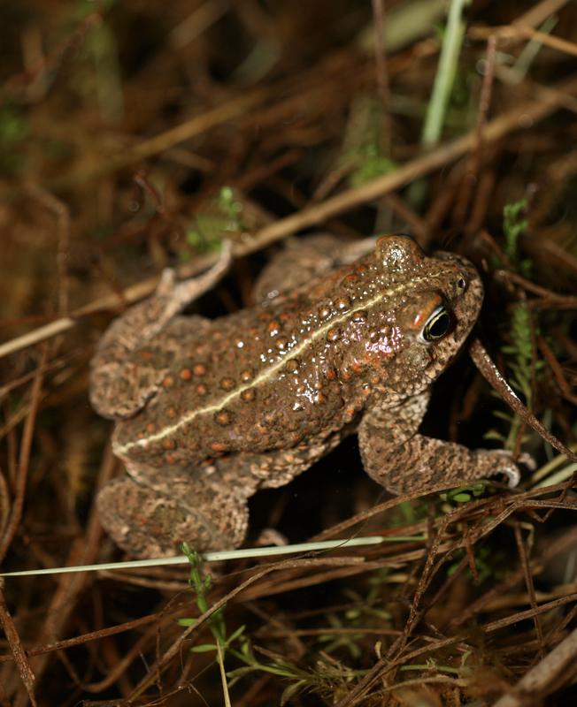The Natterjack Toad is a native British amphibian which resides in warm, moist areas such as dune slacks and upland heath. Adults are approximately 60-70mm in length, have a lifespan of 10-15 years and have a distinctive yellow dorsal stripe down its back (Wildlife Trust, 2013). It’s an endangered species in Britain despite it’s abundance in mainland Europe, so keeping the population maintained through reproduction is vital. Breeding ponds ideally would be a shallow depth and dry up once they have been used to prevent predators colonising whilst the toads are hibernating.

Figure 1: A Natterjack toad with its characteristic yellow dorsal stripe down its back (Lancashire Wildlife Trust, 2013).

This study was carried out with the intention of revealing the state of the breeding efforts of the Natterjack toad in 2013 compared to P. H. Smith’s paper in 1990 who investigated the breeding efforts of the Natterjack during the 1988 and 1989 seasons. Both of these studies were carried out at the Merseyside sand dune slacks and both investigated the breeding efforts successes by using the snout-vent lengths of toads to determine whether or not the previous seasons breeding efforts were successful. Snout-vent lengths are used for this purpose as a low average snout-vent length in the population will mean that the previous season or season before last was successful. A high average would signify poor recruitment into the population and therefore an ageing population. The interest in the comparison of results was one of the motives behind the study.

**1.1 – Aims and Objectives**

This study has a number of different aims and objectives which intended to provide an insight into whether the breeding of Natterjacks was more successful in the modern day than in 1988/89 seasons. Some of the aims and objectives included:

* To investigate the success of the breeding season in the Ainsdale Sand Dunes population of Natterjack Toads;
* To compare the data gathered to that of the years 1988 and 1989 in P. H. Smith’s 1990 paper;
* To determine what has caused the success or failure of the breeding season and why;
* To determine whether any action needs to be taken if necessary to encourage the survival of tadpoles and toadlets.

**2.0 - Literature Review**

This literature review shall give a guide to the background of this study. This includes providing information on the ecology of the Natterjack Toad and other information such as how the Natterjacks are monitored when they are being studied. The information shall start off by giving a background to the Natterjack Toad Ecology and why it’s a protected species and eventually detail more specific topics related to the study such as how the Natterjacks are monitored and recruitment into the population. By the end of this literature review the reader should be able to understand the reasoning for carrying out this study.

There shall be more literature based on methodology which shall be reviewed in the methodology section of this dissertation. This shall include comparisons to other studies which have had methodology which can be related to with this study.

**2.1 – Natterjack Toad Ecology**

The Natterjack toad (*Bufo calamita*) is one of Britain’s native amphibians and is a highly protected species. This section shall give some background information on the ecology of the Natterjack toad.

**2.1.1 – Life Cycle**

The Natterjack Toad lives on warm, open habitats including coastal dunes and lowland heath. These habitats must have ‘open, unshaded habitat’ with large areas of unvegetated land or minimal amounts of vegetated land of which a maximum skyward height of 1cm is a must. They also must have substrate to burrow into to hibernate and to live in during the day which they do to escape any extreme temperatures. Both adults and juvenile Natterjacks hunt their prey during the night time and to be able to do this they need open ground to be able to see their prey and then be able to eventually capture them. This is the case for all Natterjacks except for tadpoles who feed in warm shallow water and new toadlets who have just emerged from the tadpole stage. The Natterjack breeds in ephemeral ponds and this leads to the problem of not being able to breed when a pond dries up. This leads to the problem of declining populations of Natterjacks, however, due to their ability to recover quickly when vital habitat features have been restored the Natterjack is able to increase the population again. Breeding ponds normally have 5-10cm of water and ponds with slightly sloping sides are ideal for this (Baker *et al*, 2011). Natterjack tadpoles are equally intolerant of seawater as other amphibians and will only use the breeding ponds that are sufficiently diluted by fresh water (Beebee *et al*, 1993).

**2.1.2 – Population Dynamics**

Population Dynamics in Natterjack Toad populations has a big affect on such factors as breeding and can be affected by a number of factors. Population dynamics are an important resource to use in conservation efforts and are of great interest (Mangel & Tier, 1994). Beebee *et al* (1996) found in his study that the factor that determines how dense a population of Natterjack Toads the most is the number of toadlets that are produced during spawning and especially how successful the metamorphic process is. This factor in turn is affected by the density of the breeding sites in the area. Many Natterjack Toad populations are threatened by extinction through environmental threats and a small gene pool, due to their small size and the isolation from other populations of Natterjacks. For these situations a large density of adult specimens is desirable and breeding pools should be increased in amount and variation to attain sustainable “regular reproductive success”.

Stevens *et al* (2003) carried out a study on a small isolated population of *B. calamita* in Southern Belgium and found that fecundity (2000 eggs per clutch) and adult survival rates (27%, with the average being 50-80%) were both very low. The population age-structure was overall very young with most toads being 2-4 years old. Male reproductive success was based mainly on calling activity and length of chorus attendance. All these characteristics indicate the population could be under stress. The low fecundity is thought to stem from the poor body conditions of the females which in turn are thought to be due to unfavourable breeding conditions. The poor adult survival rates had an affect on the breeding attempts of the toads. Due to poor body conditions the smaller toads would arrive early during the breeding season and partake in a long chorus attendance whereas large males arrived late and had a short chorus. It is thought that the smaller males preferred to spend most of their energy on reproduction, rather than surviving as the survival rate is low. This explains why recapture rates were low in this study. This study showed that due to factors that caused poor body conditions the population eventually ended up small and under stress. To solve this problem it is recommended that the habitat be enlarged and managed by conservationists.

Natterjack Toads have been found to have significant local extinction rates and recoveries of populations compared to other amphibians. David M. Green collated a table of censuses of different amphibians which was published in (2003). In 396 census intervals the Natterjack Toad populations decreased 52% (206) of the intervals and increased 41.4% (164) of the intervals. There was no change in 6.6% (26) of the intervals. The Natterjack Toad also had a crash rate of 0.033 (13 crashes) and a recovery rate of 0.028 (11 crashes) which means that the Natterjack Toad population recovers nearly as many times as it crashes.

**2.2 – Sand Dunes, Lowland Heath, Saltmarshes and other Habitats**

Natterjacks prefer coastal dune systems, especially those that have vast areas of bare sand with scattered vegetation cover such as Marram grass. The frontal dune system is the preferred specific area in dune systems as it has all of the features mentioned. Whereas, other dune types such as overly fixated dunes that support trees are unsuitable as they do not provide the open landscape which the toads need to forage and in densely vegetated dune systems they may be home to other amphibians which will out-compete the Natterjack during it’s tadpole stage (Beebee and Denton, 1996). The ponds in the dune-systems are located in dune slacks which can be categorised into different types. Compiled by Ranwell (1972), there are three separate types of dune slacks: 1) Semi-aquatic: these are slacks where the water table never drops below 0.5m below the soil surface. These slacks are flooded from autumn to spring and are usually home to amphibious hydrophytes; 2) Wet slack: the water table in these slacks never drops more than 1 metre below the soil surface and populated majorly by mesophytic flora with bryophytes also in large abundance. These slacks contain relatively few grass species; 3) Dry slack: the water table measures between 1m and 2m below the surface during all seasons. Grass species are highly abundant in these slacks.

Other habitats used by Natterjacks include the upper saltmarshes in which they use dry stone walls as shelter and other forms of shelter such as embankments and patches of dunes. The shallow pools at the upper edges of the salt marshes provide ideal areas for breeding which fill up with salt water during high tides and replenish during rainfall or run-off from land in late spring/early summer. Any potential predators or competition are removed through seasonal saltwater inundation, so this provides ideal sites for sustaining a population of Natterjacks. Lowland Heaths are another site used by Natterjacks as they have sparse vegetation but the breeding ponds must be pH 6 or higher as the eggs and tadpoles of the Natterjack cannot tolerate very low pH levels and will not develop properly. These habitats are the most commonly used by *B. calamita* however other habitats used occasionally include disused sand quarries, moorland areas and a disused ironworks in Cumbria. These areas are similar to the common habitats as the quarry is similar to the dune habitat and the ironworks is sparsely vegetated but with plenty of shelter (Beebee and Denton, 1996). One particular re-introduction site has a breeding pond with a drainage system to allow for drainage during the hibernation period to prevent predators from taking over the pond (Simpson, 2000).

**2.3 - Methods of Monitoring Natterjacks and other Amphibians**

There are a number of ways a population of Natterjacks can be measured to monitor how healthy the population is and how it should be managed. Many of the common forms of monitoring a Natterjack population shall be detailed in this section.

**2.3.1 – Adult Body Size**

Adult body size, which is measured from vent to snout tip, is for most populations quite strongly correlated with age. When there is a large presence of immature Natterjacks (less than 40mm in length) this indicates that there has been successful breeding taking place in the previous two years. Specimens over 70mm in length are usually around four or five years old. A median of around 50-60mm indicates a healthy population and this should include a variety of different aged Natterjacks. Populations comprised mainly of specimens with a length of 65mm or above should be monitored carefully (Beebee and Denton, 1996).

**2.3.2 – Numbers of Toadlets Produced**

Measuring the amount of toadlets produced is a useful way of determining how healthy a population is. The more toadlets produced means the more successful breeding is and the amount of toadlets produced over a certain amount of years is directly related to adult population size. It is useful to know the amount of toadlets produced so spawn string numbers can be put into perspective.

Knowing when metamorphosis occurs for the population is vital as this is when the tadpoles transform into toadlets. In most populations this is between mid-May and June but for some populations it can carry on until July or possibly longer. A reliable sign that metamorphosis is about to occur is a large disappearance of large sized tadpoles in ponds that had vast amounts of tadpoles. This is due to a change in behaviour where they become more secretive and hide in silt at the bottom of the ponds before emerging. When this change is noticed then the ponds should be monitored at weekly intervals and the edges of the ponds should be checked for small toadlets of around 7-8mm in length. The small toadlets can be identified by their yellow dorsal stripe but are small enough to miss so great care must be taken to not overlook them. Once the first toadlet is spotted then the ponds should be searched thoroughly over two weeks and the maximum number of toadlets counted can be used as guideline of the output of toadlets. Care should be taken not to check the same regions constantly as with certain weather conditions causes the toadlets to disperse quickly from the breeding ponds and therefore monitors will miss successful breeding (Beebee and Denton, 1996).

**2.3.3 – Spawn String Counting**

Spawn string counting is another way of monitoring the populations and this is done by walking around the breeding pond margins and marking strings which have already been counted before. Newly laid strings are easily recognisable. This should be carried out at least once a week for eight weeks or more, from late April to early June at least. Suitable weather, however, can trigger a bout of spawning. The amount of spawn strings found at a site is generally a reflection of how many females there are on the site and when the sex ratio is calculated doubling the female numbers usually gives a rough approximation for the total adult population. However, this method is not accurate as there are females that do not spawn every year and the number of non-spawning specimens is increasing due to dryness in the spring whereas some females may spawn more than once in a breeding season. In extreme circumstances it may be the case that no females in the population spawn at all. With all this considered spawn string number monitoring should be read into carefully and climate conditions and monitoring efforts should be carried out seriously (Beebee and Denton, 1996).

**2.3.4 – Other Methods**

Other forms of monitoring include searching for the toads at night when they are most active and are relatively easy to find as they search for food on open ground. This is particularly successful during the summer and autumn months in areas that are sparsely vegetated and don’t suffer from dry, hot spells of weather. The optimum weather condition for this is mild or warm nights after a spell of rain (Beebee and Denton, 1996).

Calling Males is an alternate form of monitoring the population and this is done by counting the amount of males at a chorus during the breeding season in late April to early June or even July and can be heard from up to 1km away. The males can even be coaxed into calling by playing a recording of a chorus at or near the breeding ponds. This method isn’t the best way of calculating the population however as only a proportion of the male population will attend the chorus sessions and not all of this proportion will be calling (Beebee and Denton, 1996). This can be done using the Mark-Release-Recapture method. This method is commonly used with other amphibians such as Great Crested Newts. This involves the capture of the toads at which point they are marked in a way they can be easily recognisable if seen again. In a study carried out by Stevens *et al* (2003) a unique toe clip code was used. In their process they visited the breeding ponds at night at least once a week and this was done for a minimum of two hours with a torch being used to locate the toads.

Artificial refugia are another form of monitoring and it involves the placement of artificial refugia in habitats which the Natterjacks can use during the daytime for shelter. Monitors can then go and inspect the refugia for any toads. The refugia should be of a reasonable size (40cm x 30cm) and placed on sand rather than vegetation as this is preferred by the toads. The artificial refugia do have a number of faults however, including predation as a result of using them in areas where snakes prowl and in some cases where human influence exists it can lead to death. Artificial refugia are also rejected for natural refugia such as burrows in hot weather (Beebee and Denton, 1996).

Population monitoring can be calculated mathematically with the use of a count index which is a formula used to estimate the population size. C = N x P where C = the count index, N is the true population size and P is the detection probability of the count index (C) (Schmidt, 2003). For the count index to be of any use the detection probability must be of a constant value between years and preferably of a high value. The count index must also be accurate in portraying the population size so it should not vary independently of the true population size. This method is only a calculation so it is not entirely reliable and retrieving data from the field would yield a much more accurate representation of the true population size (Buckley and Beebee, 2004).

More technological methods of monitoring Natterjacks come in the form of radio tracking. An example of this is a study carried out on the thermal ecology of *B. calamita* in a semi arid landscape by Oromí (2010) *et al* between 2006 and 2008. This involved the seasonal monitoring of the variation in body temperature in adult *B. calamita* in a free-range. 15 toads were radio tracked in Mas de Melons in Catalonia, Spain and the temperature was recorded using temperature-sensitive transmitters. This is carried out by implantation into the abdominal cavity through a latero-ventral longitudinal incision of around 1.5cm (Sinsch, 1989). The wound is then closed by using 3-5 cotton thread sutures and the toads were then placed in 1cm deep water filled box were they were to rest until they awake from sleep. Before the implantation takes place, the radio transmitters are covered in paraffin and the toads were sexed, had their body mass weighed and had their snout-vent length measured. They were then anesthetized by immersion in a 500ml solution with 250mg/l of ethyl 3-aminobenzoic methanesulfonate salt. The transmitter signal is picked up using a hand held scanner which has a device connected to it. This device interprets the amount of time between two signals which is converted to temperature using regression models gathered before the test is carried out. After the implantation, the specimens are then transferred to a 30cm x 60cm x 45cm terrarium in which they stay for five to seven days with access to water and fed as many cockroaches as the Natterjacks desire. When the toads resume normal behaviour they are then released back to the original habitat from which they were taken where they are placed approximately 30m from the breeding pond and then tracked for three months.

**2.4 – Protection of the Natterjack**

The Natterjack Toad is a European protected species and has many laws preventing the handling, capture or killing of Natterjack Toads. In Europe, the Natterjack is not listed on the IUCN red list due to it being locally abundant across most of its range even though it is declining in the north of its European range. It is however still protected by legislation in Europe under Annex IVa of the EC Habitats directive and Appendix II of the Bern Convention. In England specifically, the Natterjack is protected by the Wildlife & Countryside Act 1981 (as amended) under Schedule 5 and the Conservation of Habitats and Species Regulations 2010 under Schedule 2, the latter of which also protects it under European legislation. These two laws prevent the capture, disturbance, injuring and killing of Natterjacks and also prohibit the damage and destruction of their breeding sites and resting places. The reason the Natterjack is highly protected in England is due to it being an endangered species and a license must be obtained from Natural England to be able to conduct work which may disturb them which includes terrestrial searches and netting. A license is not needed, however, for such surveying as listening to Natterjack choruses or for spawn string counting. Unlicensed surveyors must cease survey work if they encounter a specimen unless they are in the presence of a licensed surveyor (IEEM, 2011).

A paper carried out by Beebee, Banks and Cooke (1993) entitled ‘Conservation of the Natterjack Toad *Bufo calamita* in Britain over the Period 1970-1990 in Relation to Site Protection and Other Factors’ documents the efforts in protecting the species in Britain. The number of known sites by conservationists rose from 21 to 40 between 1970 and 1990 in Britain excluding those from translocation efforts. The number of protected sites in Britain has also rose in this time period from 60% in 1970 to 83% by 1990. The study did show that protective legislation on protected species declined in effectiveness over this period with much of the damage in this time period on ‘unscheduled sites’ occurring as a result of agricultural improvements by landowners with no knowledge of Natterjacks on their land. However, from data studied by Beebee *et al* during the prior 20 years to 1990 it seems to be the case that there is little to no evidence that the Wildlife and Countryside Act of 1981 had any affect on the conservation of the Natterjack Toad. SSSI’s (Sites of Special Scientific Interest) and Nature Reserves have proved successful in conservation however. Inadequate management, specifically of insidious scrub, is another problem that was identified in this study.

**2.5 – Threats to the Natterjacks**

There are many threats to *B. calamita* with some being more serious than others. This section documents the different threats and how serious they are towards the toad.

**2.5.1 – Predation**

Great crested newts predate large amounts of eggs and tadpoles whereas most vertebrates choose not to predate them due to their distasteful skin. Tadpoles do, however, fall prey to many invertebrate such as dragonflies, damselfly nymphs, dytiscid water beetle larvae/adults and also water-boatmen (Baker *et al*, 2011).

Predation is not a large problem however in healthy populations, with predation of the Natterjacks just being a natural component of the food chain. Therefore, control of predators should not be the main focus and instead, the attention should be faced towards habitat management which will in turn bolster the numbers of toads (Beebee & Denton, 1996).

**2.5.2 – Competition**

Natterjack toads struggle to survive when in competition with other species. The Common frog (*Rana temporaria*) and the Common toad (*Bufo bufo*) both out-compete the Natterjack during the tadpole stage as they both breed earlier in year than the Natterjack. Due to this they may be eaten by the more advanced tadpoles of the common frogs and common toads and if not then they will fare poorly in finding food. Where there are common species they tend to out-compete the Natterjacks and exclude them from all locally available breeding ponds (Baker *et al*, 2011).

**2.5.3 – Environmental Change**

Invasive scrub can cause problems for the Natterjacks survival if it is not managed carefully as Natterjacks require open areas to hunt for prey and cannot do this with unmanaged invasive scrub. Therefore, it must be managed through either constant trimming or by using animal grazing schemes (McGrath & Lorenzen, 2010).

‘Environmental Change as a Cause of Natterjack Toad (*Bufo calamita*) Declines in Britain’ was a study also carried out by Beebee in 1977. The study found that in those previous 40 years *B. calamita* had declined more in heathland areas than in dune systems. It was concluded that the decline in heathland was not due to climate change, public pressure or direct development on the heathland. Beebee put down the reason for the decline to large-scale changes in flora in the heathland areas. The lack of grazing in the heathland areas and the increase in amount of forestry activities leads to tall vegetation in these areas which in turn creates shade leading to an undesirable environment for the Natterjacks and an environment in which the common toad *Bufo bufo* to become a successful competitor. The Common Toad is thought to be one of the main reasons for the decline of the Natterjack Toad population on heathland. This study shows prime reasons for Natterjack population declines and is therefore useful for this dissertation study.

**2.5.4 – Human Influence**

Human influence is one of the bigger threats to *B. calamita* as it can lead to many negative consequences for the Natterjack. The alteration of landscapes can lead to drastic effects including such simple acts such as the removal of slag piles can lead to the loss of shelter for the Natterjacks. The restoration of disused quarries and other industrial sites can lead to the deaths of Natterjacks if the sites have not been surveyed beforehand for Natterjacks which can have serious consequences for those involved. This includes other restoration processes which can harm the toads such as the filling of ponds, altering drainage of the site or chemical/agri-chemical pollution. Other activities including mismanagement of vegetation around ponds and increased recreational activity in areas where there are toads can also have detrimental effects on the toads (National Trust, 2004). Human influence on Natterjack habitats can cause fragmentation and destruction of the habitats, due to this Natterjacks are forced to move to sites were the permanence of these sites are uncertain which can also lead to deaths (Stephan *et al*, 2001).

Beebee *et al* (1990) carried out a study on reasons for Natterjack Toad decline titled ‘Decline of the Natterjack Toad *Bufo calamita* in Britain: Palaeoecological, Documentary and Experimental Evidence for Breeding Site Acidification’. This study found that heathland ponds has acidified over time in the 20th century and tests in both field and lab conditions showed that pH decreases at one pond studied would have serious implications on Natterjack reproduction. The tests showed above pH 5.0 hatch rates were high, the larvae successfully grew and nearly all specimens survived to the metamorphosis stage. However, between pH 5.0 and 4.0 the mortality rate increased dramatically and even when excess food was available the larvae growth rate was heavily retarded. Even small decreases in pH have an effect on *B. calamita* as Natterjacks require rapid larval growth stages to have any reproductive success. This shows that Natterjack Toad declines in population have a strong link with pond acidification and may have a link with many cases of extinction at heathland sites. Add this factor to the already specific habitat requirements the Natterjack Toad has and it makes the Natterjack particularly vulnerable to acidification. The acidification was believed to be caused by atmospheric pollution due to increases in heavy metal and particulate deposition which is mostly down to human influences.

**2.6 – Breeding and Recruitment to the population**

**2.6.1 – Breeding Behaviour**

Natterjack Toads will breed in shallow ponds in discrete areas from March to June. They will lay eggs in the form of spawn strings at the edges of the breeding ponds. Breeding behaviour in Natterjacks involves the use of chorus sessions during the night at breeding ponds. The males will call out for females and these calls can be heard from several kilometres away. Chorus activity is strongly linked with male mating success so chorus sessions are vital for males to showcase themselves to a female (Halliday & Verrell, 1986). However, this factor has been largely overlooked for other factors such as size of males causing females to choose larger males over smaller ones.

One of the factors affecting breeding success is large male advantages over small males in the breeding season. A number of hypotheses were theorised by Tejedo (1991) as to why this was the case including chance possibility, sexual selection hypothesis or energy constraints. The chance possibility was ruled out through the insignificance of the operational sex ratio and the nightly average body size of the males. This also quashed the theory that larger males were more likely to attend the breeding site than smaller males on more female abundant nights. The sexual selection hypothesis was also ruled out as females did not show preference to either the natural or synthetic calls. The energy constraints hypothesis proved to have a positive trend as the smaller males spent more energy in breeding than larger males.

Tejedo (1988) carried out a similar paper to his 1991 paper three years previously on “Fighting for Females in the Toad *Bufo calamita* is affected by the Operational Sex Ratio”. In this study he found that the males fighting were larger than the other males and were present more at breeding nights than others but this had no affect on their mating success. The fighting was caused by the sex-ratio not being biased towards males. The results showed that it is most likely that the males show aggression towards each other instead of towards paired females because they are more likely to see male specimens than pairs. *B. calamita* is the only species for which an effect of the operational on a mate-acquisition strategy (signs of over aggression for the acquisition of already paired females) has been shown.

Denton & Beebee (1992) published a study on the reproductive strategies implemented in a female biased Natterjack Toad population. 40-44% of indistinguishable individuals only visited the breeding ponds for the first two weeks of the breeding season; however, those who stayed for the majority of the breeding season had more success at amplexing with females. Interestingly this study found out there was no general correlation between male body size and breeding success. Fighting between males was rarely seen due to the large amount of females and it was the case that some females weren’t able to find a mate as all the males were already amplexed. Two strategies were seen commonly implemented: 1) residents visiting once and using the same site to call from for the rest of the breeding season and 2) switchers which moved between different ponds. Switchers were found to be more successful in recruiting a female and also did not have as high mortality rates as the residents. There was a direct correlation found between the amount of male calling activity and it’s attractiveness to a female. It was also found that in any one year only 44-64% of the females spawned.

Different genders of Natterjacks show preferences to different breeding sites. A paper based on the behaviour of *B. calamita* by Sinsch in 1992 provides useful information on how genders in a Natterjack population studied showed different preferences towards breeding sites. More than 90% of the males showed a lifelong attachment to one particular breeding side where they first bred whereas females did not show a preference towards a particular site. Due to this behaviour involving mainly female exchange between breeding sites the genetic distance between the populations was found to be low in local populations but as distance increased, so did the genetic distance between the populations. P. H. Smith (1990) found that in the Merseyside coastal sand dunes the Natterjacks bred in a discrete group of slacks and excavated scrapes which were 3km from the next nearest breeding site and although most Natterjacks are known for their ability to migrate to other slacks, especially during times when their breeding ponds dry up (Beebee, 1983), the Merseyside specimens generally stick to their site. Local populations of Natterjacks show no synchrony in breeding activities which suggests that each population acts independent from each other. However, regional populations, show synchronicity in egg laying and in the starting and length of the breeding season (Aubry *et al*, 2012). The possible reason for this given by Aubry was that it could be due to regional synchrony in rainfall and temperature.

P. H. Smith and K. R. Payne carried out a study titled ‘A Survey of Natterjack Toad *Bufo calamita* Distribution and Breeding Success in the North Merseyside Sand-Dune System, England’ in 1978. The study showed that adult Natterjacks congregated at 101 out of 132 sites that contained water in the sand dunes system. At 95 of those sites, Smith and Payne found that 95% of the spawn was deposited before 11th May with a total of 2001 spawn strings being counted at the 95 sites. 28 sites had confirmed metamorphosis and a further 12 sites were estimated to have metamorphosis occurring in the dune system. The spawning was found to take place in shallow ponds in dune slacks or excavated scrapes and deep ponds were avoided for breeding. Any failed attempts at breeding were mostly down to shallow water bodies drying up before metamorphosis could take place. 82% of the sites where metamorphosis was confirmed were slacks excavated for conservation purposes which are an example of the effort being put in to protect this endangered native species.

Rainfall is one of the factors found to have an effect on spawning, especially in the short time period before spawning and this is preferably followed by a dry spell. In a study carried out by Banks & Beebee (1986), the calling and spawning both occurred over a wide range of environmental conditions with a surprising trend of calling still carried out on nights where temperature dropped bellow 5°C and both calling and spawning finishing before frost later on those nights. Temperature does have an effect on calling with calling sparse on nights were the previous days had maximum temperatures of less that 10-12°C but sunshine hours weren’t shown to have a relationship with this however. Maximum preferred temperatures on the day before spawning of 10°C minimum and a series of preceding temperatures of 5°C minimum (on average) which should be 2-4 days beforehand. This differs from Beebee’s original suggestion that a minimum of 8°C was necessary.

Older portions of Natterjack populations know when the right conditions occur to breed and will therefore attend calling at the ponds at these times. Younger toads may leave it too late for the calling which won’t leave enough time for metamorphosis to occur before the winter. Younger toads instead use temperature or rainfall to determine when they should start calling at the ponds (Persson, 2012).

**2.6.2 – Offspring and Calculating Recruitment**

The calculation of recruitment can be carried out through the use of snout-vent lengths. The larger the average size of the snout-vent lengths, the older the population is so for an indication of good recruitment into the population the average snout-vent length size needs to be small which means there is a lot of young toads. This technique was used in P.H. Smith’s paper (1990) on ‘Size differences of Natterjack Toads breeding in the North Merseyside sand dunes’. To do this the snout-vent lengths were measured to the nearest 1mm and with the information gathered from this fieldwork it was then used to calculate the success of recruitment into the Natterjack Toad’s populations. The study showed that this technique was successful and could be used to calculate the amount of recruitment to the population.

Younger toads act differently than older toads and this can be used as a way to identify younger specimens. Toads were weighed and had their snout-vent lengths measured which would give the age and attribute how each age group act. The more identified that act as a young specimen would act would mean that breeding was highly successful the season before. This technique was used in Persson’s study (2012) on Natterjack populations in Sweden. This technique is similar to that used in P. H. Smith’s paper (1990) but it is useful to know how to identify how a younger specimen acts.

**3.0 – Methodology**

The methodology section covers what has been carried out during this dissertation. This shall include such things as a study of the fieldwork site and a step by step guide as to what methods were employed both out in the field and in the analysing of the results. By the end of this methodology the reader should be able to replicate the methods themselves and be able to carry out their own version of this study.

**3.1 – Site Study**

The study site was located in Ainsdale, Merseyside near to the Ainsdale Discovery Centre. The grid reference of the site is SD 295106. The site itself extends over 20km between Southport and Crosby and is a designated SSSI (Site of Special Scientific Interest) and the dunes at Ainsdale are also a NNR (National Nature Reserve) (Natural England, 2013). Located in the site were a number of different slacks in which different populations of Natterjacks habituated. The habitat is a dune system which is one of the preferred habitats of the Natterjack Toad. The dune slacks at the study site are mainly semi-aquatic and wet slacks however some of the older slacks on the site have become dry slacks. The different slacks at Ainsdale can be seen in appendix 11. The population at Ainsdale is a metapopulation which means that Natterjacks fine it easy to cross between different breeding ponds (Rowe *et al*, 2000).

**3.2 – Method Development**

The methods that have been set out in this study have had to adapt to the problems encountered along the way. The first problem encountered was over the original aims of the dissertation. The aim was to investigate how predation of tadpoles/toadlets by Great-crested Newts affected Natterjack Toad populations. The problem was down to a lack of research and data on the conflicts between Great-crested Newts and Natterjack toad tadpoles/toadlets. After much searching for a way around the problem, it was decided to take an alternate approach to the study. This came in the form of changing the study aims to focus solely on the health of the Natterjack Toads’ populations in the Ainsdale sand dunes and how successful breeding has been in the previous seasons, instead of how the predation affects the Natterjacks.

**3.3 – Methods**

The intention for the study was to collect data early in the breeding season during the summer of 2012, this was not possible however, as there was the complications over the original aims of the project so when the current aims were finalised the breeding season had finished. Due to this, the field site at Ainsdale was eventually visited early on in the next breeding season on 10th April 2013. The toads would have come out earlier, around March, but due to unsuitable weather conditions this prevented the toads from coming out of hibernation at an earlier date. This delayed a field visit until the stated date in the hope that the toads would have exited their burrows and come out of hibernation. The site was visited at 6:00pm on the day before the study was carried out and a tour of the slacks – each different area of the habitat used by different toad populations – was carried out by John Gramauskas who pointed out where different breeding ponds began and ended due to the complicated coding system. Pictures were then taken of each slack to include in the study. After this, a briefing on how to handle the toads and how to measure the snout-vent length was carried out at the Ainsdale Discovery Centre by John Gramauskas. The slacks were then revisited once it went dark at around 8:30pm as this is when the measuring was carried out due to the toads being nocturnal. Each slack was visited for a set duration and the amount of toads was measured at each slack and each specimen’s snout-vent length was measured.

The slacks were divided into two types, those with natural ponds and those with excavated ponds. The excavated ponds are newly introduced after being finished using a digger the in 2012 and are planned as more suitable breeding sites for the toads rather than the unreliable natural ponds which are susceptible to drought and flooding. The natural ponds can be seen in the appendices in Appendix 1 through to 6 whilst the excavated ponds can be seen in Appendix 7 through to 10. The route followed involved visiting all the natural pond slacks first and then finishing off with the new excavated ponds. The periphery of each pond and the surrounding banks were checked for toads and the amount of toads and each toad’s snout-vent length and gender was compiled at each pond. The snout-vent length was measured using a transparent ruler gently applied against the specimen from the tip of the specimen’s snout to its anus. Specimens are sexed through snout-vent length of specimens with females usually being larger than males who the majority of are 6-8cm, peaking out at 10cm. The toads are also sexed through large external vocal sacs underneath the chin and nuptial pads which are located on the inside of the three inner digits, both of which females do not possess (SARG, 2011). Once each specimen had been measured it was immediately returned to the spot where it was found.

The information gathered from the fieldtrip shall be compared to data from previous years at the site and scientific reasons for the gathered results shall be given to backup the results. Depending on how successful the data from the fieldtrip turns out to be will determine whether or not statistical analysis can be carried out to allow for a more accurate conclusion. These statistical analyses shall have similar statistical tests carried out to those on P.H. Smith’s paper (1990) which include the ‘two sample t test’ and the ‘ANOVA f ratio’. This is so an accurate comparison can be made between the results from the 1990 paper and the results from 2013. From the results of the statistical analyses a conclusion can be made as to whether or not the breeding has become more successful than when P. H. Smith carried out his study during 1988 and 1989.

**4.0 – Results**

All the data gathered from this study is presented here in the form of tables and graphs:

|  |  |  |  |  |  |  |  |  |  |  |  |  |  |
| --- | --- | --- | --- | --- | --- | --- | --- | --- | --- | --- | --- | --- | --- |
|  | Slack 170 | Slack 171 | Slack 172 | Slack 173 | Slack 174 | Slack 169f | Slack 168/9 | Slack 167 | Slack 169d | Slack 189 | Slack 188 | Slack 187 | Slack 54 |
| Males | 0 | 0 | 0 | 0 | 0 | 0 | 0 | 0 | 0 | 0 | 0 | 0 | 0 |
| Females | 0 | 0 | 0 | 0 | 0 | 0 | 0 | 0 | 0 | 0 | 0 | 0 | 0 |

Table 1: Accumulation of male and female toads at each slack.

|  |  |  |  |  |  |  |  |  |  |  |  |  |  |
| --- | --- | --- | --- | --- | --- | --- | --- | --- | --- | --- | --- | --- | --- |
|  | Slack 170 | Slack 171 | Slack 172 | Slack 173 | Slack 174 | Slack 169f | Slack 168/9 | Slack 167 | Slack 169d | Slack 189 | Slack 188 | Slack 187 | Slack 54 |
| No. Sampled | 0 | 0 | 0 | 0 | 0 | 0 | 0 | 0 | 0 | 0 | 0 | 0 | 0 |
| Mean Snout-vent Length | 0 | 0 | 0 | 0 | 0 | 0 | 0 | 0 | 0 | 0 | 0 | 0 | 0 |
| Standard Deviation | 0 | 0 | 0 | 0 | 0 | 0 | 0 | 0 | 0 | 0 | 0 | 0 | 0 |

Table 2: Mean snout-vent lengths measured at each slack including standard deviation.



Figure 2 Dip-well data for the year 2009.

Figure 3 Dip-well data for the year 2010.

Figure 4: Dip-well data for the year 2011.

Figure 5: Dip-well data for the year 2012.

Figure 6: Dip-well data for the year 2012 and for the early months of 2013.

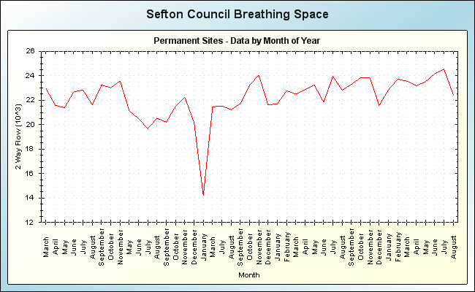Figure 7 Graph of monthly temperatures for 2013. (Sefton Council Breathing Space, 2013)

Figure 8 Graph of daily temperatures for the month of April 2013 (Sefton Council Breathing Space, 2013).

Figure 9: Graph of daily temperatures for the month of March 2013 (Sefton Council Breathing Space, 2013).

Figure 10: Graph of hourly temperatures for the week 24th March 2013 (Sefton Council Breathing Space, 2013).

Figure 11: Graph of hourly temperatures for the week 1st April 2013(Sefton Council Breathing Space, 2013).

Figure 12: Graph of hourly temperatures for the week 7th April 2013 (Sefton Council Breathing Space, 2013).

Figure 13: Graph of hourly temperatures for the week of 1st April 2012 (Sefton Council Breathing Space, 2013).

Figure 14: Graph to show the temperatures for April 2012 (Sefton Council Breathing Space, 2013).

Figure 15: Graph to show total rainfall over last 24 hours (mm) for the year 2013 (Sefton Council Breathing Space, 2013).

Figure 16: Graph to show total rainfall over last 24 hours (mm) for the year 2012 (Sefton Council Breathing Space, 2013).

**5.0 – Discussion**

The data collection for this study did not go as intended and no results were collected due to factors that were out of control (see table 1 and 2). This was mainly down to poor weather conditions during the weeks prior to the intended excursion date to the field, and on the intended excursion week, which prevented the toads from coming out of hibernation and exiting their burrows. With this being the case, the toads could not be measured for their snout-vent lengths and therefore no data was obtained. Due to this, an alternate set of data had to be sought in the form of data explaining the reasons as to why the toads had not come out of hibernation when they were expected to. This data came in the form of dip-well data which measures the water table level of the sand dune slacks. This is important as this helps the formation of the breeding ponds which are necessary to keep the Natterjack population healthy and reproducing. Other forms of data include rainfall data and temperature data which are both important in determining when the toads come out from hibernation and when they choose to attempt to start breeding (Banks & Beebee, 1986).

In relation to the paper by P. H. Smith (1990) that is being used to compare to this years results, the results garnered by Smith obviously show more positives for the toads. Even though there was low recruitment recorded by Smith in the 1988 and 1989 seasons this is still better than the results from 2013 so far which could predict a large amount of deaths due to the cold weather and late emergence from hibernation. Even if the toads do avoid death from lack of food or cold weather then the late emergence will lead to a later ending breeding period which in turn leads to late metamorphosis. This will lead to high mortality due to winter conditions or from the drying up of ponds. In a conversation on 10th April 2013 John Gramauskas, the head ranger at the Ainsdale Discovery Centre who helped towards this project voiced his concern during the trip to the field saying “I genuinely fear for my toads, because they should have been out a month by now” (Gramauskas, 2013). He added to this by saying “I wouldn’t be surprised if most of them died because they need to get out and eat but it’s too cold for them”. Some breeding ponds have also started to dry up with visible differences which are able to be seen in Appendix 12, however this is too early for them to be drying up. In relation to recent years spawn string counts compared to 1988/89 there were 617 spawn strings counted in 2008 compared to the 1576 and 1076 counted in 1988 and 1989 respectively (Sefton Council, 2013).

From temperature data it is obvious that due to the harsh weather conditions there would be no Natterjacks coming out of hibernation when they are expected to as it would be too cold for them to survive. From figure 7, a monthly overview is given for the year 2013 which shows that the temperatures have been declining since the start of the year. From this it is easy to tell that even at the start of the year in January when the average temperatures were highest it was still not enough to bring the Natterjacks out, not to mention that they would still be hibernating. Most Natterjack populations emerge at the start of April yet the average temperature so far for April is 1.8°C which is too cold for the toads as Natterjacks normally need at least two days of suitable weather, around 8°C at night and 15 °C during the day at the very least for the Ainsdale specimens, to bring them out of hibernation (Beebee, 1979). If the toads cannot come out from hibernation early enough then it has major impacts on their survival chances. The longer they stay in hibernation, the later they start to breed and the longer they go without food. This can lead to them coming out on the best day available and risk dying in the cold weather or starving to death in their burrows. Poor weather conditions can also delay metamorphosis until it is too late for the toadlets to survive and the harsh winter weather will kill them before they can fully grow and enter hibernation or be killed by a predator (Natural England, 2012). Natterjacks heavily rely on their quick metamorphosis and are Britain’s fastest metamorphosizing amphibian with a metamorphosis period of four weeks if conditions are warm. Compare this to the Common toad which takes ten weeks and it shows that they rely on this heavily and warm temperatures are vital (Natural England, 2012).

There were days in April, however, where the temperature was suitable for the emergence of the toads which was the weekend of the 13th April. During this weekend the temperatures reached a peak of 8.7°C which would possibly be enough to bring the toads out of hibernation, especially if the following days reached temperatures of similar or higher levels. These days, however, were days where venturing out into the field was not a possibility due to circumstances beyond control such as John Gramauskas not being able to attend, which was necessary due to him holding a license to handle the toads. Without him the toads would not be allowed to be touched due to legislation preventing the handling of toads without a license as stated in the literature review (IEEM, 2011). The month of March is the usual month when the Natterjacks of Ainsdale emerge from hibernation, which is slightly earlier than some populations in other areas of Britain who generally emerge in April, but this month was equally as poor as April with a high of 7.1°C during the whole of March still not satisfactory enough to bring the toads out. Using figures 11 and 13 to compare this years weather results to the same months of 2012, the results show that 2012 temperatures had a higher average than 2013. This means that the toads would have come out earlier in 2012 than 2013 and stood a much better chance of survival and reproducing than 2013. The peak of temperature readings was higher, however, in 2013 than in 2012 with 2013’s peak being 12.8°C and 2012’s peak being 10.4°C. However, 2013 had a much lower coldest reading with -4.6°C at one point and -1.4°C for 2012’s coldest reading. Colder temperatures lead to a longer tadpole stage for the Natterjacks which leaves them less time to metamorphosize and eventually reach sexual maturity and attempt to hibernate (Natural England, 2012).

Rainfall is also helpful towards the emergence of Natterjacks from hibernation as Natterjacks like moist, warm climates. This means that most of the calling and breeding is done on these nights with these characteristics. This means high rainfall is important in Natterjack habitats. When results from 2013 are examined it is found that there is nowhere near enough rainfall to create a moist enough environment. According to figure 15, the peak rainfall for 2013 was on 13th February at 19mm which was too early for the Natterjacks as they were still in hibernation. During the whole month of April it was seen that there was 0.0mm rainfall, which is detrimental to the toads as this means the breeding ponds could dry up. March had better results with a peak of 4.9mm but this is still not good enough. For 2012, figure 16 shows a peak of 13.9mm of rainfall, which came during the hibernation period on 26th November. No data was available at Ainsdale during the months of March and April for rainfall. However from 25th February to 30th July, there was little to no rainfall recorded which is a problem as this would be when breeding would occur and yet again the ponds could dry up before metamorphosis occurs if they are not topped up over winter through rainfall (Buckley, 2001; Rowe & Dunson, 1995). Low breeding pond levels can also have adverse effects on tadpole density, metamorph size, food supply and predation pressure (Brady & Griffiths, 2000). Dry years do have their benefits however, and aren’t considered as much of a disastrous impact as it once was as it can prevent the breeding of Common toads which if allowed to overpopulate a site where Natterjacks reside could greatly impact the Natterjacks chance of survival more than a dry year would (Buckley, 2001). Also, better breeding conditions arise from having just enough rainfall to breed rather than high rainfall levels (Smith & Payne, 1980). The Natterjack is on the edge of it’s range in the west of Britain and receives twice as much average rainfall here than in the rest of it’s European Range where it isn’t as endangered so any impacts on the climate may not necessarily be as negative for the Natterjack as it is predicted for other amphibians in Britain (McGrath & Lorenzen, 2010). Overall, low rainfall levels can provide both advantages and disadvantages.

Dip-well data is another form of data gathered in this study. Dip-well data involves the use of wells which monitor the water table level in the sand dunes. The water table is important in the sand dunes as it can affect whether a slack gets flooded or dries up. Dip-well data is measured in metres above ordnance datum (mAOD). This is the height above a datum point used by the Ordnance Survey as a reference point to calculate the level or altitude above a desired point which in this case is the ground level (British Geological Survey, 2013). From the data gathered from this year it is obvious that the water table level is not as high as the ground level. This means that the breeding ponds are more likely to dry up as they will not fill up as quickly or refill at all through the water table due to it being below the ground level. There are eleven wells in total and the ground level is given for each well in mAOD. At each well in April 2013, the reading showed that the water table level is below ground level which means that the water table will not keep the ponds water at constant level and is more likely to dry up without sporadic rainfall. This is normally the case that the ponds dry up and this brings the added bonus of preventing competitors and predators from taking over the ponds whilst the Natterjacks are hibernating, but with the low water table it could occur earlier than desired and kill the tadpoles (ARG UK, 2012). The winter results for 2012 were even worse than April’s results which could predict pools drying up earlier than desired but some positive can be taken as 2011’s winter results were worse than 2012’s and significantly low compared to the ground level, justifying why 2012 was a poor year for the Natterjacks and explaining why many of the ponds dried up that year also (Natural England, 2012). In the past four years the lowest level the water table dropped to was on the 1st October 2009. Dip-well 2 was one of the wells that recorded water table levels higher than ground levels which means that this area did not rely on rainfall to keep the water level constant unlike the other wells which the majority of did not come close to equalling the ground level. Some of the other wells fared poorly in comparison with Dip-well 2 such as Dip-wells 1, 3, 4, 5, 8 and 9 which all fell short of the ground level by at least one metre, at some dates even worse. This can be seen in figures 2 through to 6.

Translocation is not a viable option here to remedy the early drying of ponds as dune slacks are one of their favoured habitats due to the open areas for hunting with shaded areas to burrow in, not to mention the risk of translocation, including the time consumption and the stress it would cause to the Natterjacks. Therefore other methods of assistance have to be used which comes in the form of the newly created ponds in slacks 189, 188, 187 and 54 – which can be seen in Appendix 7 to 10. These ponds were newly excavated the previous year in 2012 and were excavated with the hope that these newly created, fenced ponds would provide the perfect amount of time for the Natterjacks to breed, metamorphosize and then hibernate for the winter yet dry up quickly enough so the competitors and predators of the Natterjacks could not take over the pond during their absence. They have been dug at certain depths in their different respective areas to allow for perfect time scales of drainage once the hibernation period has begun and have been fenced off to try and prevent disturbance from dogs and civilians. The temptation to deepen the existing breeding ponds to counterbalance low rainfall and early desiccation should be resisted as it is likely that the water table is experiencing a long-term downward trend (Baker *et al*, 2011). To avoid further problems to the already difficult task of keeping the Natterjack populations alive the Common toads should be as far away from ponds with Natterjacks in. Therefore spawn strings and Common toads themselves should be removed from any ponds they have colonised in to increase the chance of the survival of Natterjack toads. This should be carried out until the numbers of Common toads have decreased greatly (Buckley, 2001). This should definitely be carried out if the deepening of ponds is required for water replenishment as it could inadvertently create a better adapted environment for the Common toad rather than the Natterjack.

**5.1 – Study Limitations**

There were quite a number of limitations to this study that were encountered. One of the major limitations was the timing of the breeding season, for the completion of the study. Another limitation was the weather conditions which prevented any useable data being collected. With better weather then actual data could be recorded which would provide a different insight into the population at Ainsdale.

**5.2 – Future Work**

Changes would be made to this study if it was ever undertaken again to allow it to become more accurate and provide a better account of the population. This would include carrying the study out over a two year period, possibly more, which would allow for more results which in turn would give more accuracy. This would also allow for statistical analysis to be carried out too, as it was originally intended for this work. If there was the possibility of performing another study towards the end of the breeding season, with no limitation on breeding seasons, then results could provide more insight into the health of the population and more importantly, the success of the breeding season. A larger insight could be undertaken by carrying out the study over at least two years which would include at least two breeding seasons. Also, any problems in obtaining field data would not have as much of an impact as there would still be more opportunities to obtain data. The possibility for including extra slacks into the study would most likely be exercised as this would provide a better overview of the site. Also, to bring further meaning to the results collected at Ainsdale, a possible second study site could bring the extra results to compare to those at Ainsdale.

**5.3 - Conclusions**

The major findings from this research were few and far between which was mainly due to the lack of desired data. However, the circumstances which brought about the lack of data have itself become a major finding in this study. The weather conditions which prevented the intended aims from being fulfilled are a cause for concern for 2013’s breeding efforts with the Natterjack toads still not emerged from hibernation a month later than expected. With this worrying forecast the utmost should be done to preserve the small chance the Natterjacks have of breeding and the toadlets to hibernate in time. This should include focusing on creating the best conditions at the best slacks, notably the newly excavated slacks 188, 187 and 54 which are the slacks that hold the most promise among the rangers at the Ainsdale Discovery Centre. If these slacks are managed well and the temperature is warm during the summer months then there could be a positive ending to this years breeding season.

**References**

Amphibian and Reptile Groups of the UK. (2012). A Radical Plan to Help the Natterjack! Available at: http://www.arguk.org/a-radical-plan-to-help-the-natterjack. Accessed 22nd February 2013.

Aubry, A., Becart, E., Davenport, J., Lynn, D., Marnell, F. and Emmerson, M. (2012) 'Patterns of synchrony in Natterjack toad breeding activity and reproductive success at local and regional scales', *Ecography,* 35(8), 749-759.

Baker, J., Beebee, T., Buckley, J., Gent, A and Orchard, D. (2011). Amphibian Habitat

Management Handbook, Amphibian and Reptile Conservation, Bournemouth.

Banks, B. and Beebee, T. (1986). ‘Climatic Effects on Calling and Spawning of the Natterjack Toad *Bufo calamita* – Discriminant Analyses and Applications for Conservation Monitoring’, *Biological Conservation*, **36**, (4), 339-350.

Banks, B., Beebee, T. and Cooke, A. (1994). ‘Conservation of the Natterjack Toad *Bufo calamita* in Britain over the Period 1970-1990 in Relation to Site Protection and Other Factors. *Biological Conservation*, **67**, (2) 111-118.

Beebee, T. (1979). ‘Environmental Change as a Cause of Natterjack Toad (*Bufo calamita*) Declines in Britain’, *Biological Conservation*, **11**, (2), 87-102.

Beebee, T. (1979). ‘Review of Scientific Information Pertaining to the Natterjack Toad *Bufo calamita* Throughout its Geographical Range’. *Biological Conservation*, **16**, (2), 107-134.

Beebee, T., Denton, J. and Buckley, J. (1996) 'Factors affecting population densities of adult Natterjack toads Bufo calamita in Britain', *Journal of Applied Ecology,* 33(2), 263-268.

Beebee, T., Fleming, L. and Race, D. (1993). ‘Characteristics of Natterjack Toad (*Bufo calamita*) Breeding Sites on a Scottish Salt-Marsh’. *Herpetological Journal*, **3**, (2), 68-69.

Beebee, T., Flower, R., Stevenson, A., Patrick, S., Appleby, P., Fletcher, C., Marsh, C., Natkanski, J., Rippey, B. and Batterbee, R. (1990). ‘Decline of the Natterjack Toad *Bufo calamita* in Britain – Palaeoecological, Documentary and Experimental Evidence for Breeding Site Acidification. *Biological Conservation*, **53**, (1), 1-20.

Brady, L. and Griffiths, R. (2000) 'Developmental responses to pond desiccation in tadpoles of the British anuran amphibians (Bufo bufo, B-calamita and Rana temporaria)', *Journal of Zoology,* 252, 61-69.

British Geological Survey. (2013). Explanation of Abbreviations and Units Commonly Found on Borehole/Water Well Records. Available at: http://shop.bgs.ac.uk/georecords/examples/GeoRecords_Abbreviations.pdf. Accessed: 7th March 2013.

Buckley, J. (2001). The Conservation and Management of Amphibians in UK Temporary Ponds, With Particular Reference to Natterjack Toads. *Freshwater Forum*, **17**, 54-62.

Buckley, J. and Beebee, T. (2004) 'Monitoring the conservation status of an endangered amphibian: the Natterjack toad Bufo calamita in Britain', *Animal Conservation,* 7, 221-228.

Denton, J. and Beebee, T. (1993). ‘Reproductive Strategies in a Female-Biased Population of Natterjack Toads, *Bufo calamita*’, *Animal Behaviour*, **46**, (6), 1169-1175.

Green, D. M. (2003). The Ecology of Extinction: Population Fluctuation and Decline in Amphibians. *Biological Conservation*, **111**, 331-343.

Halliday, T., and Verrell, P. (1986). ‘Sexual Selection and Body Size in Amphibians’. *Herpetological Journal*, **1**, (3), 86-92.

Institute of Ecology and Environmental Management. (2011). Competencies for Species Survey: Natterjack Toad. Available at: http://www.cieem.net/data/files/Resource_Library/Technical_Guidance_Series/CSS/TGSCSS-Natterjack_Toad.pdf. Accessed 8th March 2013.

Lancashire Wildlife Trust. (2013). Natterjack Toad. IN: Lancashire Biodiversity Partnership. Lancashire Wildlife Trust. Available at: http://www.lancswt.org.uk/uploads/images/Natterjack%20Toad_002.jpg.

Mangel, M. and Tier, C. (1994). ‘4 Facts Every Conservation Biologist Should Know About Persistence’. *Ecology*, **75**, (3), 607-614.

McGrath, A. and Lorenzen, K. (2010) 'Management history and climate as key factors driving Natterjack toad population trends in Britain', *Animal Conservation,* 13(5), 483-494.

National Trust. (2004). MANAGING RISK – European Protected Species Natterjack Toad *Bufo calamita*. Available at: http://www.nationaltrust.org.uk/document-1355766966819/. Accessed 21st February 2013.

Natural England. (2012). Is the Natterjack About to Croak? Available at: http://www.naturalengland.org.uk/about_us/news/2012/050412.aspx. Accessed 17th March 2013.

Natural England. (2013). Sefton Coast – Ainsdale Sand Dunes. Available at: http://www.naturalengland.org.uk/ourwork/conservation/geodiversity/englands/sites/local_id54.aspx. Accessed 17th February 2013.

Oromí, N., Sanuy, D. and Sinsch, U. (2010) 'Thermal ecology of Natterjack toads (Bufo calamita) in a semiarid landscape', *Journal of Thermal Biology,* 35(1), 34-40.

Persson, K. (2012). *Size, Temporal and Spatial Dynamics of a Natterjack Toad (Bufo calamita) Population in Scania*. MsC Thesis. Lund University.

Ranwell, D. S. (1972). *Ecology of Saltmarshes and Sand Dunes*. Chapman and Hall,

London.

Rowe, C. and Dunson, W. (1995). ‘Impacts of Hydroperiod on Growth and Survival of Larval Amphibians in Temporary Ponds of Central Pennsylvania, USA’. *Oecologia*, **102**, (4), 397-403.

Rowe, G., Beebee, T. and Burke, T. (2000) 'A microsatellite analysis of Natterjack toad, *Bufo calamita*, metapopulations', *Oikos,* 88(3), 641-651.

Schmidt, B. (2003) 'Count data, detection probabilities, and the demography, dynamics, distribution, and decline of amphibians', *Comptes Rendus Biologies,* 326, S119-S124.

Sefton Council Breathing Space. (2013). Weather Data. Available at: http://breathingspace.sefton.gov.uk/Default.aspx?bsPage=weather. Accessed 10th April 2013.

Sefton Council. (2013). Natterjack Toad. Available at: http://www.sefton.gov.uk/default.aspx?page=5932. Accessed March 7th 2013.

Simpson, D. (2000). Links for Wildlife. *Enact*, **8**, (1), 11-15.

Sinsch, U. (1989). ‘Behavioral Thermoregulation of the Andean Toad (*Bufo spinulosus*) at High Altitudes’. *Oecologia*, **80**, (1), 32-38.

Sinsch, U. (1992). ‘Structure and Dynamic of a Natterjack Toad Metapopulation (*Bufo calamita*)’, *Oecologia*, **90**, (4), 489-499.

Smith, P. (1990). ‘Size Differences of Natterjack Toads Breeding in the North Merseyside Sand-Dunes’. *Herpetological Journal*, **1**, (11), 493-498.

Stephan, T., Ulbrich, K., Grosse, W. R. and Meyer, F. (2001). Modelling the Extinction Risk of Isolated Populations of Natterjack Toad *Bufo calamita*. *Web Ecology*, **2**, 47-56.

Stevens, V., Wesselingh, R. and Baguette, M. (2003) 'Demographic processes in a small, isolated population of Natterjack toads (Bufo calamita) in southern Belgium', *Herpetological Journal,* 13(2), 59-67.

Surrey Amphibian Reptile Group. (2011). Natterjack Toad. Available at: http://www.surrey-arg.org.uk/SARG/08000-TheAnimals/SARGSpeciesData.asp?Species=Natterjack_Toad. Accessed 27th March 2013.

Tejedo, M. (1988). ‘Fighting for Females in the Toad *Bufo calamita* is Affected by the Operational Sex-Ratio’. *Animal Behaviour*, **36**, 1765-1769.

Tejedo, M. (1992). ‘Large Male Mating Advantage in Natterjack Toads *Bufo calamita* – Sexual Selection or Energetic Constraints’. *Animal Behaviour*, **44**, (3), 557-569.

**Appendices**

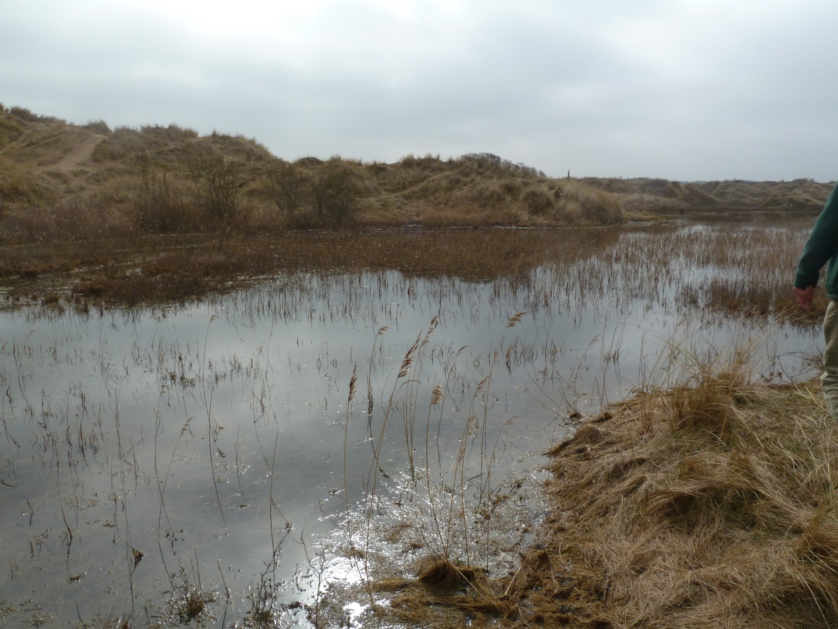

Appendix 1: Slack 170.

Appendix 2: Slack 172.

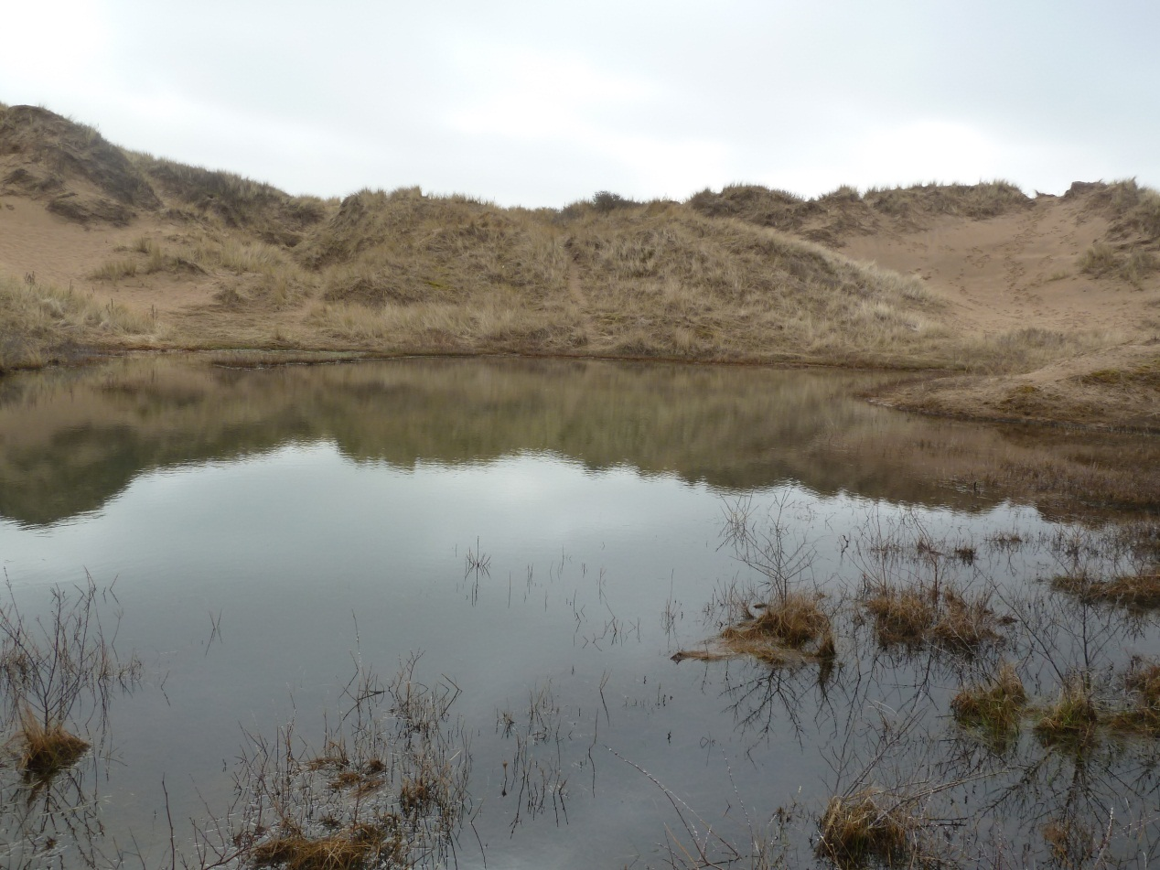

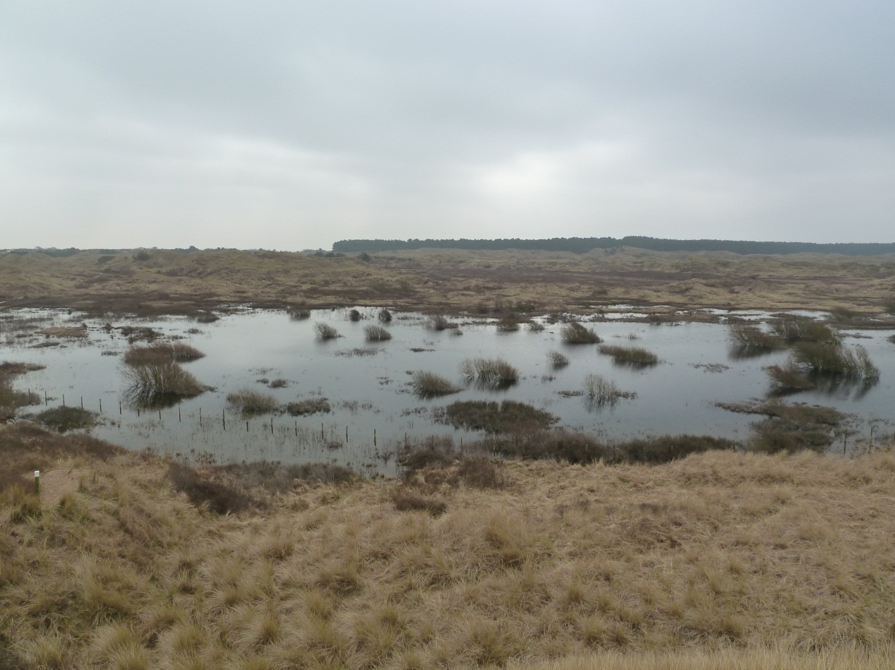Appendix 3: Slack 173.

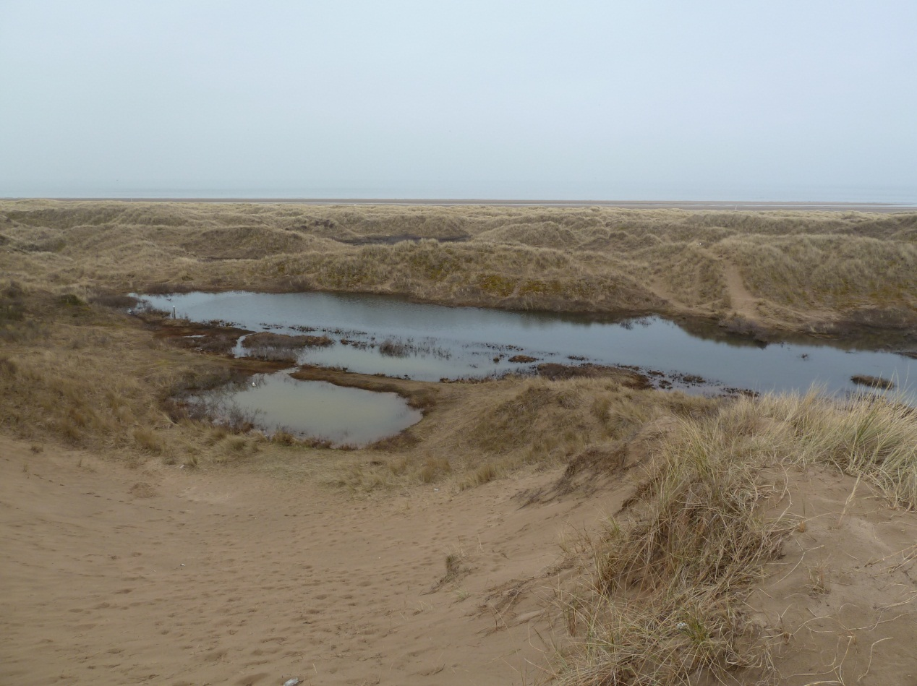Appendix 4: Slack 169f (foreground) and Slacks 168/169 (background).

Appendix 5: Slack 167.

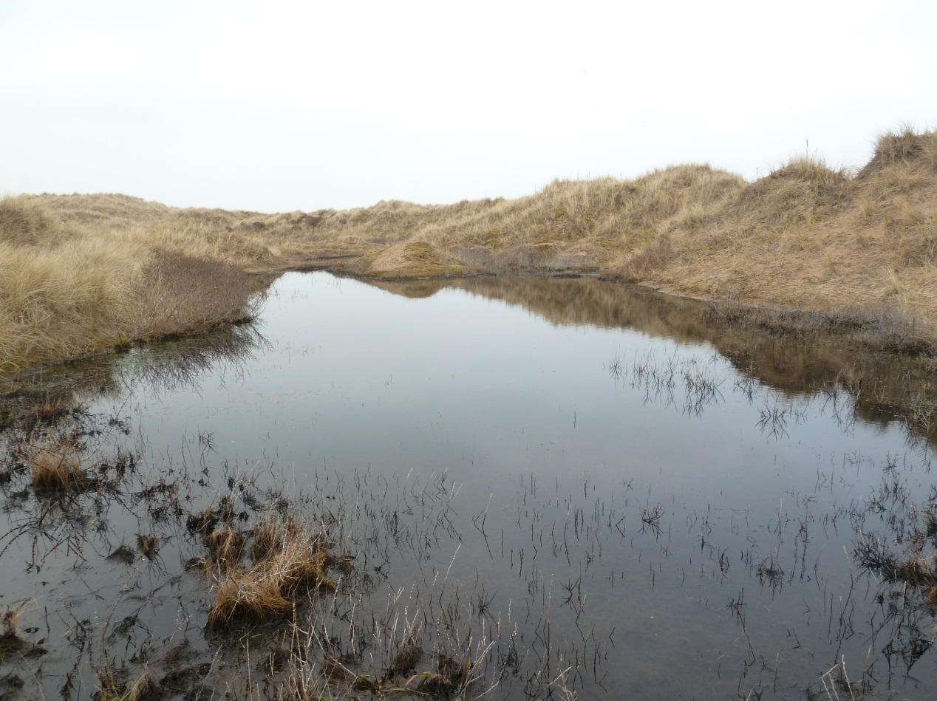

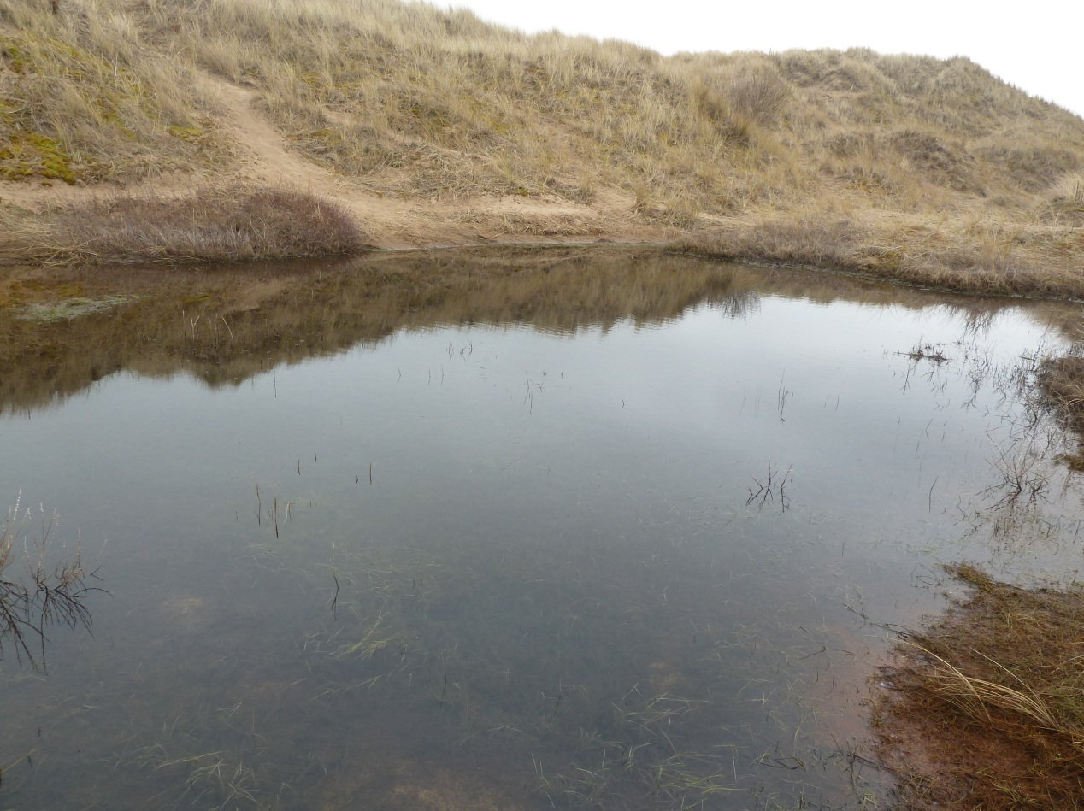Appendix 6: Slack 169d.

Appendix 7: Slack 189.

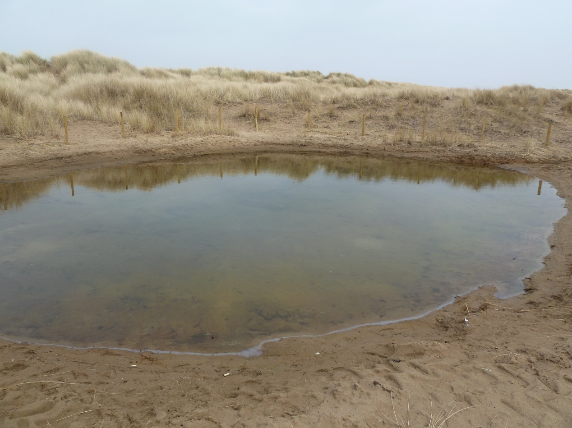

Appendix 8: 188

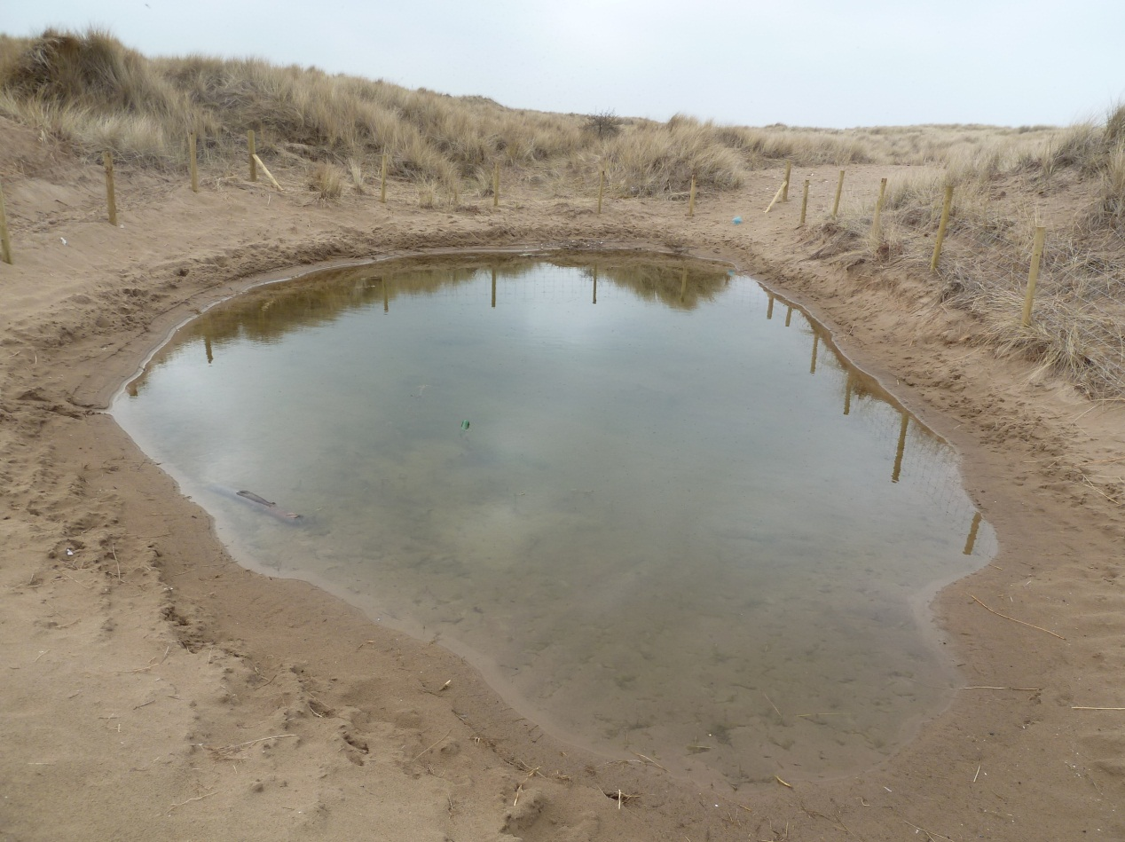

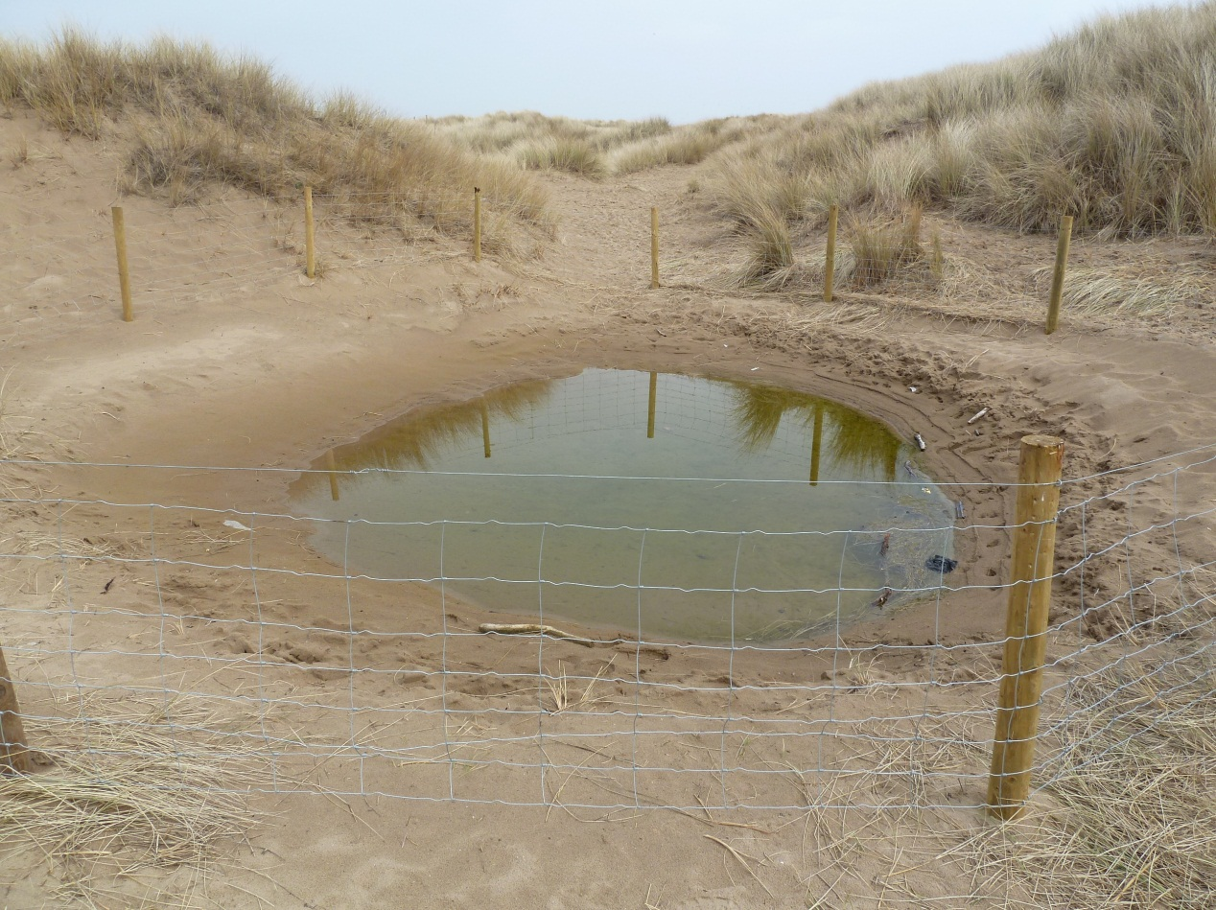Appendix 9: Slack 187.

Appendix 10: Slack 54.

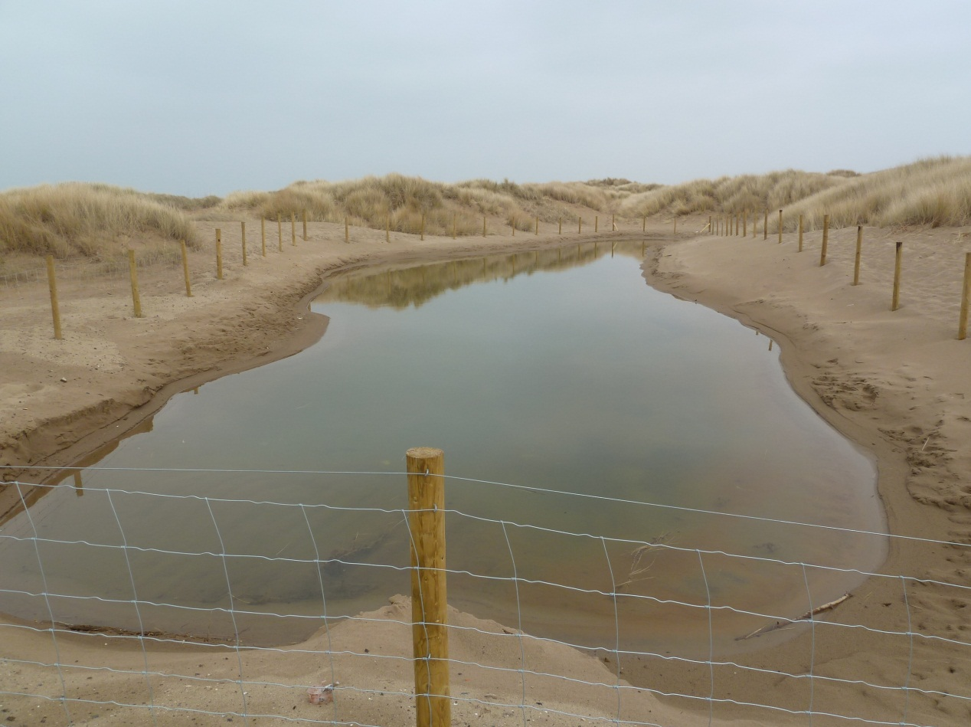

Appendix 11: Overview of the Ainsdale slacks.

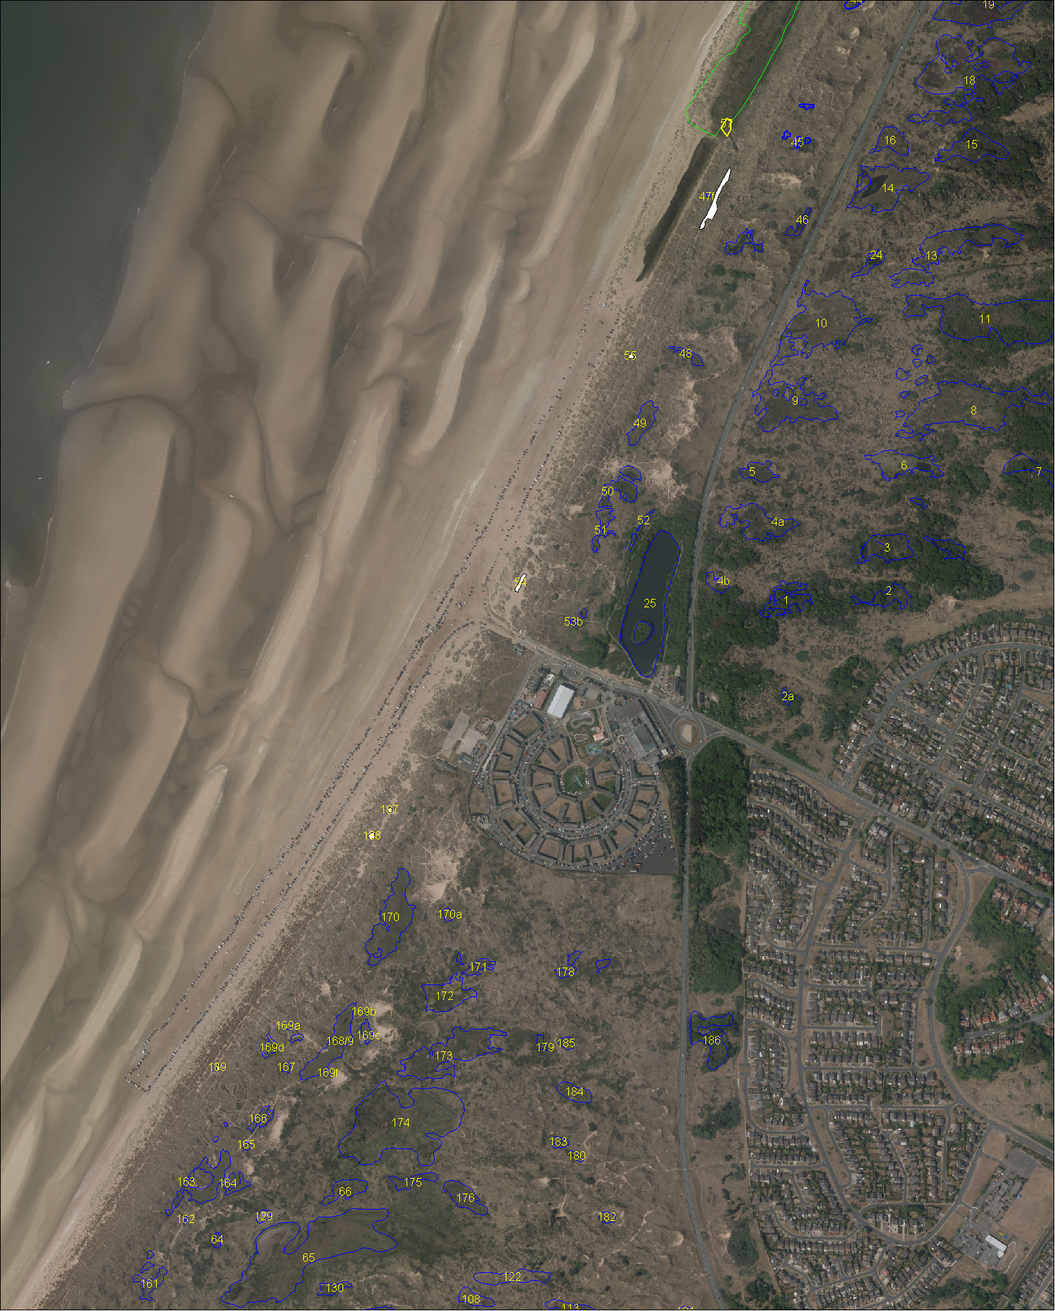

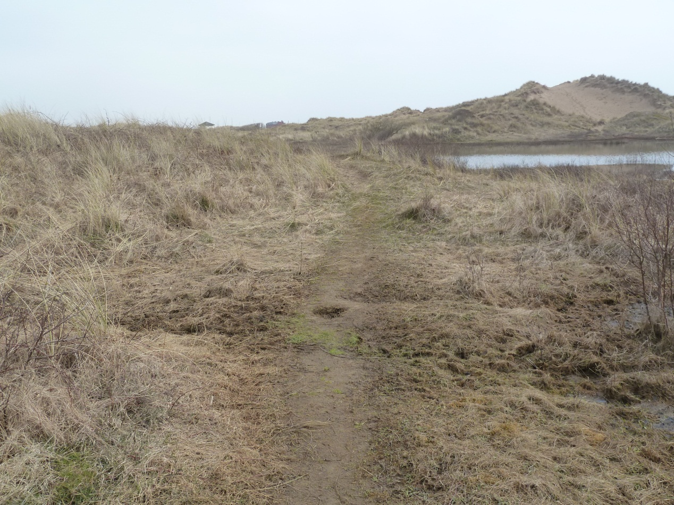Appendix 12: Water level drop difference at Slack 170. The path in the picture was covered until recently by the pond seen in the background.