University of Central Lancashire

School of Built and Natural Environment

The Impact of Agricultural Activity on Nitrate Pollution Affecting UK River Systems – A Comparative Study between Commercial and Private Land-Use

Louis Wilmot

Student ID: 20506102

12/04/2013

University of Central Lancashire
School of Built and Natural Environment

Geography BSc

Undergraduate Dissertation

I, Louis Wilmot, declare that the main body of text in this dissertation is no more than 10,000 words and is all my own work and effort. All other source material used for this dissertation is referenced herein.

Signed:.........................................

Date: 14/03/2013

Word count: 9,728 (main body only)
Abstract:
Water samples were taken over 5 month period from several sites in an effort to evaluate whether private agricultural sites release a disproportionally large amount of nitrates in comparison to a variety of commercial agricultural sites. This was done by taking samples of run-off water from the sites and then analysing them using ion chromatography. After statistical analysis it became clear that there was a significant difference between commercial and private agricultural nitrate concentrations of run-off water. The key findings of this research suggest that private sites do not follow the same fertilisation techniques employed by agricultural land managers and as a consequence, continue to emit nitrates through winter. This suggests that there is scope for more research into nitrate pollution from private sites (which is currently unregulated). This research also found potential for a public consultation process on best management practices in an effort to reduce nitrate pollution and decrease the amount of land classified as a Nitrate Vulnerable Zone (NVZ).

Keywords:
Agriculture, Water Sample, run-off, Nitrate Vulnerable Zone (NVZ), comparative study

Acknowledgements
I would like to use this space to acknowledge all the lecturers throughout my course at the university which gave me the necessary skills and information to conduct this research. Thank you.
Contents
List of tables 6
List of Figures 6
List of Abbreviations 7
1.0 Introduction 8
2.0 Literature Review 10
2.1 Context of Research 10
2.2 Nitrates and their Sources 11
2.3 Nitrate Problems 12
2.4 Nitrate Regulation 14
2.5 Regulation of Allotments 14
2.6 Measuring Nitrates 15
3.0 Research Aims and Objectives 19
3.1 Research Questions 19
3.2 Null and Alternative Hypotheses 19
4.0 Methodology 20
4.1 Site Selection 20
4.2 Sampling Techniques 24
4.3 Samples Analysis 25
4.4 Qualitative Sources 25
4.5 Handling Data and Statistical Analysis 26
5.0 Results 27
5.1 Overview of Results 28
5.2 Site 1 Results 30
5.3 Site 2 Results 30
5.4 Site 3 Results 31
5.5 Site 4 Results 32
5.6 Statistical Analysis Results 32
6.0 Discussion 34
6.1 Limitations 34
6.2 Key Findings 35
7.0 Conclusion 39
8.0 Appendix i. 40
9.0 Appendix ii. 40
10.0 Appendix iii. 40
11.0 References 40

List of tables
Table 1: Mean value sample data for statistical analysis
Table 2: P value outcomes of paired t-Test
List of Figures
Figure 1: An Early NVZ Distribution map - 1996
Figure 2: The current NVZ distribution map - 2013
Figure 3: PAS- 100 approved fertiliser
Figure 4: The eutrophication process
Figure 5: A publication advocating the expansion of allotment sites
Figure 6: Testing for nitrates using chemical agents
Figure 7: A photometer
Figure 8: A variety of ion specific electrode detection techniques
Figure 9: An ion chromatograph instrument
Figure 10: The distribution of sampling sites across the Ribble catchment
Figure 11: Aerial view of site 1
Figure 12: Aerial view of site 2
Figure 13: Aerial view of site 3
Figure 14: A normality test conducted on the dataset
Figure 15: A scatter plot displaying mean sample results against sample date
Figure 16: Site 1 sample results
Figure 17: Site 2 sample results
Figure 18: Site 3 sample results
Figure 19: Site 4 sample results

List of Abbreviations

NVZ - Nitrate Vulnerable Zone
NO₃ - Nitrate
EA - Environment Agency
EEA - European Environment Agency
Defra - Department for Environment Forestry an Rural Affairs
UK – United Kingdom
Kg - Kilograms
PPM – Parts per million
P-value – Value of statistical significance
Mg/l – Milligrams per litre
Mol/l – Molecules per litre
Kg/l – Kilograms per litre
m - Metre
m² - Square metre (area)
*pdf – Portable document format

- Introduction
“We abuse land because we regard it as a commodity belonging to us. When we see the land as a community to which we belong, we may begin to use it with love and respect.” – Aldo Leopold, 1887-1948.
When Aldo Leopold penned the above words, he did so because he saw the environment around himself deteriorating, these words were penned to inspire future generations to take up the challenge of ensuring the environment is managed to a higher standard than the world he knew. It is no secret that as a result of the industrial revolution, the agricultural revolution and mechanisation, the environment in the early 20th century was highly polluted. This has often been attributed to a lack of knowledge about the consequences of polluting the environment, combined with little (or no) regulation regarding the environment (Young, 2000).
The green revolution, a greater public awareness of environmental issues and also the large amount of media attention paid to issues surrounding nuclear radiation, all led to an increase in the exposure of the general public to the environment and the many issues which result in poor management of the environment in the middle of the 20th century. Since this increased public interest in the environment has been established in the population, politicians have made policies surrounding environmental issues a key part of election manifestos and issues that local authorities must address in the later part of the 20th century. Increased research into specific areas of pollution, such as nitrate pollution or heavy metal pollution, has resulted in much more concise legislation book, which seeks to preserve the environment, whilst also enabling industry to flourish (with varying degrees of success).
Figure 2: The current NVZ distribution map - 2013
Figure 1: An Early NVZ Distribution map - 1996

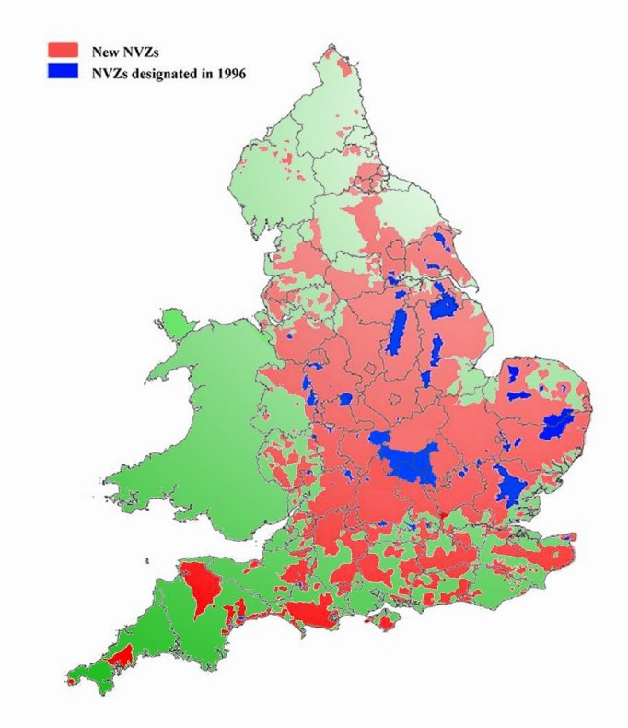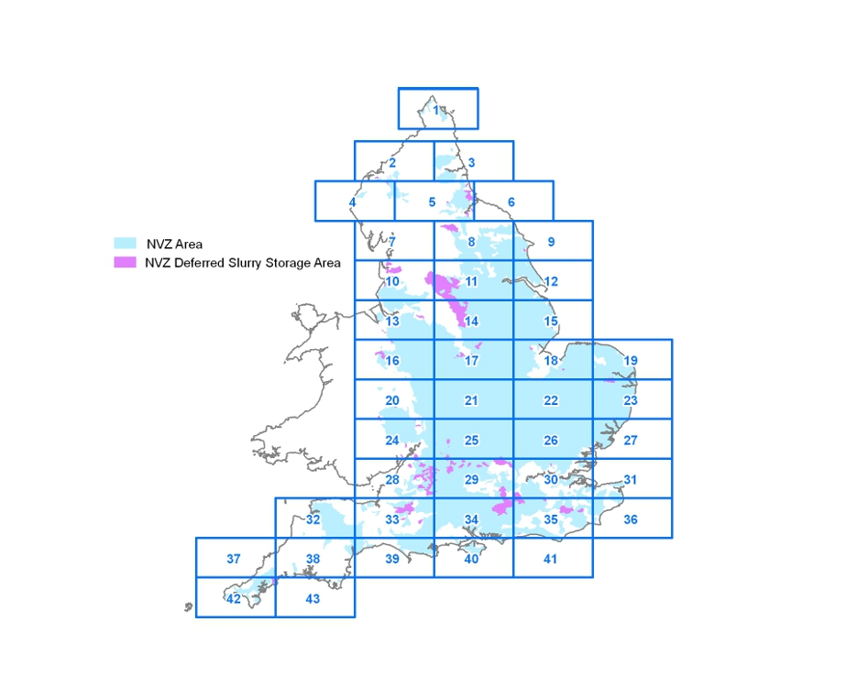
Due to the poor quality of UK Rivers in the mid to late 20th century, ways of measuring the quality of the water in a river had to be devised; a good water quality indicator is the level of nitrates in a river. This is because nitrates have detrimental impacts upon aquatic environments, and as such, have been identified as a key measure of the quality of UK Rivers. The Environment Agency (EA) and the Department for the Environment Farming and Rural Affairs (Defra) have kept track of nitrate levels in UK Rivers and have, since 1996, advised the UK Government to implement legislation regulating agricultural practices in order to meet European Environment Agency (EEA) targets to reduce the amount of areas of Europe classed as Nitrate Vulnerable Zones (EA, 2013). Figure 1 shows an early NVZ classification map which, when compared to the latest NVZ map available (Figure 2), shows that the amount of land classified as such, has decreased. The definition of a NVZ is an area of land which drains into a river which has a concentration of over 50mg/l (Defra, 2011) and the legislation affects individuals which practice commercial agriculture. No such legislation has been implemented governing the private practices of agricultural activities, which would affect individuals such as allotment owners.

- Literature Review
2.1 Context of Research
In terms of the context of this dissertation, it is possible to identify that agricultural practices in the UK are now beginning to be more widely noticed for their impact on the nitrate levels of water bodies, for example the relatively recent ban on spreading organic slurry fertilisers on frozen ground in the UK, which has been in place since 2008. This is because a water body with a nitrate level of just 30 PPM can begin to inhibit growth and fecundity of some aquatic species in the UK (Blakely, 2005). This has meant that in recent years an increased focus on the levels of nitrates entering water bodies has been apparent in policies being pursued, this was first highlighted in a European Environment Agency initiative to reclassify areas of Europe as Nitrate Vulnerable Zones (NVZs). This directive meant areas of land within a catchment of a water body that has more than 50mg/l of nitrates (NO₃), are to now be classified as NVZs (EEA, 2002).
The result of this reclassification of land has resulted in consequences for farmers and commercial agriculture as a whole. For example in Scotland, the increased regulation of fertilizers has meant that farmers and commercial bodies, since 2008, have had to submit fertilisation planning forms along with risk assessments and cannot legally use more than 170kg of nitrates per hectare (Scotland.gov, 2010). This “push” towards regulating agricultural nitrate pollution has only really gathered pace in recent years; this is largely due to research publications such as Nitrogen in the Environment: Sources, problems and management (Follett, 2008). It is, however, important to highlight the fact that although much of the research is aimed at the causes of the nitrification of rivers, the research tends to only highlight commercial agriculture as a key source of nitrates (Johnson, 1991, Rosen, 2009, Saad, 1999) entering water bodies. It could therefore be submitted that private agricultural activities potentially have a disproportionate impact on the nitrate levels of local water bodies in the UK, which has relatively large amount of land classified as NVZ’s, considering the limited distribution of commercial agriculture in the UK (Wilde, 2003). This contention therefore warrants scientific research to establish whether or not this is the case, as no research of this nature has been undertaken, this dissertation will use a simple comparative study to establish whether nitrate discharge has the same level of variance as commercial agricultural run-off, which will enable the researcher to determine whether or not increased expenditure on education for private agricultural practitioners would be beneficial to the environment.
Ultimately this work aims to fill a niche that has yet to be examined and will attempt to be a stepping stone for future research projects into the impact of an increased amount of private agriculture in the UK and (at least) raises the question as to whether private agriculture has a greater detrimental impact in terms of size of land used in comparison to that of commercial agricultural practices. The reasons as to why this work is important are for the clear fact that the supporting material referenced in this dissertation is aimed at commercial agriculture and the nitrogen cycle, not private agricultural activity (for which research publications are relatively non-existent). Research material in the public domain is extremely sparse, in terms of the contributions of private agricultural activity, often relying on estimates and the firsthand accounts of allotment owners. Also the issue that the implications of a human activity that has taken place in the UK for over 300 years and is not yet fully understood, seems trivial and relatively simple for an individual to investigate, given advances in the access to technology and information available in the digital age. These issues coupled with the health issues for species (including humans) and the impacts on the nitrogen cycle suggest that this research is not only filling a gap in information, but is using aforementioned commercial agricultural studies to build an understanding of the implications for the environment of shifts in human activity to a more self sufficient style of existence, often referred to by allotment patrons as “the good life”.

2.2 Nitrates and their Sources
Nitrates can be said to be a chemical compound which are widely utilised throughout the natural world by a range of species (Marschner, 1999). An individual nitrate molecule (the smallest derivation of a compound) essentially consists of a nitrogen atom which shares a bond with three oxygen atoms to form the molecule nitrate (NO₃). Nitrates tend to categorised into two particular groups, organic nitrates and inorganic nitrates, both of which can be utilised by vegetation (with a wide range of nitrate requirements) as a vital part of stimulating plant growth and development. Organic nitrates tend to occur naturally as a result of the decomposition of organic matter by a variety of species of nitrifying bacteria, such as Nitrococcus Mobilis (N. mobilis), which are a fundamental part of the nitrogen cycle (Dawson, 2013). Inorganic nitrates can be said to be the form of nitrates with which most refer to when speaking about nitrate pollution. Inorganic nitrates are often referred to as mineral nitrates; they are usually found in arid areas, due to how soluble the compounds can become when exposed to water. These nitrates are commonly commercially mined from large deposits to feed the global agricultural industry and then applied to farmland as fertilisers.
It is the process by which nitrates are reaching UK river systems which has to be identified and managed in order to prevent the nitrification of UK river systems to unsustainable levels. The level of nitrates which one may expect to find in contaminated freshwater runoff bodies typically ranges from 1ppm to 4ppm of nitrate (Nolan et al, 1988). However it has been submitted that these values can be greatly exceeded in highly concentrated runoff streams, which if unregulated, can result in areas being classed as an NVZ due to excessive nitrate content. Rivers tend to have their highest nitrate content in their lower courses due to the accumulation of nitrates across a catchment, however it has been identified that measuring nitrates after they mix with saltwater is extremely difficult due to the salinity of the water (Young, 2000), which when put into an ion chromatograph results in extremely low nitrate detection levels because of interference.
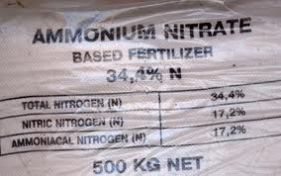
Figure 3. PAS- 100 approved fertiliser

In terms of the anthropogenic induced nitrification of UK river systems, as a result of poor land management practices, it is possible to state that the largest contributor to detrimental nitrification (in the UK) is the application of nitrogen based fertilisers (PAS 100 - approved fertilisers in the UK, as seen in Figure 3) to farmland,. The dependence on nitrogen based fertilisers in the UK is required to maintain crop production in arable farming. As has been mentioned, nitrogen is a key component for the development of plants; in commercial agriculture large quantities of ammonium nitrate (NH₄NO₃), which is a weak acid, are applied to soils. This ammonium nitrate then undergoes a series of chemical reactions which results in the production of nitrates (NO₃), which are utilised by the roots of vegetation. Nitrates that are not utilised by plants then have the potential to reach UK river systems as a result of run-off during precipitation events.
Although commercial agriculture as a whole contributes a vast amount of nitrates into UK river systems, there is very little research on the impact of the fertilisation practices of individuals partaking in private agricultural activity. The possible necessary regulation of private agricultural pollution (an issue barely recognised in the 1998 Allotments Act) and the possible need to enforce caps on crops which require excessive amounts of nitrates to grow in comparison to other crops, such as tomatoes, which are a very common feature in private allotments across the UK, is an issue that requires increased focus.

2.3 Nitrates problems
Nitrates have been identified as having detrimental impacts upon the health of a wide range of organisms, including humans. Typically, for terrestrial organisms, nitrates must be consumed either directly or indirectly. Examples of direct consumption include drinking water which is highly contaminated with nitrates. An example for indirect consumption can include the predation of organisms which have been exposed to large amounts of nitrates, such as a fish in a polluted river. When nitrates begin to become concentrated in humans it results in a restriction of oxygen in the blood, as a result of restricted oxygen in the body, the organs of humans begin to experience oxygen stress, which can damage tissue and reduce the ability of an organ to operate effectively (EEA, 1999). This can be the result of direct or indirect nitrate consumption, it does not make a difference how nitrates find their way into the human body, they are seen as detrimental to human health in large volumes (EU Council, 1998).
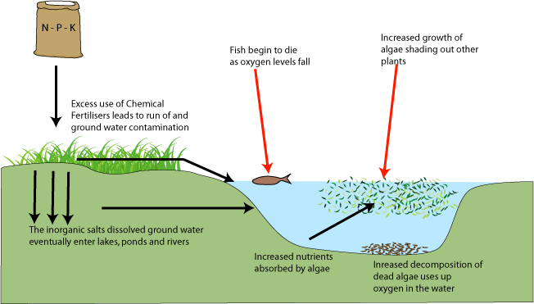
Figure 4: The eutrophication process
In terms of the impact upon aquatic species, it can be said that nitrates have a much more detrimental impact upon organisms which occur in this environment. This is because of a combination of factors which can be best demonstrated by an example with reference to a species. A good example for a species which can demonstrate multiple issues surrounding nitrates is Ostrea Edulis (O.edulis), also known as the Common Oyster or European Flat Oyster, which is a species that before the 18th century had a vast distribution across UK Rivers, but has since declined. The species O.edulis remains fixed to strata in situ in shallow waters, this means that if a river is nitrified, the organism has no option to move to a less polluted stretch of river. As algae in polluted water are stimulated to reproduce, as a consequence of increased nitrate availability, oxygen content of the water begins to decrease due to algae utilising oxygen for photosynthesis (eutrophication), this can cause the suffocation of many river organisms, such as O.edulis which rely on the oxygen content of water for respiration (Jackson, 2008), this process has been illustrated in figure 4. It is also possible to highlight other pollution issues using the same species, for example as a result of its feeding mechanism (filtration of water), O.edulis has no option but to consume suspended particles which pass through its feeding system, in a habitat where nitrates are excessively high this can result in suppressed development as organisms reach maturity, often resulting in reduced size of individuals; this is the same for other river species which experience inhibited growth as a result of the nitrification of rivers (European Commission, 2010).
Other than the inhibition of growth of some species, the death of other species and an increased risk to organisms which consume species that have been exposed to concentrated nitrates, it can be said that nitrates have many varying impacts upon a range of habitats, such as acidification of waterways. For the purpose of this dissertation only the key issues surrounding the problems of nitrates in an ecological sense will be identified, this is because ultimately this dissertation aims to be used as tool to help guide legislation to enable habitat amelioration.

2.4 Nitrate regulation
The official regulation of nitrates, as a target for the Environment Agency, has only gathered pace in recent years as a result of the increased awareness of the aforementioned environmental problems surrounding nitrates. The first regulations found to regard nitrates are from 1998, in the appendix iii attached to this dissertation, which contains the EA position statement on the regulation of NVZ’s and the specific details of allowances and best management practices of fertilisers from 1998-2013. Essentially the document refers to fertiliser storage and spreading techniques and outlines the definition of an NVZ (which can be seen in the introduction of this dissertation). In short the regulation of nitrates in the UK requires enforcement by the EA, but is mainly geared towards providing fertiliser management techniques on farms which have been proven to work at other sites in the UK.

2.5 Regulation of allotments
Allotments in the UK are common sight throughout the country and have been since the early 18th century when people from the countryside began to become urbanised and live in towns and cities. The first piece of regulation seen on the statute book was made in 1758, which suggests the land-use must have been relatively widespread even then (Savile, 2009). The Enclosure Act of 1845 protected the status of allotments in towns and cities across the UK and added the caveat that allotments could only be removed with ministerial consent, removing the rights to redevelop sites for other purposes without a substantial reason. The Allotments Act of 1925 then stipulated that all new town planning projects must allow for allotment spaces in urban areas. The Allotment Act of 1950 further reinforced local authorities obligations to allotment gardens in the UK because it meant that access routes to and from sites must be provided to enable access for patrons.
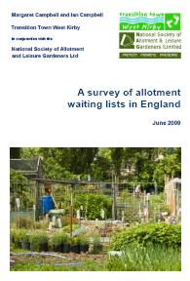
Figure 5: A publication advocating the expansion of allotment sites
Acts, such as these, have meant that allotments have survived in the UK for centuries and that they will continue to do so in the future, especially considering the determination of allotment patrons through publications such as that of figure 5, which was commission by the organisation “allot more allotments”. However in recent years a drive towards self-sustainability has increased the demand for allotments in the UK (House of Commons, 1998), thus making a window for new research into the impacts of growing on allotment sites rather than simply buying in a supermarket, and the implications for untrained members of the public releasing fertilisers at their discretion across the UK. As is evident in all of the Acts of Parliament that have been identified, none contain any reference to the regulation of pollutants at the sites or the liability of individuals for run-off water quality from the site.

2.6 Measuring Nitrates
Techniques for measuring nitrogen in UK river systems vary greatly. Having a wide variety of methods which enable researchers to conduct nitrate detection and analysis with equipment that best suits the parameters that they have set for their work and the objectives that need to be achieved. It is also worth identifying that the units of measurement that will be used for this dissertation is ppm and also mg/l. The unit ppm is same as mg/l for this dissertation, this because ppm can be seen to be a somewhat ambiguous term. The unit ppm expresses the number of a given particle dissolved into a solvent per one million molecules, but in chemistry ppm refers to mg/kg rather than mg/l (this because chemists typically use a weight to weight unit of measurement rather than a weight to volume unit of measurement, such as mg/l). However because the solvent of the solution in this dissertation is water (with a weight of 1kg per litre), then ppm in this instance can be used interchangeably with mg/l (this is because mg/l is equal to mg/kg in this case). This is important to highlight because legislation focuses on >50 mg/l where as lab results are expressed as ppm. Again, for this dissertation, ppm and mg/l have the same value, this is not to be confused with the number of molecules present in a solution (mol/l) also common in chemistry which will not be used in this dissertation or to be confused with international nitrate measurements whereby only the molecular weight of the nitrogen in a compound is measured (often called the nitrate-N weight) and therefore gives different results (Johnson, 1991). Different nitrate detection techniques will be discussed in further detail, however, biological indicators, such as eutrophication or large quantities of algae, will not be discussed due to their low resolution in comparison to all other analytical methods.

- Chemical Agents
Figure 6: Testing for nitrates using chemical agents
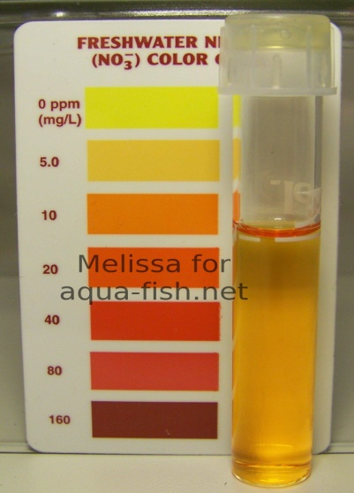
Chemical tests tend to be seen as the cheapest and most basic of the nitrate detection methods implemented in investigative research, figure 6 shows a simple nitrate test being conducted using a chemical agent. The methodology of this technique involves taking a small water sample, for example 25 ml, and then exposing the sample to a specific chemical agent, which varies depending upon what compound is needed to be detected. This agent then reacts with the water sample and causes a visual change in colour, which then enables the researcher to examine it against a colour chart. Variations on the colour chart identify different concentration levels of a substance, which enable the researcher to gain a relatively inaccurate view as to what the concentration level of a substance is, but is generally used to give an indication as to the presence of a substance, rather than a set of data to be used as the base for quantitative research. This method does require individuals to know what they are looking for (in terms of which chemical agent to add to a sample), but is effective as a detection method for potential runoff streams which may harbour a substance which is being sought for analysis. However this technique is largely dependent upon the ability of a person’s eyes to discern colour and quality of light at the time of analysis, meaning two people could look at the same sample and see different results.
- Photometers
Figure 7: A Photometer
Photometric detection can be said to be a more advanced version of chemical tests, whereby the same chemical agents are added to samples, but rather than holding the sample to a colour chart and using the naked eye to assess the colour of the samples, a photometer (light sensor) is used to determine the sample colour. A relatively inexpensive nitrate photometer can be seen in figure 7. This advanced technique has a much higher resolution than simple chemical testing because the light sensor enables a sample analysis calibration process to determine the exact frequency (colour) of the light and then cross reference this with a computer database containing concentration frequency (colour) data. This method is much more reliable than chemical tests; however it is not the most effective method of nitrate detection.

- Ion specific Electrode
Figure 8: A variety of ion specific electrode detection techniques

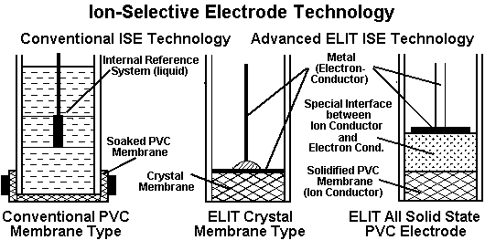
The more advanced methods of nitrate detection include the use of an ion specific electrode and can come in a range of forms, as seen in figure 8, but are all more effective detectors than the previously mentioned methods. Utilisation of this tool is vital in order to gain the most accurate readings available to researchers, which is essential for producing robust data which can be used to guide legislation. The process, by which this level of accuracy is achieved, is through the use to two probes, one of which is in the sample being tested, and the other probe being placed in a control solution which is used to calibrate the results. The probes which are in the solution detect nitrates by measuring the presence of molecules as they pass across a membrane located at the tip of the probe, which is then presented as a visual data readout on screen or paper (depending upon how advanced the instrument is).

- Ion Chromatography
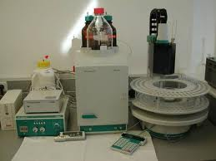
Figure 9: An ion chromatography instrument

Ion chromatography is a process which is carried out by scientists and chemists alike, the instrument itself is a complex machine, and figure 9 shows an ion chromatograph in a lab. The process is by far the most accurate analysis technique available which is practical. This is because this method makes use of chemical analysis, photometric analysis and the use of an ion specific electrode, but also uses multiple sample analysis to eliminate results which are not consistent with the sample. This is done by passing multiple samples through the machine in order to create a standardised sample dataset. The data output of this instrument consists of the production of pdf* file, consisting of numerical data and also the original detection graph which was used to determine concentrations provided in the numerical data.

- Research Aims and Objectives

After looking in detail at the literature available surrounding nitrates, agricultural pollution, allotment management and environmental policy, it is possible devise a series of questions and hypotheses which can be examined. This dissertation will seek to answer the following questions.

3.1 Research Questions
- Is there any difference between the patterns of nitrate concentrations in run-off waters from commercial agricultural sites in comparison to private allotments?

- Do allotments pollute UK river systems disproportionately in comparison to commercial agricultural sites, in terms of nitrates pollution?

- Is there a need for increased research into the environmental impacts of private agricultural activities?

- Is there scope for an expansion of best management practices regarding fertiliser management for gardeners?

3.2 Null and Alternative Hypotheses

Null hypothesis - There is no significant difference between commercial and private agricultural, sites in terms of nitrate run-off.

Alternative hypothesis - There is a significant difference between commercial and private agricultural sites, in terms of nitrate run-off.

  - Methodology

The methodology that has been developed to answer the questions that this dissertation poses uses the simple principles of a basic comparative study, whereby samples were taken from sites, analysed and then statistically analysed to test for meaningful relationships between different sample data using a paired t-Test (Rice, 2006). This was achieved by an initial period of surveying sites for suitability (using chemical analysis), a period of sampling combined with laboratory analysis and statistical analysis over the sample period in order to provide data which can then be interpreted to answer the research questions set. This quantitative data was also supported by informal conversations with parties involved to enable further qualification of results. In total 80 samples were taken over the 5 month study period, which ran from the 25th of October 2012 until the 21st of March 2013. Sampling was intended to always occur on a Thursday with 3 weeks left between samples. Samples were taken at approximately 10:00 am and transported to the University of Central Lancashire’s Forensic Science Building for chemical analysis after the sample cycle had been completed. Sampling cycles took approximately one hour, given the distribution and topography of the sample sites, and were all carried out in the same conditions on the same day. Images of each site are available in the appendix in order to give the reader more insight into the site and situation of each sample site.

4.1 Site selection
The site selection process for this dissertation was a lengthy process given how appropriate the site comparison needed to be in order for results to be meaningful. This meant that all samples needed to be taken from a similar area, relatively close to each other, with a diverse range of agricultural practices taking place at the sites. An initial sample of run-off water was taken from a variety of sites in the summer of 2012, which underwent analysis in order to determine levels of chlorates, nitrates and sulphates. Nitrates were an obvious molecule to test for as the comparative study is focused on these molecules, however, chlorides are a good indicator of contamination resulting from sewage networks (this is because the chlorine content of wastewater is high) and sulphates are a good indicator of industrial pollution (sulphur dioxide being a key emission of large scale industry, such as the coal industry, which was present in the area in the 20th century). After eliminating catchments that did not meet the necessary criteria or which had an exceedingly high level of chlorates and sulphates in comparison to other catchments, the Ribble catchment was chosen. This is because this catchment provided the diverse range of agricultural activity required for the comparative study, within a distance of approximately 5km, as can be seen from Figure. The sites are relatively close and as a result will undergo many of the same mitigating factors, such as pollution, and experience the same weather patterns, which due to the topography of the area, can be extremely varied. The study reach itself has undergone little to no redevelopment and remains mainly forested along the rivers in the catchment, with moorland at higher elevations.
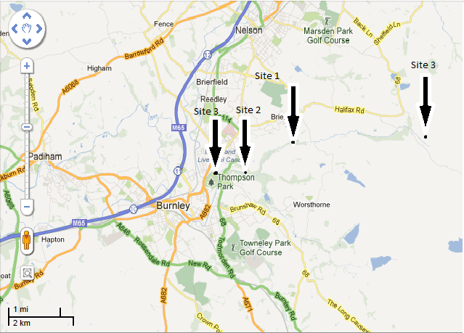
Figure 10: The distribution of sampling sites across the Ribble catchment

The Ribble catchment itself covers an area of some 860 square miles (Ribble Trust, 2013) and supports a wide variety of birds, mammals, fish and invertebrates. This makes the catchment a vital community resource in an area of high unemployment and low life expectancy (ONS). The catchment itself experienced a period of rapid industrialisation at the start of the 19th century, with areas establishing themselves as vital hubs in the international cotton trade and marking towns within the catchment as Victorian industrial towns, such as Burnley. With this growth the area suffered from high levels of pollution and deterioration of the environment. As industrialisation slowed the key industry in the catchment was coal production up until the 1950’s, after which primary sector employment decreased and most people became employed secondary industries, however environmental deterioration continued due to poor wastewater management and unsustainable water extraction from rivers. Since the 1960’s the environment within the Ribble catchment has experienced amelioration and continues to do so (Ribble trust, 2013). The catchment itself contains areas downstream which are classed as NVZ’s and areas upstream which have NVZ deferred slurry storage areas. These restrictions are in place in order to manage the nitrification problems downstream; however there are no restrictions in place in the 5km reach of the survey area, even though restrictions are in place just 500 metres upstream of site 3. Each site will now be individually examined along with a satellite image in order to give a better insight into the specific sites used for sampling.

- Site 1 – Commercial Agricultural Production Site
Site 1 is a key sample site as it is this sites comparison to site 2 which will give the answers to some of the key research questions. It was located approximately 1.5km upstream from site 2 and 3km downstream from site 3. The site can be found at +53° 48' 20.43", -2° 11' 17.52", next to the River Don and covers an area of approximately 600m². The run-off stream for this site was located in the south-western corner of the field. The location is a commercial agricultural site which is used to grow Kale. Kale is a root vegetable which is used to feed livestock that inhabit areas further upstream, such as site 3. In order to grow at this location the site is exposed to slurry fertilisers (after harvest) and also nitrogen based fertilisers (to aid growth in the Spring), it is also worth pointing out that in the satlilitte image, Rapeseed can be seen growing. Rapeseed nitrifies the soil and is a way of enabling the soil to recover after crop growth on nutrient poor soil. The site itself is situated approximately 1.2km from the watershed to the north and has a similar land-use occurring around the site such as ploughed fields. This site was chosen because of the easy access routes which did not cause disturbance to animals or fields; this had to be a key consideration due to the study length, the nature of the land-use at the site and health and safety issues.

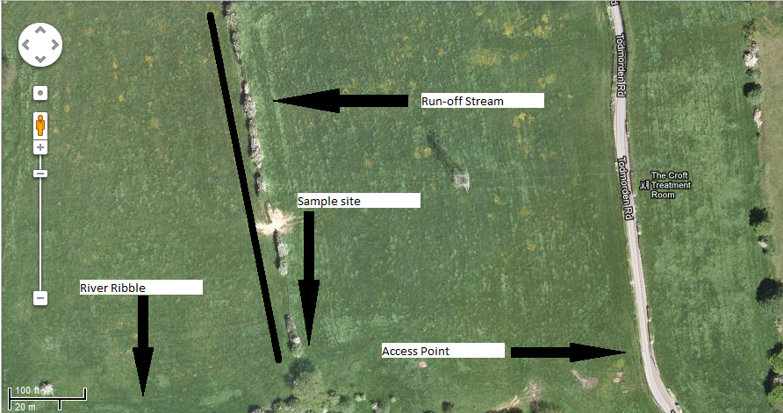
Figure 11: Aerial view of site 1

- Site 2 – Private Allotment Site
The allotment site, which is a key focus for this study, can be said to be the most important of the sampling sites for this research as it is the key variable. The site is located approximately 1.5km downstream from site 1 and approximately 750m upstream from site 4. The site can be found at +53° 47' 58.40", -2° 13' 36.96”, next to the River Brun and covers an area of approximately 700m². The site itself is located substantially closer to urbanised areas, unlike sites 1 and 3; however it remains relatively natural surrounding the site, as can be seen on the satellite image. In the centre of the site is a man made drainage ditch that has been put in to manage site drainage and prevent water logging. There is a diverse range of vegetation grown at this site, with most growing taking place under greenhouse covers. Managed vegetation that could be found at the site included tomatoes, leeks, cabbages and in one structure rhubarb was being grown in the dark. This goes to signify the diverse range of practices at this location and the diverse nutrient requirements of these crops. This site was selected due to the low chlorate level in comparison to other potential allotment sites investigated.

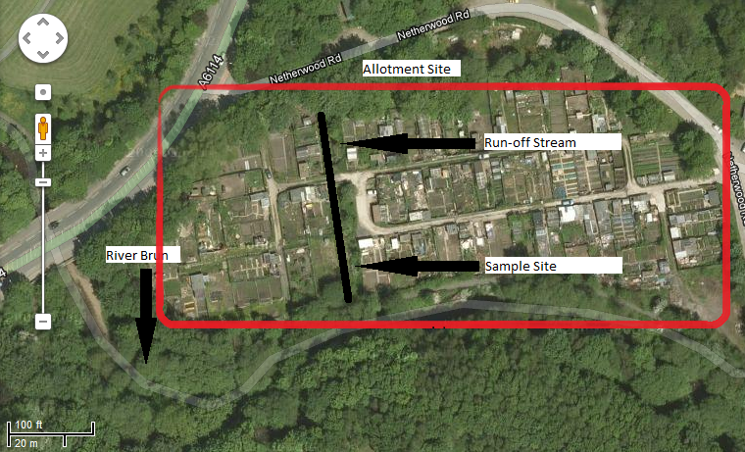
Figure 12: Aerial view of site 2

- Site 3 – Sheep/Cow Grazing Site
Site 3 was identified as being an important sampling site as it serves the potential of highlighting the differences in nitrate emissions between crop production and food production. The site is the furthest upstream point of the study and is located on the River Don at +53° 48' 35.14", -2° 8' 54.26" on the right side of the river. This site covers an area of approximately 1km² and is by far the largest sample site and the most rural site with it being located close to moorland. This field contains the remains of an old farmhouse and is used for the grazing of sheep and cows. The site itself undergoes slurry fertilisation biannually in Spring and Autumn to enable bulk quantities of grasses to flourish. The soil at this site tended to be of a poorer quality, consisting mainly of quartz, in comparison to the other sites.

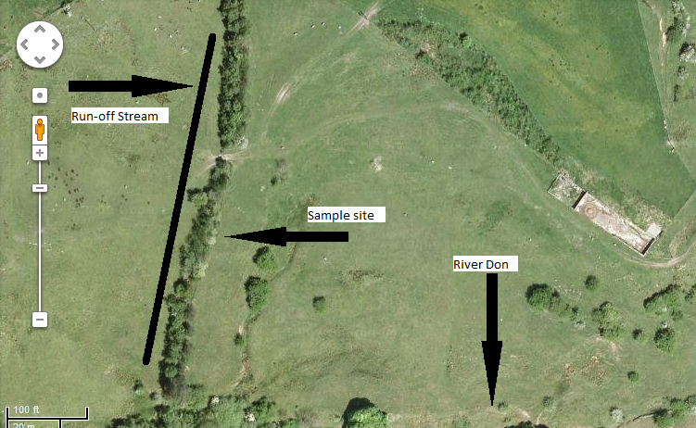
Figure 13: Aerial view of site 3

- Site 4 – Downstream Qualifying Sample Site
Site 4 was a sample site that was selected to facilitate an overall insight into the general pattern of the River Brun over the study Period. This is because all of the other 3 sites flow into the River Brun. The site was located approximately 750m downstream from site 2 at +53° 47' 58.48", -2° 13' 41.84" on the right bank of the river. The sample site was located in the centre of a public park which ensured access over the study period and was selected for the aforementioned reasons.

4.2 Sampling techniques
In terms of the sampling techniques that were implemented in this study, it is possible to state that 2 sampling cycles ran alongside one another in order to give the highest possible data resolution for statistical analysis, sample cycle A and sample cycle B. Both cycles took place at the same time in order to ensure that outliers (such as sample 2a at site 2) did not have a disproportionate affect on the data produced or the conclusions of this research.
As has been identified in section 4.1.iv, great care was taken to ensure that mitigating factors did not corrupt data; this was continued throughout sampling by using a standardised treatment of samples coupled with a systematic point sample selection process at each site. This was achieved in the sampling stage by washing all sampling containers in their respective run-off waters downstream from the site to prevent cross contamination of samples over the study period. This meant that no prior substances remained in the sampling containers and removed the issues of washing containers with tap water (which contains chlorates) at the site. This was seen as an effective sampling method because it would not affect data as long as all samples were collected and managed in exactly the same way.
Samples were taken consistently from the same nearest safe point along drainage ditches, 3cm below the surface of the run-off streams (unless low flow prevented this, but this information is available in the appendix data sheet) to prevent floating debris in the channel from entering sampling containers. The samples were taken once only regardless of what suspended materials made their way into the sample. The sample consisted of approximately 300ml each, so each site had 600ml of run-off water carried in separate containers. This is a large sample, but necessary sample size given the required quantities for chemical analysis. Storage of the samples consisted of keeping them in the laboratory fridge before analysis.

4.3 Sample Analysis
After reviewing the methods of nitrate detection at length and corresponding with chemists at UCLAN laboratory facilities to ascertain what detection methods were available at UCLAN, ion chromatographical analysis was the option selected (see section 3.6iv). The process of chemical analysis was a relatively straightforward procedure by which an individual sample volume was split into numerous small samples to run through the ion chromatograph in order to establish a standard. This was done to ensure that large fluctuations did not occur as a result of only testing a small volume of a sample. After the samples had been fed into the machine they produced a pdf* file after several minutes, which could then be “corrected” by the lab technician against the standard that had already been done. This meant that results retained their highest possible resolution and that there was a much more reduced chance of only sampling a highly concentrated volume, which could potentially render the research useless.

4.4 Qualitative Sources
In terms of the qualitative sources that were used to gather information on the site, unfortunately both sources opted not to be identified by name; this meant that they must be referred to as source 1 and source 2. Source 1 was the owner of sites 1 and 3 and had been part of the commercial agricultural production industry for 34 years, the source had firsthand experience of the application of fertilisers at site 1 and site 3 (when they were fertilised and what they were fertilised with). Source 2 owned an allotment at the site 2 allotments; this meant source 2 could give general background information about patrons and practices on the site (which has limited reliability) and give specific details about their own personal allotment practices and experiences. However as the study progressed source 1 began to become uncooperative and as a result, the use of interviews in the research was abandoned.
4.5 Handling Data and Statistical analysis
The data for this work was initially 80 separate spread sheets, which were then compiled into a spreadsheet format as the complete data-set for the study; this can be seen in appendix ii. It is from this complete data-set that all calculations, observations and conclusions will be made. The data set was initially as ppm and does not need to undergo any calculation to convert to mg/l (see section 3.6.vi).
The data that has been produced for the statistical analysis tests is a mean value of both sample cycle A and cycle B, in an effort to give an accurate value in the paired t-Test that is not affected by anomalous data. All of the statistical analysis carried out in this study was done using the Minitab 16 statistical software package, the result of this analysis can be seen in section 5.0.

- Results
In this section the results of the laboratory analysis will be examined in order to identify patterns and relationships between the data and will give a brief overview of the entire dataset. In an effort to ensure that this is a pithy section, the data that will be explored in statistical analysis is the mean of two samples taken at each site; these values can be seen in table 1. The initial samples (samples A and sample B) can be seen in the corresponding specific site results section; it is here that individual samples at specific sites will be examined. The original raw data can be seen as a whole in Appendix B. Table below, is a summarised version of the original raw data seen in the appendix ii. This data is the basis for the statistical analysis of the aforementioned Null and Alternative hypotheses.
The values for this section were all derived from the original 80 samples that were taken over the study period. The values throughout this section refer to the concentration of nitrates in agricultural run-off and refer to ppm (mg/l). Original sample analysis data can be found in the appendix in the form of a printed *pdf sheet which shows an example of the data output from ion chromatographical analysis (see section 2.6 for details). This data was then accumulated, the mean of the samples was taken on each sample date, and then the information was displayed in Table9.

Table 1. Mean value sample data for statistical analysis.
Sample date | Site 1 | Site 2 | Site 3 | Site 4
25/10/2012 | 3.816 | 6.398 | 0.424 | 4.209
08/11/2012 | 3.095 | 1.976 | 0.387 | 3.52
22/11/2012 | 3.126 | 2.076 | 1.088 | 3.731
06/12/2012 | 2.827 | 2.059 | 0.923 | 3.899
17/12/2012 | 2.397 | 5.011 | 0.742 | 3.652
14/01/2013 | 2.579 | 1.782 | 0.598 | 3.997
31/01/2013 | 2.39 | 3.116 | 0.284 | 2.542
14/02/2013 | 2.816 | 2.197 | 0.382 | 2.74
01/03/2013 | 3.676 | 2.154 | 0.818 | 3.172
21/03/2013 | 3.126 | 1.735 | 0.673 | 3.129

5.1 Overview of Results

Figure 14: A normality test conducted on the dataset

From the data that has been produced it is possible to identify from the raw data sheet in the appendices, that the lowest recorded concentration occurred at site 3 and registered 0.278ppm on 31/01/2013 and was taken from sample A. The most concentrated sample occurred at site 2 on the 25/10/2012; the sample was sample A and measured 11.19ppm which is more than twice as highly concentrated as any other sample. The mean value for the 80 samples is 2.482ppm with a standard deviation of 1.585. The data contains only 1 anomalous result which was taken at site 2 on the 25/10/2012 as sample A. After conducting a normality test on the entire dataset, it is possible to state that the data is normally distributed.
In terms of an overview of the patterns and relationships of the results, it is possible to identify that the most erratic results can be said to be seen at site 2. Site 2 can also be seen to have a higher variance than other sites in the study. The data from site 3 produced the lowest results of all 3 sites and was the only site which experienced a greater concentration at the end of the study period in comparison to concentration levels at the start of the study period. Site 4 can be seen to have the highest consistent nitrate concentration over the study period, with site 2 only registering a higher reading 3 times out of the 10 samples taken and site 1 only containing higher concentrations for 2 sample dates out of the 10, both towards the end of the study. In terms of correlation between peaks and troughs of the data (as seen below), it is possible to identify similar patterns in the peaks and troughs of sites 1, 3 and 4, however this is not the case with site 2.

Figure 15: A scatter plot displaying mean sample results against sample date

  - Site 1 results

Figure 16: Site 1 sample results
The above data coupled with the scatter plot shows that the data for site 1 has a high level of correlation, with both data sets containing similar figures in terms of differences between minimum and maximum results. The most concentrated sample was taken as part of sample B on the 01/03/2013 and measured 3.89ppm. In contrast to this the lowest result seen at site 1 had a concentration of 2.232ppm on the 31/01/2013, again as part of sample B. Over the study period it is possible to identify an overall decrease in the concentrations of nitrates found at the site. The lowest sample concentrations seen were found to occur during the middle of the study.
  - Site 2 Results
Figure 17: Site 2 sample results

The results from site 2 can be said to be the most varied between the two sample cycles that ran together over the 5 month study period. The peak sample concentration for site 2 was part of sample A and had the largest concentration of the 80 samples taken in the entire study and measured 11.19ppm. The least concentrated sample seen at site 2 was over 5 times lower than the peak sample concentration and occurred in December. The scatter plot produced suggests that there is a high level of correlation between the results, however this is an illusion caused by the scale (ppm). When looking at sample values individually in the raw data spreadsheet in appendix ii, it is possible to see the differences in sample concentration with greater ease; however the scatter plot does effectively demonstrate the outlier in this dataset.

  - Site 3 Results

Figure 18: Site 3 sample results

Site 3 samples can be seen to be consistently low, with the lowest variance of any of the other sample sets. The greatest difference between sample A data and sample B data is in the initial sample that was taken, however the concentration difference is less than 0.5ppm, which is exceedingly low in comparison to other datasets. Unlike other datasets in the study both sample cycle’s peak on the same date (22/11/2012). It is possible to see from the scatter plot that across the 5 month study nitrates increase; this is not seen in any other dataset.

  - Site 4 Results
Figure 19: Site 4 sample results

The results of site 4 will be used to qualify patterns of the data in the discussion, this is because all of the 3 other sites flow through site 4, which aims to give an overview of what is happening in the river channel itself, opposed to measuring run-off. Samples A and B both fluctuate similarly across study the period however there is a decrease in the concentration of nitrates over the study period. The variance between samples A and B is low in comparison to other sites. The peak samples seen is this dataset are consistently higher than other results seen in the study due to this sample originating from a different source. It is the pattern of change of nitrates over the 5 month study which will be used in discussion, opposed to minima and maxima sample results.

Table 2. P-value outcomes of paired t-Test
  - Statistical Analysis Results
 | Site 1 | Site 2 | Site 3 | Site 4
Site 1 |  | 0.792 | 0.000 | 0.039
Site 2 | 0.792 |  | 0.002 | 0.228
Site 3 | 0.000 | 0.002 |  | 0.000
Site 4 | 0.039 | 0.228 | 0.000

Given that the data collected from this study has already been identified as being normally distributed, it was possible to perform statistical analysis to test for a significant difference between samples. Using the Minitab 16 statistical software package it was possible to conduct paired t-Tests (by establishing equal variances) between sample sites to test for a significant relationship between data. This can be seen in table 2, which shows the resultant P-value output of a paired t-Test from the statistical software package. A P-value of below 0.05 shows that there is no statistically significant difference between data, whereas a P-value above 0.05 suggests that there is a statistically significant difference.

Statistically significant differences that are visible from the above table show that site 1 and site 2 did have a statistical difference in the amount of nitrates found in samples, as did sites 2 and site 4. Both P-values were exceeded in the analysis; however it is site 1 that is the commercial agricultural site and site 2 which is the private agricultural site. It is the comparison between these two sample sets which answers the original research question posed (section 3.2), by stating that there is a significant difference between the commercial and private agricultural sites in terms of nitrate discharge.

6.0 Discussion
The purpose of this section is to discuss the results of the comparative study. This will be achieved by discussing the limitations of this research, the key findings of the study and the potential strategies for further investigation into the nitrate concentration of private agricultural practices (which will be identified throughout the discussion). The discussion will be conducted in this fashion in order to enable the reader to understand the key problems with this research that have been taken into account before drawing any conclusions from the data. The original research questions will then be answered systematically with reference to limitations.
6.1 Study Limitations
i. Scope of the study
It is possible to identify that the general scope of this study is not wide enough, failing to utilise a wide range of catchments, rather than merely the one reach of a catchment. Using a variety of catchments and then breaking down data using a similar sample size to this study from each catchment. This would have resulted in a higher resolution study over a wider area, enabling much broader conclusions about the potential consequences of unregulated fertilisation practices on allotments to be made. This limitation can be put down inexperience on the part of the researcher and means that broader, more conclusive statements about the impact of private agricultural practices are difficult to support using only one dataset from one catchment.

ii. Site selection
In terms of the site selection of this study, it can be said, that finding sites that were suitably close (for the aforementioned reasons in section 4.0) was extremely difficult. Having a lack of academic publications and knowledge of allotment sites meant that the site selection process targeted a cluster of sites along one continuous stretch of river, which was an extremely difficult task to complete. However, in hindsight, it would have been possible (given the resources) to set up this study in a relatively controlled environment, allowing for sites have a greater similarity and therefore produced higher resolution data. A study of this nature has not been done before and would require limited resources.

iii. Sample size
Another key limitation with this research is the issue of the total samples taken. Having to develop a method of testing the research questions meant that running two sample cycles next to each other would mitigate any anomalous data. This was a key issue because literature reviewed pointed to expected concentrations ranging from 1 – 4ppm throughout the year (Defra, 2013), however as the study was conducted over the winter period it was important to keep the dataset complete because what appeared to be incorrect may be meaningful data. Potentially using 3 – 5 sample cycles at the same time would gave a much more accurate study. Although many individual samples were taken from the volumes of water collected to calibrate the machine, technically only two samples were taken from a site, in retrospect this would have been done differently in order to give a more representative view of what was occurring at sites, particularly when using the mean result from the sample cycles at each site for the paired t-Test.

iv. Mitigating factors
In terms of the general mitigating factors such as pollution, weather conditions and unknown variables such as site history, it is possible to suggest that although these impact upon the data itself, it does not have an overbearing influence on the study as a whole. This is because the study does not seek to be a conclusive piece of work giving a specific value on private site run-off in mg/l. The study is instead a piece of work intended to show that there is a significant difference in the emissions from agricultural sites and that this needs to be investigated and potentially legislated for the good of the environment. It is for this reason that although mitigating factors do play a part in distorting data to some extent, many of the sites undergo the same mitigating circumstances in this particular catchment, given the proximity of the sites used (particularly sites 1, 2 and 4). It is however, worth highlighting the extreme weather conditions experienced throughout the study, with temperatures after December 2012 remaining consistently low over the study. This was not expected and meant that fertiliser detection from site 1 was potentially greatly reduced as a result of frozen ground restricting fertiliser application.

6.2 Key Findings of Research
- There is a difference between the patterns of nitrate concentrations in run-off waters from commercial agricultural sites in comparison to allotments.
From the research that has been conducted it is possible to submit that there is a difference between the patterns of nitrate concentration in run-off water from commercial and private agricultural sites. This is because the statistical analysis conducted on the data suggests that there is a significant difference in the nitrate concentrations between site 1 and site 2, which were the key study sites for this research question.
Farmers follow a best management guide in order to effectively manage their fertiliser distribution and reduce the risks of allowing nitrates to enter river systems. This is not the case for private allotment owners. This difference means that through the winter months, when farmers practices can be highly restricted, allotment owners can still continue to fertilise soils at the site (some crops grow year round in an enclosed spaces also). It is the belief of this researcher that the significant difference between nitrate emissions of the sites is the result of a lack of education and legislation governing practices at allotment sites, rather than the consequence of corrupt data that has been influenced by mitigating factors at sites. This is because the sites were all initially tested for pollution and showed no sign abnormally high levels of contamination (EA, 2012).
This finding is further supplemented by the significant difference seen between site 2 and site 4. This is because site 4 was the main body of water in which the 3 previous sites drain and has been used to qualify what is going on in run-off channels in comparison to the main body of water. There was no significant difference between any other sample and sample site 4, which further isolates the allotment sites and makes it identifiably different from the other sites. Leading to the conclusion, that allotment sites do have a significantly different nitrate emission pattern in comparison to commercial sites in this study.

- Allotments do pollute UK river systems disproportionately in comparison to commercial agricultural sites, in terms of nitrate pollution.

By analysing the results obtained in this study, it is possible to suggest that allotment sites do pollute disproportionately in comparison to commercial agricultural sites. This conclusion has been reached using a number of sources of information and does not make attempt to state the degree to which allotment sites pollute for the reasons that have been identified in the limitations section.
By looking at the data from site 2 it is clear to see the nitrate concentrations at the site are somewhat erratic in comparison to other sites. This could potentially be the result of contamination at the site, however given the site proximities and the research methods implemented, this is unlikely. Further evidence of this disproportionate pollution is supported by site 2 (which was smaller than site 1 and 3) having the highest run-off nitrate concentration during the entire study. Although site 2 was not consistently higher during the study period than site 1, its nitrates concentration did on occasion register higher than site 2 which further supports the finding. This is because consideration needs to be taken when considering how much of the 600m² allotment site is actually cultivated, which realistically is about 75% of the total area of the site when roads, walls and other structures are removed from the total. This is in comparison to the Kale field which has approximately 95% (conservative estimate) cultivated.

- There is a need for increased research into the environmental impacts of private agricultural activities.

The literature review alone supports this finding. The lack of research materials and academic papers published by professionals (as opposed to the public) is extremely low. This is considering the rising popularity for allotment ownership and campaigns to expand allotment sites as seen in figure
In terms of this finding being supported by the data obtained in this study, it is possible to identify that the statistical analysis poses more questions than it does answers, in terms of why the result suggested a significant difference was in the data. This is something that can only be investigated with increased research.
As more information is obtained through studies such as this one, it raises awareness of issues such as nitrification. Only by obtaining increasing quantities of accurate data can informed decisions be made regarding the implementation of legislation in the UK. With many areas of land across the nation being classed as NVZ’s, researching all sources of nitrate pollution must be investigated in order to better manage the natural world. This study does not suggest that increasing research into nitrate pollution sources, such as allotments, will resolve all issues surrounding the nitrification of the UK environment, but it does suggest that exploring new avenues of investigation has the potential to help decrease this burden on the environment.

- There is scope for an expansion of best management practices regarding fertiliser management for gardeners.
This is the simplest and potentially most effective finding of this piece of research. In order to avoid pollution, wasting mineral resources and also wasting money, this research suggests that a best management practices guidance sheet for allotment owners, much in the same way that farmers are provided fertiliser management information by the environment agency. This is a simple solution to a potentially costly problem because, as has been discussed, nitrates tend to be retained in the soil and remain in areas for prolonged time scales (Young, 2000). As a result even small continuous pollution from private sites can have long term ecological implications. This is avoidable by way of a simple leaflet which could be distributed around allotment sites and at garden centres; this does not currently exist. The leaflet could contain basic information such as the most effective times of year to use fertiliser for popular allotment vegetation, temperatures and conditions which result in high concentration of run-off (and thus a waste of material to the gardener) and even a scale as to what quantity of fertiliser should be used on a given area of land. This is a simple idea that would benefit everybody affected in the sense that the EA would benefit from a reduced amount of nitrate pollution (thus reaching EEA targets), gardeners and allotment owners would save money on fertiliser costs if they are misusing it and the environment would benefit from the reduced pollution. It is for this reason that this key finding is strongly advocated to the reader as the most important thing to come out of this research.

7.0 Conclusion
In conclusion it is possible to state that this research set itself an ambitious target by trying something that has not been attempted before. The study had a set of clear objectives and research questions and has gone some way to answering the questions. However as has been seen in the limitations, this study was not flawless and has left room for other works to expand upon this one and improve the template of this study. The research did however complete its objectives and produced interesting results, which when interpreted and coupled with site information gained by conversing with individuals at sites, enabled the researcher to deduce what was occurring at the site.
The most positive thing to come from the study is the identification of the simple idea that educating individuals on how best to go about their private practices can potentially help the environment. This can be achieved by producing simple concise pieces of information that use scientific knowledge to influence the actions of the general public and avoid extra legislation. However it is also important to identify the significance of the relationships that have been demonstrated in this dissertation, although it is also vital to not overestimate the significance of results and leave room for interpretation on behalf of the reader. It is clear that this piece of research serves as evidence that more research in this field is required to establish facts. It is only through the sharing of information and the expansion of investigation that we can begin to resolve complex issues surrounding ecological problems using a variety of disciplines.

11.0 References
Allot more allotments.org (2011) Figure 5. Publication advocating allotment expansion. Available at http://www.allotmoreallotments.org.uk/news.htm - Accessed - 28/05/2012

Aqua-Fish.org (2013). Figure 6. Chemical analysis available at - http://www.aqua-fish.net/show.php?h=aquariumammonianitratesnitrites – accessed 21/03/2013

Blakely. B. R.(2005)Nitrate and Nitrite Poisoning: Introduction - The Merck Veterinary Manual. http://www.merckvetmanual.com/mvm/ind ex.jsp?cfile=htm/bc/212300.htm. Retrieved 08/03/2012

Cest Chemisty (2013) Figure 9. Ion chromatography instrument. Available at http://www.cest-chemistry.com/index.php?id=297. – accessed 18/03/2013

Dawson, J.(2013) Lecture – Soil degredation & management. University of Central Lancashire. NT3023. Soil Acidification. 02/2013

Defra (1996). Figure 1. Early NVZ distribution map. Available at - http://defranvz.adas.co.uk/arcive/4267/data/England&Wales.htm - accessed 26/02/2013

Defra (2013). Figure 2. NVZ distribution map. Available at -http://defranvz.adas.co.uk/regional.htm – accessed 02/03/2013

Defra (2013). Nitrate information document – available at - http://magic.defra.gov.uk/datadoc/metadata.asp?dataset=46 – accessed 12/01/2013

Ebay (2013). Figure 7. A photometer. Available at – www.ebay.com/3466/pgl – accessed – 14/04/2013

Environment Agency (2012) – Chemical standards of UK River Systems – available at - http://evidence.environment-agency.gov.uk/ChemicalStandards/home.aspx accessed 08/01/2013

European Commision.(2010). Nitrate Fact sheet available at- http://ec.europa.eu/environment/pubs/pdf/factsheets/nitrates.pdf - accessed 22/02/2013

E.U. Council (1998), Council directive 98/83 about water quality intended for human consumption, Official paper of the European Communities, V. L330, pp. 32-54.

European Environmental Agency (1999), Groundwater quality and quantity in Europe, Environmental assessment report, No 3.

European Environment Agency (2002) – Classification of NVZs - http://www.eea.europa.eu/data-and-maps/figures/nitrate-vulnerable-zones-eu - retrieved 02/03/2012

Follett. R. F(2008) – Nitrogen in the Environment: Sources, problems and management – 2nd edition available online – www.sciencedirect.com

Google Maps (2013). Figure 10, 11, 12, 13. Available at – www.google.maps.com – accessed 15/02/2013

House of Commons (1998) – House of Commons select committee on the environment, transport and regional affairs fifth report - http://www.publications.parliament.uk/pa/cm199798/cmselect/cmenvtra/560/56008.htm#a9 – retrieved 14/03/2012

Johnson. S.(1991) – On the farm costs of groundwater pollution. The American Journal of agricultural economics 73, 168-176

Jackson, Angus (2008). Ostrea edulis - basic information Plymouth: Marine Biological Association of the United Kingdom.

Marschner, H. (1999) Mineral nutrition of higher plants. Academic Press, London. 889

NICO (2000). Figure 8. A beginners guide to ISE’s. Available at - http://www.nico2000.net/Book/Guide5.html - accessed 02/02/2012

Nolan ,B., Ruddy, B., Hitt, K., Helsel, D.(1988) Water Conditioning and Purification, January 1988, v. 39, no. 12.

Ribble Trust (2013) Information Site - http://www.ribbletrust.org.uk/ - accessed 18/02/2013

Rice, A. (2006), Mathematical Statistics and Data Analysis, Third Edition, Duxbury Advanced

Rosen. C. J., Horgan. B. (2009). "Preventing Pollution Problems from Lawn and Garden Fertilizers". Extension http://www.extension.umn.edu/distribution/horticulture/DG29923.html. Retrieved 14/03/2012

Saad. J (1999) – The effects of fertilisation and irrigation on nitrate leaching – American Journal of Agriculture 106- 68-69
Savile. R. (2009)- Allotments in England – available at http://www.telegraph.co.uk/gardening/4967971/Englands-oldest-allotments-celebrate-200-years.html - retrieved18/03/2012

Scienceblitz (2012). Figure 4. The eutrophication process – available at - http://sciencebitz.com/?page_id=597 – accessed 08/04/2013

Scotland.gov (2010) – NVZ key information – available at - http://www.scotland.gov.uk/Topics/farmingrural /Agriculture/Environment/NVZintro/KeyRequirements - retrieved 07/03/2012

Telegraph (2011). Figure 3. PAS 100 approved fertiliser. Available at - http://www.google.co.uk/imgres?q=fertiliser+plan&um=1&hl=en&rlz=1R2SMSN_enGB405&biw=1366&bih=589&tbm=isch&tbnid=W1yAAUS-1S1LzM:&imgrefurl=http://www.telegraph.co.uk/news/worldnews/asia/afghanistan/7947964/Fertiliser-used-to-make-roadside-bombs-seized-in-Afghanistan.html&docid=XcaZDKg6Mxde5M&imgurl=http://i.telegraph.co.uk/multimedia/archive/01697/fertiliser_1697309c.jpg&w=460&h=288&ei=8TpvUaemBcPB0QX3wIDYCg&zoom=1&ved=1t:3588,r:56,s:0,i:257&iact=rc&dur=1694&page=3&tbnh=178&tbnw=284&start=37&ndsp=21&tx=188&ty=72 – accessed – 12/04/2013

Wild, A. (2003). Soils, Land & Food. Managing the Land During the Twenty-First Century. Cambridge University Press, Cambridge.

Young, A. (2000). Land Resources. Now & for the Future. Cambridge University Press, Cambridge

