Solar Cooling for Maldives – a Case Study

Ahmed FATHHEE^{1,2}, Liben JIANG³
- University of Central Lancashire, Preston, PR1 2HE, UK. Email: ahmedfathhee@gmail.com
- Housing Development Corporation Ltd, Maldives. Email: ahmedfathhee@gmail.com
- University of Central Lancashire, Preston, PR1 2HE, UK. Email: Ljiang2@uclan.ac.uk

Abstract: A study carried out by NASA showed that global temperature has risen about 0.8 ⁰C, resulting an increase in sea level of about 3.24 mm per year. This increase is a huge threat to low-level countries like the Maldives, where around 80% of the islands are less than 1 m above the sea level. The Maldives lies on the Equator, having a tropical climate with an average temperature of 31 ⁰C and plentiful of sunlight. It has a high demand for cooling, but its primary energy source (electricity) is from combustion of marine gas oil, a high carbon fuel. As being an environmental refugee and a signee of Montreal Protocol, it is important for the Maldives to minimise the CO₂ emissions by utilizing low/zero carbon energy sources.
This paper, therefore, investigated a method to utilize solar energy to provide cooling for the Maldives, ultimately minimising the CO₂ emissions. A thermal model of a typical office building was created using Autodesk Revit to calculate the cooling loads, which was then used for the simulation with the Polysun software. Vacuum tube solar collectors were used to provide hot water with the required temperature of 90 ⁰C or above to drive an absorption chiller (LiBr-H₂O), but only for the period of 11:00 AM to 06:00 PM. Therefore, a second simulation was carried out using an auxiliary powered tank, which helped achieve the required temperature all day. Finally the results were compared with a traditional vapour compression system (R134a) in terms of CO₂ emissions and running cost.
Keywords: solar energy, cooling system, tropical climate

1. INTRODUCTION
Thermal comfort is an essential need to achieve a healthy living environment for building users. This can be achieved by introducing conditioned air to the building space. Cooling the air in building space is very much necessary on hot climates, while traditional cooling systems require energy which is often sourced by combustion of fossil fuels, emitting greenhouse gases to the environment. Excessive accumulated greenhouse gases in the past centuries caused global warming, resulting in the sea level arising nearly 7 inches in the last century ( about 3.22 mm per year during the past 20 years) (NASA, 2015). This rising sea level could wash away the tiny islands of the Maldives in the near future, where around 80% of the land areas is less than 1 m above the mean sea level (Ministry of Environment and Energy, 2015).
The Maldives, which lies on the Equator, has a hot, humid and tropical weather, reaching to an average temperature of around 31 ⁰C throughout the year (Maldives Meteorological Service, 2015). Traditional ways of cooling the building is through openable windows and a ceiling fan, which do not provide enough comfort cooling to the occupants. Hence, the introduction of air-conditioning units (mainly split air-conditioners) were much needed, which relies on the electricity powered by marine gas oil (STELCO, 2015). However, these systems are not reliable because a) they depend on the grid electricity that goes off during the peak time of the day; b) frequent failure of the electricity generators are causing severe disruption in supplying electricity. The Maldives 2009 Carbon Audit stated that around 53% of CO₂ emissions are due to consumption of energy for electricity generation (Ministry of Housing & Envirionment, 2010), while 40% of electricity consumed in resorts contributes toward air-conditioning systems.
The Maldives sea area is roughly about 99% and only 1% is for land areas, consisting of 1192 islands, where a population of about 340,000 people are distributed in 200 islands (Maldives Meteorological Service, 2015). The difficulty in supplying and storing of fuel has challenged the country in providing electricity to these islands. As the Maldives is importing the fossil fuels, the energy production prices keep changing, depending on the fuel market which ultimately affects the end users. However, due to its location, the Maldives receives bountiful sunshine throughout the year. Figure1 shows the average sunshine hours recorded since 2000 in the three different locations of the country, i.e. Gan (Southern area), Male’ (Central area) and Hanimaadhoo (Northern area). The long hours of sunshine gives high hopes to use solar energy as a source to provide air-conditioning to the building occupiers.
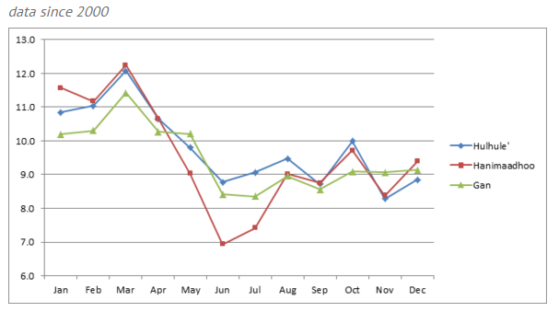
Hours
Figure 1: Average annual sunshine hours since 2000
Currently, the country is still using air-conditioning systems with Hydrochlorofluorocarbons (HCFCs) as a working fluid (EPA Maldives, 2010). Since the Maldives is a signee of the Montreal Protocol against the substances that deplete ozone layer (United Nations, 2016), phase-out management plan for HCFCs has been in action since January 2009. To comply with the Montreal Protocol Article 5, the Maldives has agreed on a timeframe to phase-out of the HCFCs in various stages, i.e. to reduce the consumption of the HCFCs by 35% in 2020 and by 67.5% in 2025. Also HCFC dependant systems would be allowed for servicing with an annual average rate of 2.5% for the period 2030 – 2040 (EPA Maldives, 2010). This increases the urgency to use a more environmental friendly refrigerant and to harness the available renewable energy, such as solar energy, to provide comfort cooling in buildings.
Hence, this paper is to investigate the possibility of utilising solar energy to provide cooling for buildings by using a solar powered absorption chiller. It will be followed by the analysis of financial benefit and CO2 emissions of the system.
As the country does not have regulations covering energy efficient buildings, company’s internal standards and guides become the only references when setting up the simulation model. Also there is no literature focusing on the Maldives’s cases, this paper will use Autodesk Revit and Polysun software, where the Maldives’ weather data is available, to do the simulation.
2. METHODS
As an example, a typical single storey office building was used in this paper with assumptions of the operation of the building to be 10 hours per day for 6 days a week (Saturday to Thursday). Total cooling season has 52 weeks per year (3120 hours/year). The location of the building is Hulhumale’ (Central Province), Maldives (see Figure 2) with a floor area of 140 m².

2.1 Building Model – Autodesk Revit
Using Autodesk Revit, an office building was created, taking into account the construction methods and materials commonly used in the Maldives. The material database within the software package was used in designing the building.
The building orientation was set to South facing, having larger wall areas on North and South sides, as East and West walls will receive more solar radiation due to the location on/near the Equator.
The walls are constructed using masonry blocks which has a thickness of 150 mm for external walls and 100 mm for internal walls, with a plaster (cement, sand aggregate mixture) rendering on both sides. The rest of the building elements consist of a gable shaped roof with a steel sheet finish, gypsum board ceiling, and concrete ground slab with a cement screed finish, wooden doors and single glazed windows. These building elements are often used in the Maldives. Especially single glazed windows are used for new buildings, which are readily available in the country and are used to provide natural ventilation by opening the windows. The double or triple glazed windows are not available in the country. For external walls, normally a plaster finish with coloured walls are used where the colour of the wall highly depends on the developer or building owner. Some buildings are not externally painted and often can be seen with just the plaster finish.
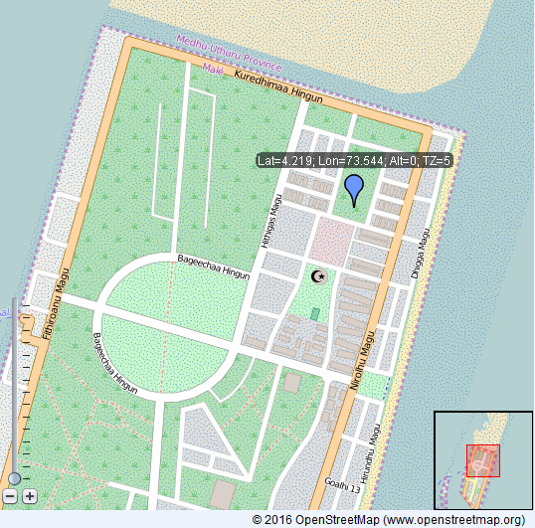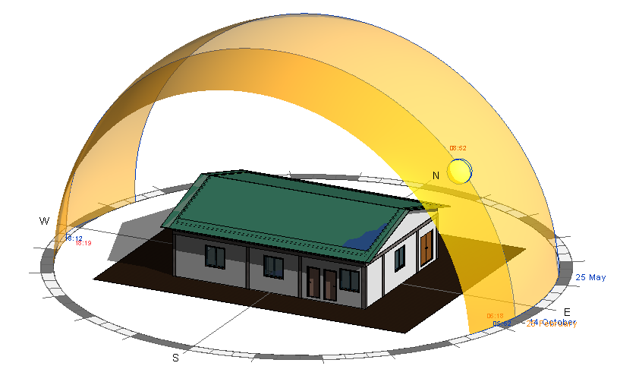
Figure 2: building location (OpenStreetMap) Figure 3: Thermal model created using Autodesk Revit
Internal heat gains from equipment, lights and people are considered, i.e. lighting load density as 11.84 W/m², power load density as 16.15 W/m², sensible gains as 73.27 W per person and latent gains as 58.61 W per person. Autodesk Revit was used to generate the cooling loads based on the thermal model shown in Figure 3. From the cooling load calculations, the peak load value was considered for the further simulation.

2.2 Solar Thermal Cooling Model - Polysun
Using the Polysun software, a solar thermal cooling system was modelled with respect to the location of the building (Hulhumale’, Maldives). The material database within the Polysun software package was used to create the model which consists of evacuated tube solar collectors, pumps, primary and secondary storage tanks, absorption chiller, air handling units and a cooling tower (wet cooler). The function of the system was operated by programmable controllers to adjust the temperatures and flow rates. The schematic diagram of the proposed cooling system is shown in the Figure 4.
The angle of the solar collector is an important factor as the Sun path changes with time, varying the amount of sunrays fallings on the collectors. As the Maldives latitude is smaller or closer to zero, a tilt angle of 5⁰ to 15⁰ can be used which would not have an enormous difference in capturing solar energy (Idowu, et al., 2013). In this paper, a tilt angle of 15 ⁰C was adapted.
A cooling tower (wet re-cooler) was used to reject the heat from the condenser and absorber of the absorption chiller. The cooling capacity of the tower has been calculated by using the rule of thumb, i.e. the cooling tower capacity should be twice as the cooling capacity of the chiller (Vela Solaris AG, 2014).
A programmable controller was used to obtain the nominal temperature at the collector outlet (200 ⁰C) by adjusting the pump speed to circulate the fluid within the loop. Another controller was used to adjust the diversion of the fluid using the two-way valve with respect to the hot water storage tank temperature. Pressurised hot water storage tank was used which has a maximum set point of 120 ⁰C. Two storage tanks were used, one as the hot water storage tank and the other as chilled water storage tank having a capacity of 200 litres and 1,000 litres respectively. A smaller hot water storage tank can reach higher temperatures sooner than the ones with higher capacities. Whereas, increasing the chilled water tank can supply cooling for the periods where the chiller is not in function but with sacrifice of higher temperature of chiller water.
The cooling set point temperature was set to 23 ⁰C based on the CIBSE guide A. The total annual cooling capacity, the peak cooling power and seasonal cooling hours were used in the Polysun software. The suggested chiller is less than 10% of the peak load. Lithium-Bromide/Water (LiBr-H₂O) was used as the working fluid for the absorption chiller, where water acts as the refrigerant and lithium-bromide as the absorbent.
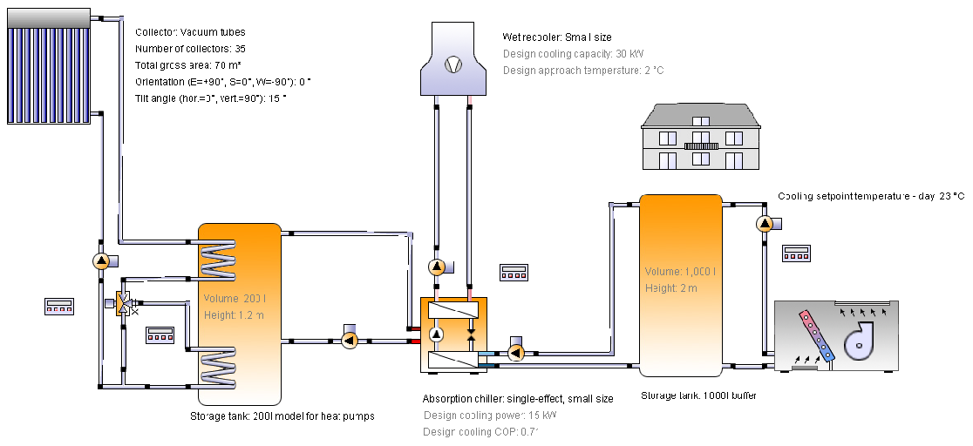
Figure 4: Schematic of the solar thermal cooling system

3. RESULTS AND DISCUSSION

3.1 Building Model – Autodesk Revit
From Autodesk Revit, it can be seen that the annual cooling load is 50,238 kWh with respect to the peak cooling power of 16.1 kW, and the peak cooling month is April. The results also show that, approximately 93% of the total cooling load is to offset the sensible heat gains.

3.2 Solar Thermal Cooling Model – Polysun
The Polysun simulation show that the energy demand for the building is covered during the periods where the chillers input temperatures are above 90 ⁰C. Since the absorption chiller has a design inlet temperature of 90 ⁰C. The results explain that the collector is able to provide an annual solar thermal energy of approximately 33,387 kWh, giving an efficiency of 33%. The collectors require only half of the roof space which accumulates around 70 m² for 35 collectors.
It can also be seen from the results that the total electricity consumption of the system is 1,720.6 kWh, supplying 15,014 kWh of cooling (30% of cooling load). This means there is a shortage of cooling in certain periods accounting for approximately 35,200 kWh a year, as the temperature in the hot water tank is not high enough to power the absorption chiller especially in the morning.
To get the clear understanding of the supplied energy shortage periods, a periodical analysis was carried out at the different time of the day (16th April). The study shows that the temperature of the supplied thermal energy from collectors does not reach to the minimum temperature input of 90 ⁰C to run the absorption chiller commencing 9:00 am, as shown in Figure 5. Until around 11:00 am, the temperature of the hot water tank is high enough (92 ⁰C) to run the system. For example, its temperature is up to 108 ⁰C at 12:00 noon and 116 ⁰C at 04:00 pm, respectively.
To boost the temperature of hot water tank in the morning up to the desired minimum temperature of 90 ⁰C, an electrical heater is used for the convenience, which consumes additional electricity of 5198.30 kWh a year, leading to much bigger CO₂ emissions.

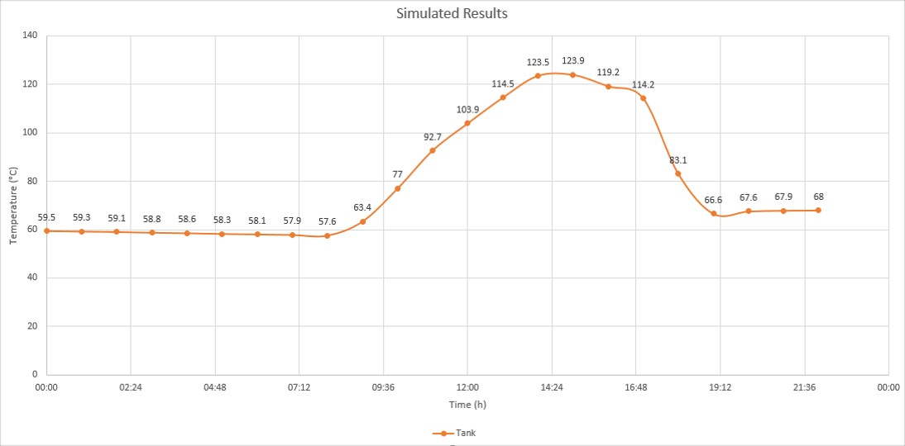
Figure 5: Temperature profile in the tank on 16th April

3.3 CO₂ Emissions and Running Costs
The amount of emissions and running cost highly depend on the type and amount of energy input to run and maintain the system. As there is no published data referring the carbon emission factor for the electricity generation in the Maldives, the UK’s published data was used for the calculation, i.e. 0.285 kgCO₂/kWh through marine gas oil (DEFRA, 2012).
For annual running cost calculations, the electricity rates provided by the service provider was used for the calculation, where the rates are categorised into 7 different bands. To make it simple, the average value given in Maldivian Currency (MVR) was used. The average price of electricity tariff (MVR) during the time of calculation was 3.27 MVR (STELCO, 2016), equivalently 0.15 GBP.
Comparison was made to look at the CO₂ emissions and running costs between the proposed systems (with and without auxiliary power) and a traditional vapour compression system with R134a as working fluid ( a typical COP of 3.7) (Karagoz, et al., 2004). From Table 1, it is clear to indicate that new systems could save 49.0% and 87.3% of annual CO₂ emission and annual running cost with and without auxiliary power respectively. Also the system’s performance, which is defined as the ratio of cooling capacity to the total electricity input, is much better than the traditional air conditioning system, taking into account the fact that solar energy is free.
Table 1: Annual running cost and carbon emission comparison
Item | Absorption chiller (without auxiliary power) | Absorption chiller with auxiliary power | Traditional vapour compression system (R134a)
Performance | 8.73 | 7.26 | 3.7
Annual cooling load (kWh) | 50,238  (30% cover) | 50,238  (100% cover) | 50,238  (100% cover)
Total electricity input (kWh) | 1,720.60 | 6,918.90 | 13,577.84
Annual carbon emissions (kgCO₂) | 491.04 | 1,974.58 | 3,874.98
Annual running cost (£) | 258.09 | 1,037.84 | 2,036.68
Installation costs for the solar thermal cooling system will be higher requiring more space for the system components, such as storage tanks, chiller and cooling tower. These systems will be difficult to install than the traditional split air conditioners and will require specialist personnel for the installation. Since these systems are not available in the country, it has to be imported and will require additional costs. However, installing a good design can make the system financially viable with respect to the life time of the system, as these systems can have a design life of 25 – 30 years (Eicker, 2003). The major downside of the solar thermal cooling system is that the cooling tower’s maintenance will be critical, requiring regular cleaning and disinfection of Legionella. The CIBSE technical memorandum (TM13) recommends that at least in every 3 months the water samples should be tested in a laboratory for Legionella.
On the other hand, split air-conditioners require regular maintenance for the system components like the filters, coils and fins to be functioning effectively and efficiently (USA.Gov, 2016). Therefore, split air conditioners requires frequent maintenance as well, increasing the maintenance costs.

3.4 Minimisation of Cooling Loads
The office building model was set up very close to a real one in the Maldives, which receives large amount of the solar gain. To minimise the solar gain, resulting in much less cooling load, there are many practical passive designs which can be adopted without changing much of the existing buildings, such as
- Night-purge ventilation, which can flush warm air out from the building by opening the windows during night;
- Planting trees/plants: Indoor plants could provide cooling power of up to 16 W/m² due to the evaporating power (Preisack et al, 2002), while external trees can provide shading during the daytime.
- Shading: Alongside the shading strategy from the trees, window shadings can minimise the solar heat gains through windows by blocking direct sunlight entering to the building space;
- External envelope: Adopting light coloured paint on the external walls can reflect the solar lights into the sky.
Other technologies with a bit financial investment can be considered as well:
- Earth Air Tunnel (EAT) system:
The unique geometry of Maldives with low sea levels and being surrounded by the sea offers a low and stable temperature of ground. Using the EAT system, fresh air can be pre cooled down before being supplied to the building. This method can be used especially during the night and in the early morning when the chiller does not work.
- Insulation of the roof:
The detailed cooling load calculations show approximately 54 % of the heat gains are through the roof. Therefore, insulating the roof with lower U-value materials will ultimately minimise the heat transfer through it.
4. CONCLUSIONS:
Based on a close to reality building model , Autodesk Revit software was used to calculate a peak cooling load for the peak month (April) in the Maldives, followed by the use of Polysun software to identify the potentiality of using solar thermal energy to provide cooling for the building. The simulation shows that evaluated solar collectors are able to provide most of the required hot water to drive an absorption chiller (with LiBr-H₂O as working pair) starting from the noon. A second simulation was carried out to use auxiliary power to back up the shortage of energy input in the morning when the temperature in the hot water tank is not high enough, resulting in additional large amount of electricity consumption and CO₂ emission consequently.
The comparison, in terms of the running cost and CO₂ emissions, was made between the purely solar powered chiller, solar powered chiller with auxiliary power, and a traditional vapour compression chiller with R134a. It showed that the purely solar powered chiller had the lowest annual CO₂ emission and running cost, but only partial cooling demand can be met. The system with auxiliary power is not the preferable, but overall performance in CO₂ emission and running cost is still much better. Both systems have a better performance as defined.
Passive design of the building, such as earth air tunnel, shading, planting trees and proper insulation of roof, is recommended to minimise the cooling load, reducing the size of the whole system, CO₂ emission and running cost as well.
5. REFERENCES
DECC, 2012. The Future of Heating: A strategic framework for low carbon heat in the UK, London: DECC.
Eicker, U., 2003. Solar Technologies for Buildings. West Sussex: John Wiley & Sons.
EPA Maldives, 2010. Environmental Protection Agency Maldives. Available at: http://epa.gov.mv/ [Accessed 05 March 2016].
Idowu, O. S., Olarenwaju, O. M. & Ifedayo, O. I., 2013. Determination of optimum tilt angles for solar collectors in low-latitude tropical region. International Journal Energy Environmental Engineering, 4(1), pp. 1-29.
Karagoz, S., Yilmaz, M., Comakli, O. & Ozyurt, O., 2004. R134a and various mixtures of R22/R134a as an alternative to R22 in vapour compression heat pumps. Energy Conversion and Management, 45(2), pp. 181-196.
Maldives Meteorological Service, 2015. UNESCO IOC Perth. Available at: http://iocperth.org/IOCPerth/ .[Accessed 25 October 2015].
Ministry of Environment and Energy, 2015. Maldives Climate Change Policy Framework. Available at: http://www.environment.gov.mv/v1/ [Accessed 11 10 2015].
Ministry of Housing & Environment, November 2010. The Maldives 2009 Carbon Audtit, Male': s.n.
NASA, 2015. Global Climate Change. Available at: http://climate.nasa.gov/ [Accessed 05 12 2015].
Preisack, E.B., Holzer, P. and Rodleitner, H. 2002. Raum-Klimatisierung mit Hilfe von Pflanzen, Programmlinie Haus der Zukunft des bm: vit, Neubau Biohof Achleitner, Gebaude aus Stroh & Lehm, p42
STELCO, 2015. State Electric Company Ltd. Available at: http://www.stelco.com.mv [Accessed 08 10 2015].
STELCO, 2016. STELCO. Available at: http://www.stelco.com.mv/ [Accessed 10 April 2016].
United Nations, 2016. United Nations Treaty Collection. Available at: https://treaties.un.org [Accessed 05 March 2016].
USA.Gov, 2016. U.S. Department of Energy. Available at: http://energy.gov/ [Accessed April 11 2016]
Vela Solaris AG, 2014. Poysun Simulation Software - Manual, s.l.: Vela Solaris AG.

