Owl-Light
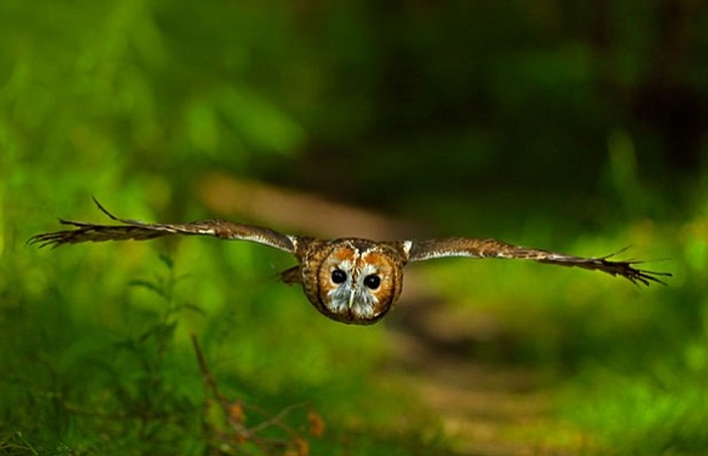
Manchester is a city ringed by moors. My local heath is an edgeland of heather and spoil-heaps. On hot days, everyone under seventeen comes to cool off in the reservoir (though there’s Weil’s disease in the water.) You can hear all the traffic in the suburbs, and the distant howl of planes from the airport; the ground is pockmarked with coal-pits. You’d think that no owl in its right mind would want to live here.
I’d taken the tram from the city centre, just as lockdown was easing. Five of us were there to meet Bob. Bob walks on the moor most days, and knows its plants and creatures better than anyone. He and his wife have devoted their retirement to birdwatching and to caring for the moor: replanting broad-leaf trees, building ponds, restoring drystone walls. Members of a local conservation group and many of Bob’s fellow birdwatchers were also there, hoping to catch a glimpse of the owlets. It was Bob who first took me to see a wild long-eared owl.
The summer before the virus, Bob and I had crept along a deer track to a stand of stocky conifers on the edge of a neglected plantation. An owl broke cover, launching from a lone pine, completely silent. I saw the dappled feathers, the fluffy feet concealing hooked talons. The long-eared owl is a stunning bird: bark-grey on the back and mottled chestnut on the breast, the eyes orange and the head crowned with those famous ear-tufts. ‘We probably woke it up,’ commented Bob.
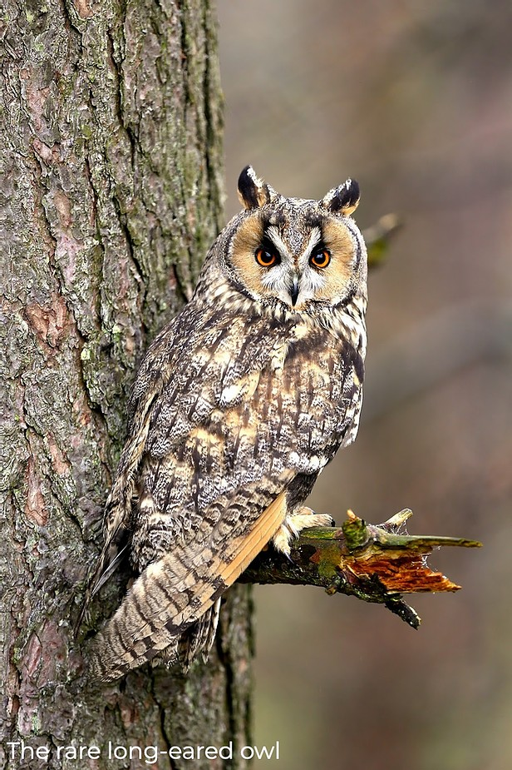
2020 witnessed the strangest spring for decades. While most people were stuck behind locked doors, some creatures clearly enjoyed the peace and quiet of lockdown. Goats roamed the streets of Llandudno, partridges set up home in a Cambridge car park, and cuckoos were heard calling in London. By early summer, the Peak District had a very unusual visitor: a bearded vulture, more often seen in the Alps. But with fewer walkers roaming Britain’s woods and moors, wildlife criminals took the opportunity to strike.
Lockdown witnessed a sharp rise in the illegal killing of birds of prey. Hen harriers, peregrine falcons and owls were brutally shot. The RSPB had been used to receiving three or four reports of raptor killings per week. As soon as lockdown was announced in March, these surged to three or four per day. Most of the killings occurred on land managed for grouse and pheasant shooting, where birds of prey may take game bird chicks. Most people who work on the moors are conservationists, and would never harm rare birds – but there are exceptions. Years ago, I’d witnessed the aftermath of raptor persecution first hand, during a hike by the River Torridge in Devon. A buzzard lay in a meadow by the riverside path, wings outspread to the sky. When I came across the wreckage of a barn own in the same field – little more than draggled wings and the keel of the chest – it became clear there was a war on. One side was armed with lead shot, poison and traps.
❦
That bright June evening on the moor, we were looking for long-eared owlets who had recently left the nest, but were still dependent on their parents for food. We trudged up the path by a scar of burnt ground. Willowherb and foxgloves were just beginning to break through the charred soil after a wildfire. The owlets lived deep in the lightless tangle of spruce-trees.
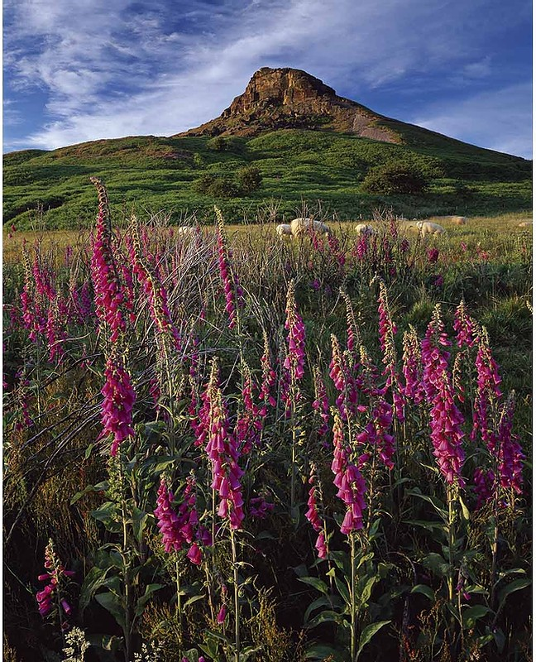
Connor, who surveys nests for the RSPB, was cupping both hands to his ears. He froze as soon as we got near the plantation.
‘Young long-eared owl! Squeaky gate.’
I heard nothing beyond the babble of small birds and the roar of traffic.
We decided to follow the edge of the open moorland, looking for daytime birds. Our group would go back to the plantation later. The owls, of course, would be more active as night fell.
Everyone else knew far more about birds than I did.
‘Crossbills! Four of them!’ A flock flew overhead, chittering, going east to west.
‘Blackcap!’ someone exclaimed, identifying a burbling song.
Keen birdwatchers discuss kestrels’ nests in much the same way that suburbanites talk about their neighbours’ extensions.
On the open moorland to the right of the trees, a stonechat flittered to perch on a foxglove. It was the male of a nesting pair, dark-headed, with a crimson throat. I snapped away with an unwieldy lens, getting a few blurry shots. I’d have had no chance of identifying the stonechat if Bob hadn’t pointed it out. I know a hawk from a heron, but that’s about it. Yet owls are unmistakable.
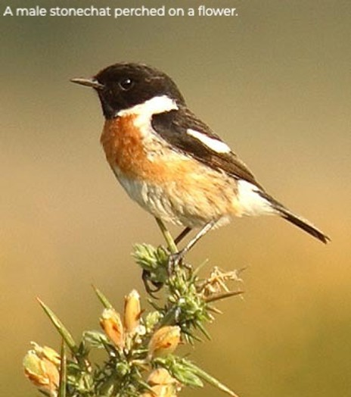
That was when I heard them. The sound was so close that they appeared to be perching over our heads. The famous ‘squeaky gate’ cry of long eared owlets is eerie, shrill, far-carrying. It’s easy to see why owls inspire ominous legends. The howlet’s wing in the witches’ cauldron in Macbeth, the French name for the barn owl that means ‘belfry terror.’ With this brood, you could make out three distinct voices, one a quarter-tone higher than the other. The trick was to count the number of babies from the calls. Young long-eared owls demand food from their parents for up to two months after they leave the nest. The adult owls had put up with their all-night squeaking for some months.
We sat by the old larch plantation, waiting for the dusk to draw in. In lower light, the owlets would begin trying their newly-learned flight skills. I pressed Bob for news of other species. I’d heard that short-eared owls sometimes visited the edge of the open moor. Those migrant visitors from Europe have dramatic, mask-like markings. ‘Asio flammeus!’ Bob declared, ‘for the flame-marks round its eyes!’ But that spring, no short-eared owls had travelled from Scandinavia back to the moor. Nesting on open ground, short-eared owls are vulnerable to fires. And shotgun fire.
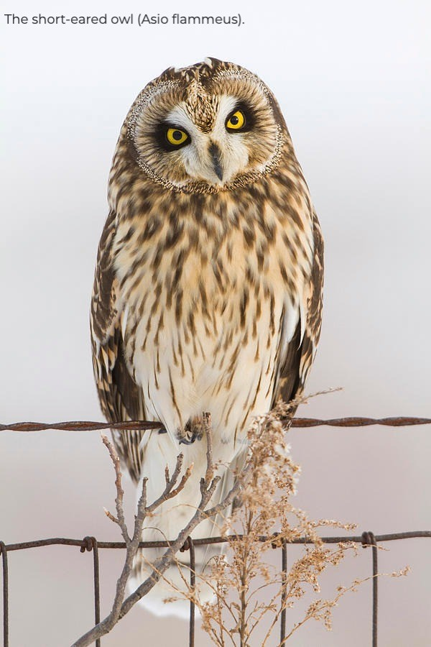
The long-eared owl is the other member of the genus Asio that lives in Britain. There’s a no-nonsense descriptiveness to its scientific name, which means ‘eared owl.’ The ‘ears’ are not for hearing at all – they are tufts of feathers, used to communicate emotions. Owls raise them when they are attentive, or alarmed. (I remembered a tame long-eared owl that I’d held on a glove at an owl sanctuary. The ear-tufts were bolt upright: it was peeved.) According to a dusty old Histoire naturelle that my Swiss grandmother owned, the owl was believed to lead the smaller birds – this is why French speakers call some species of owl ducs, or dukes. The eagle owl is a grand duc (Grand Duke), the long-eared owl is a moyen duc (Middle Duke) and the short-eared owl is a petit duc (Lesser Duke).
❦
I’ve always liked owls, and I was once very fond of a man who lived with them. (They didn’t actually live in his house – nor did he make his home in a hollow tree.) He bought a pair of captive-bred barn owls for an empty barn in his parents’ fields. The birds even had a comfortable nesting box. The breeder he bought them from kept so many creatures that they were eating him out of house and home, and often tried to offload eagle owl chicks or baby peacocks onto the neighbours. My (then) boyfriend’s barn was a modern one, and it fell short of the owls’ high standards. (Barn owls like quiet barns, and can even be coaxed in with special owl windows.) His owls flew off to the woods, and raised many broods of fuzzy, squawking owlets.
I found out about my ex boyfriend’s owl mania when we went for an evening walk that quickly turned into a wildlife-spotting competition. He won hands down by stopping dead, grabbing my arm and whispering ‘Barn owl!’ Just visible over the rank grasses of the water meadows, it was quartering the edge of a field, like a ghost drawn in chalk. When I returned to his sister’s cottage, babbling with excitement, she wasn’t at all surprised: ‘Give that man a pair of spectacles, and he’ll find you an owl…’
❦
On Manchester’s heathery edge, the sun dipped below the horizon at nine, and the street lights of the city below us winked on. We headed to the border of the plantation, where ling meets oak and larch. The animal-track we followed had to be tackled bent over, at deer height. Dead stumps stood in rows underfoot, carpeted in shed spruce-needles. The owlets’ calls sounded from the north-east.
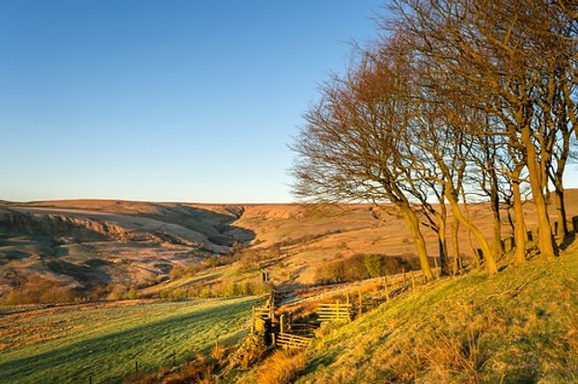
We rounded the top of the plantation and reached a muddy trackway. The cries were piercing, louder than ever, but we still weren’t within sight of them.
‘They know we’re here. Perhaps the parents will come in and feed the young once we’ve moved off,’ said Connor. ‘One year, I sat right here and watched two playing around me, flapping from one post to another. They’re quite clumsy when they first learn to fly. Lots of whitewashing on these posts.’
Whitewashing! A very polite way of saying ‘owl shit.’
Through the trees, flapping and fluster of wings. A feathery shape in the gloom, perched on a horizontal branch. Through binoculars, you could make out scraps of its fledgling down.
The owlet launched itself into the air and darted towards the path. It saw us – dodged left into the nearest spruce. It was far lighter than an adult long-eared owl. Spectrally pale.

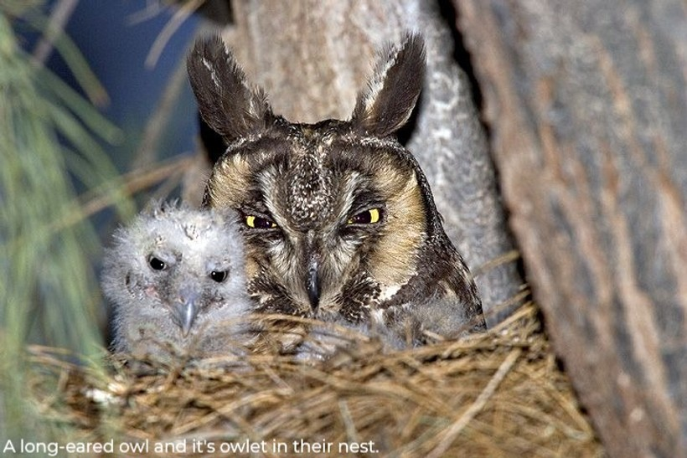
❦
Even before they can fly, long-eared owlets have some ingenious survival strategies. They begin to take their first steps towards independence by clambering about on the branches near the nest. If one falls out of the nest, it needs to be able to haul itself back to safety. Bob told us that he had once seen an owlet climb a tree to escape a fox.
‘Did it climb with its beak as well as its talons?’ I asked.
‘They have claws on their wings! It’s a primitive thing.’
Young long-eared owls face many threats when they leave the nest, from predators to passing cars. (Like barn owls, they are vulnerable to vehicles because they hunt along road verges.) The adults often congregate in winter roosts. This always makes me think of the collective noun for a group of owls: a parliament. Conclaves of long-eared owls were once much more common in Britain, but these spectacular winter assemblies are declining. There had been four owlets in the brood by the moor a week ago. No-one knew what had become of the fourth.
The police are encouraging the public to be their eyes and ears on moors and woods. Operation Owl is their new initiative for protecting birds of prey. Dog-walkers, nature-lovers and anyone who enjoys the outdoors can join the fight against wildlife crime. But helping birds of prey doesn’t stop there. We can also help them to feel at home by restoring their habitats. One spring, I helped to plant oak and hornbeam saplings on the moor, hoping that the owls will have mixed woodland to live in for centuries to come.
I was curious to hear if Bob had witnessed any threats to the owls during lockdown.
‘When I see the gamekeepers,’ said Bob, ‘I ask, “Seen any short-eared owls? Any hen harriers?” They know I’ve got these,’ he added, tapping his binoculars. ‘And this,’ pointing to his camera.

Steven Morris. ‘Rare UK wildlife thriving in lockdown, reveals National Trust.’ Guardian 20 May 2020. https://www.theguardian.com/environment/2020/may/20/rare-uk-wildlife-thriving-in-lockdown-reveals-national-trust
Claire Marshall. ‘“Surge” in illegal bird of prey killings since lockdown.’ BBC news. https://www.bbc.co.uk/news/science-environment-52667502
Georges-Louis Leclerc, Comte de Buffon. Histoire naturelle des oiseaux. Paris: L’imprimerie royale, 1775. Vol. 6. 52.
I learnt that owl windows existed from reading Patrick Leigh Fermor’s A Time of Gifts. The author dosses down in a barn that features one of these special apertures. See also https://www.barnowl.co.uk/page19.asp
Ben Moyes. ‘Understanding Birds: Long Eared Owl.’ British Trust for Ornithology. N.d. https://www.bto.org/understanding-birds/species-focus/long-eared-owl
National Police Chiefs’ Council. ‘Operation Owl: be our eyes and ears.’ https://www.operationowl.com/

