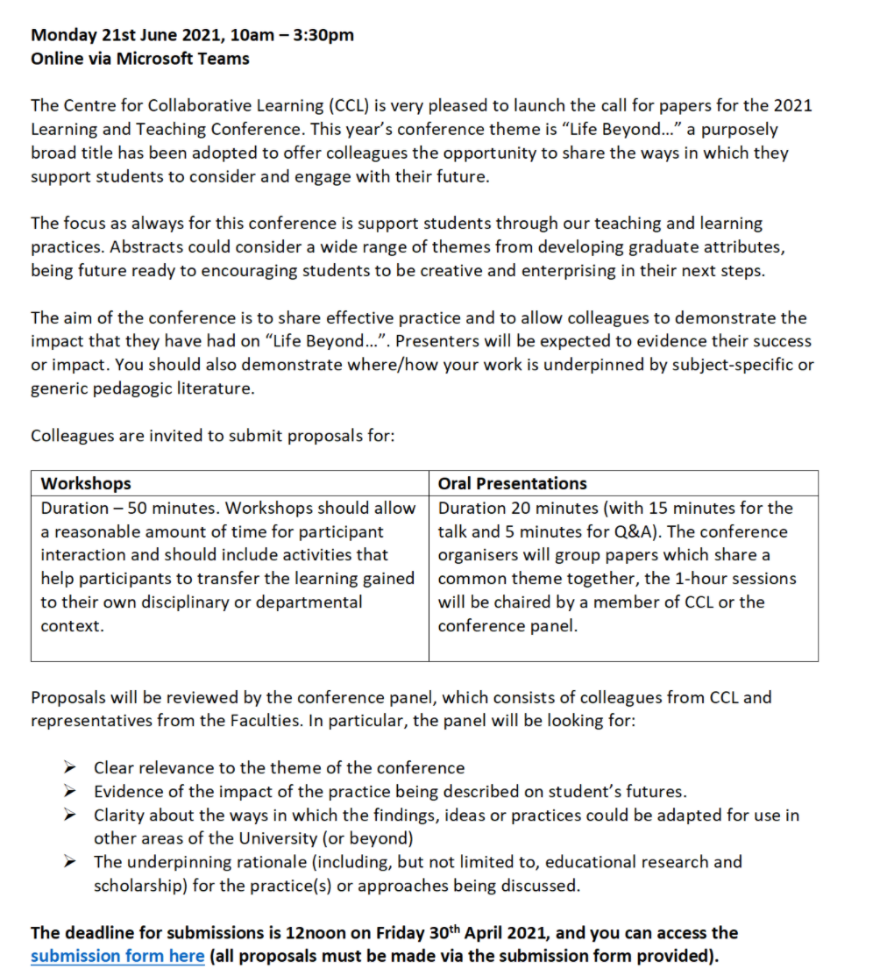
8.Title of your Presentation
A novel use of interactive scenarios for combining face to face and remote learning: Thinglink
9. Give a summary of your proposed presentation.
Max, 300 words
Covid-19 has presented many challenges, how were we to provide a realistic patient experience without patients and with some students learning remotely? “Thinglink” is an interactive, online platform that has many benefits; audio, video, images and text can be embedded in a widescreen photograph with hotspots for the students to explore, discuss and complete a patient record card as they would for a real patient. Having video embedded allows the students to observe a patient rather than simply reading a case scenario. When used within TEAMS, it was also possible to allow a mixed group of students on and off campus to collaborate together. The sessions were facilitated by members of staff using the “diamond”¹ debrief to ensure consistency and that the learning outcomes were met. The scenarios also provided the benefit of enabling the students to work through a variety of different pathologies and situations, which would not otherwise have been possible with real patients. Although initially designed for final year students to address the lack of real patients on campus, l saw the potential of using the scenarios with the first years as a way of introducing them to case-based collaborative learning. In this way they are able to apply their learning to a patient scenario in a safe space, before seeing real patients in the clinic. Students were encouraged to role-play Feedback survey from both groups was very positive, with 100% of the final years recommended their use after the pandemic for both year groups, they favoured a mix of real and simulated patients to widen their experience. Feedback from the first years was also very positive, they found that the sessions helped to bridge theory with patient interaction and identify knowledge gaps. The over-welcoming consensus was a preference for small groups over individual or full group learning.

10. What significance does your presentation have for colleagues in other departments across UCLan?
Max. 300 words
Patient simulation is relevant to all healthcare courses across UCLan and potentially also in areas of all courses where students are required to apply their knowledge, analyse problems and formulate a management plan. Small group learning builds collaboration skills and allows peer-learning in a safe space. Students access the simulations using a weblink from any device, this can be done on campus in small groups, online remotely or a mix of both which has great potential for blended learning. It is also possible to quickly adapt sessions to be on or off campus without any additional changes. The simulations can be easily be cloned and adapted for different year groups depending on the stage of the course and they have proved very useful in the test, learn re-test model. First year students can experience a patient encounter in a safe space, allowing them to realise the importance of building a sound knowledge base, it adds relevance to their learning. Thinglink is free to use and easy to build simulations, it is also fun for students and introduces an element of gamification into the session. Existing written scenarios and real patient case studies can be easily adapted. Most importantly, the student feedback was excellent and overwhelmingly in favour of their continued use in the course after the pandemic.

11. How does your presentation relate to the Curriculum Framework?
Max. 300 words
The use of Thinglink patient simulations allows students to experience real-world learning in a safe environment, with scenarios being drawn from real case studies. Although designed to replace real patents is the clinic in line with the professional body for Optometry’s requirements (General Optical Council), their use has proved successful earlier in the course. They also allow students to discuss, analyse and develop a management plan in a fun and simulating learning environment.² The need for diagnostic reasoning in medical education is well known³ and this new technology used in small groups with the aid of a facilitator allows this to be achieved consistently across different groups of students.
Feedback surveys for both groups of students strongly supported the continued use of Thinglink scenarios in line with student co-creation. This presentation will demonstrate how this can be achieved using a creative, digital approach which is inclusive for both on and off campus students and can be accessed on any device with an internet connection using a weblink.

12.Please note any references used
- ‘The Diamond’: a structure for simulation debrief. Peter Jaye, Libby Thomas and Gabriel Reedy. 2015 The Clinical Teacher 2015; 12: 171–1752015; 12: 32–36.
- Clinical simulation practise framework. Hossein Khalili. The clinical teacher.
- Constructivism: reflections on twenty-five years teaching the constructivist approach in medical education. Reg Dennick. International Journal of Medical Education. 2016;7:200-205.
13.Are there any prior commitments on the day of the conference that we would need to take into consideration when planning the timeslots?
No

