The importance of built heritage in the English seaside experience

*David Jarratt*

**Introduction**

The United Nations estimates that approximately half of tourists visit a coastal area, whilst within the European Union, 51% of all hotel bed capacity is concentrated in coastal areas and in the UK seaside locations account for 39% of holiday nights (European Commission, n.d.; UNWTO, 2013; Visit Britain, 2016). So, a high proportion of all leisure tourism is coastal tourism – which can be defined as ‘the full range of tourism, leisure, and recreationally oriented activities that take place in the coastal zone and the oﬀshore coastal waters’ (Hall 2001: 602). At this point, one may question if coastal tourism in general and seaside tourism in particular differ? In other words, what do we mean by ‘seaside’? A quick survey of dictionary definitions suggests that the most common definition of seaside is, first and foremost, a place by the sea, but *especially* a holiday area – most commonly a resort. So, in common usage the ‘seaside’ embraces an element of leisure or tourism; this, in turn, reflects how most inland dwellers access this coast – as visitors. Hence, the concepts of coastal tourism and seaside tourism are in some respects very similar, although the latter implies an increased emphasis on popular forms of tourism and, therefore, resorts. As such it is the correct term for this chapter, the focus of which is on the most popular form of coastal leisure tourism in England – visiting a traditional seaside resort.

There are no earlier examples of mass tourism than these seaside resorts which, in the nineteenth century, grew rapidly to accommodate demand from the residents of the new towns and cities of the Industrial Revolution. By the early twentieth century, their scale and complexity was unmatched. Despite economic restructuring, increased competition and other challenges, they remain popular today; indeed, when one considers that these places are products of the Industrial Revolution, they have proven remarkably adaptive and resilient (Walton, 2000). There now exists, of course, a significant variety of seaside resorts across the globe and they offer a range of experiences but, arguably, the combined historical and contemporary cultural significance of the English resorts offers a unique opportunity to consider the touristic experience of the seaside.

The purpose of this chapter, then, is to consider the visitor experience of the English seaside resorts of today. Inevitably, such experiences it will vary a great deal, for seaside visitors comprise a large, heterogeneous group and the way in which they experience the coast will inevitably differ, just as seaside places across England also differ. Nonetheless, if the seaside experience is explored from the perspective of broader cultural themes and meanings associated with English resorts, then a number of patterns emerge. The seaside is on the limen of the built environment and the ocean, which represents nature or even wilderness to modern man (see Gillis, 2012), and can therefore be considered as a culture-nature interface. The natural element of this interface holds a popular appeal that transcends any one country or culture. Specifically, natural spaces are more likely to facilitate topophilia, or place-attachment, for those living in urban-based cultures (Beery, Jönsson & Elmberg 2015; Tuan, 1974). So, in contemporary Western culture, a positive genius loci and emotionally charged experiences are more likely to be associated with these spaces (Tuan, 1974). The seaside is one example of natural spaces but, whilst the appeal of nature may seem universal, the cultural element of the coastal nature-culture interface is more specific and one with which, arguably, visitors are likely to identity**.** Elborough (2010, p.8) describes the English seaside as ‘deeply cultural’, a place that is often part of personal history, as well as of national history. In particular, therefore, this chapter explores the experiential elements of this seaside sense of place. Specifically, it considers the English seaside resort as an enduring socio-cultural construction which is framed by the physically constructed, or *built,* environment.The buildings and built heritage of the seaside are absolutely essential to its character and to the seaside experience.

**The seaside as a cultural space**

There appears to be a disconnect between the seaside in our head (or *heart*) and the physical reality of these resorts. For one thing, there is quite a variety of English seaside resorts. For instance, Brighton is a successful and cosmopolitan city by the sea, whilst Blackpool has managed to retain its popular/working-class appeal as the Las Vegas of the North. The small costal town of Grange-over-Sands now functions as retirement town for the middle classes and a place for day-trippers, and regenerated Margate is seen by ‘Shoreditch by the Sea’ by some. Conversely, New Brighton, on the Mersey Estuary, embodies the most pessimistic potential outcomes of the Tourism Area Life Cycle Model (Butler, 1980) – the end of tourism. Interestingly, Grange-over-Sands, in complete contrast to New Brighton, never witnessed decline (Walton, 2000). This variety of seaside histories demonstrates that there is neither an inevitable seaside narrative nor a single experience of English seaside resorts. Instead there is a complex interaction of macro and micro factors, from the global and the local, which determine why some resorts fair better others. It is clear that many seaside resorts fell from grace during the second half of the twentieth century as mobility, wealth, visitor aspirations and competition were in a state of flux. The medium-sized working-class resorts, such Clacton or Morecambe seemed to be especially hard hit – they were too small to keep attracting tourists but too big to become exclusive (Jarratt, 2019). Yet, despite the variety in scale, economic fortune, class connotations and other differences, all of these places are a part of the seaside – not just because of their coastal locations but because of a particular set of cultural features and visitor beliefs/behaviour that distinguish them. So, apart from proximity to the ocean, what makes the seaside the seaside – what is its genius loci or sense of place?

Before addressing this last question, we briefly consider place and ‘sense of place’ more generally. Place is a concept that can be interpreted in number of different ways but, in simple terms, it can be defined as space which has been ascribed meaning: ‘place = space + meaning’ (Turner & Turner, 2006: 205). Furthermore, it is fluid, subjective and socially constructed. Tuan, one of the foremost scholars of place, focuses upon experience which is a ‘cover-all term for the various modes through which a person knows and constructs a reality’ (Tuan, 2011: 8). He stresses that experience and place cannot be fully separated (Tuan, 1974). Indeed, place is the crucible in which experience is forged.

Sense of place is referred to when place identity is significant enough to be experienced; it is the emotional attachment people have to place(s). Jorgenson and Stedman (2001) refer to sense of place as the relationship or bond with a place which is experienced through the individual’s conscious and unconscious feelings, ideas and perceptions regarding that environment/place. These different elements interact with each other. For example, Ettenger (2015) identifies how the sense of place of cultural tourists is much influenced not only by their direct experience but also by what they have heard beforehand. In line with these scholars, this chapter adopts the definition offered by Jarratt, Phelan, Wain and Dale (2019, p.410): sense of place is

The fluid and multi-faceted way in which we know notable or memorable places through sensing, experiencing, and remembering a geographical location and its features. It is, therefore, a combination of our interaction with a physical environment and the meanings that we (as individuals and a society) bestow upon it, at the time or subsequently.

Some have considered the genius loci of the seaside. A number explain, in part, this ‘indefinable seaside spirit’ (Lindley 1973, p.11) through liminality and marginality (Bennett, 1986; Shields, 1991; Webb, 2005). Since industrialisation, this zone has hosted the healthy seaside, the carnivalesque seaside and other versions of the seaside in which social actors play their part (Baerenholdt, Haldrup, Larsen & Urry 2004; Shields, 1991). The culture-nature interface that is the seaside (Preston-Whyte, 2004) grew to be socio-culturally distinct to fulfil its role as a place for tourists to re-connect with nature and with themselves; that is, their authentic selves as opposed to public roles (Wang, 1999). In particular, Wang (1999) suggests that nostalgia or romanticism represent the ideal of the tourist's search for authenticity and it not, perhaps, coincidental that the traditional British seaside resort is often associated with family holidays, childhood, a romantic view of the past and nostalgia (Walton, 2000, 2010).

These theories point towards the seaside as a distinctive place that hosts a variety of potential meanings, but it is more ambiguous than it is truly transgressive (Chase, 1999). These meanings and the distinctive experience offered by the seaside, are now explored in more detail.

**Seasideness - sense of place at the seaside**

There has been little research that maps the visitors’ sense of place at the seaside, although in an attempt to do so, Jarratt (2015) conceptualises such a sense of place as ‘seasideness’ – see Figure 33.1.

Seasideness is a distinct sense of place associated with seaside resorts as experienced by visitors to these coastal destinations. It comprises a combination of factors, including the distinctive natural environment, leisure activities undertaken and the built environment of coastal resorts. It is ‘a distinctive experience which is centred around the inter-related themes of nostalgia, wellness and spirituality’ (Jarratt, 2015, p. 351). So, this seaside experience is associated with various feelings, especially feelings of restoration and subjective wellbeing – which embraces a semi-spiritual element. Visitors consider the seaside to be a place of relaxation where the mind is free to wander and where they can experience a sense of connection to something bigger and more significant than themselves. This ‘something’ most often takes the form of ‘nature’ but can also be something more akin to religious thought (Jarratt & Sharpley, 2017). Wellness also is central to seasideness, perhaps second only to feelings of nostalgia, which is now discussed in more detail.

**Figure 33.1:** Seasideness



**Source:** Jarratt (2015)

It is well recognized that nostalgia is a fundamental component of visitor motivation for a variety of tourism experiences (Davis, 1979, Vesey & Dimanche, 2003). Yet, whilst seaside heritage is increasingly recognized; contemporary nostalgia for the seaside rarely affords anything more than a passing comment, although Notable exceptions include historian John Walton and the sociologist John Urry. Thirty years ago the latter commented that seaside resorts should not try to resist the trend to nostalgia but should instead embrace it before further deterioration to tourism occurs (Urry, 1990). More recently, Jarratt and Gammon (2016) discussed seaside nostalgia. primarily based around a definition of nostalgia as an idealised, selective and therefore adapted reflection of the past but one which also incorporates a dissatisfaction or frustration with the present – we cannot return to ‘the good old days’.

However, nostalgia is not that simple. For example, the extent of the aforementioned dissatisfaction will vary a great deal and it operates on a number of levels, from the individual to the national or another collective. Furthermore, nostalgia does not necessarily rely on personal memories, for stimulated nostalgia is vicarious in nature and can be evoked from images, objects and collective narratives (Goulding, 1999). In essence, nostalgic experiences are intertwined with identity because it facilitates a meaningful narrative from the past. Nostalgic images associated with the seaside are instantly recognizable as ‘part of England's collective consciousness’s, our folk memory’ (Elborough, 2010, p.7). Such nostalgia feeds into national identity; the English shoreline and seaside resort has become a symbol of Englishness (some might say Britishness but the focus here is on England) with one foot in the past (Jarratt, 2015). The decline of resort infrastructure can, of course, lead to physical demolition but, in the stages preceding this, resorts can adopt a faded grandeur that some people find attractive, affirming, and deeply nostalgic. In considering the seaside, Bracewell (2004) attempts to explain this:

For a little while though, within those fading grand hotels, silent boarding houses, dormant ornamental gardens and windswept piers is both an ultimate expression of Englishness and its plangent requiem – the ‘sense of something lost’, perhaps, prompting nostalgia for a former innocence.

As we saw earlier, the seasideness model reflects the meeting of place and the visitor. Just as the visitor is influenced by their feelings, memories and experiences, the place in question is shaped by distinctive buildings and the sea itself, which dominate the somatic environment and therefore the visitor experience. Yet, in the study of tourism more generally, the emphasis is more often on the tourist experience, rather than on sense of place with which it is bound; indeed tourism has been associated the very opposite of sense of place – placelessness and an erosion of ‘authentic’ landscapes (Relph, 1976). Robinson and Picard (2009) argue that an individual’s social experience is more important than the scene in which the tourism experience occurs. Indeed, familiarity with places is an important element of touristic motivation, whether they be ‘authentic’ or not (Leisen, 2001). Furthermore, the experience of authenticity can be more social and existential than reliant on an objective authenticity (Wang, 1999). Also, any clearly stated sense of place can never be entirely representative of place owing to the dynamic, relational and subjective nature of place in general (Massey 1997). So, offering a perhaps simplified notion of sense of place, as proposed in the seasideness model (Fig. 33.1), does have its limitations. Nevertheless, it is useful as a key component and determining factor in the tourist experience; place is rather more than just the stage upon which tourism is played out. For instance, the seaside’s liminal/limonoid nature, which is sometimes described as a part of its appeal, flavours the experience.

So, seasideness, as discussed by Jarratt (2015), reflects an experience that spans the boundary of two zones and can be described as limonoid. In other words, the marginal seaside setting is a place where nature physically meets culture in the form of the man-made and built environment. The multi-sensory sea, which represents wilderness to urban man, can have a Proustian effect. Environmental psychologists tell us that blue spaces offer just the right level of somatic stimulation, and exposure to them can have more powerful wellness impacts than green spaces (White et al 2010). This connection between the coast and wellness is a longstanding one of course; indeed, the word ‘resort’ comes from the Old French ‘restortir’ – something you turn to for help or assistance. In addition to the health benefits of blue spaces, the leisure state of mind could also be an intervening factor in this coastal wellness (see Figure 33.2).

**Figure 33.2:** Leisure Health Receptor Model

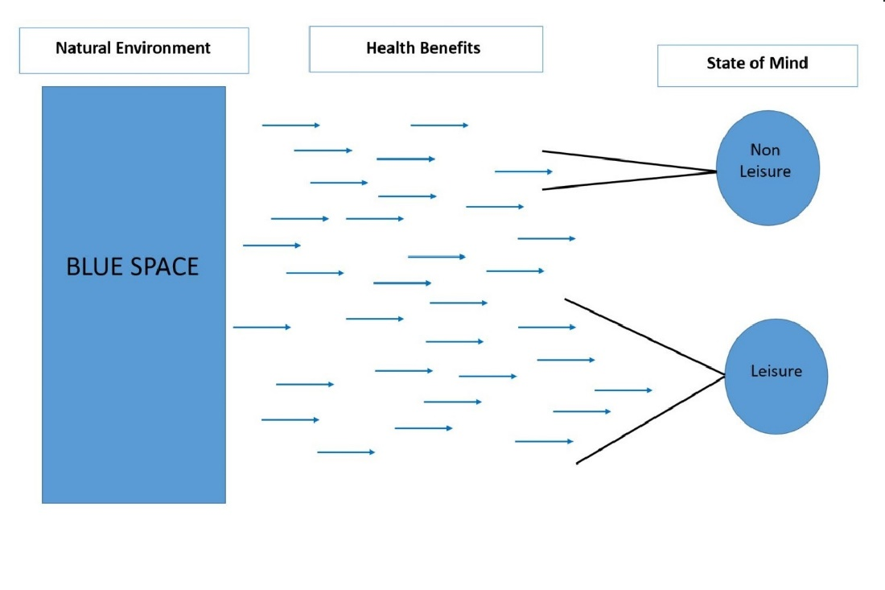

**Source:** Gammon and Jarratt (2019)

What seems to have attracted less attention, however, is the impact of exposure to built elements of the seaside, the most obvious manifestation of the cultural side of this boundary. The marginal setting seems to be an appropriate one for the traditional limonoid or carnivalesque seaside behaviours. These tended to take place on the beach, promenade or in the buildings that line the coast. In other words, these places served a purpose. Many couples were to meet in The Winter Gardens and dance halls and piers around the English coast, The Grand in Brighton is synonymous with the ‘dirty weekend’ and all piers have an element of romance. The quote from Gray, in the next section, sums this up well.

**Seaside architecture – framing seasideness**

At some point in their lives, most people in Western societies have, in search of leisure and pleasure, holidayed in resorts by the sea. These experiences, together with a multitude of seaside images from postcards to films, and from novels to advertisements, leave people with complex memories and feelings about the seaside. Cut through and sequenced by time and place, these might include sunburnt childhood holidays on a beach littered, depending on the place, with deckchairs and windbreaks or sun loungers and parasols; teenagers having fun in the sea or open air lido; fumbled first sexual encounters under a pier; a family stroll along a promenade or boardwalk or a cliff-top park; visits to seaside entertainment complexes, from funfairs to casinos; or old people sitting in a seafront shelter watching the world go by. These examples, of course, are deliberately chosen to make the point that the resort experience is frequently framed and conditioned by seaside architecture: the buildings and built form, the open spaces and design detail, that go to make up resorts. (Gray, 2006, p. 7)

The promenade and the buildings along *the front* are vital to the identity of the seaside resort and a wealth of distinctive seaside architectural survives along the British coast. This built heritage spans many different times and places and cannot be easily summarized here (see, for example, Brodie, 2018; Brodie & Winter 2007; Gray, 2006). One distinguishing feature of seaside architectural heritage, however, is a tendency towards the out of the ordinary and fantastic, especially from the nineteenth century onwards. Orientalism and other ‘exotic’ architectural designs have come to represent seaside architecture and are important to the ‘otherness’ of the seaside (Ferry, 2009; Gray, 2006). Examples include the Morecambe’s Central Pier, which was once known as the ‘The Taj Mahal of the North’ because of its intricate domesbut this structure has now sadly disappeared(Ferry, 2009, p.102), Marine Parade in Bexhill, the impressive Royal Pavilion in Brighton as well as a variety of shelters and bandstands (see Figure 33.4). This exoticism feeds into a distinctive sense of place that Elborough (2010, p. 227) captures well:

The seaside, though, was always about being somewhere else, in English life. Historically, literally points of departure for travelers, its stock in trade was offering a departure from normality. The architecture, from ornamental iron balustrades and Raj bandstands to the glitterball-lit ball rooms and neon-signed amusement arcades, seduced by transporting visitors into realms of fantasy.

**Figure 33.4:** Brighton’s Western Bandstand – Orientalism from the Victorian period.

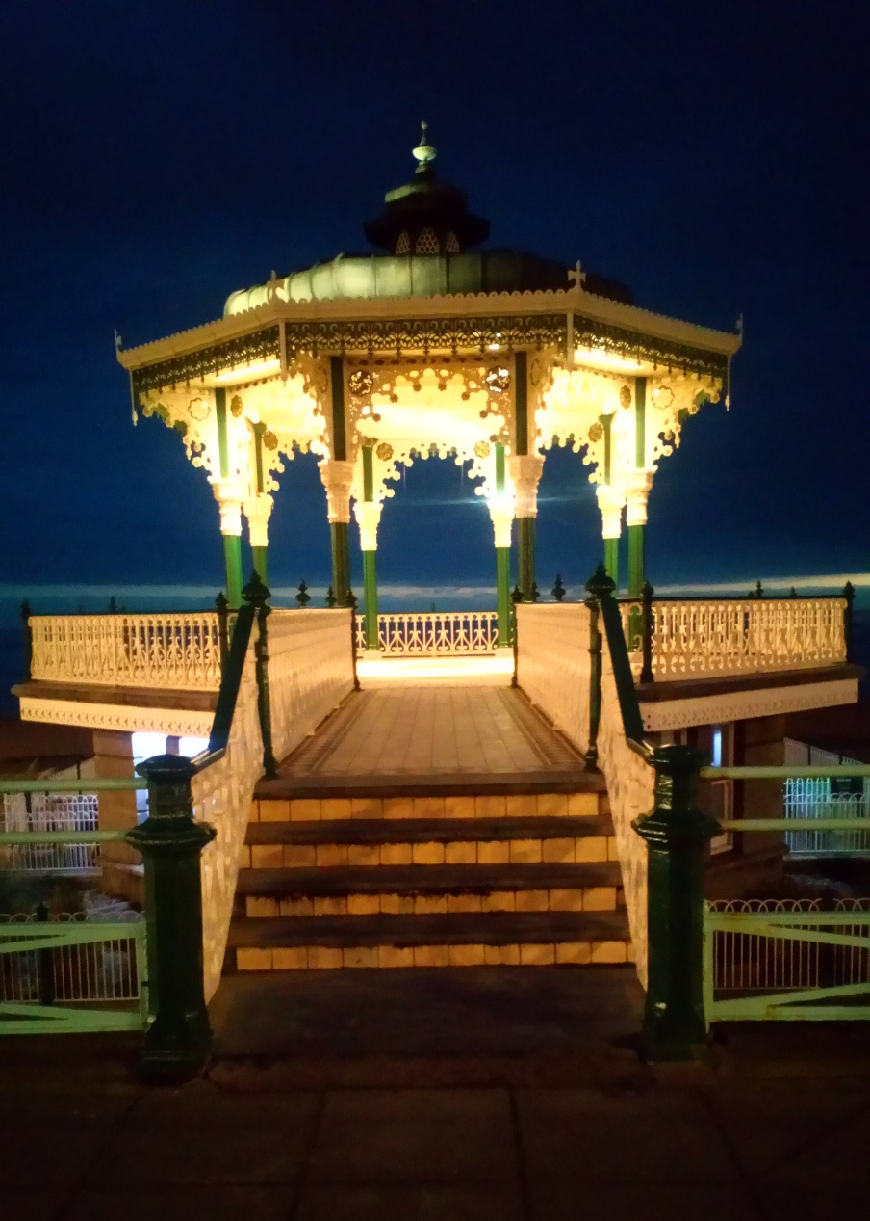

Photo : Kathryn Ferry (reproduced with permission).

The tendency towards the out of the ordinary continued, and in the inter-war and post -war period seaside architecture took an art-deco and modernist direction(s) which was equally distinct (see Steele, 2015 and Figures 33.5, 33.6 and 33.7).

**Figure 33.5**: Blackpool Pleasure Beach and Casino, designed in the International Modern style by Joseph Emberton and built 1937-1940.

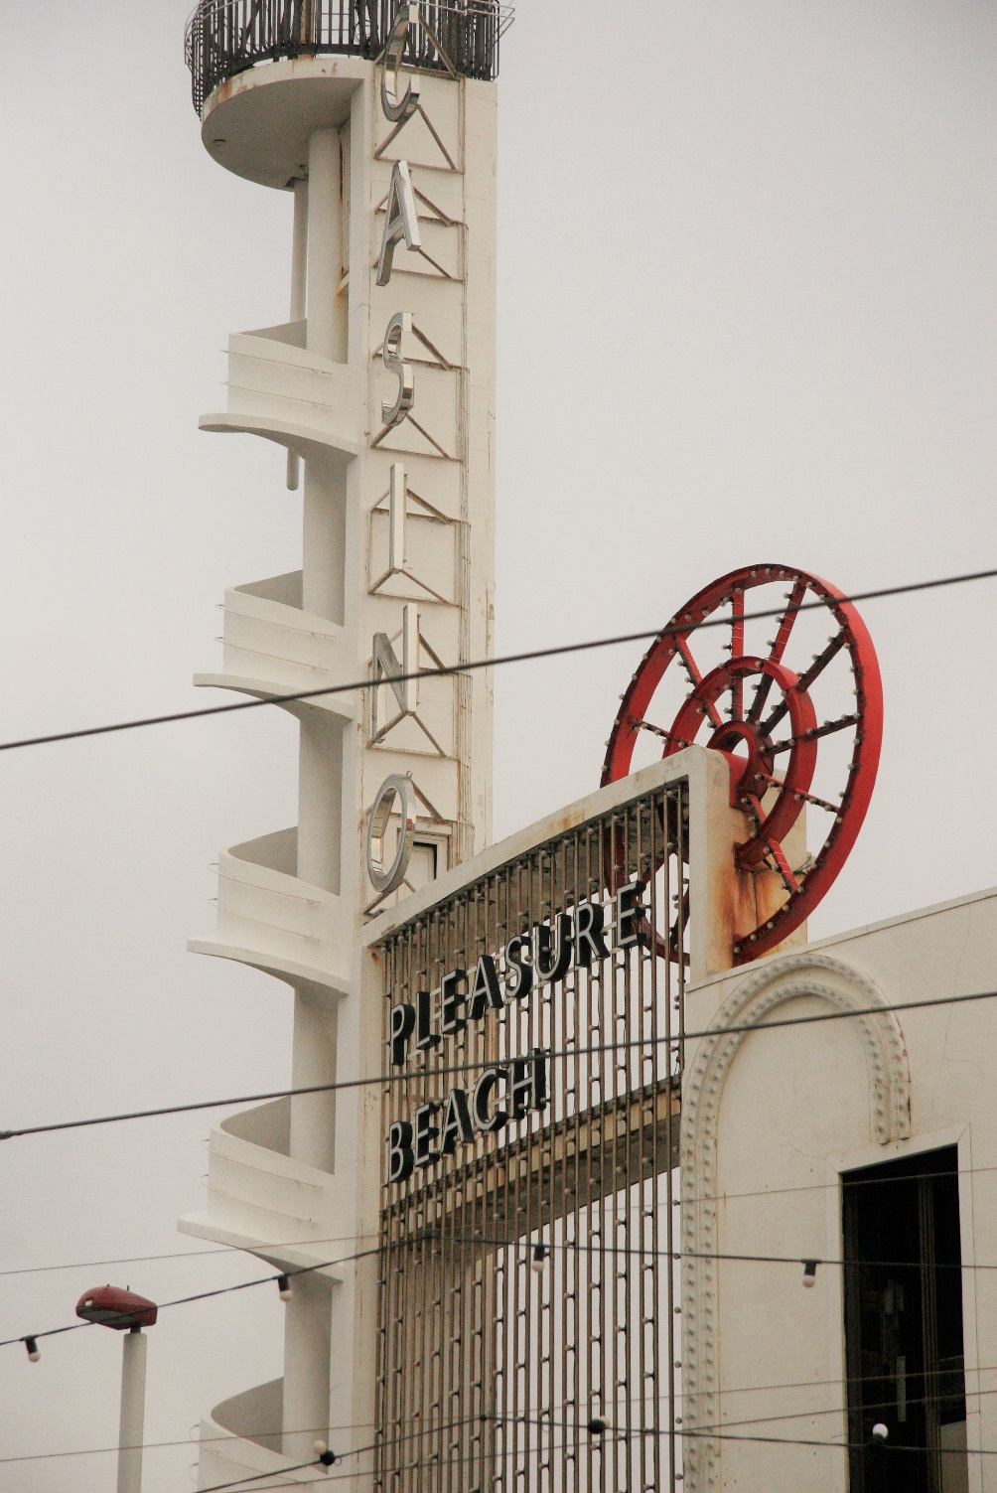

Photo : Jenny Steele (reproduced with permission).

The seaside experience of resorts is one that has remained surprisingly unscathed in minds of many English visitors, and there can be little doubt that a hazy nostalgia played a role in this. Yet, the physical reality is somewhat different. Tourism has continued through the years but there have been causalities in terms of seaside heritage. With the ravages of time and changing leisure and tourism patterns, the built heritage at the seaside has suffered; structures and buildings have disappeared or changed usage (Jarratt 2019). The removal of seaside heritage is still taking place today. Most seaside heritage has remained outside the authorised heritage discourse (the traditional /mainstream view of heritage as sanctioned byexperts) but in this century a growing number of voices have begun to consider it significant (Smith, 2006).

In 2001 the English Tourism Council observed that ‘Seaside resorts have made an enormous contribution to the cultural identity of England and contain some of the finest examples of our built heritage. This is overlooked rather than promoted’ (ETC, 2001: 23). However, since then it seems that surviving seaside heritage is overlooked less frequently. For example, the grade two listed Blackpool Winter Gardens now boasts heritage tours and Blackpool museum will soon be under construction. Dreamland in Margate, which is now grade two listed, has reopened. Weston-Super-Mare’s Grand Pier was reopened in 2010 after investment of over £51 million following a fire. Britain has a National Pier Society (see <https://piers.org.uk/>) and these vulnerable structures are the objects of ‘affectionate nostalgia’ (Walton 2010 p.1). English Heritage has shown an interest in seaside heritage and surveyed resorts in 2002 (Brodie & Winter, 2007) and more recently the sea front itself has been carefully examined (Brodie 2018). The over-due recognition of seaside architecture is underway, yet working-class resorts are still subject to stigma (see Walton & Wood, 2009). One reason for this delay in recognition is the focus on the heritage of production rather than consumption – seaside resorts are still in use, quite unlike most industrial heritage sites in the UK which are representative of something more clearly consigned to the past. With time, we may see an even wider recognition and nostalgic appreciation of English seaside heritage through the experiences of coastal visitors.

**Case-study: Morecambe**

Morecambe, in Lancashire in north-west England, is a medium sized seaside resort that developed in the nineteenth century. During the twentieth century it boomed as a working-class resort before falling into a very sharp decline during the 1970s and 1980s. Much of the original resort infrastructure, including the two piers, a large lido, a variety of popular entertainment venues and the majority of accommodation providers were lost (see Jarratt 2019 for more detail). By the turn of the new millennium regeneration was underway, but progress was slow. Today, the resort offers a popular promenade, a well-known hotel, some early to mid-twentieth century built heritage and, as always, impressive views across Morecambe Bay towards the Lake District, but little else in terms of tourism infrastructure.

The research discussed here formed part of a wider study that looked at the seaside experience in Morecambe (see Jarratt, 2013). It revolved around semi-structured interviews and aimed to reflect a perspective in some depth, rather than a population, as is common in studies of this type (Smith, Flowers & Larkin, 2009). Interviewees were aged 55 to 74 years, resided in the North of England and were repeat visitors, thereby reflecting the typical profile of a visitor to Morecambe.

For the interviewees, the place identity of the British seaside, specifically Morecambe, operated on different, inter-connected, levels. These meanings were both individual and collective. In broad terms, place-related meanings operated on the basis of the individual, family and nationality. Typically, childhood holidays with loved ones were remembered on the one hand and a sense of tradition and national identity was expressed on the other. Morecambe reminded visitors of Englishness (the term Britishness was also used), chiefly because it is considered an old-fashioned place rich in English leisure traditions and history. In a similar fashion, cultural signifiers, such as sticks of rock, Bed and Breakfasts, sandcastles and the windswept front were all identified as symbols of the English seaside. Cultural signifiers constitute the building blocks of place identity and sense of place.For the interviewees, cultural signifiers mark the past and are intertwined with memory:

I think a lot of people sort of my age in a way, remember about the seaside, would be the typical visit to the seaside, spending time on the beach, the ice cream, the building sand castles, they…the paddling, all those sort of things that would be a typical seaside visit for kids my age back in, in the you know, the sort of 50s, early 60s.

The beach and the built environment held more cultural signifiers than any other aspect of the seaside environment. When asked what, if any, changes they would like to see to the resort, the interviewees referred to new or improved swimming pools, theatres and more cafes. The suggestions were always attractions that Morecambe already had or had lost over the years. The interviewees wanted Morecambe to be a traditional seaside resort, just a *better one* or one more like the way it used to be, with built heritage being a key part of this. They viewed the Tern Project (the regenerated promenade with various artworks) favourably but considered the regeneration of the resort as piecemeal and incomplete. Tangible heritage was considered a positive defining characteristic of Morecambe by interviewees. The Victorian and inter-war period were often referred to and the related tangible heritage appeared to be valued:

Them old buildings are, are the ... they were built a lot in Victorian times but they're still fine buildings, and that is what when you go to a seaside and you look at all bed and breakfasts' along the front and, and they are the essence of, of the seaside anyway...

For the respondents, built heritage offered an appealing tradition and tangible link to the past, but also cemented a distinct place identity. Oneinterviewee thought that many contemporary towns and cities lacked the distinctiveness still offered by seaside resorts that have retained something of what they were:

When we were youngsters if you went to a… Well like it you just went to Preston or Wigan you would get a variety of shops that were owned by different people and I mean now you just go and they’re all the same…

However, this distinctiveness is not entirely positive, as the image of seaside towns as old-fashioned and even run-down was recognized:

I think that's the image you get and sort of almost all of them have seen their heyday and they’re not as they were.

Such negative assertions do not entirely go against visitor appeal; rather, they feed into a bitter-sweet nostalgia for the past. Such decay marks a stage further back; it allows a connection to a golden age. One interviewee acknowledged some changes to the resort since his youth but overlooked decay to enjoy a place rich in narrative and meaning. He distinguished between the physical characteristics of place and the meaning he continues to ascribe to such resorts:

Physically obviously everything changes. But I think in our minds, culturally, it’s a great place to go and enjoy yourself.

Nostalgia not only allowed such enjoyment but appeared to very much underpin visitor appeal. Nostalgia was savoured; interviewees considered it to be one of the primary reasons to visit, as the following quote suggests:

…it’s a trip down memory lane really when we go to Morecambe. And I, I certainly enjoy it myself. It’s not too far, and essentially that’s why we go.

One interviewee described the seaside as a type of nostalgia that is ‘bred into the English people*’* as part of our national identity, a birth-right and clarified the importance of personal childhood memories: ‘your childhood memories always bring you back...’Another interviewee pointed out that reminiscing about the past was very often a shared, social and pleasurable experience:

...I mean your whole life when you get older is your memories and, you know, you become boring because you’re repeating them, you know, ‘Oh do you remember when…’ you do and often with affection.

These nostalgic interviewees considered a visit the old-fashioned seaside to be reassuring and enjoyable. Furthermore, it provided a contrast to and perhaps a temporary escape from everyday life. Built heritage and specific seaside sites were a key component of this appeal as they were linked to memories and family narratives. Notably, interviewees placed a high value upon the built heritage of the seaside, and all of them wanted these buildings to be restored and used:

I just think that the... the buildings that they... the old buildings that they have should be utilised and should be, you know, made more accessible to people, or... they should do some... they shouldn’t knock them... certainly shouldn’t pull them down. You know, the Winter Gardens, for example...

Half the respondents brought up the significance of the Midland Hotel to Morecambe as a destination during their interviews. The restored and reopened Modernist hotel (see Figures 33.6 and 33.7) attracted a good deal of attention nationally as a unique piece of architecture and potential barometer of change – a symbol of successful regeneration and therefore a symbol of a potentially brighter future (Sharman, 2007). This was reflected in the comments of the interviewees for whom it represents the best of Morecambe: ‘...the Midland Hotel just looks… it’s just an icon, isn’t it, really?’ Most often the interviewees considered the re-invented Midland was a symbol of the resorts’ past when it attracted a wealthy and glamorous clientele as a destination hotel: ‘It was sort of the place to be.’

Furthermore, a modern day visit to this hotel acted as a tangible link to an idealized and selective version of the past. Interviewees even described this experience as reliving a decadent past – an imagined past influenced by postcards, a television episode of ‘Poirot’ which was filmed there, and other images. This distinctive building appears to allow or encourage an experience of escape or fantasy:

You're thinking ... 'cos it did have a, a part in history when it was the venue of all the rich. Big cars were parked outside, I've seen photographs. Very rich people using it in the 20s and 30s. And so you're now able to go there and it, it's like reliving that, you know*.*

**Figure 33.6:** The Midland Hotel, which was designed by Oliver Hill and dates to 1933, during the 2015 Vintage by the Sea Festival

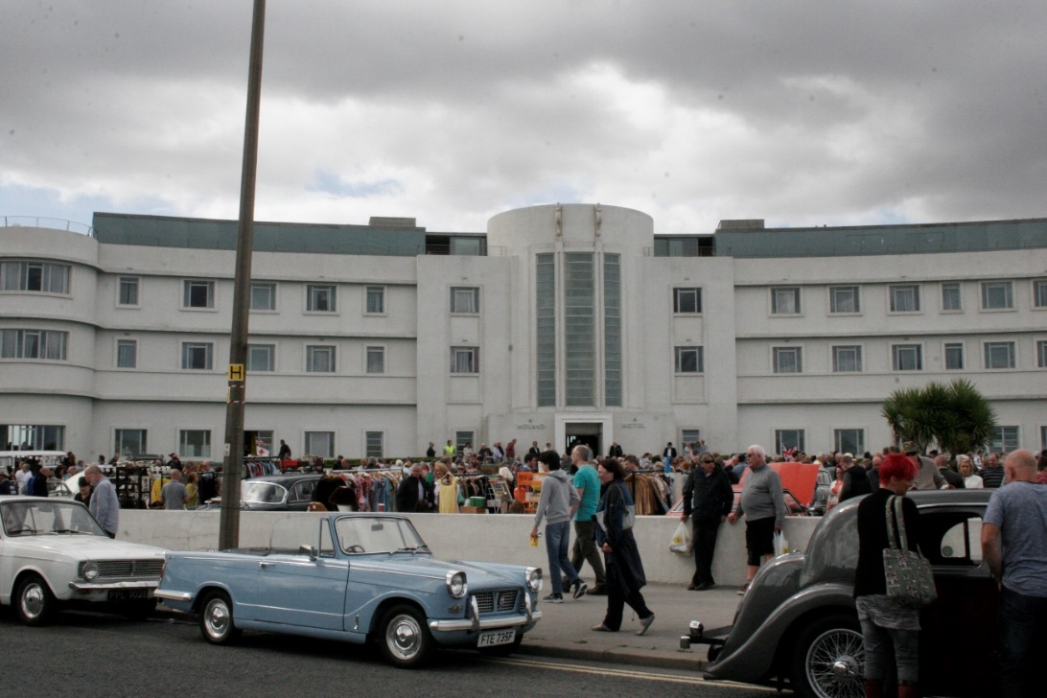

Photo : Jenny Steele (reproduced with permission).

**Figure 33.7:** The main stairway of the Midland Hotel with a medallion relief by Eric Gill.

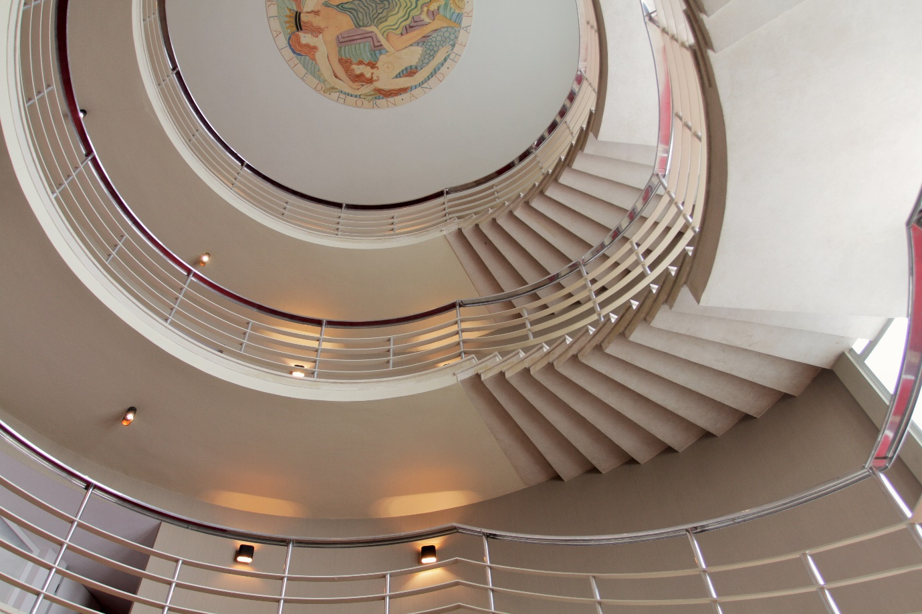

Photo : Jenny Steele (reproduced with permission).

The Midland Hotel is the resort’s most obvious and best-known built heritage site. Indeed, it was the most consistently discussed site across the interviews. It usually appeared to be the objective of a collective nostalgia for times gone by as opposed to more personal memories. However other less obvious, less grand sites and more varied sites of heritage were revealed by the interviews. These places were linked specific personal memories of family holiday experiences which they hosted. Therefore, these places within the resort were linked to family narratives and memories of loved ones. In most cases, these were childhood memories and often involved parents who have now passed away or children who have now grown up. For example, traditional cafes were sites which had meaning attached to them. Indeed, for some it appears that nostalgia and re-telling family narrative is a key reason to visit particular eating places where family members once gathered. One interviewee claimed to visit Morecambe chiefly for the sea-views and nostalgia associated with particular café. He observes that visiting Brucciani’s café (which was built in 1939 and appears to have changed remarkably little over the last 50 years or more – see Figure 33.8) is a ‘trip down memory lane’ for him and especially his wife:

We have to go into Brucciani’s because this is a kind of period piece, and I get the same tale – I get the same tale every time we go in: this is where she and her sister came with her mum and dad and they had an ice cream and so on. So, that’s the kind of thing I mean by memory lane. But, but it’s not just Brucciani’s; of course these other places are significant in her memory.

Fig**ure 33.8:** Brucciani’s café window.

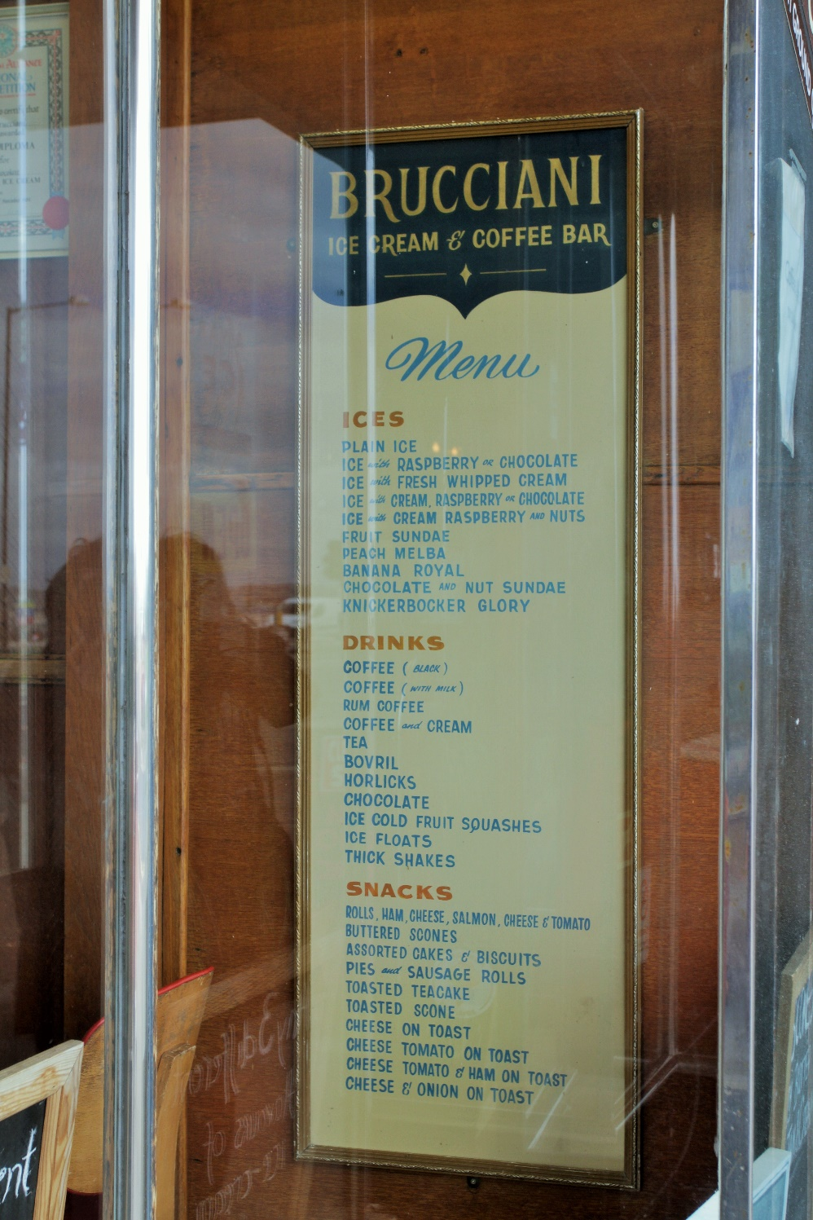

Photo : Jenny Steele (reproduced with permission).

Nostalgia for the loss of childhood was usually, but not always, that of the interviewee themselves. Another interviewee suggests that a different café is linked to very specific memories of his daughter who has long since grown-up and moved out. He recalled how she always ordered the same prawn sandwiches.

The specific seaside scenes of reminiscence or nostalgia varied and included cafes, old railway stations, penny arcades as well as the beach or promenade. In each case, the setting was traditional and can still be visited today. Without the physical presence of these sites, perhaps, the appropriate neuronic triggers could not facilitate a connection with selected elements of the past. These scenes were all positive re-telling of a seaside narrative and very often a family narrative too, thereby underpinning individual and collective identity through nostalgia. Lowenthal (2011) points out that, for many people, this type of identification with the past is achieved through attachment to certain places which hold memories or meaning. Such places are often shaped over time, preserved to some degree but need not be magnificent.

This case-study echoes the observation of Gray (2006) and others that built heritage is a vitally important aspect of the seaside visitor experience. Diverse places were the sites of meaningful experiences and memories to the interviewees. These traditional places hold a nostalgic appeal, underpin sense of place and feed into personal and collective identities, both of people and place. It is interesting that the Midland Hotel appeared to inform collective elements of identity, whilst the other sites (such as the cafes) tended to inform personal elements. The Midland symbolised elements of the past in general of collective nostlagia rather than family narratives, particular memories of childhood and personal nostlagia. Interviewees often referred to the traditional built seaside environment in generic terms, which could describe any such resort; however, these references were often punctuated by specific reference to landmarks and sites in Morecambe. These informed Morecambe’s sense of place which, in turn, fed into a more transferable seaside sense of place, or seasideness. Whether one’s focus is Morecambe or seaside resort’s more generally, distinctiveness was vitally important to appeal.

**Conclusion**

This chapter has observed that seaside nostalgia has endured and seaside heritage has been rediscovered of late, inferring that seaside resorts are no longer places of recovery, but places in recovery as they move back into the cultural mainstream (Steele & Jarratt, 2019). Elborough (2010) observes that our ‘rapprochement’ with the seaside has been underway since the start of the twentieth-first century when the artist Tracy Emin sold her Whitstable beach hut to Charles Satchi for £75,000 – which would soon reflect the real-world inflation of beach hut prices in Southern England. He also points to the popular TV series Coast, which was first aired in 2005. Gentrification is now well established in many coastal resorts, especially those within commuting distance from major economic centres. This does not necessarily diminish the serious socio-economic challenges facing residents in many coastal communities though (BBC News, 2019). Nevertheless, those migrating to and visiting these seaside towns, want distinctive towns that afford access to blue spaces. Built heritage is at the centre of this distinctiveness which, as discussed in this chapter, is an important part of the seaside experience (Jarratt, 2015). This distinct resort experience, or seasideness, is framed and conditioned by the sea but also by the built environment. Seasideness relies on the culture of the coast just as much as it does nature. So, it is vital that the struggle to preserve remaining seaside heritage continues; it appears the tide is now moving in this direction. Equally, any new developments in resorts that wish to be popular destinations should wherever possible be distinctive from today’s ‘blandscapes’ and foster their appeal as *somewhere else.* In short, this distinctive seaside heritage and design remain crucial to the visitor experience of English resorts and, therefore, to the future of the seaside.

**References**

Baerenholdt, J., Haldrup, M., Larsen, J. and Urry, J. (2004) *Performing Tourist Places*. Aldershot: Ashgate Publishing.

BBC News (2019) England's most deprived areas named as Jaywick and Blackpool. BBC News, 26 September. Available at: <https://www.bbc.co.uk/news/uk-england-49812519>, (Accessed 27 September 2019).

Beery, T., Jönsson, K. and Elmberg, J. (2015) From environmental connectedness to sustainable futures: Topophilia and human affiliation with nature. *Sustainability*, 7(7), 8837–8854. Available at: http://dx.doi.org/10.3390/su7078837.

Bennett, T. (1986) Hegemony, ideology, pleasure: Blackpool. In: T. Bennett, C. Mercer and J. Woollacott (Eds), *Popular Culture and Social Relations.* Milton Keynes: Open University Press, pp. 135-154

Bracewell, M. (2004) The Last Resort. Available at: The Independent On Line: <https://www.independent.co.uk/news/uk/this-britain/the-last-resort-5539247.html> (Accessed 22 October 2020).

Brodie, A. (2018) *The Sea Front.* Swindon: English Heritage Books.

Brodie, A and Winter, G. (2007) *England’s Seaside Resorts*. Swindon: English Heritage Books.

Butler, R. (1980) The concept of a tourist area cycle of evolution: Implications of management resources. *Canadian Geographer,* 24(1), 5-12.

Chase, L. (1999) *Creation of Place Image in Inter-War Clacton and Frinton*. Unpublished Ph.D thesis, University of Essex.

Davis, F. (1979) *Yearning for Yesterday*. New York: The Free Press.

Elborough, T. (2010) *Wish You Were Here: England on Sea*. London: Hodder & Stoughton.

ETC (2001). *Sea Changes* – *Creating World Class Resorts in England*. London: English Tourism Council.

Ettenger, K.(2015) The other Maine guides: How the humanities create sense of place and enrich tourism.  *Maine Policy Review*, 24(1), 73-79.

European Commission (n.d.) *Integrated Marine Policy: Coastal and Marine Tourism*. EU Commission: Available at: https://ec.europa.eu/maritimeaffairs/policy/coastal_tourism_en (Accessed 5 November 2020).

Ferry, K. (2009) *The British Seaside Holiday*. Oxford, Shire Publications.

Gammon, S. and Jarratt, D. (2019) Keeping leisure in mind: The intervening role of leisure in the blue space – health nexus. In R. Foley, R. Kearns, T. Kistemann and B. Wheeler (Eds.), *Blue Space, Health and Wellbeing: Hydrophilia Unbounded*. Routledge: Abingdon, pp.38-52.

Gillis, J. (2012) *The Human Shore: Seacoasts in History*. Chicago: Chicago University Press.

Goulding, C. (1999) Heritage, nostalgia and the grey consumer. *Journal of Marketing Practice: Applied Marketing Science,* 5(6), 177-199

Gray, F. (2006) *Designing The Seaside.* London:Reaktion Books.

Hall, M. C. (2001) Trends in ocean and coastal tourism: The end of the last frontier. *Ocean & Coastal Management,* 44, (9-10), 601-618

Jarratt, D. (2013) *A socio-cultural analysis of the traditional seaside resort and its contemporary meaning to tourists with specific reference to Morecambe, U.K*. Ph.D. thesis, University of Central Lancashire. Available at <https://clok.uclan.ac.uk/9621/1/Jarratt%20David%20Final%20eThesis%20%28Master%20Copy%29.pdf> (Accessed 1 October 2020).

Jarratt, D. (2015) Sense of place at a British coastal resort: Exploring 'seasideness' in Morecambe', *Tourism: An International Interdisciplinary Journal,* 63(3), 351-363.

Jarratt, D. (2019) The development and decline of Morecambe in the nineteenth and twentieth centuries: A resort caught in the tide. *Journal of Tourism History*, 11(3), 263-283.

Jarratt, D. and Gammon, S. (2016). ‘We had the most wonderful times’: Seaside nostalgia at a British resort. *Tourism, Recreation Research,* 41(2), 123-133

Jarratt, D., Phelan, C., Wain, J. and Dale, S. (2019) Developing a sense of place toolkit: Identifying destination uniqueness. *Tourism and Hospitality Research* *19*(4), 408-421

Jarratt, D. and Sharpley, R. (2017) Tourists at the seaside: Exploring the spiritual dimension’ *Tourist Studies*, 17(4), 349-368.

Jorgenson, B. and Stedman, R. (2001) Sense of place as an attitude: Lakeshore owner’s attitudes toward their properties. *Journal of Environmental Psychology,* 21(3), 233-248.

Leisen, B (2001) Image segmentation: The case of a tourism destination. *Journal of Services Marketing*, 15(1), 49-66.

Lindley, K. (1973) *Seaside Architecture*. London: Hugh Evelyn.

Lowenthal, D. (2011) *The Past is a Foreign Country.* Cambridge: Cambridge University Press.

Massey, D. (1997) A global sense of place. In T. Barnes and G. Gregory (Eds) *Reading Human Geography*, London: Arnold, pp. 315-323.

Preston-Whyte, R. (2004) The beach as a liminal space. In A. Lew, M. Hall and A. Williams (Eds), *A Companion for Tourism,* Oxford: Blackwell, pp.349-359

Relph, E. (1976) *Place and Placelessness.* London:Pion Limited.

Robinson, M. and Picard, D. (2009) *The Framed World: Tourists, Tourism and Photography*. Aldershot: Ashgate.

Sharman, R. (Producer & Director). (2007). Southport to Whitehaven [Television series episode]. In S. Evanson (Series Producer), *Coast -* Series 3. London: BBC2.

Shields, R. (1991) *Places on the Margin: Alternative Geographies of Modernity.* London: Routledge.

Smith, J. A., Flowers and Larkin, M. (2009) *Interpretative Phenomenological Analysis: Theory Method and Research.* London: Sage.

Smith, L.J. (2006) *Uses of Heritage*. London: Routledge.

Steele, J (2015). Looking Back Moving Forward [Blog]. Avialable at <https://lookingbackmovingforward2014.wordpress.com/> (Accessed 1 November 2020).

Steele, J. and Jarratt, D. (2019) The seaside resort: Nostlagia and restoration. In E.Speight (Ed.), *Practising Place: Creative and Critical Reflections on Place*. Sunderland: Art Editions North, The University of Sunderland, pp.132-150.

Tuan Y-F. (1974) *Topophilia: A Study of Environmental Perception, Attitudes, and Values.* London: Prentice-Hall.

Tuan, Y.F. (2011) *Space and Place: The perspective of Experience*. Minneapolis: University of Minnesota Press.

Turner, P. and Turner, S. (2006). Place, sense of place, and presence’, *Presence*, 15(2), 204-217.

UNWTO (2013) *Sustainable Marine Tourism: Expert Group Meeting on Oceans, Seas and Sustainable Development: Implementation and Follow-up to Rio+20*, 18-19 April 2013, New York: UN.

Urry, J. (1990) *The Tourist Gaze: Leisure and Travel in Contemporary Societies.* London: Sage Publications.

Vesey, C. and Dimanche, F. (2003) From Storyville to Bourbon Street: Vice, nostalgia and tourism*. Journal of Tourism and Cultural Change*, 1(1), 54-70.

Visit Britain (2016) *The GB Tourist: Statistics 2015*. Visit Britain: https://www.visitbritain.org/sites/default/files/vb-corporate/Documents-Library/documents/England-documents/gb_tourist_report_2015.pdf (Accessed 5 November 2020).

Walton, J.K. (2000) *The British Seaside: Holidays and Resorts in the Twentieth Century*. Manchester: Manchester University Press.

Walton, J.K. (2010) The Victorian Seaside. Available at: <http://www.bbc.co.uk/history/british/victorians/seaside_01.shtml>. (Accessed 17 November 2020).

Walton, J.K. and Wood, J. (2009) Reputation and regeneration: History and the heritage of the recent past in the re-making of Blackpool. In L. Gibson and J. Pendlebury (Eds.), *Valuing Historic Environments*. Aldershot: Ashgate, pp. 15-137.

# Wang, W. (1999) Rethinking authenticity in tourism experience. *Annals of Tourism Research,* 26(2), 349-370.

Webb, D. (2005) Bakhtin at the seaside: Utopia, modernity and the carnivalesque. *Theory Culture and Society,* 22(3), 121-138.

White, M., Smith, A., Humphryes, K., Pahl, S. Snelling, D. and Depledge, M. (2010). Blue space: The importance of water for preference, affect, and restorativeness ratings of natural and built scenes. *Journal of Environmental Psychology,* 30(4), 482-493.