What factors affect customer’s decisions when choosing to shop at out of town vs. in town retail centres?
Case study: The Rock, Bury Vs. The Trafford Centre

Mathew Collum
BA Geography Honours
3rd Year Dissertation
University of Central Lancashire
April 2013

Declaration

I declare that the main text of this dissertation is no more than 10,000 words, and is all my own work.

Mathew Collum

Abstract

The aim of this study is to examine attitudes towards shopping at out-of-town and in-town shopping centres in the context of what factors are most important when choosing where to shop. Shopping attitudes were collected from The Rock shopping centre in Bury and the Trafford Centre in the form of a survey. The quantitative data collected is presented visually in the form of graphs and the qualitative data is analysed to provide further understanding into shopping decisions between in-town and out-of-town retail.
The results found the quality of shop to be the most important factor when choosing where to shop, while also noting the importance of image and shopping environment. However it is also shown that where somebody shops depends on the time available to make the shopping trip and the purchase aims.
Understanding how shoppers choose between different locations is important as it allows bosses of in-town retail centres to better prepare and adapt in order to reduce business lost to new out-of-town shopping centres. By providing shoppers with everything they want and need in their own town, they can reverse this spiral of decline that has been happening in town centres and high streets across the UK over the last 20 years.

Acknowledgements

I would like to than Mark Toogood, Hannah Neate and Chris Lowe for their help with my dissertation.
I would also like to thank the all of the 100 participants that took the time to complete the questionnaire.
Finally, thanks to my family for driving me to Preston and back every weekend.

Table of Contents
Acknowledgements……………………………………………………………………iii
List of graphical representations……………………………………………………..v
List of figures………………………………………………………………………......vi

Chapter 1: Introduction
  - Introduction………………………………………………………………………...2
  - Introduction to The Rock, Bury shopping centre……………………………....4
  - Introduction to the Trafford Centre………………………………………………6
  - Overview if dissertation layout…………………………………………………...7
  - Aims of research…………………………………………………………………..7
  - Objectives of research……………………………………………………………7
Chapter 2: Literature review
- 2.1 Growth of Out-of-town retail centres……………………………………….9
- 2.2 Decentralisation of retail…………………………………………………....10
- 2.3 Understanding the consumer………………………………………………11
- 2.4 Importance of Image………………………………………………………...13
- 2.5 Effects of Recession………………………………………………………...14
Chapter 3: Methodology
- 3.1 Questionnaire design……………………………………………………….17
- 3.2 The questionnaire Process…………………………………………………18
- 3.3 Results and analysis………………………………………………………..19
Chapter 4: Research and analysis
- 4.1 Representation of questionnaire results…………………………………..21
- 4.2 analysis of qualitative data…………………………………………………30
Chapter 5: Discussion……………………………………………………………..33
Chapter 6: Conclusion……………………………………………………………..38
References……………………………………………………………………………40
Appendix………………………………………………………………………………45
List of graphical and tabular representation.

Table 4.1 Location travelled from, Trafford Centre……………………………..21
Table 4.2 Location travelled from, The Rock, Bury……………………………22
Graph 4.3 Mode of transport used………………………………………………23
Graph 4.4 Reason for shopping trip…………………………………………….24
Graph 4.5 Average number of monthly visits……………………………………..25
Graph 4.6 Average level of influence, The Trafford Centre……………………26
Graph 4.7 Average level of influence, The Rock…………………………………27
Graph 4.8 Access to Metrolink, The Rock……………………………………….28
Graph 4.9 Access to Metrolink, the Trafford Centre……………………………28
Graph 4.10 Would you use this service?.........................................................29

List of figures
Page number

Figure 1.1 The Rock,Bury……………………………………………………………4
Figure 1.2 Planned extension for the Metrolink …………………………………..5
Figure 1.3 The Trafford Centre……………………………………………………..6

Chapter 1- Introduction

Chapter 1.1: Introduction
Understanding people’s wants and needs when they are shopping is essential to be able to provide the environment that attracts the maximum amount of customers and reduce the loss of custom to other shopping centres. Whether or not a shop or shopping centre is successful all relies on people choosing to shop and spend their money at that certain centre and choosing not to at an alternative shopping destination. In the case of The Rock, Bury, the people shopping there have made a decision not to travel further, either by car or public transport to the Trafford Centre because the positives of shopping at The Rock outweigh the positives of traveling further to the Trafford Centre, so for The Rock to continue to be successful this balance must remain. Therefore it is essential to understand exactly what aspects of the shopping experience people regard as most important when making the decision of where to shop.
As technology develops, so does the way we shop. The invention of the car has been by far the most influential technological advance that has completely changed the retail industry. The freedom of travel that the car brought use has given people more choice of where they shop. Peoples choices used to be pretty much already decided, dependant on where they lived and what was available within walking distance. Therefore the high streets of towns and villages were by far the most important and valuable retail spaces in a time when people would rarely if ever venture outside of their home town. The rise in popularity of the car during the early 1900s allowed people to travel long distances in a short space of time, this gave people the choice to travel further to neighbour towns or cities to do their shopping if they preferred to shop there. This choice increased competition for the loyalty of customers, therefore shops needed to compete with similar shops within an area that would be accessible by car. Other aspects of the shopping experience became important other than just the price and location, rise in advertising, customer services and creating an optimum customer friendly all became far more important than they had been before the invention of the car.
Modern day consumerism has also been an important factor in shaping the retail industry today and providing a platform for huge mega-malls and out-of-town shopping centres to be successful. The retail industry constantly aims to promote consumerist behaviour and in the 18th century the middle-class embraced these ideas about luxury consumption and the growing importance of fashion and the need to purchase goods and service in much larger amounts than what is essential.
The British high street has always been a focal point of a town or city and plays an important role as the centre of a community. The high street is seen to exemplify the town as a whole and is the place to go when visiting a new town. They are a hub for social interaction and provide towns with a sense of place. The recession along with the rise of alternative kinds of retail such as internet shopping and out-of-town centres has caused a decline of the UKs high streets. This decline has resulted in large chain stores moving to out-of-town locations leaving as many as one in four shops being vacant in places such as Blackburn and Grimsby which have been deserted by chain stores resulted in the loss of custom to local shops, causing further closures. Left behind are empty shop, discount shops, betting shops and local shops struggling to make a profit. ‘The demise of the small shop would mean that people will not just be disadvantaged in their role as consumers but also as members of communities – the erosion of small shops is viewed as the erosion of the 'social glue' that binds communities together, entrenching social exclusion in the UK.’ (J.Hamlett, 2008).
The government values the importance of improving high streets and town centres and as of December 2012 introduced policy aimed to address the issue. The policy encourages local partnerships and consortiums to come up with innovative ideas about how to revive their local high streets into a social place, bustling with people, services and jobs (GOV, 2012). There will be two waves of pilots, the first of which will include 12 town centres including Stockport, Greater Manchester. Successful towns will receive funding of £100,000 along with government support to regenerate their town centre. This is just one of many government policies which are aimed at restoring the UKs high streets and town centres to their former glory. Others include, National Markets Day which aims to promote retail markets over a fortnight of events, also a £500,000 Business Improvement Districts loan fund to help finance the development of new business improvement districts.

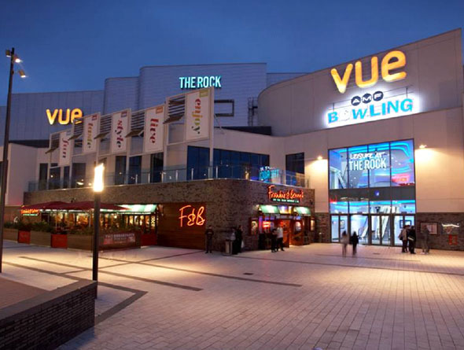
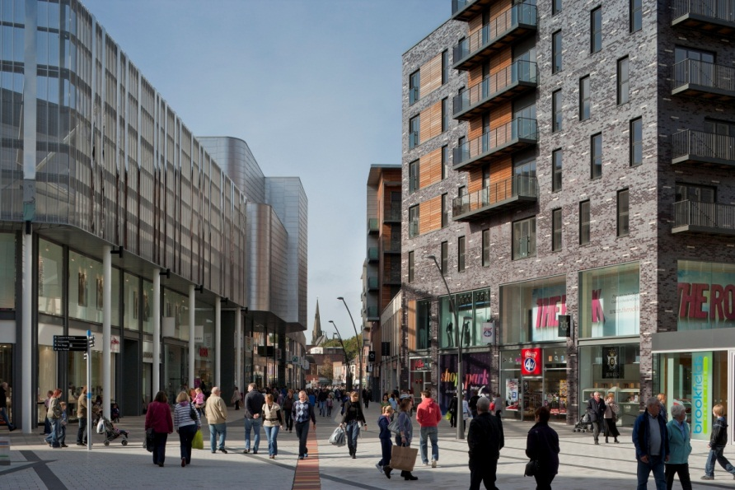
1.2. Introduction to The Rock, Bury shopping centre.
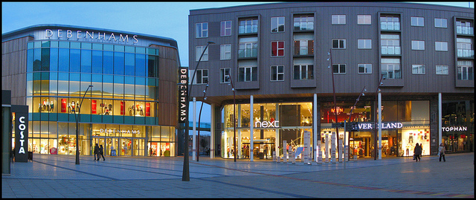
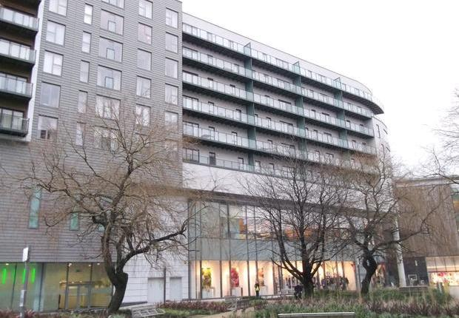
(Figure 1.1) The Rock
The Rock, Bury is a shopping and entertainment destination in the centre of the Town. It was completed and opened its doors to the public in July 2010 costing £350 million, making it the biggest project of its kind in the UK during 2012. The development was anchored by the supports of big name brands, Marks & Spencer, Debenhams and Primark who all occupy large department stores within the Shopping centre. The Rock also offers 60 additional stores, 8 restaurants and coffee shops as well day and night entertainment from 10 pin bowling, cinema and health club. In addition, the development also has residential space in the form of 400 Flats and a multi storey car park with space for 1,250 cars.
The Rock promised to bring business to all areas of the town as well as reducing the loss of business out of the town. David Laycock, The Rock’s Centre director said: ‘This is giving people what they’ve previously been travelling outside of Bury to get by visiting places like the Trafford Centre’’.
After one year of being open reports show that The Rock shopping centre succeeded and beat its targets after attracting 10m shoppers. It also boosted business at the ‘world famous’ Bury market located 5 minutes from The Rock.
However The Rocks strongest competition for customers from the Bury area as well as people living in surrounding areas such as Radcliff, Ramsbottom and Rochdale comes from the Trafford Centre which is located 19 minutes away by car. Therefore if current plans (see Fig.1.2) go ahead to extend the Metrolink service directly to the Trafford centre, making it easier for the residents of Bury to get there, especially young people that don’t have access to a car, than this could lead to an increased loss of business for The Rock.
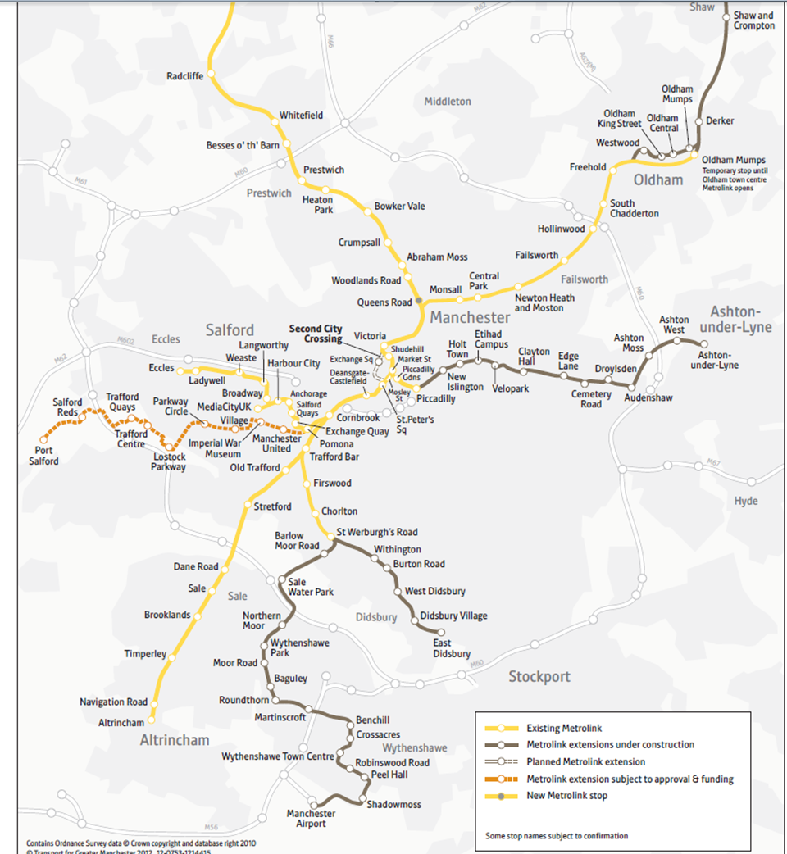
Figure 1.2 Map of planned extended metrolink service.

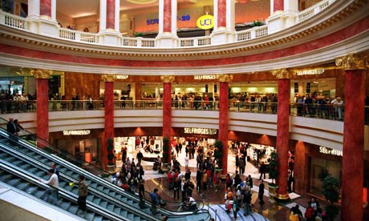
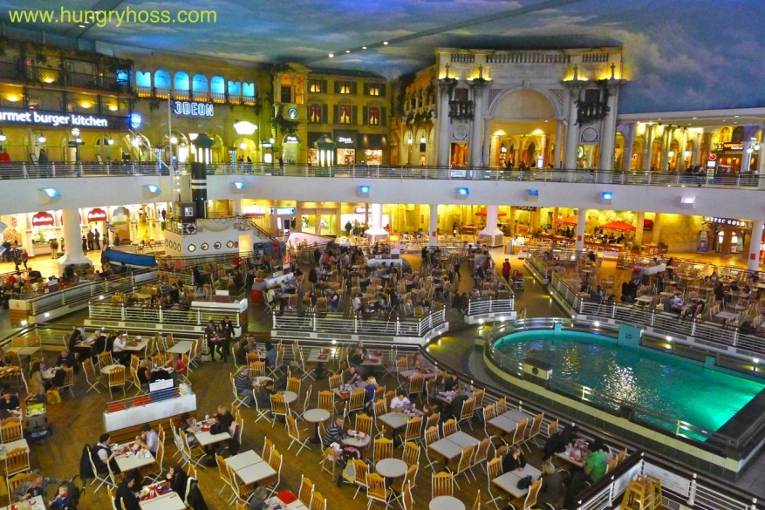
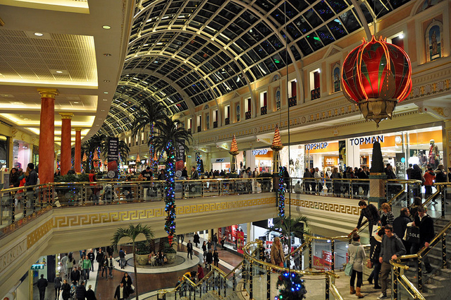
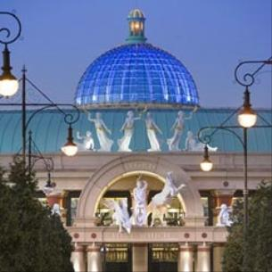
1.3 Introduction to the Trafford Centre

(figure 1.3) The Trafford centre
The Trafford Centre is the second largest retail centre in the UK by retail size and has extensive retail, leisure and dining space. It opened in 1998 and as of 2012 cost £750M to construct. It is located 5 miles west of Manchester city centre and its prime location means that 10% of the UK population lives within a 45 minute drive of it, this result in it attracting over 35 million visits a year.
As of 2008 it has 6 major anchor stores: Bhs. Boots, Debenhams, Selfridges, John Lewis and Marks & Spencer all of which occupy large department stores. The Trafford Centre also offers over 280 stores and services as well as having the largest food court in Europe with 60 restaurants, cafes and bars. It’s also home to the UKs busiest cinema, attracting more than 28,500 visitors each week. There are good transport links as it is just off the M6 and offers 11,500 free car park spaces and also has its own bus station.

1.4 Overview of dissertation layout
Chapter one has introduce how retail has changed since the invention of the car and given a brief background of The Rock, Bury and the Trafford centre. As well as outlining the aims and objectives of the research. Chapter two will review the available literature on in-town and out-of-town shopping. Chapter three will outline the methodology used in the research. Chapter four will display and analyse the results found from the questionnaire. Chapter five will draw all threads of the study together, discuss the findings and highlight limitations of the study. Chapter six will summarise the key findings and suggest possible future research.
1.5 Aims of research
Examine attitudes towards using out of town vs. in town retail in context of economic austerity. The study will look at the main factors that affect customers decisions when choosing were to shop and how decisions may have changed over the last few years.
1.6 Objectives of research
• Identify the main factors that affect people’s decisions of where they shop through questionnaires at both locations.
• Look at how plans for the metro link to be extended to the Trafford centre may affect the choices of residents from Bury in the future.

Chapter 2: Literature review

Chapter 2: Literature review
Answering the question, ‘why do people shop where they shop’ (C.Dennis, 2005) is harder than it seems, and one that if answered would be vitally important to whole retail industry as well as local councils and the government. There has been various study’s looking at different factors that affect people’s decisions where to shop. The majority of the study’s concentrate on the shopping themselves such as how Image and ‘attractiveness’ affect relative success. However external factors have also been taken into account as potential choice influences, such as household income and transport links. It is also important to understand that shopping habits have changed dramatically over time and continues to do so; therefore research into retail choices soon becomes outdated and irrelevant.
2.1 Growth of Out-of-town retail centres.
The Growth of the car industry and the freedoms of travel that it brought to people were essential in providing the environment for decentralised retail platforms to be successful. This growth changed the way people shopped, ‘Car ownership is a principal determinant of major variations in shopping behaviour.’ (Bromley & Thomas, 1993.)The first modern day shopping mall was the Country Club Plaza in Kansas City and opened in 1922. The thought behind this new concept of retailing is that people would be attracted to travel further distances to have access to a wide range of choice and verity in one place and would mean there was no need to travel around the town to several different shops. In the 1980s giant mega malls were developed outside towns and cities around the US, offering hundreds of shops and entertainment in one place. These mega malls were usually only accessible by car because they were located on cheaper land away from the central hub providing a wide customer catchment area. It’s this car culture that has made out-of-town shopping centres such a success in the UK because retail developments constituted a national car orientated infrastructure (Edensor, 2004). This growth of private cars and different forms of retail meant that people had more choice, therefore advertising and marketing became one of the most important areas in retail to attract customers and promote consumerism.
Out-of-town retail developments evolved in a series of stages (Schiller 1987). The first two stages of decentralisation are associated with the initial growth of superstores, which were first developed by food retailers to provide more choice which would attract large amounts of customers to travel that little bit further. Superstores were then used by retail park companies to sell DIY and household goods. The third stage which occurred in the 1990s was most important and posed a direct threat towards the high street, as large chain stores such as Marks & Spencer decided to pursue a duel location strategy. Other large chain stores followed suit and began investing in out-of-town developments. The government responded to prevent an explosion of new out-of-town developments by implementing stricter building regulations and changes in planning policy. The predicted levels of new out-of-town developments failed to surface in the early 1990s as government intervention as well as recession meant that many plans were scrapped, this resulted in 1994 witnessing the lowest numbers of shopping centres opening since 1965 (Jones Lang Wootton/British Retail Consortium 1996). Hence, the development of out-of-town shopping centres was described as a ‘boom that never was’ (Guy, 1994, p. 172). The fourth stage of decentralisation was less about up-market retail but instead was focused around quality, value for money products, this resulted in the introduction and rise of new retail formats such as discount stores and value retailing (Humphries 1995). These stores offered competitive prices on quality merchandise in order to attract rescission suffering British consumers.
Since the mid-1960s there have been changes in the retail environment with the growth of new forms of retail such at out-of-town shopping centres and internet shopping, this has impacted adversely on the traditional retail hierarchy. Evidence suggests that the middle order which consists of small towns, district centres and small market towns have all been affected the most and there is potentially ‘a spiral of decline’ in such centres stated by Thomas and Bromley (2011). Many communities are already losing their commercial and social foci due to this shift in retail. The government, both Local and central have actively aimed to readdress this problem by a combination of strategies such as enforcing stricter constraints on new developments and promoting the regeneration of town centres, such as Bury. It is suggested that it is possible to reverse the commercial fortunes of a middle-order traditional centre in order to prevent continued decline of our central town retail, even from strong competition from newer retail forms. From 1980 until 1991 the proportion of retail sales from out-of-town stores in the UK more than tripled from under 5% to over 17% (BDP, 1992).
2.2 Decentralisation of retail.
The growth of decentralised retail had a profound negative affect on Britain’s traditional high street resulting in stores closing down or moving their business to out-of-town locations. In the case of the Opening of The Trafford Centre in 1998, town centres in the North West have tried to reduce the negative impact that the Trafford Centre will have on their high streets. In order to counter this loss of custom, councils have collectively focused their efforts through proactive place marketing initiatives with a PR focus to promote the retail provision of town centres. Rather than just advertising, the strategy the north-west towns took was to rebuild and reconstruct the image of the town to bolster its image. Town centre management has been defined as ‘the search for competitive advantage through the maintenance and strategic development of both public and private areas and interests within town centres, initiated and undertaken by stakeholders drawn from a combination of the public, private and voluntary sectors’ (Warnaby, Alexander & Medway, 1998, pp. 17–18).
Decentralization of retail allowed many opportunities that the ageing retail centres in towns or cities cannot provide. Moving retail out of the city allows shopping centres to be built on much cheaper land than more congested central locations, as well as providing far more space for more shops, car parks and new or extended transport links. These areas also are seen as safer environments to shop in with lower crime levels, as the environment is more controlled (J.Fitzgerald and N.Leigh, 2002). The new retail developments away from the central hub are more attractive to the retail visitors because of the generous space, easier access and free parking (Kalman, 1985).
The location of a shopping centre is one of the most important factors in becoming a successful centre. Optimum locations will have a large population within a small distance with good transport links and little competition. Before building or even planning a shopping centre there is much research and data collection before any decisions are made in order to build a picture of what the customer base will be. Currently many organizations make use of geographical information system (GIS). GIS was used in Istanbul to build new shopping malls in order to choose locations which will optimise the potential success of new shopping centres in areas that are both densely populated but also have a high number of conflicting shopping centres (C.Gundogdu, 2011). The Trafford Centres Location means that it is easily accessible from Manchester city centre as well as a high number of surrounding towns, 10% of the population of the UK are within a 45 minute. Shopping centres located in the centre of towns such as The Rock in Bury have a much smaller area from which customers travel.
2.3 Understanding the consumer
Understanding peoples shopping choices is more important than ever. Gregory P. Stone (1954) was the first to identify types of shoppers in relation to the shopping choices of Chicago housewives. He identified four types of shoppers: economic, personalizing, ethical and apathetic. It was found that each type of shopper is distinguished by a specific pattern of social characteristics reflecting their position in the social stricter of the community. Also personalizing shoppers relationships form subjective identifications with parts of a community in which they have choices of where to shop. Economic shoppers were those who took on their household duties because they enjoyed shopping and there shopping behavior was determined by price. Quality, and merchandise assortment. Personalizing shoppers preferred shopping at a store that they knew well and the people that worked there knew them. This is a personnel attachment that is crucial for the patronage of a retail place; these kinds of shoppers are less bothered about price or selection of products. An ethical shopper is someone who tries to choose products and retailers that will benefit their small neighborhood stores and are against the big chains. They are not interested in shopping but instead see it as a necessity. Therefore convenience and location are most important for this type of shopper in determining where they shop.
Charles Dennis (2005) looked at ‘Why would people visit one shopping centre rather than another? Using a questionnaire based on ‘attributes of image’ which was used by McGoldrick and Thompson (1992) to gain empirical evidence of people’s perceptions of the shopping centres by scoring specific attributes attributed compared to relative spending at that shopping centre. C.Dennis(1995) received a somewhat contradicting set of results participants reported that they did not see travel distance or time a particular important, however regression results showed that travel did play an important role in shopping decisions. These findings were in line with results found by Gentry and Burns(1977), they concluded that shoppers choices were determined perceived proximity, however participants failed to express this in a questionnaire format. C.Dennis(2005) most important finding was a positive relationship between attractiveness scores and spending. This could indicate that shopper’s perceived attractiveness of a shopping centre has the biggest influence on spending. However there were differences in category scores between the different shopping centres and between different personalities, age and gender of participants. This would suggest that the profile of the shopper has the biggest influence on shopping decisions and retail planners should plan each centre with a shopper profile in mind.
M. Z. Osman (1993) believes in a psychological approach assuming loyalty and patronage from good past experiences to explain peoples retail choices. Osman (1993) research investigates behaviours to stores, however theories still apply on the larger scale of a shopping centre. He builds on Martineau (1958) that stores have a ‘personality’ and patronage behaviour towards a shopping centre should be viewed from a store image perspective but this is also relevant as a shopping centre has a personality of its own. Retail marketing’s job is to build this personality that gives the shopper a good experience in order to increase the chances of loyalty patronage. Loyalty is said to be indicative of the highest level of patronage motives (James,Walker and Etzel 1975). However the shoppers experience is also formed by their perceived importance of retail attributes which are based on each individual’s life style.
P.Williams and P.Hubbard (2001) believe in social interactions as crucial in consumers being influenced in their use of particular shopping locations. They theorise that social exclusion leads to certain types of shopping behaviour in ‘disadvantaged’ consumers impartially low income families because certain factors mean that they have less choice and more or less follow the behaviour of similar people with their social status. Results also identify significant differences in peoples shopping behaviour and location are influenced by car-ownership, family size, illness, employment status and age. Convenience and access are often perceived to be the biggest influences by participants them self’s when taking part in questionnaires, however results show that it is not as clear cut as this. Often socio-economic groups are important in determining where someone shops, however individuals themselves often believe they have more control and personal choice and their shopping behaviour is not affected by socio-economic status.
2.4 Importance of Image
P.McGoldrick and M.Thompson (2006) highlight the importance of image in the attraction of out-of-town shopping centres. Although location, accessibility and transport are key determinants of success, there are many other factors which also have a strong influence and are often neglected when explaining patronage behaviour. Image is important in creating personality and attraction that will persuade consumers to travel that bit further or spend a little extra money in order to be a part of something more than just the menial task of shopping. This image is created by the planning and architecture of the building, a good example of an out of town shopping centre with a distinct image is the Trafford centre. Its unorthodox style is aimed at giving a unique shopping experience with lavish designs that do not alienate shoppers; its focal point is the large food court which is designed to look like a large cruise ship. Shopping centres can create an image by using a theme that runs throughout the whole centre, everything from the style of flooring to small features such as lighting and style of signs all add to its image. It is possible to rate a shopping centres image by giving ratings to attributes such as lighting, decor, cleanliness, availability of seats and etc.
J.Charterina (2012) similarly investigates how city districts retail attractiveness effects shopping decisions between in-town and out-of-town. To understanding how shoppers choose between two possible locations he analyses a set of four judgement indicators in a cities different districts in order to form its retail attractiveness. Understanding shopper’s behaviour is both important for retail companies themselves, in order to provide consumers with the choice and environment that they desire, therefore increasing customers and profit. It is also important for local governments in order to allow them to implement strategies to encourage the loyalty of its customers to a urban environment, thus giving the town or city an economic and social boost and reducing the adverse effects that loss of local custom to out-of-town shipping centres would bring, such as a society that depends on the car, As well as the reduced attractiveness of towns centres. J.Charterina found that shoppers decide their means of transport depending on their shopping destination. Therefor if shopping in the city centre it’s more likely that the mode of transport they will use will be by foot, bicycle or by public transport. If they are traveling to an out-of-town retail centre they are most likely to use a private car. It was also found that an increase in retail attractiveness of local shopping centres increases the use of shoppers using public transport, bicycle or foot as shoppers tend to prefer to shop in areas that are nearest to the home. It is also interesting that income also plays a role in decision making, both personal income and general income of an area has an effect on decision making. When retail attractiveness is low, the higher income group uses public transport significantly less for trips to local or other shopping districts, instead using the car more to travel out-of-town.
Effects of Recession
Recent years of recession have caused many retailers to rethink retail strategies as customers spending habits have also changed. With fewer new stores opening and many of the UKs largest most profitable companies closing down stores and even going into administration, peoples shopping habits have also changed and there priorities have altered as consumers are spending less. Retailers are now applying new strategies to maintain market share and protect margins, such as focusing on attracting new customers which have no loyalties towards and company. Survey data from McKinsey (2010), indicate that in many product categories have an average of 18% of consumers trying reduced-priced alternatives and of these consumers a significant proportion were pleased with how the cheaper products performed. These results are bad news of companies that depend on premium pricing, particularly those who sell products which have little room to reduce price or provide cheaper alternatives. Therefore it is essential that company’s better understand consumers altered motivations towards spending in times of recession, as consumers become less willing to spend more and instead make sacrifices in order to spend less.
Other results McKinsey (2011) found indicate that different product categories had different percentage of people switching from high-priced brands to cheaper alternatives. Of these customers that switched to lower priced brands 48% said that they performed better than they expected suggesting a change of loyalties. Over 20% of consumers had switched from their usual cold and allergy medicines to cheaper alternatives. However some products don’t experience the same levels of people switching to cheaper brands as only 12% of beer buyers made the switch and only 31% said the cheaper option was a good experience therefore there may only be a loss of 4% of custom of premium priced beer. Recession has undoubtedly changed the face of many UK high streets and local shopping centres, most predominantly with the increase in discount stores such as Poundland, this is often been seen as a negative change. Even small shifts in peoples shopping decisions can have a huge detrimental effect on the profitability of brands and can alter market dynamics and force brand leaders to respond. For example in 2010 the company P&G released a cheaper version of its category leading laundry detergent. Other companies are following suit in order to reduce the effects of recession and maintain market share.
The current state of the competition between in-town and out-of-town retail is quite contradicting with different reports in the media suggesting opposing trends. J.Kollewe (The Guardian, 2012) suggests that recent evidence shows that retailer, such as Marks & Spencer as well as discount chains are steadily moving out of town. This poses bad news for ‘rundown high streets’. Results also show that the number of empty shops has increased from 2010 to 2011 (The VCR Wood Associates, 2012). However there is also evidence suggesting that increasing petrol prices are deterring shoppers from traveling to out-of-town malls (T.Bawden & D.Milmo, The Guardian, 2011). John Lewis revealed big sales declines of up to 14% when compared with last year’s sales at its shops in Bluewater, Kent and Cribbs Causeway. T.Denison (director of intelligence at Synovate Retail Performance) claims ‘If petrol prices remain high, there is likely to be some kind of structural shift, with people going to out-of-town centres less frequently and spending more time there when they do’.

Chapter 3: Methodology

Chapter 3: Methodology

The aims of the study are to find out what factors affect customers decision, when they chose to shop at a local shopping centre or travel further to shop at an out-of-town shopping centre. The Trafford centre was used as an example of an out-of-town shopping location because it is the biggest of its kind in the North West. The in-town shopping centre was chosen to be The Rock in Bury because this is a new development and one of the main ideas behind this development was to reduce the loss of business from the residents of Bury and its surrounding areas to the Trafford Centre.
In order to get the information needed to better understand consumer’s choices between shopping centres, both qualitative and quantitative data was received from the shoppers themselves in the form of a questionnaire in which 50 participants took part at each location to provide results that could be analysed and compared.
3.1 Questionnaire design
In order to determine the correct questions to ask that would provide results that could be analysed and provide conclusions that would answer the study’s objectives, back ground research was done on the topic and this included journals, books and past dissertations. This allowed the formation of a precise set of questions that would be in line with the aims of the study.
The questionnaire was designed to be friendly, easy to follow and quick to complete (Taking 3 to 5 minutes for each completed survey). The questionnaire was open about the aims of the study and these were outlined at the beginning, after which the participant was assured that any data would remain anonymous and confidential and before they proceeded to answer the questions they were given the option not to take part.
Once the draft questionnaire was formed a pilot study of 10 participants was undertaken to test the questionnaire flowed and was easy to understand. Comments on the questions and structure were taken from these 10 participants as well as any recommendations were considered. Minor changes were made to the questionnaire after the pilot study before the final questionnaire was ready to be used.
Personal information such as name or age was not taken as this could have the potential to offend or compromise trust, also this information would have less relevance in understanding people’s personal choices and more on the types of people that which this study was not looking at.
The structure of the survey began with information about the shopper in order to build a picture of where they travelled from, how and why they were there. It then moved on the 9 questions about how important 9 different aspects of the shopping trip were to them when making the decision of where to shop. This was in the form of a rating system which participants gave a rating for each question on a scale of 1 to 10, giving a score of 1 meant that the shopper considered it to have no influence on their decision, whereas giving a score of 10 meant that they felt that this was a major influence in their decision of where to shop. This rating scale was easy to understand and provoked thought in the participant without making the boundaries too small. 5 of the 9 questions were based on the shopping centres and the other 4 questions were only for people who travelled by car.
Next there were three questions about the Manchester metrolink and if plans go ahead to extend it to the Trafford centre, if and how that would change the participants shopping habits. The final question was an open ended question in order to gain qualitative data and aimed to understand what the main reason for their shopping centre choice was on that day and give the participant a chance to make any additional points that the main body of the questionnaire failed to cover. The participant was given the chance to make any additional comments or ask any questions at the end.
One limitation of this type of questionnaire is that it is impossible to know if the information the respondent is giving is accurate. For example, their results may differ on different days depending on their mood or their type of shopping trip. Also some participants may rush the questionnaire in order to get away quicker and might not fully understand the question or give false information. Crompton (2010) states ‘People do not always act in line with the values that they hold to be important- they often fail to practise what they preach’. Therefore results from this questionnaire could be unreliable or misleading.

3.2 The questionnaire Process
At both locations, The Rock and the Trafford Centre 50 questionnaires were taken from 50 different participants. The sample for the questionnaire was simply on an opportunity basis and chosen by the person conducting the questionnaire. Potential participants were identified then approached and politely asked if they would like to participate in an undergraduate study about shopping. If the response was positive then the outline of the study was outlined before the questionnaire was completed by the participant with assistance if it was needed.
A limitation of this method of gaining participants is that it is biased because the person conducting the questionnaire is choosing who to approach based on their personal preference of whether or not they look like someone who will take part in a study. This means that the sample may not be representative of the wider population. However with this type of study it would be impossible to get a random sample as not everybody would agree to participate.
The questionnaires were conducted on the same day of the week, which was a Wednesday and at the same time of day which was noon. This increased the accuracy of the results when compared. However it is highly likely that the results would have been affected by the day, time and weather. For example people may have different priorities when shopping on a weekend rather than a week day. Therefore follow up studies on different days and times are advised in order to get the most accurate results.
3.3 Results and Analysis
In order to draw conclusions from the results to the questionnaires and compare results between those from the Trafford centre and those from The Rock. Microsoft Excel will be used. Qualitative data will also be taken into account when drawing up conclusions.

Chapter 4: Results

Chapter 4: Results
This chapter contains the results that were collected from the questionnaires. The results are displayed in the form of tables and charts and these are discussed in chapter 5.

Part 1
These results are from the first part of the questionnaire which aimed to define the type of shopper that was taking part in the survey.
Question 1- Location travelled from.
Table 4.1
Location | Number of people | Distance(miles) | Time by car (minutes)
Within the M60 (greater Manchester) | 16 | 5 | 10
Oldham | 4 | 18 | 22
Stockport | 4 | 12 | 16
Bury | 3 | 15 | 21
Middleton | 3 | 13 | 12
Altrincham | 2 | 7 | 15
Bolton | 2 | 11 | 15
Crew | 2 | 41 | 50
Rochdale | 2 | 17 | 24
Warrington | 2 | 16 | 24
Wigan | 2 | 22 | 30
Blackburn | 1 | 32 | 39
Burnley | 1 | 31 | 35
Cheadle | 1 | 10 | 14
Chorley | 1 | 23 | 27
Lancaster | 1 | 55 | 54
Leigh | 1 | 11 | 20
Macclesfield | 1 | 21 | 37
The Trafford Centre

Mean distance peopled travelled from= 18.67742miles
Mean time travelled by car= 24.16129 minutes

Table 4.2
The Rock, Bury
Location | Number of people | Distance (miles) | Time by car (minutes)
Radcliffe | 9 | 4 | 10
Ramsbottom | 9 | 5 | 13
Brandlesholme | 7 | 2 | 6
Tottington | 7 | 3 | 10
Bury Centre | 6 | 1 | 2
Greenmount | 3 | 4 | 9
Heywood | 3 | 3 | 8
Rochdale | 2 | 7 | 18
Prestwich | 1 | 6 | 12
Haslingden | 1 | 10 | 15
Rawtenstall | 1 | 10 | 15
Whitefield | 1 | 4 | 11

Mean distance people travelled= 4.46miles
Mean time travelled by car= 9.56minutes
This first question is important because it provides a clear idea of the sphere of influence that each shopping centre has. The distance and time by car were calculated using Google maps using the locations that the participants had said they had travelled from. The time by car result is just as if not more important than the distance travelled result because it gives us the actual time taken for the trip and this could be used to work out petrol use. It’s also important because distance and time do not fit any sort of trend.
The results show that people travelled on average further to get the Trafford Centre with a mean distance of 18.6 miles compared to the mean distance travelled to the Rock which was only 4.46 miles.

Question 2- Mode of transport used.
Graph 4.3
Number of People people
Mode of transport

The mode of transport provides use with clear results showing us the difference between modes of transport between the Rock and the Trafford Centre. With the Trafford centres predominant mode of transport being the car with 92% of people making use of its extensive free car parks, compared to Bury with 60% traveling by car. Another interesting point is that 14% of The Rocks shoppers travelled of foot or by bike compared to 0% at the Trafford centre showing us that the Trafford Centres location means that it is not pedestrian friendly.

Question 3- Reason for shopping trip.
Graph 4.4
Product/service type
Number of People people
Predictably clothing is the most popular product people are shopping for at both shopping centres; however The Trafford centre has a significantly higher percentage of people shopping for clothing. Whereas 18% of participants at The Rock were shopping for food compared to 0% at the Trafford Centre. It’s interesting that household and toiletries were both the same, although in recent years The Trafford centre has expanded its household section at Barton Square. Entertainment also has similar results which may be expected as both shopping centres have a cinema, bowling and restaurants.

Question 4- Average number of monthly visits.
Graph 4.5
Number of visits per month

This question shows us the frequency of the visits to the shopping centre that the participant filled out the survey. The results show that shoppers visit The Rock significantly more times a month than the Trafford Centre with 2.6 times a month compared to only 1.4.

Part 2
Questions 1-9
This next section of the questionnaire should answer the main aims of the study by providing information about what the participants believe to be the most important factors when deciding between an in-town-shopping centre and an out-of-town shopping centre. Participants were asked to score each factor from 1-10, 1 meant that it did not have any influence on their decision and 10 meant that it was a highly important factor in making a decision. The graphs show the averages for each centre.
Graph 4.6
Type of influence

The results from the Trafford centre show the most important decision making factor as the quality of shops. Services and extras, indoor shopping and variety of shops are all highly rated. People were least concerned with the price of petrol and the time the shopping trip will take.
Graph 4.7
Type of influence
Participant at the Rock rated the variety of the shops as the most important factor with indoor shopping, quality of shops and time the shopping trip will take all scoring high. Least important was the price of petrol and traffic and road congestion.
Many of the factors scored similar levels of influence at both shopping centres. Time the shopping trip will take was the biggest difference as it was perceived to have high importance at the Rock but scored low at the Trafford centre. The availability of parking was also of high importance at the Rock unlike the Trafford centre.

Question 10- If the Manchester metro link was extended to the Trafford centre, would have access to this service in your local area?
Graph 4.8
The Rock
No
Yes
Graph 4.9
Yes
No
The Trafford Centre
Bury has a metrolink station just a 5 minute walk from the rock and with most of the shoppers at the Rock from the local area it is predictable that the majority would have access the metrolink hence the score of 94% positive responses. The Trafford centre has a far more diverse range of areas that people have travelled from therefore scores much lower with 38% having easy access to the metrolink.

Question 11- Would you use this service?
This question was only for the participants that do have access to the metrolink in their local area and answered yes to question 10.
Graph 4.10

Overall at both shopping centres over half of the people that do have access to the Metrolink said they would use it and another 16% said maybe.

Part 3- What is the main reason you are shopping at The Rock Bury/Trafford centre and not shopping at an in-town retail park/The Trafford centre?/ Additional comments
Part 3 was the final part of the questionnaire and provided some additional qualitative data to be taken into account and analysed and gave participants to give a single main reason for choosing to shop where they were. It also allowed participants to come up with anything that the main body of the questionnaire may have missed or make any additional comments.
The following section shows the comments that were made in part 3.
At the Trafford centre:
- Better Shops
- Making a day of it
- The food court
- Enjoyable setting
- The ‘in’ place to be
- Lack of shops near home
- Specific shops (Hollister shop)
- Easy free parking
- Its indoors

At The Rock, Bury:
- Quicker
- Cheaper
- Cheaper for transport
- Difficult to get The Trafford Centre
- Trafford centre for younger people (no shops for older people)
- Can get everything I need from bury
- Bury Market
- Discount shops (Wilkinson’s, Poundland)

From the qualitative data that was collected there were some interesting points that were not included in the questionnaire. One of the frequent comments at the Trafford centre was that they went to the Trafford centre for the day and were ‘making a day of it’. This comment was hard to anticipate it being so popular and hard to put into context of shopping decisions, however it does show the importance of image and how shopping centres have developed to become more than just somewhere to shop and more of a social activity.
The most frequent sort of comments at The Rock about the shopping trip being quick and providing everything that was needed therefor there was no need to go anywhere else. There were also people that were planning on making use of the shops around the Rock including discount shops and the Bury market.
Many comments at the Trafford centre related to the shopping environment and image of the shopping centre, some participants claimed it was ‘the in place to be’ suggesting it had built up a reputation.
The free parking also seemed to be a strong pull for the Trafford centre however part 2 of the questionnaire suggested it to be of little importance.

Chapter 5- Discussion

Chapter 5- Discussion
The main focus of the research was to understand consumer’s decisions when choosing where to shop between an in-town shopping centre (The Rock) and an out-of-town shopping centre (the Trafford centre). The study aimed to evaluate how important different factors of the shopping trip were to making to decision of where to shop. The results also aimed to enable us to draw conclusions upon why has been a decline of the high street and central retail in towns. Also being reviewed was how the potential extension of the metrolink service to the Trafford Centre may have a negative effect on The Rock shopping centre as well as other local retail centres that are on the route.
The first part of the questionnaire looking at where people travelled from and the mode of transport used did not directly address the participant’s reasons for their choices of shopping venue but it did provide a clear picture of the difference in size of each shopping centres catchment area. The results clearly show that the Trafford Centres catchment area is much bigger with the mean distance travelled over 4 times further than that of The Rock. This shows that customers at the Trafford Centre are prepared to travel much further distances, even as far as Lancaster which takes 55 minutes to get there compared to the furthest distance found to be travelled to The Rock which was Haslingden and Rawtenstall both taking only 15 minutes. However although people are happy to travel much further distances to the Trafford Centre they make the trip less often which is shown in question 4 as the frequency of monthly visits to the Rock is 54% more than that of the Trafford Centre, further research could include asking participants about the average amount of money spent on each trip as this would allow use to understand any differences in the level of money people are spending between each location. It could be that the average number of monthly visits result has little significance as people may go to the Trafford Centre less but may spend more when they are there. Additionally one limitation could be the accuracy of the destinations of which people travelled from, especially the larger towns and cities from which people travelled to the Trafford Centre from. Taking the participants postcode would provide a more accurate distance, rather than just the name of the town or city.
The results from the mode of transport question back up the idea that out-of-town shopping centres developed because of the rise in popularity of the car and they are not easily accessible by food as nobody questioned travelled to the Trafford Centre on foot. Therefore Bromley & Thomas (1993) comment ‘Car ownership is a principal determinant of major variations in shopping behaviour’ is proven in a culture that is so reliant on the car. It was surprising that only 18% of people travelled by bus as The Trafford Centre have its own bus station, however this percentage seems set to rise if the plans to extend the metrolink service go ahead as question 11 shows that 56% of people that would have access to this service would use it. Both shopping centres have multi-story car parks however The Rock charges its customers unlike the Trafford centre where it is free to park, this could explain the 22% more people traveling by car to the Trafford Centre. However the higher percentage of people traveling by bus to The Rock may be due to people being more willing to travel shorter distances by bus. Although the mode of transport does not answer the main aims of understanding peoples decisions when choosing where to shop it does give indications of how the extended metrolink may reduce the number of people traveling to the Trafford Centre by car and increase the use of public transport. It could also have a negative effect on The Rock with its already higher percentage of people using public transport the extension would defiantly increase the amount of custom lost to the Trafford centre, this is backed up by comments made by participants at The Rock ‘Difficult to get The Trafford Centre’ as a reason for choosing The Rock and would provide people that do not have access to a car an easy alternative way to get the the Trafford Centre.
Part 2 of the questionnaire provided the most valuable results to understanding shoppers choices when choosing between in-town and out-of-town shopping locations. The price of petrol scored consistently the lowest as a decision making factor at both locations, this contradicts T.Bawden & D.Milmo (2011) who suggested increasing petrol prices were deterring shoppers from traveling to out-of-town shopping locations. However rising petrol prices could be indirectly reducing out-of-town shopping due to the general decrease in disposable income of the average shopper and this may have not been at the forefront of the participants mind. Another explanation may be that participants did not want to seem ‘cheap’ or expose personal information such as low income or money troubles in front of the person taking the questionnaire. The questionnaire process may be adapted to provide more honest answers by allowing the participant to fill in the questionnaire in private without anyone else causing any kind of outside influence.
Other similar results at both locations included high scores for variety and quality of shops which was expected to be the 2 main factors to consider when choosing where to shop. As other factors become increasingly more important to shopping centres such as the importance of image which P.McGoldrick and M.Thompson (2006) highlight and retail attractiveness which J.Charterina (2012) discusses it seems that the quality of the shops themselves will remain the top priority to consumers. The importance of the shops themselves is also backed up by the comments made in the open ended question such as ‘better shops’ and consumers naming specific shops that attracted them to that shopping centre because that specific shop is not available at a closer location. Often the anchor stores are used in this way to attract customers, as stores such as Selfridges and John Lewis are very selective about where their stores are located. Equally the Trafford Centre may miss out on some customers because of its type of shops not including discount stores that The Rock has, from the part 3 results it’s clear that The Trafford centre was thought to be more expensive and more of somewhere to go only for luxury items. Comments from participants such as ‘there are no shops for older people’ suggest that the Trafford Centre may be missing out on a whole section of consumers. However it is not known if this is a conscious decision by retail management at the Trafford Centre to avoid these two types of shops in order to maintain an image and reputation of being a classy and premier hopping destination. This shows that the age of the shopper may be one of the main influencing factors for deciding where somebody shops and further research may look at how age may affect shopping behaviour in addition to how the image of different shopping centres may be perceived by different age groups.
One major difference was how services and extras were perceived to be at both different locations. The Rock scored this factor at just 3.5 compared to 7.9 at the Trafford Centre, one externality that could have possibly effected this result could be the location of which the questionnaires were carried out in relation to the entertainment areas of the shopping centre. Another possible explanation could be linked to the comment received at the Trafford Centre ‘making a day of it’. This comment along with the lower frequency of shopping visits could suggest that people were spending longer at the Trafford Centre and had the purpose to shop as well as make use of the extras that are available such as restaurants. Whereas shoppers at The Rock had travelled shorter distances and were there with the aim do only one, either shop or visit the entertainment area. Therefor conducting the questionnaire on the other side of the shopping centre next to the cinema would surely produce different results, whereas at the Trafford centre the results would be less affected by the location of the questionnaires because of the central position of the entertainment area. Therefore a follow up study should include samples of participants from different locations in order to get a better overall sample of shoppers. Due to The Rock offering free parking after 6pm it would also be advised to use participants at different times of the day.
The popular comment ‘making a day of it’ also showed up in the questionnaires as the time the shopping trip will take was of low concerned at the Trafford centre, people seemed to give up more time and allow themselves not to be in a rush compared to The Rock where a popular reason for choosing that destination was because it was quicker and more convenient. This gave an overall impression that in-town shopping will always give something that out-of-town shopping will and that is the option to quickly purchase thing that are needed and be home within a short space of time, unlike out-of-town shopping centres that take longer to travel there and back, park and navigate to the specific shops needed that may be at the opposite ends of a huge shopping centre that could take 20 minutes to walk from one end to the other. Therefore the importance of in-town shopping centres is very apparent but maybe people don’t choose between in-town shopping and out-of-town shopping based on what the centre actually has to offer but more on what the shopper’s specific needs are on that day. Based on the results, if people don’t have a lot of spare time and are not planning on making use of the extras that a shopping centre may offer such as restaurants and bowling, than they are likely to choose to shop at an in-town shopping centre. Whereas a shopper with more time to spare on the shopping trip and may not have specific items in mind before the shopping trip will be more likely to shop at an out-of-town hopping location.
The Availability scored reasonably high at both locations, both locations provide good facilities for parking and on the day of the survey neither was near capacity. This factor is obviously an important factor as if you are going on a shopping trip you need to park your car somewhere where it both nearby and safe, both locations offer this therefore at a shopping centre where parking availability is more of an issue then this category would record a higher level of importance. The Rock is a case of an in-town shopping centre that provides good parking, this is unlike many other in-town shopping centres which are known for having poor parking because of the restriction in space that the centre of towns can offer. Past experiences of incidents where parking was not available readily or was problematic in a previous shopping trip may provoke an individual to regard the availability of parking as much more important than somebody that has never had any problems or issues with parking before. Therefore this question may be quite irrelevant giving a large range of different responses depending on the individuals past experiences. A better indicator would be to ask participants if they have had any issues with parking in the past and if so how this affected future shopping decisions.
The results suggest that extended the metrolink would negatively affect The Rock and result in a loss of custom to the Trafford centre. However it is not clear as to whether or not this would be a temporary effect with people trying out the new service because it would still mean that their shopping trips would take up more time traveling all the way to the Trafford centre on the tram which in reality may not be as appealing to the people that said they would use it as first thought. Before the plans go ahead to extend the metrolink more research needs to be done on how this will affect all of the towns on the route.

Chapter 6- Conclusion

Chapter 6- Conclusion
This section will summarise the main findings of the research ad advise potential areas for further research.
Firstly it is important not to look at the two different shopping centres as if they are in direct competition because this is not the case. Both shopping centres offer benefits to the customer that the other will never be able to offer. The Rock offers convenience and allows shopping needs to be fulfilled quickly, whereas the Trafford Centre offers extensive space for hundreds more shops and extras that allow people to make a full day of it. Therefor an important finding is that an important factor in peoples shopping decision is the aim of their shopping trip and time available. Increasing the leisure facilities in-town as The Rock has done, is an effective way of reducing loss of business to places outside of Bury such as the Trafford centre by giving consumers almost everything the Trafford centre can offer therefore offering more reasons to stay in Bury.
Another finding is that contrary to reports petrol price is of little to concern when choosing where to shop, but the price of parking and availability is much more important.
Predictably the most important factors that consumers consider to have an influence on their shopping decisions are the variety and quality of shops. Shopping centres use this to their advantage by having anchor stores, such as John Lewis and Selfridges at the Trafford Centre and Debenhams and Marks & Spencer at The Rock. These key tenants draw retail traffic the whole shopping centre.
Consumers commented on the Trafford centres ‘enjoyable setting’ and the ‘in place to be’ this backs up the importance of image and retail attractiveness stated by P.McGoldrick and M.Thompson (2006) and J.Charterina (2012). Retail managers need to realise how important the shopping environment is to the shopper. The Trafford Centres distinct unorthodox style and themes such as the orient, food court and cruise ship theme add to the enjoyment of the shopper making the Trafford Centre distinct.
In terms of the effects that extending the metrolink service to the Trafford centre will have on The Rock, the results suggest that there will be a negative affect as an increase of customers choosing to go to the Trafford centre with 56% of participants stating that they would use the service to travel to the Trafford centre. However more research needs to be done to accurately predict the Long term effects that the extension will have on The Rock.
Further research needs to be done in order to fully understand shopper’s decisions between in-town shopping centres and out-of-town shopping centre. Research at different shopping centres may result in different results and differences in age groups, ethnicities and genders may also provoke different results as to what these different types of people want from a shopping trip.

References
Bawden, T & Milmo, D. (2011). Out-of-town shopping malls suffer as fuel price deters shoppers. Available: http://www.guardian.co.uk/business/2011/apr/08/town-shopping-malls-fuel-price. Last accessed 14th March 2013.
B.Bohlen. (2010). How the recession has changed US consumer behavior. McKinsey Quarterly. 1 (4), 17-20.
BDP Planning & Oxford Institute of Retail Management (1992) The effects of major out of town retail development: a literature review for the Department of the Environment.
Bromley, R.D.F. and Thomas, C.J. (1993), `The retail revolution, the carless shopper and disadvantage'', Transactions, Institute of British Geographers, New Series, Vol. 18,pp. 222-36.
Ceren Erdin Gündogdu (2011). Suitable Location Selection Optimization for ShoppingCentres and Geographical Information System (GIS). Istanbul: David Publishing. 711-712.
Charles Dennis (2005). Objects of Desire: Consumer Behaviour in Shopping Centre Choices. Middlesex: Palgrave Macmillan. 41-54.
Colin J. Thomas, Rosemary D. F. Bromley (2011). The Changing Competitive Relationship between Small Town Centres and Out-of-town Retailing: Town Revival in South Wales. Swansea: University of Wales . 2-9.
Crompton, T (2010). Common cause, the case for working with our cultural values. London: WWF. 30.
Department for Communities and Local Government. (2012). Improving high streets and town centres. Available: https://www.gov.uk/government/policies/improving-high-streets-and-town-centres. Last accessed 18th March 2013.
Edensor, (2004) 'Automobility and National Identity: Representation, Geography and Driving Practice', in Theory, Culture and Society, 21(4-5), pp 101-120.
Fernie, J (1998). The breaking of the fourth wave: recent out-of-town retail developments in Britain. London: Routledge. 304-314.
Fitzgerald,J & Leigh,N,G (2002). Economic Revitalization, London: Sage Publications.
Gentry J W and Burns A C (1977) ‘ How “important” are evaluative criteria in shopping center patronage?’, Journal of Retailing, 53 (4): 73-86.
Gregory P. Stone (1954). City Shoppers and Urban Identification: Observations on the Social Psychology of City Life. Chicago: The University of Chicago Press. 36-45.
Guy, C. M. (1994) The Retail Development Process (London: Routledge). 172.
Humphries, G. (1995) Prospects for Food Discounters and Warehouse Clubs, FT Management Reports, London: Pearson.
Hamlett, Jane (2008). "Regulating UK supermarkets: an oral-history perspective" History & Policy (in English). United Kingdom: History & Policy.
James, D.L., Walker, B.J. and Etzel, M.J. (1975) Retailing Today, New York: Harcourt Brace Jovanovich
J.Charterina (2012). The Moderating Effects of City Districts' Retail Attractiveness on the in-Town versus out-of-Town Shopping Decision. 4th ed. Bilbao: International Journal of Marketing Studies. 9-16.
Jones Lang Wootton/British Retail Consortium (1996) Retailer Property Intentions: A Survey of UK Retailers, London: Jones Lang Wootton/BRC.
Kollewe, J. (2012). Blow to UK high street as more retailers move out of town. Available: http://www.guardian.co.uk/business/2012/apr/17/blow-uk-high-street-retailers-move-out. Last accessed 15th March 2013.
Kollewe,J. (2012). Up to 40% of high street shops 'could close over next five years'. Available: http://www.guardian.co.uk/business/2012/mar/20/high-street-shops-close-deloitte. Last accessed 14th March 2013.
Kalman, H (1985). Crisis on Main Street, In Reviving Main Street. Toronto: University of Toronto Press. 31-54.
McGoldrick and Thompson (1992). Regional shopping centres: Out-of-town or in-town shopping. Aldershot: Avebury. 58-60.
McKinsey & Company, 2011. The Business of Sustainability: McKinsey global survey results. McKinsey Quarterly.

M. Z. Osman (1993). A conceptual model of retail image. Malaysia: Faculty of Business Management, Universiti. 113-148.
Schiller, R. (1987) ‘Out of town exodus’ in E. McFadyen (ed.), The Changing Face of British Retailing, London: Newman.
Warnaby, G., Alexander, A. & Medway, D. (1998) Town centre management in the UK: a review, synthesis and research agenda, International Review of Retail, Distribution and Consumer Research, 8(1), p. 15–31.
Williams, P & Hubbard, P (2011). The International Review of Retail, Distribution and Consumer Research . London: Routledge. 268-286.
Wootton, J, L (2006). Survey shows pressure for shop space in the high street. (U.K. retail industry). London: International Journal of Retail & Distribution Management.

Appendix
- Sample Questionnaire ……………………………………………….ii

What factors affect customers decisions when choosing to shop at an out of town vs. in town retail centres.
This study aims to find out the main factors and concerns that customers have when choosing where to shop between in town retail centres (The Rock, Bury), and out of town retail centres (The Trafford centre). The results from this questionnaire will be collated with the responses from other questionnaires at both The Rock and Trafford Centre and then analysed.
You have been chosen to participate in this study on an opportunity basis and your acceptance to participate is completely voluntary. All the data you provide will remain anonymous and confidential.

Part 1
Personal information
- Location Travelled from. .
- Mode of transport used. .
- Product/service type. .
- Average number of monthly visits.(to The Rock/Trafford Centre)

Less than 1 | 2 | 3 | 4 | 5 | More than 5

Part 2
On this next part please give each section a score from 1 to 10, for how important it is when making your decision where to shop. (1 meaning it has no effect of where you shop and 10 being vital to your decision when choosing where to shop).
- Time the shopping trip will take
No concern | 2 | 3 | 4 | 5 | 6 | 7 | 8 | 9 | Major Concern

- Quality of shops
No concern | 2 | 3 | 4 | 5 | 6 | 7 | 8 | 9 | Major Concern

- Variety of shops
No concern | 2 | 3 | 4 | 5 | 6 | 7 | 8 | 9 | Major Concern

- Indoor or outdoor shopping
No concern | 2 | 3 | 4 | 5 | 6 | 7 | 8 | 9 | Major Concern

- Services and extras (restaurants, Food court, bowling, cinema)
No concern | 2 | 3 | 4 | 5 | 6 | 7 | 8 | 9 | Major Concern

If you did not travel by car, move on to question 10
- The price of petrol
No concern | 2 | 3 | 4 | 5 | 6 | 7 | 8 | 9 | Major Concern

- Availability of parking
No concern | 2 | 3 | 4 | 5 | 6 | 7 | 8 | 9 | Major Concern

- The price of parking
No concern | 2 | 3 | 4 | 5 | 6 | 7 | 8 | 9 | Major Concern

- Traffic and road congestion (Included getting in and out of car parks)
No concern | 2 | 3 | 4 | 5 | 6 | 7 | 8 | 9 | Major Concern

- If the Manchester metro link was extended to the Trafford centre, would have access to this service in your local area.

Yes No
If you answered ‘No’ to question 10, please move on to question 13.
- Would you use the service?

Yes Maybe No

- Would the introduction of this service increase the frequency in which you visit the Trafford centre?
Yes No

Part 3
- What is the main reason you are shopping at The Rock Bury/Trafford centre and not shopping at an in-town retail park/The Trafford centre.

Additional comments:
Thank you for completing the questionnaire

