A study into the Feasibility of Urban Agriculture in Preston City.
Alexander Brian Rawcliffe
BSc Geography
2013

Declaration
I declare that the main text of this dissertation is no more than 10,000 words, and is all my own work.
Signed

Alexander Brian Rawcliffe

Abstract
This study into urban agriculture is primarily an attempt to assess the feasibility of an alternative agricultural system in a city such as Preston. Global issues regarding social, economic and environmental insecurity threaten the current, unsustainable way of life in all countries. The key to sustainability begins with grass roots projects which mitigate the potential impacts of climate change, malnutrition (obesity in the developed world), poverty (both psychological and material) and the overall health and well-being of society and the environment.
The study involves a query into the lives of allotment owners in Preston, and how the current economic crisis is affecting them. Findings include a range of mixed results, with some allotment owners unaffected by the recession, whilst others have been forced to adapt to the situation by changing their lifestyles and altering their farming practices. Changes in allotment ownership demographics are also witnessed, with the younger generations reportedly gaining a growing interest in allotment ownership. Employing organic methods appeared to be a low priority amongst many allotment owners, although contributing to the environment and supporting local wildlife appears to be common practice.

Acknowledgements
I would like to thank my parents, my Supervisor, Dr Chris Lowe for his help and advice, the Head Ranger of Preston City Council for providing me with access to sites and useful information, Dr Ronny Ford for pointing me towards useful literature, and the allotment owners who took part in the interview.

Contents Page
Title Page i
Declaration ii
Abstract iii
Acknowledgements iv
Contents v
Table of Figures viii
Table of Tables ix
Chapter 1: Introduction 1
1.1.1: Urban agriculture 1
1.1.2: Aims and Objectives 3
Chapter 2: Literature Review 5
2.1.1: Literature Review Introduction 5
2.2.1: Climate Change 5
2.2.3: Agriculture 6
2.2.4: Land-use 7
2.2.5: Waste management 9
2.2.6: Pollution 10
2.2.7: Biodiversity and Wildlife 11
2.2.8: Organic methods of growing 13
2.2.9: Livestock 13
2.3.1: Urban agriculture and the economy 15
2.3.2: Global and National economy 15
2.3.3: Local economy 16
2.3.4: The economic downturn since 2008 16
2.3.5: Sustainable food systems 17
2.3.6: Food security 18
2.4.1: Urban agriculture and society 20
2.4.2: Social benefits 20
2.4.3: Integrating agriculture into urban areas 21
2.4.4: Allotments/community gardens 23
2.5.1: Preston City 25
2.5.2 The Feasibility of urban agriculture in Preston 26
Chapter 3: Methodology 28
3.1.1: Literature Review of the Methodology 28
3.1.2: Implementing the Methodology 29
3.1.3: Outcome of the Methodology 31
Chapter 4: Questionnaire Results and Analysis 32
4.1.1: Summarised results for Question 1..... 32
4.1.2: Question 1 discussion 32
4.1.3: Summarised results for Question 2...... 33
4.1.4: Question 2 discussion 33
4.1.5: Summarised results for Question 3..... 34
4.1.6: Question 3 discussion 34
4.1.7: Summarised results for Question 4.... 35
4.1.8: Question 4 discussion 35
4.1.9: Summarised results for Question 5.... 37
4.1.10: Question 5 – Discussion 37
4.1.11: Summarised results for Question 6... 38
4.1.12: Question 6 – Discussion 39
4.1.13: Summarised results for Question 7.... 40
4.1.14: Question 7 – Discussion 40
4.1.15: Summarised results for Question 8.... 42
4.1.17: Question 8 – Discussion 42
4.1.18: Summarised results for Question 9..... 43
4.1.19: Question 9 – Discussion 43
4.2.1: Study limitations 45
4.2.2: Future work 45
4.2.3: Conclusion 46
References 47
Appendices 53

Table of figures
Figure 1: Urban agriculture and associated anthropogenic factors (pp.3)

Figure 2: Map of Preston allotments (pp.30)

Figure 3: Graph to show......age range (pp.32)

Figure 4: Graph to show.....year ranges (pp.33)

Figure 5: Graph to show....reasons allotment owners rent (pp.34)

Figure 6: Graph to show...what they produce...on their allotment (pp.35)

Figure 7: Graph to show response to ‘Has the economic recession affected you?’ (pp.37)

Figure 8: Graph to show...Wildlife support options used by allotment owners (pp.38)

Figure 9: Graph to show.....self-sufficient in at least some if not all produce (%) (pp.40)
Figure 10: Graph to show... ‘Do you grow elsewhere?’ (pp.42)

Figure 11: Graph to show...theft and vandalism in past five years (pp.43)
Table of Tables

Table 1 : Question 1 See Appendix pp.LV

Table 2 : Question 2 See Appendix pp.LV

Table 3 : Question 3 See Appendix pp.LV

Table 4 : Question 4 See Appendix pp.LV

Table 5 : Question 5 See Appendix pp.LV

Table 6 : Question 6 See Appendix pp.LV

Table 7 : Question 7 See Appendix pp.LV

Table 8 : Question 8 See Appendix pp.LV

Table 9 : Question 9 See Appendix pp.LV

Chapter 1: Introduction
1.1.1 Urban agriculture
Urban agriculture, as defined by Mougeot (2006, pp.4), is:
“In very general terms……the growing, processing, and distribution of food and nonfood plant and tree crops and the raising of livestock, directly for the urban market, both within and on the fringe of an urban area”
The common image of urban agriculture according to Nordahl (2009, pp.51), “is a community garden on a vacant parcel in a distressed neighborhood”. In the urban environment there are potentially hundreds of ways of exploiting the disused spaces available, particularly in economically depressed areas, from converting them to community and private gardens, growing crops on green rooftops, in containers, on roadsides, beside railroads, within utility rights of way, in vacant lots, on the banks of rivers, and on the grounds of schools, hospitals, prisons (Mougeot, 2006; Broadway, 2009), to name a few.
Urban agriculture has become more topical in recent years due to, “global imperatives such as climate change mitigation, more equitable economic models, and dietary health concerns” (Gorgolewski,et al. 2011, pp.9). Authorities globally are now beginning to recognise the importance of urban agriculture in contributing to urban sustainability (Mendes et al. 2008; Colansanti et al. 2012; Bell and Cerulli, 2012; Broadway, 2009; Veenhuizen, 2006).
Urban agriculture also complies with the United Nations Millennium Development Goals set out in September 2000. According to Mougeot (2006), urban agriculture directly and indirectly helps towards achieving four of these Development Goals, those being; eradicating extreme poverty and hunger, reducing child mortality, improving maternal health (particularly in developing countries), and finally ensuring environmental sustainability.
Urban agriculture is most certainly not a new idea. However, it is only recently that it has become more prevalent in developing countries. In many cases:
“Food production in the city is......a response of the urban poor to inadequate, unreliable and irregular access to food, and the lack of purchasing power” (Veenhuizen, 2006, pp.3)
Urban agriculture was practised on a large scale during the Second World War, when the Victory Gardens scheme was introduced. Unused public spaces and private gardens were transformed into productive areas in order to increase the food security (see chapter 2.3.6, pp.18) of the nation, until post-war affluence brought about the decline of the practice which lasted until the economic crisis during the 1970’s (Gorgolewski et al, 2011; Broadway, 2009).
There are many forms of urban agriculture. One form has appropriately been defined as ‘Guerilla gardening’ where vigilante gardeners take over disused land in urban areas primarily for growing plants and food. Nordahl (2009) has criticised this type of movement as extremism. However, the author does add that the movement is a positive indication of the willingness and desirability for urban agriculture in the public domain.
Another, more legal form is often known as public produce or civic agriculture. This form of:
“Urban agriculture takes place in a multi-sectoral environment, touches on a large number of urban management areas (eg. Land use planning, environmental and waste management, economic development, public health, social and community development and involves a large diversity of systems and related actors” Veenhuizen (2006, pp.20)
Figure 1 below (Veenhuizen, 2006, pp.89) illustrates the general categories and the levels at which each of these categories takes place, in terms of anthropogenic factors.

Figure 1 – Urban agriculture and associated anthropogenic factors
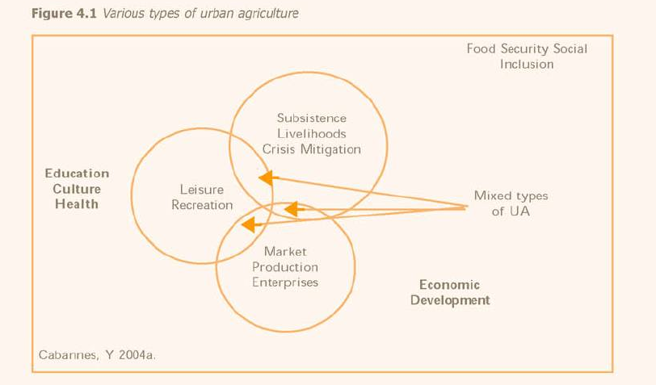
Preston City in Lancashire County, the Northwest of England, will be the subject area for this project, but examples from further afield will also be referred to in the Literature review (see chapter 2, pp.5).

1.1.2 Aims and Objectives
The main aim of this project is to assess whether it is feasible for urban agriculture to be practised on a wide scale in Preston City, and to investigate some of the measures already being undertaken in Preston which relate closely with urban agriculture. The project also aims to determine whether the current economic climate has impacted on urban agriculture.
The project focuses on allotment owners in Preston. It is this group that will be investigated regarding the current state of urban agriculture. Using questionnaires and interview techniques, information about what they grow, practise and the impacts of the current economic climate on their agricultural practices will be assessed (See methodology - chapter 3, pp.28 and Results and Discussion – chapter 4, pp.32), taking into account supporting literature.
The project will also consider how urban agriculture can be implemented in urban societies and what benefits it may bring to communities, socially, economically and environmentally.

Chapter 2: Literature Review
2.1.1 Literature Review Introduction
This study into urban agriculture will touch upon many topics, related to the environment, economy and society. Firstly reference will be made to the broader, more global issues related to the study, and then a more localised view will be taken in terms of urban agriculture and the City of Preston in general.
2.2.1 Urban agriculture and the environment
2.2.2 Climate change
Man-induced climate change, the accelerated warming of the planet due to increased CO₂ emissions and environmental damage, has been directly linked to the resulting consequences of separating cities from their food sources (Gorgolewski et al. 2011). McGregor et al. (2012. pp.41) state that:
“Climate change has a direct impact on the environment and all living things on the planet. Severe economic and social impacts quickly follow the environmental impacts”.
McGregor et al. (2012) continue to suggest that climate change in urban areas around the world is set to result in more extreme weather events, such as heat waves and extreme rainfall periods, resulting in the creation of many micro-climates and urban heat islands. Consequently, with this, “unstable climate comes an unstable food supply” (Nordahl, 2009, pp.xiii). According to Gorgolewski et al. (2011) and Despommier (2009) the world population today of 7 billion will potentially increase to 9 billion by 2050. With the consequential rise in demand for resources that will result from this, it will therefore mean:
“modifying what we eat, how we produce it, and where it comes from…[will be]….a necessity to combat climate change” (Gorgolewski et al. 2011, pp.13).
According to McGregor et al. (2012, pp.46), dealing with climate change will require:
“Sustainable thinking applied to policy, planning, and design....in a balanced way”.
While there are many other alternatives to combating climate change, such as harnessing renewable energy, these technologies are expensive, and McGregor et al. (2012) suggest that instead societies should focus on improving efficiency by reducing the population’s dependency on systems which contribute heavily to climate change. Reducing the need for these systems is the first step towards a zero-carbon design. Urban agriculture can be used as a method for reducing the need. Urban agriculture could help, “meet our international obligations on reducing CO₂ emissions and moving towards sustainable development” (Edwards, 1998, pp.xiii), subsequently reducing, “a city’s ecological footprint even as the city continues to grow” (Nelson, 1996 cited in Mougeot, 2006, pp.7). The sequestration of carbon emissions goes hand in hand with urban agriculture, which as a bi-product according to Patel et al. (2010) could provide us with more time to prepare to adapt to the inevitable climate change.

2.2.3 Agriculture
As pointed out by Mougeot (2006, pp.25):
“When you first hear it, the term “urban agriculture” sounds like a contradiction.”
This is mainly due to, according to Gorgolewski (2011), modern agriculture currently being a globalised system, disconnected from local urban policy and design. Conventional agriculture is associated with rural countryside and heavy industrial processes which generate noise, waste and unpleasant odours, traits which many urban dwellers may find unfavourable (Mendes et al. 2008).
At present, the production and supply of food accounts for 20-30 % of greenhouse gas emissions in the UK, with crops such as green beans being imported from as far as Kenya for example (Kulak et al. 2013), a crop which could grow perfectly well here in the UK given the right conditions. As a result of these increased food miles (See Chapter 2.3.2, pp.15), this current global agri-food network is highly unsustainable according to Bell and Cerulli (2012).
The UK’s reliance on imports for its food supply is inextricably linked to oil, and as petroleum prices increase so will the price of food (Nordahl, 2009). According to Despommier (2009), the increasing price of oil has roughly doubled the cost of eating in most places globally between 2005 and 2008. Food imported from foreign countries also requires extra inputs to preserve the produce. Mass-production and high demand results in a system of global agriculture which favours cultivated varieties that pack tighter and bruise less, consequently sacrificing the flavour and suppleness local fresh produce brings (Nordahl, 2009).
This centralised and concentrated agricultural system leaves little room for the involvement of the consumer in the process of production, often further exacerbated by historical trends that have defined food as a rural issue (Travaline and Hunold, 2010; Rojas-Valencia et al. 2011). The need for agriculture to return to the densely populated urban areas is pivotal to the improvement and sustainability of the environment at large. The reduction in the amount of land available particularly in countries such as England is becoming an increasing problem with an ever growing total population.
2.2.4 Land-use
Land, as put by Veenhuizen (2006, pp.13), “is a very important resource for urban agriculture, and its availability, accessibility and suitability are of particular concern for urban farmers”. It is a resource that is fixed in supply, and so is becoming increasingly valuable (Azadi et al. 2012) as the global population expands. The majority of contemporary developed and developing world cities and towns are designed in such a way that they have resulted in humanity divorcing themselves from nature, becoming, “biologically sterile” (Gordon, 1990, pp.3), places to live. With time, growing urban areas, “expand outward, often overwhelming the natural environment, destroying ecosystems, and drawing resources from well beyond their defined limits” (Mougeot, 2006, pp.7), contributing drastically to climate change (See Chapter 2.2.2, pp.4). In answer to this, urban agriculture will provide a, “green eco-infrastructure [which] parallels the grey urban infrastructure of roads, drainage and utilities” (Yeang and Spector, 2009, pp.9).
However, according to Gordon (1990, pp.61) the answer to this urban problem is not to, “deurbanise our future civilization”, but to promote the urban areas to be, “integrated to the distribution of productive activities”. Gordon (1990, pp.82) goes on to suggest that, “the city can become a place where new natural diversity augments or even creates healthy social vibrancy”. However, Hess and Trexler (2012) argue that agriculture is inherently conflicting with nature, as it uses many of its resources and contributes waste. This is true to an extent, but in terms of the potential damage to nature agriculture could do if it was to carry on as it is today could result in a far worse scenario, as it is highly unsustainable as mentioned earlier by Bell and Cerulli (2012) in Chapter 2.2.3 (pp.6). However, there are many instances where urban agriculture can benefit nature if implemented and managed properly. Hess and Trexler (2012) later accept this view, citing from other authors who reject this idea of conflict, stating:
“Agriculture can also be harmonious with natural systems and even act as a technology to improve environmental quality” (Hrubovcak, Vasavada, & Aldy, 1999; Robertson & Swinton, 2005 cited in Hess and Trexler, 2012)

In fact, it is the urban areas themselves, not the agriculture, which is more problematic. Morgan (2005) states that completely urbanised areas produce increased runoff from impervious surfaces which, for example, eventually results in accelerated levels of bank erosion in rivers downstream of the urban area. “Contamination of soils and products with heavy metals due to traffic emissions and industrial effluents” (Veenhuizen, 2006, pp.4), is also a recurring problem (See Chapter 2.2.6, pp.10 for more information on pollution).
The greening of the cities could provide, “root systems...[which]...absorb and retain water....thereby adding to the capacity of municipal sewage systems to deal with storm water surges” (Gordon, 1990, pp.192). Wastewater, once treated properly, can also be used, “for various activities such as horticulture, fodder production for dairy activities, agroforestry, orchard keeping, floriculture, aquaculture and cereal production” (Veeinhuizen, 2006, pp.247) (See Chapter 2.2.5, pp.9 for more on waste management).
According to Mougeot (2006, pp.7), even if it is on the smallest of scales:
“By cultivating every available piece of open space — even rooftops — urban farmers contribute to the greening of the city” (Mougeot, 2006, pp.7)
Depending on the levels and type of urban agriculture in place on a building, the subsequent greening of the structure could also, “reduce the heating and cooling needs of adjacent buildings and extend growing seasons through the creation of microclimates” (Gordon, 1990, pp.191).
Urban agriculture in public areas can also improve the recreational use and aesthetic appearance of abandoned brown-field sites through urban greening (Gordon, 1990; Mendes et al. 2008), providing a host of social, economic and environmental benefits to areas previously associated with criminality, poverty and pollution (Bell and Cerulli, 2012; Broadway, 2009).
However, utilising previously urban and industrial land for agriculture comes with inherent risks. As Mougeot (2006, pp.9) states:
“There are health risks…..for urban farmers who grow crops on contaminated lands, as well as for those who consume the produce from those lands.”
These issues are discussed later in Chapter 2.2.6 (pp.10).
There is also the issue of conflicting stakeholder interests as mentioned by McClintock et al. (2013). Some members of society may wish to see urban agriculture as a temporary phase, as the land utilised could provide more economic options in the future, such as housing for example. For urban agriculture to become a permanent fixture, it will require solid support from authorities and supporting interest groups to create a sustainable outcome. However, there are alternatives, such as multi-purpose land uses, as discussed in Chapter 2.4.3 (pp.21).

2.2.5 Waste management
As described by Veenhuizen (2006, pp.210):
“Urban waste could be solid or liquid, organic or inorganic, recyclable or non-recyclable. A considerable quantity of urban waste is biodegradable and hence of immediate interest in recycling”
Mougeot (2006, pp.35) adds with:
“A city is a huge nutrient sink, continually absorbing food to feed the ever-growing urban population…..The sink could be made more effective if it recycled more of what it discharges”
What is clear here is that urban agriculture’s inherent local self-reliance ethic, if utilised correctly, could solve many of the waste disposal problems that many large cities and towns encounter. With less available room for the physical disposal of waste, and the urge to mitigate the impact on the natural environment, urban agriculture can turn, “urban wastes into a productive resource through compost production, vermiculture, and irrigation with wastewater” (Veenhuizen, 2006, pp.4). The subsequent production of organic mulches that results from, “a process of microbial degradation [which] releases the useful nutrients in organic waste for soil improvement and plant growth” (Veenhuizen, 2006, pp.212), can provide a free and environmentally friendly form of fertiliser. According to Mougeot (2006) the re-use of wastewater can also reduce the demand and pressure on freshwater sources. However, as Rojas-Valencia et al. (2011) point out, some untreated wastewater, particularly those from industrial practices, can potentially pollute soils (See Chapter 2.2.6, pp.10). However, once treated most wastewater in the UK is safe enough to use for irrigation, particularly when managed and applied properly.
This decentralised form of waste management and fertiliser production urban agriculture brings, “is all about getting the nutrients and organic matter in a waste back into the soil in the most efficient and effective manner” (Veenhuizen, 2006, pp.213). As a result, urban agriculture could also result in, “discouraging practices such as unregulated dumping of garbage, and building on unsuitable land” (Mougeot, 2006, pp.35), through increased environmental awareness (Kulak et al., 2013).
2.2.6 Pollution
The presence of urban agriculture could provide a natural green filter for the atmosphere and hydrology, particularly where vehicle and industrial emissions cause the deterioration of the urban environment. Visual and noise pollution can also be ameliorated, and urban agriculture could also potentially reduce the risks posed by flooding and other hazards (Van der Meulen, 2011), a factor which negates some of the problems posed by climate change (See Chapter 2.2.2, pp.5). Polluted land deemed unsuitable for growing food upon could also be remedied through urban agriculture. For example, in Cuba and Argentina, this problem was overcome using raised beds filled with compost, or in Africa and Latin America floriculture (the growing of flowers) replaces agriculture as a means of increasing the productivity (Mougeot, 2006), allowing the population to utilise land that would originally have been worthless. However, the likelihood of pollution affecting urban agriculture produce is very low, and according to a study by Nabulo et al. (2012):
“Washing leafy vegetables reduced chromium and lead concentrations but exogenous contamination of leaves also depended on vegetable type”
Therefore, in known polluted areas, should urban agriculture be practiced it is recommended that precautions still be taken adhering to findings such as these.
2.2.7 Biodiversity and Wildlife
As highlighted by Veenhuizen, 2006, pp.280):
“Biodiversity is a key natural resource that supports agriculture”.
The greening of a normally biologically hostile concrete urban area, “enables the area to flourish as a natural habitat for a wide range of wildlife, delivering benefits to humans and the natural world alike” (Yeang and Spector, 2009, pp.9). At present, as Gordon (1990, pp.192) states, “current landscaping practices tend to create a sterile “green desert and lollipop tree” environment which attracts few species”. The introduction of urban agriculture can be combined with the planting of wildflowers or providing wildlife refuges (for example beehives), which can create functioning gardens that are also visually impressive (Gordon, 1990). Urban agriculture is best implemented through, “practices that enhance species resilience and symbiosis, for example through biological pest control” (Veenhuizen, 2006, pp.280). According to the National Food Alliance (1996, pp.5):
“Biodiversity should be enhanced at local level by, for example, organising ‘seed and plant swapping fairs’ for gardeners, by reducing chemical use on local authority owned land and creating green corridors”
Evidence of ‘seed and plant swapping’ are evident in the Results and Discussion chapter (Chapter 4.1.8, pp.35) in this case.
Even on the smallest parcels of land urban agriculture can make a difference, particularly when designed so wildlife specifically can benefit. This can include creating ponds, providing leftover food or even habitats for wildlife to shelter in. Another benefit can be to set aside land on the borders to create wildlife corridors, which can not only create habitats but promote existing ones as well, enhancing the natural functions of what is already there as pointed out by Yeang and Spector (2009). Growing varieties of plants is another method of benefitting the environment while practising urban agriculture. Growing edibles and ornamentals, or practising ‘Companion planting’, not only provides natural ecosystem functions which will reduce maintenance of the crops but also provides visual amenities too (Nordahl, 2009).
A case study example of urban agriculture co-existing with wildlife is the ‘Ecology Park’ project mentioned by Gordon (1990). Here, a pond was introduced alongside cultivations which provided a habitat for insects and amphibians and which in turn provided a natural biological control of pests that threatened the cultivated crops. Evidence of similar approaches such as this are evident in the Results and Discussion chapter (Chapter 4.1.12, pp.38).
As Gordon (1990, pp.15) conclusively states:
“Putting urbanism and nature together provides us with an opportunity to create cities that are healthy, civilizing, and enriching places in which to live”.
In contemporary urbanised settlements, “People need nature in the city.....but many are divorced from the cycles of nature and have had few opportunities to enjoy wildlife” (Jackyln Johnson, n.d cited in Gordon, 1990, pp.177). In response to this, urban agriculture, “is seen as a way to maintain or restore the relationship between urban citizens and nature, raise awareness on environmental issues and allow children to experience food production cycles” (Veenhuizen, 2006, pp.90), all while still maintaining an urbanised setting. By growing more in urban areas, less pressure is placed upon the rural areas, allowing for more land to be given over or reverted back to its original ecological functions (Patel et al. 2010).
2.2.8 Organic methods of growing
While not essential to this study, it is most preferred if agricultural practices were to follow an organic principle, as urban agriculture emphasises organic production (Broadway, 2009). This involves the growing of crops with as little aid from artificial fertilisers and chemicals as possible with little disruption to local ecology. Non-organic methods of farming have proven to contaminate water supplies if high inputs of chemicals and fertilisers are used (Veenhuizen, 2006), which is detrimental to both humans and wildlife. Non-organic principles could potentially contribute to 'Colony Collapse Disorder' among bee populations, species which are vital to pollinating plants and therefore keystone species in the agricultural system. According to Nordahl (2009), organic principles are currently the best method of tackling 'Colony Collapse Disorder', as its main cause it still not known, although theories suggest that the use of pesticides and chemicals is the problem (BBC, 2013).
The first step in moving towards a more organic system of urban agriculture would be education. According to Gordon (1990, pp.163), “it has been shown in several studies that with public education, pesticide use goes down”. See Chapter 2.4.3 (pp.21) for more on how to integrate urban agriculture.

2.2.9 Livestock
While not necessarily a vital part of urban agriculture, the keeping of livestock can provide a useful support function for the practice. As well as produce such as eggs, milk, or even meat, according to Mougeot (2006) many urban farmers mainly utilize livestock to provide fertiliser for their crops, as buying fertiliser can be expensive, particularly when it is needed in large quantities for land under intensive production. According to Pollock et al (2011) the benefits of livestock include allowing citizens to develop human-animal bonds, which could reduce stress and benefit socially to those who may be left feeling isolated in the urban environment. It also allows for the recycling of household waste through food for the animals, a potential decrease in garden weeds and other pests, all while reducing the carbon footprint of the owner.
However, as Mougeot (2006, pp.9) points out:
“Keeping livestock in the city raises the possibility of zoonotic diseases — diseases that can be transmitted from animals and birds to humans (such as avian flu). In the densely populated urban environment, such diseases could spread rapidly and be extremely difficult to control.”
To address this issue, according to Broadway (2009), authorities will have modify or create new ordinances that deal with enforcing rules such as those which hold urban farmers to account for their livestock. These could include their rearing practices, waste management, and noise and odour problems which may arise. Pollock et al (2011) even suggest that the increased reliance on local livestock could ironically reduce the risk of infectious diseases, as livestock products imported from further afield could be tainted with chemicals and drugs. Pollock et al (2011) also state that the risk of disease from such livestock as chickens is very low, no more than that of keeping a dog or a cat. Any prohibitive by-laws should be therefore be reviewed to incorporate a more modern and sensible approach to livestock keeping.

2.3.1 Urban agriculture and the economy
2.3.2 Global and National economy
One of the main benefits from urban agriculture is the reduction in food miles and the increased food security of independent countries. As put by Nordahl (2009, pp.6):
“food miles....[the]...increasing distance to market..... is of great concern in the face of a shrinking oil supply and its ever-rising cost…..[due to]……the fuel used to power tractors and combine harvesters, to the petroleum-based herbicides and pesticides liberally sprayed on the fields, and back to the fuel used to power the diesel trucks that deliver the produce hundreds, if not thousands, of miles to our urban markets”.
McGregor et al. (2012, pp.83) state that, “in a resource-constrained global economy, low carbon communities have a competitive advantage”. This is most certainly not the case for cities in MEDCs, particularly Preston. However, McGregor et al. (2012, pp.83) continue to suggest that, “the greatest opportunity for change is actually in [these] high-carbon-emission communities”. With more than 50% of the global population living in urban areas, and potentially 70% by 2050 (UNESA, 2007 cited in Kulak et al. 2013), urgent reforms are needed within a growing resource dependant population.
Among other problems globally, Veenhuizen (2006, pp.7) highlights that:
“City authorities around the world face enormous challenges in creating sufficient employment, in providing basic services such as drinking water, sanitation, basic health services and education, in planning and maintaining of green spaces, in managing urban wastes and waste water and in decentralisation and creation of efficient local autonomy”.
Urban agriculture in context seeks to ameliorate these problems to avoid a critical situation in the future. Kadenyeka and Jerotich (2012) support this, stipulating that urban agriculture can be an integral component of efforts to curb unemployment and poverty. For more on unemployment and poverty alleviation see Chapter 2.4.3 (pp.21).

2.3.3 Local economy
With urban agriculture comes a more localised approach to the sourcing of food. As put by Pollock et al (2011, pp.735):
“Control over local food systems has been promoted as a key means to creating vibrant and sustainable communities”
With more urban land being utilised for growth, according to Gordon (1990, pp.88), “it is still possible to have a sense of being in a small green town while still profiting from the economy and culture of a world city”. The greening of an urban area in terms of business improves, “economic welfare in the sense of creating buildings which are attractive and healthy to use, thereby increasing productivity and keeping company costs down”(Edwards, 1998, pp.xiii). Urban agriculture on both developed and disused land, “helps to achieve optimum land utilisation” (Veenhuizen, 2006, pp.244).
The subsequent greening of properties which can coincide with urban agriculture could also provide benefits in the form of increasing the actual economic value of the area. As put by Veenhuizen (2006, pp.154), “a home with a green roof, a dooryard garden and orchids growing in the kitchen has increased value”, aesthetically and economically, which in turn increases the desirability of the property. Kadenyeka and Jerotich (2012) suggest that with the role of urban farmers comes a sense of responsibility, that which originally the local authority held. Unused public spaces utilised for agriculture by the general public could save the authorities capital as they need no longer maintain them. In the context of this project, Preston City Council (See Chapter 2.4.3, pp.21), can no longer to afford such maintenance of some public areas, therefore this concept of public responsibility would be ideal.
2.3.4 The economic downturn since 2008
One important focus of this research is the potential effects the economic downturn since 2008 may have had on the attitude to urban agriculture. The Northwest of England has been particularly badly affected by the economic crisis, resulting in high levels of unemployment which has had adverse social impacts. However, it is not just the Northwest that is affected, as Nordahl (2009, pp.xii) highlights, “it quickly became apparent that people across the country, even the middle class, could soon be joining the ranks of our nation’s most deprived”. Therefore, as a remediation of this problem, urban agriculture is here suggested as a method of mitigating and repairing the impacts of this recession and any future economic or food-related catastrophes. See Chapter 2.5.1 (pp.25) for details of how Preston City has been affected by the economic downturn generally, and Chapter 4.1.9 (pp.37) for the results from the survey of allotment owners.
2.3.5 Sustainable food systems
“The sustainability of urban agriculture is strongly related to its contributions to the development of a sustainable city: an inclusive, food-secure, productive and environmentally-healthy city” (Veenhuizen, 2006, pp.17).
Sustainable food systems are, “associated with high levels of wellbeing, social justice, stewardship and system resilience” (NHS, 2012, pp.4). Urban agriculture provides a tool of which can be used to create sustainable systems within communities. Also, if implemented correctly, urban agriculture could contribute extensively to an NPCC (Net-Positive-Climate Community) (McGregor et al. 2012). As Gorgolewski et al. (2011, pp.13) state, “by reducing the distance between producer and consumer, urban agriculture can lessen energy use”, therefore reducing pollution and waste while at the same time making better use of existing resources (Broadway, 2009). Urban agriculture is also useful in supplying perishable products such as vegetables, fresh milk and poultry products close to the consumer without the need for travelling long distances (Veenhuizen, 2006).
Overall, as Mougeot (2006, pp.6) points out:
“It is unrealistic to expect cities can ever become self-sufficient in food….But there is no question that urban agriculture already makes a significant contribution to food security in many major cities.”
If the people of Preston were to place less reliance on certain imported food products, they could reduce their carbon footprint dramatically. For example it has been suggested that in the United Kingdom, “carbon dioxide emissions could be reduced by about 22 percent if food were produced organically, consumed locally, and grown only to be eaten in season” (Ibid, n.d, cited in Gorgoleswki et al.2011, pp.13). In terms of individual citizens, it provides them with a sense of local self reliance whilst at the same time improves their efficiency. “Efficiency reduces waste, which means reducing pollution” (Gordon, 1990, pp.32). See Chapter 2.2.6 (pp.10) for more on pollution. However, Gordon (1990, pp.33) later states that the, “primary benefits of local self-reliance is not economic it is psychological and social”. See chapter 2.4.2 (pp.20) for psychological and social benefits.

2.3.6 Food security
Food security, is defined by Nordahl (2009, pp.5) as the, “daily access to an adequate supply of nutritious, affordable, and safe food”, to which Mougeot (World Bank, 1986 cited in Mougeot, 2006, pp.46) adds, “by all people at all times……for an active healthy life”.
Veenhuizen (2006,pp.7) suggests that:
“Growing urban poverty goes hand in hand with growing food insecurity and malnutrition in the urban areas”.
The self-reliance benefits of urban agriculture could mean wonders for countries economically, environmentally, socially and even politically. Urban agriculture, “reduces the dependency on distant food supply chains that can be disrupted for any number of reasons” (Gorgolewski, 2011, pp.13). This is particularly relevant, especially in contemporary terms, where, “an era of uncertainty and change” (Gorgoleswki, 2011, pp.14) predominates much of the world due to, “climate change that is producing drought…...at the same time as flooding….is reducing crop yields”, among other problems such as crop disease and civil unrest globally, “which in turn drives up prices” (Nordahl, 2009, pp.5). See Chapter 2.2.2 (pp.5) for more on climate change and Chapter 2.2.3 (pp.6) for more on the Agricultural system. Urban agriculture mitigates these issues by creating, as put by the National Food Alliance (1996, pp.3), “an alternative economy”.
Another topic under food security is the issue of obesity. As Nordahl (2009, pp.6) points out, in contemporary societies, “the farmer is no match for the deep-pocket marketing campaigns of our fast-food chains and processed-food conglomerates, especially during tough economic times”. This is precisely the problem throughout England, particularly Preston in this case. Societies, particularly the economically depressed, where poor people spend around 60-80% of their income on food (Mougeot, 2005 cited in Veenhuizen, 2006) are stranded in so called ‘Food Deserts’ where the only available options for food are these cheaper fast-food chains and deals promoted by supermarkets, which offer little nutrition (LaCroix and Catherine, 2010). Urban agriculture could provide a nutritious and more rewarding alternative.

2.4.1 Urban agriculture and society
2.4.2 Social benefits
Urban agriculture and the general greening of urban areas has been shown to benefit people, “in four different ways: emotionally, intellectually, socially, and physically” (Mostyn, 1979 cited in Gordon, 1990, pp.236). The reintroduction of nature to urban areas has proven to give people, “a sense of identity with place and community from their (passive or active) involvement in urban nature areas” (Gordon, 1990, pp.236). It has also been shown to support, “active citizenship, combating age, gender and ethnic discrimination, preventing crime and rehabilitating offenders” (National Food Alliance, 1996, pp.3), contributing to social capital and civic engagement (Mendes et al. 2008).
As a result of the greening of an urban area due to urban agriculture, according to Edwards (1998, pp.5), “people feel ‘better’ in green buildings. They are not only healthier, but they claim an enhanced sense of wellbeing”. The individuals who will be involved in urban agriculture can experience a heightened, “sense of connection to the natural environment” (Gordon, 1990, pp.193), contributing to feelings of higher self-esteem, pride and safety among urban citizens (Veenhuizen, 2006; Broadway, 2009). The agricultural aspect provides more availability of fresh, nutritious foods coupled with increased opportunities for income which means improved overall health, physically and psychologically, and presents, as Mougeot (2006,pp.8) suggests, “perhaps the opportunity to break out of the cycle of poverty”. One report suggests that community gardeners in North America have, as a result of urban farming, witnessed higher consumption rates of fresh vegetables than those who do not practice (Blair et al. 1991 cited in Broadway, 2009), possibly indicating that the mere presence of urban agriculture encourages healthier lifestyles.
Urban agriculture in public spaces can also provide areas for people without personal green space, especially the physically disabled, the aged, and high and medium density apartment dwellers, places to engage in gardening (Gordon, 1990; Bell and Cerulli, 2012).

2.4.3 Integrating agriculture into urban areas
McGregor et al. (2012, pp.50) suggest that, “it is better to demonstrate the short-term benefits or value”, of the project at first instead of, “something painful to be endured for future benefit”. The authors continue to suggest that the main aim should be to create and promote, “a near-term strategy to increase local economy and reduce the reliance on out-of-region energy supplies”. Of course implementing this idea of urban agriculture will require great effort and adequate funding particularly in an urbanised area not designed for such activities. As put by Bell and Cerulli (2012, pp.35):
“Transitions to sustainable development require change at multiple social, economic and spatial scales”
The areas of the city which could be utilised include the, “vast suburban or exurban spaces in addition to unused rooftops and parcels of waste land” (Gorgolewski, 2011, pp.11). As put by Veenhuizen (2006, pp.41):
“Urban agriculture can be promoted in industrialised countries by regarding it as one element of a land-use combination that offers other valuable functions to society”
This is supported by the work of McClintock et al. (2013), who add that urban agriculture should not be the main dominant land use, but one of multiple uses, particularly in an open public space.
One such example of urban agriculture in a space limited area is that in Vancouver, Canada. Vancouver, according to Veenhuizen (2006, pp.48), “is a city of soaring glass towers and modern urban amenities…[but]… it is also located within one of the most productive agricultural regions in Canada”. Therefore to address the, “range of urban challenges”, which may threaten agriculture in this area, urban agriculture is incorporated into urban policy and strategies so as to best meet the demands of all the stakeholders. Research carried out by Mendes et al. (2008) in Vancouver showed that initially urban agriculture was greeted as a rural issue rather than an urban one by city planners, who knew little of food issues. However, despite these shortcomings, urban agriculture has still proven to be effective in Vancouver at improving social economic and environmental capital overall.
Educating the population that will use and/or be affected by the urban agriculture scheme on how to use it is one of the main steps in achieving the integration of urban agriculture into communities. The current ideology for the majority of people is, “that food production…[is]…no longer suitable in and around our cities….[and is]… better suited to corporate-owned, factory-like “agribusiness” in more distant parts of the country” (Nordahl, 2009, pp.3). Also, see Chapter 2.2.3 (pp.6) for more on agriculture. The main obstacles in educating the public are changing the perceived images of cities as separate from agriculture, and also the, “global generational amnesia....about how to grow food” (Colding and Barthel, 2012; Pyle 1978 cited in Barthal and Isendahl, 2013). One of the most effective methods would be to begin to educate the younger population first, by developing agricultural literacy in elementary education (Hess and Trexler, 2012), in order to regain the agrarian knowledge that can allow urban agriculture to be feasible and successful (Nordahl, 2009).
According to Gordon (1990, pp.6), “success will not be achieved without the support of local people”. This view is supported by Veenhuizen (2006) who adds that this support is the most important aspect of strategic urban planning, and without it urban agriculture would not be accepted or sustainable.
Official planning and recognition of the project by municipalities provides the population with confidence to be a part of the scheme as stakeholders, as it suggests a strong sense of predictability Mougeot (2006). As well as the authorities commitment and support, Veenhuizen (2006,pp.13) suggests that:
“Governmental organisations and the private sector should be stimulated to provide training, technical advice and extension services to urban farmers, with a strong emphasis on ecological farming practices, proper management of health risks, farm development (eg. intensification and diversification), enterprise management and marketing”.
This would, in turn, support organic methods of growing (see Chapter 2.2.8, pp.13), sustainability (see Chapter 2.3.5, pp.17), and wildlife and biodiversity (see Chapter 2.2.7, pp.11) concepts.
In the United States, a company called Farmscape, “the largest urban farming venture in Los Angeles… started in 2009 helping residents, schools, and businesses set up vegetable gardens and home orchards”. Their main purpose is to, “design, install, and maintain urban farms” (Farmscape, 2012), for those who wish to practice urban agriculture but cannot due to restrictions such as time or disabilities. For a price dependent on the situation, the company offers this and also allows participants to be taught by experienced urban farmers so that one day they may be able to practice themselves. Not only has this been successful, but similar companies have joined in on this new industry venture, meaning that urban agriculture has proven to be very desirable in this case. The same idea could perhaps gain momentum here in the UK, particularly when financial gains are on offer.
2.4.4 Allotments/community gardens
The closest practice to urban agriculture in Preston and the majority of the UK today is that of owning and managing an allotment. According to the National Food Alliance (1996, pp.2):
“The allotment has been an urban institution for centuries in the UK while the ‘Dig for Victory’ campaign was crucial to the country’s survival during World War II”
While not as prevalent as they once were, today there is an increasing demand for them, as the Preston City Council (2011) website states that, “there is an approximate waiting time of four / five years for an allotment plot in Preston”, a considerable barrier to potential urban farmers. However, the Council has begun to halve allotment plots in order to satisfy demand. Community and allotment gardens such as these:
“are contemporary examples of urban“memory workers,” which serve as living protocols for transmitting information about local climate, soils, and moisture regimes as well as about fluctuating populations of organisms, and which tend to emotionally connect people with local ecosystems” (Andersson et al., 2007, Bendt et al., in press and Tidball et al., 2010 cited in Barthal and Isendahl, 2013).”
Despite the fact that allotments and community gardens contribute to the urban agriculture idea, their impact on food production is still somewhat limited. However, this still highlights the latent capacity for food production in urban areas (Bell and Cerulli, 2012).

2.5.1 Preston City
This extract from a report on Preston by the NHS (2012, pp.5) best describes the state of Preston at present:
“The city is one of the most severely affected areas of the North West[by the recession] outside Liverpool and Manchester, with 21% of children in the city living in households which are completely workless and a further 29% in families struggling to get by with working tax credits. In some areas of Preston, more than 75% of children live below the poverty line. The two worst affected areas of the city are the Deepdale and St George's wards, where 75% and 77% of children respectively are said to be living in poverty.”

In Preston there are already, or have been, a number of urban agricultural schemes already in place. PliP (Preston landscapes in Production) is one such scheme (now defunct) which has aimed to bring about more urban agriculture in the City. The scheme primarily came about due to, “the correlation between the quality of food we eat and our personal well being”( NHS, 2012, pp.4), a correlation which tends to reflect badly in poorer communities, such as those in Preston, where, “people living on low incomes eat significantly less fruit and vegetables than people on higher incomes...[which]... is attributed to both individual factors (e.g. lack of cooking skills and knowledge.....and to environmental factors... e.g. lack of money; lack of availability of fresh foods locally; poor transport; and physical barriers to making everyday journeys to shops)” (NHS, 2012, pp.5).
The idea of greening spaces through a variety of methods has already been discussed by Preston City Council among key landholders in the area such as the social landlord Places for People. They have suggested that, “the area surrounding property was as important as the property itself”, and that the best way to integrate greening projects was to hold, “design consultations and design discussions with residents”, which would then be followed up by, “individual maintenance/management plans based upon the area, the land, the support needed, and the overall aims of the project” (Preston city council, 2012, pp.8).
The main aim of this project is theoretically exactly the same as PliP and other schemes like it, “to increase fruit and vegetable access to low income families, to break the generational cycles of health inequalities and child poverty” (NHS, 2012, pp.5). As put by Kadenyenka and Jerotich (2012, pp.728), urban agriculture, “should be recognized and developed since it is a livelihood whose benefits can enhance the lives of the poor in society”. Nordahl (2009, pp.4) concludes that, “improving the health of the.....population, especially our children, who increasingly lack everyday accessibility to fresh produce...[can provide]....a sense of self-sufficiency to even the well-to-do.....recognizing the social relationships and prosperous citizenry that could result if city spaces could help provide food for all”. In places such as Preston, there are many disused areas of space which could potentially be utilised by the public for planting and other agricultural practices as the authorities can no longer do so, “due to resourcing issues” (Preston City Council, 2012, pp.9).

2.5.2 The feasibility of urban agriculture in Preston
Preston city is not too dense a city; it still has the characteristics of a large town. This means that there is more open, disused space here than in a more developed city such as Manchester.
However, according to the NHS (2012, pp.7) ownership issues to the majority of this land mean that:
“access.....is a major barrier...[to urban agriculture]... across Preston.... Most of the land is either owned by Preston City Council, Lancashire County Council or social landlords like Gateway Association, Eaves Brook housing, Contour / Avenquest Housing and Places for People”.
At present, licenses are required if one is to grow crops on an allotment level. As suggested by Veenhuizen (2006, pp.13):
“Existing policies and by-laws regarding urban agriculture will have to be reviewed in order to identify and remove unsubstantial legal restrictions and to integrate more adequate measures to effectively stimulate and regulate the development of sustainable urban agriculture”.
Organisations such as the Wildlife Trust are already supporting urban agriculture and other similar projects. However, they alone cannot make such projects a success without the support of the public or municipality. According to Preston City Council (2012, pp.9), “the Wildlife Trust were [only] involved in advising, supporting and taking part in schemes suggested by local people individually or through various groups. The groups were given assistance with making bids for various grants”. The Wildlife Trust only, “actively encouraged Groups to take ownership of planting schemes in order to make the schemes sustainable....in partnership with the local authorities both Preston City Council and Lancashire County Council”. It is the sustainability factor (see chapter 2.3.5, pp.17) which is the key to projects such as urban agriculture making a lasting impact.
According to Preston City Council (2012, pp.10), there are a number of issues to be addressed to projects such as public urban agriculture. There are, “issues in respect of long term developer responsibility for open green space and landscaped areas”, the potential, “anti-social behaviour, crime and vandalism”, the scheme could attract; although this could be reduced should the social benefits be addressed (see chapter 2.4.2, pp.20) and other issues regarding, “resource constraints”, particularly in the contemporary economic climate.

Chapter 3: Methodology
3.1.1 Literature Review of the methodology
In order to find out what the current opinions of allotment owners in Preston were to the current state of urban agriculture in Preston and the effects of the economic downturn since 2008 (see chapter 2.3.4, pp.16), the author concluded that the best way to acquire this information would be to conduct a mixed qualitative and quantitative investigation.
Initially, a face-to-face structured interview with allotment owners would be carried out. Along with an already structured questionnaire which the interviewer would fill in while interviewing, personal observations would also be made, which could provide added dimensions to data collection (Burns, 2000).
The advantages of this qualitative method of research include the more sustained periods of contact with interviewees. As Burns (2000, pp.583) states, “face-to-face interaction assists in the establishment of rapport and a higher level of motivation among respondents”, or as Bryman (1988, pp.96) describes it as, “to be an insider”. It also allows for more time during the interviews to make the as mentioned personal observations.
The author acknowledges that there are pitfalls to this type of research method. As Bryman (1988) suggests, the representativeness or generality of extracts from brief conversations, snippets from unstructured interviews, or examples of a particular activity can be a considerable flaw. This qualitative based structured interview is an essentially exploratory way of conducting social investigations, and not necessarily a true reflection of the current state. Burns (2000) suggests that qualitative research is also restrained by time and financial factors, with interviewees potentially being made to feel pressurised into giving rushed responses, which may be difficult to categorise and evaluate.
The results from the questionnaire based interview will then quantified, using a code based upon the responses given. This will allow the results to be summarised and made clearer.

3.1.2 Implementing the Methodology
The author and supervisor agreed that at least thirty individual allotment owners should be interviewed to gain a balanced variety of results. The questionnaire formulated underwent several changes throughout the period of surveying, as some questions were deemed inappropriate or not clear enough. There was no specific group of interest, only those allotment owners that were present on the site at the time. The questions asked specifically focussed on the general history of the allotment owner and their allotment, whether the recession of 2008 has affected them, and whether they grew elsewhere and supported the environment. These questions were asked to gain an insight into the current state of urban agriculture in Preston from a public perspective via a number of individuals, and then relate these findings to the Aims and Objectives (Chapter 1.1.2, pp.3).
A questionnaire template and all completed questionnaires can be found in the Appendix (pp.53). Note that these are not the original questionnaires, and have been word processed to make them clearer.
Four allotment sites were chosen to conduct the survey. These included the West and East Penwortham allotments and Serpentine allotments 1 and 2, a map of which can be seen in Figure 2.
In order to gain access to these allotments permission was acquired by meeting the Head Park Ranger of Preston City Council who oversees these sites. As well as the completed risk and ethical assessment (see Appendix, pp.I), a key to the sites and formal permission was gained before entering. A lanyard containing UCLan ID was worn visible at all times on the sites.

Figure 2 – (Google maps, 2009) edited by author.
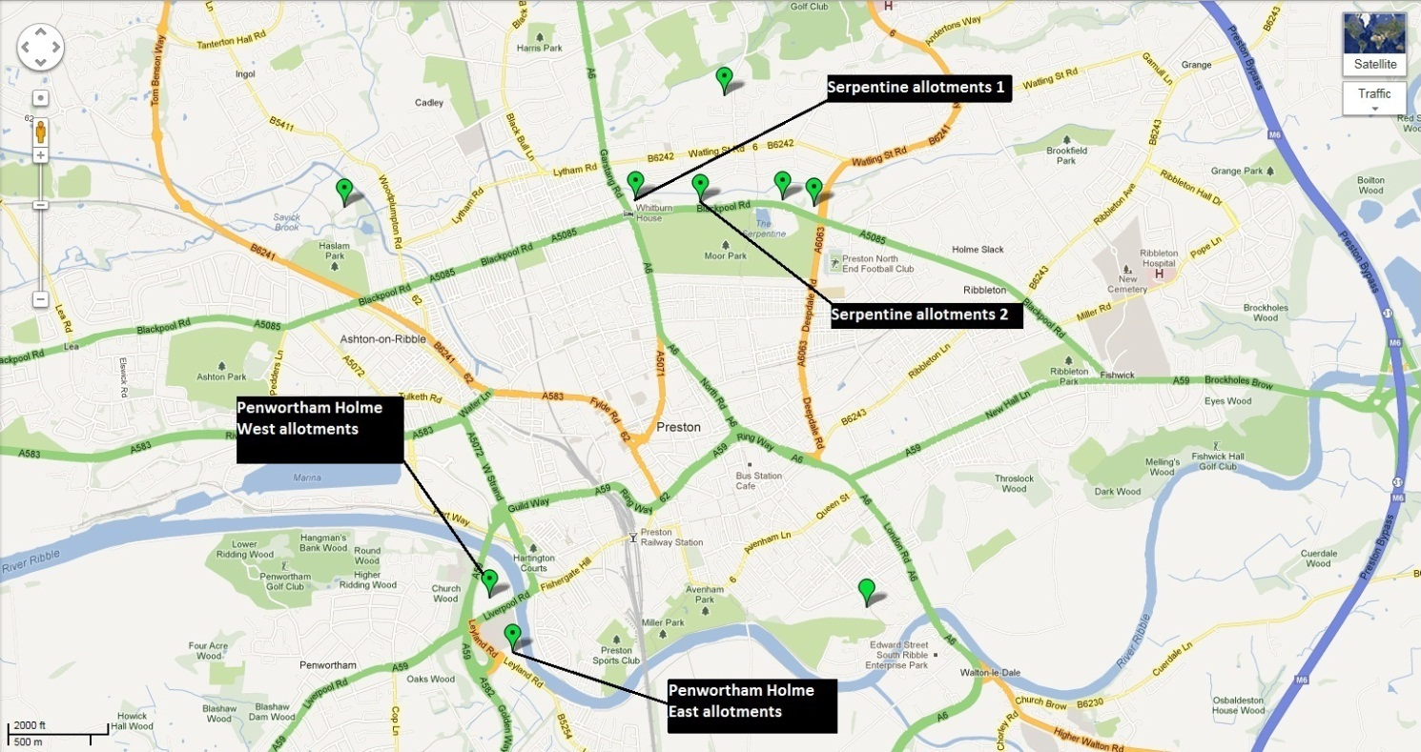

Once the survey had been completed, the results were analysed and coded using themes that appeared throughout the answers. For example, questions 5,7,8 and 9 proved easy to codify into simple ‘Yes/No’ answers. Side notes were also taken, and are mentioned throughout the discussion (Chapter 4, pp.32). Questions such as 6 however proved to be more challenging to codify, but after close analysis a number of different categories were made which illustrated the diverse number of responses clearly, and which were more common than others.
After tallying up the results (See Appendix pp.LV), they were summarised further by creating charts which best illustrated the results clearly. The answers with only two categories of either ‘Yes/No’ displayed better as a pie chart, showing the dichotomy between the results. Other results such as Question 6 proved better displayed as a bar chart showing the number of options and the levels of these clearly.

3.1.3 Outcome of Methodology
In practice, the questions asked underwent some changes, with some being discarded or altered. Some questions did not flow too well, with interviewees sometimes answering multiple questions simultaneously, making it difficult to note down. For the relatively short amount of interviews conducted it made it simple to categorise and quantify the results. The face-to-face approach of the qualitative method did prove to capture the interviewee’s attention, providing a more clear response than had it been simply and questionnaire for them alone to fill in.

Chapter 4: Questionnaire Results and Analysis
4.1.1 Summarised results for Question 1 – ‘How old are you?’
Figure 3 (Authors own)

4.1.2 Question 1 discussion
As shown by Figure 3, it is clear that within the sample the largest proportion of allotment owners are elderly, although there is also a sizeable percentage who are relatively young, between the mid-thirties and fifties age range. This evidence suggests that perhaps there is a growing number of younger people who wish to become more sustainable, or even enjoy the social and environmental aspects of gardening (Yeang and Spector, 2009; Goode, 1990; Veenhuizen, 2006). One interviewee (See Appendix Questionnaire 1, pp.VII) reports that there has been a visible change in the age range over the past few years on allotments, with younger generations buying plots of land. Another allotment owner (see Appendix Questionnaire 12, pp.XXVII) was actively trying to engage their children with the allotment, with the aim of educating them about farming and nutrition, a potentially key component to the establishment of urban agriculture as mentioned by Barthal and Isendahl (2013) and Hess and Trexler (2012).
There are no allotment owners unsurprisingly between the age ranges of 18-25, given the economic climate and high youth poverty mentioned by the NHS (2012) in chapter 2.5.1 (pp.25), perhaps this age group are not be able to afford to rent an allotment. Another reason could be the lack of experience or, “global generational amnesia” (Colding and Barthel, 2012; Pyle 1978 cited in Barthal and Isendahl, 2013) as mentioned in chapter2.4.3 (pp.21). The majority of the younger generation’s lack of experience may be the factor limiting this age range’s involvement somewhat.

4.1.3 Summarised results for Question 2 – ‘How long have you had your allotment?’
Figure 4 (Authors own)

4.1.4 Question 2 discussion
As shown by Figure 4, the largest proportion of people in the sample have only owned their allotment for 0-3 years. This could be due in part to the relatively recent increase in the availability of allotment plots due to the halving of sites as mentioned in chapter 2.4.4 (pp.23). It also suggests that there is a surge in interest in allotment ownership outside of the traditional urban farming community. The majority however still have owned their allotment for over 7 years. One in fact had owned an allotment for over 45 years (See Appendix Questionnaire 18, PP.XXXV). These allotment holders could well be the, “memory workers” (Andersson et al., 2007, Bendt et al., in press and Tidball et al., 2010 cited in Barthal and Isendahl, 2013) mentioned in chapter 2.4.4 (pp.23), who could provide the education needed for the younger generations to gain the agricultural literacy mentioned by Hess and Trexler (2012) in chapter 2.4.3 (pp.21).

4.1.5 Summarised results for Question 3 – ‘Why do you rent your allotment?’
Figure 5 (Authors own)

4.1.6 Question 3 discussion
Although some allotment owners reported that they grew produce to subsidise their income, the largest majority said they owned their allotment purely for enjoyment, as shown by Figure 5. Being in a developed country, this comes as no surprise, where food security is relatively high. This suggests that the current allotment holders still value the social and environmental aspects of urban agriculture in Preston above the economic aspects. In an industrialised country people feel the need to de-stress, re-connect with nature or gain a sense of pride as mentioned by Goode (1990), Veenhuizen (2006) and Broadway (2009) in chapter 2.4.2 (pp.20). The only evidence to show that owning an allotment is a response to the urban poor’s lack of purchasing power as mentioned by Veenhuizen (2006) in chapter 1.1.1 (pp.1), was the interviewee (See Appendix Questionnaire 13, PP.XXVIII) who stated that the allotment was bought as an alternative to going on holiday, which they could no longer afford due to the economic climate since 2008 (Also see chapter 4.1.9, pp.37).

4.1.7 Summarised results for Question 4 – ‘What crop/plant/produce do you grow/produce most at present?
Figure 6 (Authors own)

4.1.8 Question 4 discussion
As mentioned by one interviewee (See Appendix Questionnaire 2, pp.XII), potatoes grow best here in the Preston area. The majority of allotment owners said that they grew these, as shown by Figure 6. However, it is important to grow a variety of crops as most allotment owners do, as monoculture can lead to higher levels of risk from diseases such as potato blight, as mentioned by one interviewee (See Appendix, questionnaire 8, pp.XXI) and bad weather.
The range of produce here grown locally contributes to the sustainable food system (Chapter 2.3.5, pp.17) and Food Security (Chapter 2.3.6, pp.18) mentioned by Nordahl (2009), Veenhuizen (2006), Gorgolewski et al. (2011) and Broadway (2009). The crops produced usually sustain some of the allotment owners all year round (See chapter 4.1.13, pp.40), which if applied on a larger population scale could reduce the carbon footprint of Preston significantly, contributing to the Net-Positive-Climate community mentioned by McGregor et al (2012) in chapter 2.3.5 (pp.17).
Also, one allotment owner mentioned that they partake in regular seed swaps, which as mentioned by the National Food Alliance (1996) benefits biodiversity (see chapter 2.2.7, pp.11). This also potentially educates the other allotment owners about new crop varieties and how to grow them, which would aid combating the ‘global generational amnesia’ mentioned by Barthal and Isendahl (2013) in chapter 2.4.3 (pp.21), particularly among the allotment owners who are relatively new to the practice (See chapters 4.1.1 and 4.1.2, pp.32 and chapters 4.1.3 and 4.1.4, pp.33).
One allotment owner has even diversified to the extent that the allotment is now entirely devoted to the keeping of chickens (See appendix, questionnaire 29, pp.LI). This supply of local eggs contributes to this individual’s food security, as the source of the produce is known and does not have to travel to the supermarket shelf in order to be bought. It also provides the benefits mentioned by Pollock et al (2011) in chapter 2.2.9 (pp.13).

4.1.9 Summarised results for Question 5 – “Has the economic downturn affected what you choose to grow?”
Figure 7 (Authors own)

4.1.10 Question 5 – Discussion
As shown by Figure 7, the majority of respondents gave a clear ‘No’ to this question. While it is only a relatively small sample, the majority who gave this answer also mentioned that they already had strong financial backgrounds. However, one respondent said that they had bought their allotment as a response to the last recession during the 1970’s (See Appendix Questionnaire 19, pp. XXXVII), the last time urban agriculture became popular in the developed world as mentioned by Gorgolewski et al (2011) in chapter 1.1.1 (pp.1). This recession has therefore impacted little upon these people, but others responded differently. One respondent clearly said that they had stopped buying organic seeds as a result of the economic downturn and instead just buy regular seed varieties now (See Appendix Questionnaire 9, pp. XXII), a factor which does not bode well for organic farming practices in economically troubled times, as it could affect the health of vulnerable species such as the bee populations affected by Colony Collapse Disorder, mentioned by the BBC (2013) in chapter 2.2.8 (pp.13).
As previously mentioned, one reported that buying the allotment was an alternative to going on holiday (See Appendix, questionnaire 13, pp. XXVIII), in this case the recession has actually been conducive to urban agriculture in the area. Others who responded ‘Yes’ mainly put the reason down to rising allotment rent rates.
The results do show a pressing concern among many about the impacts the recession may have. But contrary to what Nordahl (2009) claims (See chapter 2.3.4, pp.16), these people are in no situation of poverty anytime soon, in fact they are rather privileged to own an allotment in such a period where demand for them is high (See chapter 2.4.4, pp.23).

4.1.11 Summarised results for Question 6 – “What do you do to support wildlife on your plot?”
Figure 8 (Authors own)

4.1.12 Question 6 – Discussion
As Figure 8 shows, bird tables, bird baths and bird feed were the most common form of wildlife provision on the allotments. The majority of owners also stated that they are considering or are going to plant wildflowers specifically for bees and butterflies. Others had converted waste, such as wood debris into hedgehog habitat, and old bathtubs into ponds. Leftover organic matter from growing crops was a common response too (See figure 8); only most allotment owners said they often had no choice in this matter as wildlife took some of their crops regardless. The benefits of these are mentioned by Yeang and Spector (2009) and Nordahl (2009) in chapter 2.2.7 (pp.11).
The variety of ways of benefitting wildlife here and the apparent willingness to do so suggest that a healthy relationship between urban farmers and wildlife can exist, providing benefits for both sides as mentioned by Yeang and Spector (2009) in chapter 2.2.7 (pp.11). A healthy number of people also claimed to farm organically, or wanted too. This shows that some members of the community are already aware of their environment, and the benefits of farming organically, which are mentioned in chapter 2.2.8 (pp.13).
One allotment owner told of taking part in seed and plant swapping among the other holders (See Appendix, Questionnaire 10, pp.XXIV), which not only increased the variety and knowledge of plants that the allotment owners grew, but potentially benefitted the biodiversity of the areas as the National Food Alliance (1996) mentions in chapter 2.2.7 (pp.11).
Questionnaire 7 (See appendix, pp.XIX) indicates one allotment owner who practices companion planting. This form of growing provides the natural benefits to the environment and the farmer that Nordahl (2009) mentions in chapter 2.2.7 (pp.11).

4.1.13 Summarised results for Question 7 – “Are you able to grow....all....you need?”
Figure 9 (Authors own)

4.1.14 Question 7 – Discussion
The majority of owners said that they could produce enough of certain produce, as shown by Figure 9, to last them all year round, albeit dependent on the weather. Some also said that they froze certain foods to make them last longer. However, some of those who responded ‘No’ pointed out that they could not due to time factors (not able to manage their allotments all year round) and space limitations (an increasing problem particularly now allotment plots are being halved). The Farmscape (2012) venture in the USA was primarily created to deal with issues such as these. They design gardens in constricted spaces so that at least some production can occur on an intensive level. They also garden for those with little time to do so, as mentioned in chapter 2.4.3 (pp.21). Should a similar venture gain momentum in Preston and the UK, these people could potentially see some form of urban agriculture on their property without giving up their time. This would also create employment opportunities, as Kadenyeka and Jerotich (2012) state in chapter 2.3.2 (pp.15), boosting the local economy and the environment at the same time.
While not as financially insecure as some, the majority of these allotment owners have increased their food security substantially, particularly if they do not need to rely on buying certain products, allowing them to gain the benefits mentioned by Gorgoleswki et al. (2011), Nordahl (2009) and the National Food Alliance (1996) in chapter 2.3.6 (pp.18).
This self sufficiency also reduces each of these allotment owner’s individual carbon footprints, sequestrating at least some of the emissions that could have been produced should they have bought their produce from further afield instead, resulting in a localised approach to mitigating climate change as mentioned in chapter 2.2.2 (pp.5) by Mougeot (2006) and Patel et al. (2010). In the same chapter, Gorgolewski et al (2011) mention some of the ways needed to combat climate change. This has been achieved here to an extent, as it has allowed them to modify how the product is produced and where it comes from, increasing food security (chapter 2.3.6, pp.18) and sustainability (chapter 2.3.5, pp.17).
Even if it is only on a small scale, each allotment owner contributes to their overall control over their local food system, adding to the sustainable community Pollock et al. (2011) mentions in chapter 2.3.3 (pp.16), and reducing the dependency on the centralised and concentrated agricultural system mentioned by Travaline and Hunold (2010) and Rojas-Valencia et al. (2011) in chapter 2.2.3 (pp.6).

4.1.15 Summarised results for Question 8 – “Besides your allotment do you also grow...where you live?”
Figure 10 (Authors own)

4.1.17 Question 8 – Discussion
As Figure 10 shows, the majority of allotment owners also grew some produce elsewhere. Some respondents only grew flowering plants in the soil of their gardens, while others grew tomatoes in greenhouses. Some respondents said that they started off some plants at home in containers, and then moved them to the allotments once they had matured.
The respondents who said ‘no’ primarily put it down to lack of space at home, problems in their gardens such as too much shade (See Appendix Questionnaire 1, pp.XI), or even rat infestations (See Appendix Questionnaire 3, pp. XIV). These are just some of the limitations which urban gardeners face, and the allotment allows for people such as these to engage in gardening when there are no other options, as Goode (1990) and Bell and Cerulli (2012) point out in chapter 2.4.2 (pp.20).

4.1.18 Summarised results for Question 9 – “Have you noticed any increase in theft or vandalism in the last five years?”
Figure 11 (Authors own)

4.1.19 Question 9 – Discussion
This question received mixed responses. As shown by Figure 11, the majority said that vandalism was very prevalent, with some saying that it was most definitely on the increase. However, others stated that it had always been a continuous and recurring factor, and not necessarily due to the recession. The sites visited had recently installed security fencing and gate mechanisms, which the majority of allotment owners said had improved the situation. However, those that said there was no change mentioned that vandalism and theft often occurred in random bursts, and was often more petty rather than serious vandalism. Also, some respondents who said ‘no’ had either not owned their allotment for longer than five years, or owned an allotment situated away from the more accessible areas of their site.
While urban agriculture is suggested by the National Food Alliance (1996) in chapter 2.4.2 (pp.20) to help reduce crime, here the actual offenders are not actively involved with urban agriculture, this form of urban agriculture is more privatised and secluded. Thus expanding urban agriculture to perhaps include these members of society and educate them about the benefits, namely the urban poor mentioned by the NHS (2012) in chapter 2.5.1 (pp.25), from a young age through the education system, as mentioned by Hess and Trexler (2012) in chapter 2.4.3 (pp.21), perhaps theft and vandalism could be reduced.

4.2.1 Study limitations
There were a number of limitations to this project, the main issue being fixating on a clear idea and direction for the project. The project firstly focused on green rooftops and vertical gardens within Preston, then on wildlife corridors, and onto green architecture, before finally settling upon urban agriculture, a topic which broadly encompasses all of these ideas. This has meant some unwanted time constraints for the project, limiting the amount of research and data collection that could be done.
Secondly, the process of data collection itself was a limiting factor in that only one group of society (the allotment owners) were of interest, and finding these people proved to be dependent on the weather, time of day and location. Online questionnaires could not be used, and instead relied upon face-to-face discussion with the allotment owners which was also time consuming and inconvenient for some interviewees. Gaining permission to enter these sites provided another barrier, but was achieved by contacting and meeting with the site manager.

4.2.2 Future work
Only a handful of 30 allotment owners were actually interviewed out of the hundreds that own a plot in Preston. Therefore this study was comparatively small. If this work was to be repeated, more allotment owners would be interviewed. Also, the questionnaire itself would have to be refined to make the questions more specific. Additional questions would be asked such as the allotment owners opinions on urban agriculture and what should be done to implement it. Time restraints and decisions on the direction of the project have caused the majority of the problems, but in future should this current project be repeated more time could be spent on altering and amending the methodology so that even more precise and deductive results could be obtained.

4.2.3 Conclusion
Overall, it would appear that urban agriculture is feasible in Preston City, but only if it can be successfully implemented and maintained as a common practice through municipal and individual support. Focussing in particular on how to encourage the population to become involved will be the one of the main priorities. Access to available land is another issue. There is currently a four to five year waiting list for an allotment in Preston (chapter 2.4.4, pp.23). It would be helpful therefore if land barriers were removed as referred to by the NHS (2012) in chapter 2.5.2 (pp.26). In the Preston City Council report (2012) it is suggested that land should be made available to create public community gardens for all to use, and that this would be particularly beneficial for the younger generation. If both the older and younger generations were to work side by side on such projects the latter would benefit from the knowledge and advice of their older, wiser mentors. As a result rates of vandalism and theft may decline, and social and economic poverty may be mitigated to some extent.
With uncertain futures for the environmental and economic climates, this project’s findings suggest that grass roots projects such as community gardens and allotments must first be established and extended locally in areas such as Preston, in order to gain the population’s confidence within the system, so that the urban agricultural movement can be supported and established nationally.

References
Azadi, H., Van Acker, V., Zarafshani, K., Witlox, F., 2012. Food systems: New-Ruralism versus New-Urbanism. Journal of The Science of Food And Agriculture, [e-journal] 92 (11) pp.2224-6. Available through: Discovery website < http://ehis.ebscohost.com/eds/detail?vid=5&sid=5b67e051-84a8-4098-8e1c-2c4c131d5bf5%40sessionmgr198&hid=101&bdata=JnNpdGU9ZWRzLWxpdmU%3d#db=mnh&AN=22505213> [Accessed 17 April 2013]
Barthal, S and Isendahl, C., 2013. Analysis: Urban gardens, agriculture, and water management: Sources of resilience for long-term food security in cities. Ecological Economics, [e-journal] Available through: Discovery website < http://ehis.ebscohost.com/eds/detail?vid=20&sid=5b67e051-84a8-4098-8e1c-2c4c131d5bf5%40sessionmgr198&hid=101&bdata=JnNpdGU9ZWRzLWxpdmU%3d#db=edselp&AN=S0921800912002431> [Accessed 17 April 2013].
BBC, 2013. Ban pesticides linked to bee deaths, say MPs. [online] Available at: <http://www.bbc.co.uk/news/science-environment-22021104> [Accessed 18 April 2013].
Bell, S and Cerulli, C., 2012. Emerging Community Food Production And Pathways For Urban Landscape Transitions. E:CO [e-journal] 14[1], pp. 31-44. Available through: Discovery website < http://ehis.ebscohost.com/eds/detail?vid=3&sid=1a3b7a11-e67c-4fe7-ba46-5c8918659187%40sessionmgr14&hid=5&bdata=JnNpdGU9ZWRzLWxpdmU%3d#db=bth&AN=74740472> [Accessed 17 April 2013].

Broadway, M., 2009. Growing Urban Agriculture in North
American Cities: The Example of Milwaukee. American Geographical Society's Focus on Geography. [e-journal] 3 (4) pp.23-30. Available through: Discovery website < http://ehis.ebscohost.com/eds/detail?vid=5&sid=1a3b7a11-e67c-4fe7-ba46-5c8918659187%40sessionmgr14&hid=5&bdata=JnNpdGU9ZWRzLWxpdmU%3d#db=a9h&AN=47253391> [Accessed 17 April 2013].

Bryman, A., 1988. Quantity and quality in social research. London: Unwin Hyman.

Burns, R.B., 2000. Introduction to research methods. London: SAGE.
Colasanti, K.J.A., Hamm, M.W., Litjens, C.M., 2012. THE CITY AS AN “AGRICULTURAL POWERHOUSE”? PERSPECTIVES ON EXPANDING URBAN AGRICULTURE FROM DETROIT, MICHIGAN. Urban Geography. [e-journal] 33 (3) pp.348-369. Available through: Discovery website <http://ehis.ebscohost.com/eds/detail?sid=0f4b213e-e91f-4658-95bf-ed941330b682%40sessionmgr113&vid=5&hid=109> [Accessed 17 April 2013].

Despommier, D., 2009. The Rise of Vertical Farms. Scientific American, [e-journal] 301 (5) pp.80-87. Available through: Discovery website http://ehis.ebscohost.com/eds/detail?vid=9&sid=d6d62eac-f294-44ba-b206-7f4f98c4c0f9%40sessionmgr104&hid=4&bdata=JnNpdGU9ZWRzLWxpdmU%3d#db=a9h&AN=44617145 [Accessed 17 April 2013].
Edwards, B. Ed, 1998. Green buildings pay. New York: Routledge.
Farmscape, 2012. Farmscape. [online] Available at: <http://farmscapegardens.com/#why> [Accessed 18 April 2013].
Google maps, 2009). Location of allotments in Preston. Allotments. 1:2000, webmanager. Available through: Google maps <http://www.google.co.uk/maps/ms?ie=UTF8&hl=en&msa=0&msid=112437382483077220532.000477619dd717e853a94&ll=53.767486,-2.705898&spn=0.035512,0.072956&z=13&source=embed> [Accessed 18 April 2013]
Gordon, D., 1990. Green Cities: ecologically sound approaches to urban spaces.s.l.: Black Rose Books.
Gorgolewski, M., Komisar, J., Nasr, J., 2011. Carrot City: Creating places for urban agriculture. New York: The Monacelli Press.
Hess, A.J., Trexler, C.J., 2011. A Qualitative Study of Agricultural Literacy in Urban Youth: Understanding for Democratic Participation in Renewing the Agri–food System. Journal of Agricultural Education, [e-journal] 52 (2) pp.151-162. Available through: Discovery website < http://ehis.ebscohost.com/eds/detail?vid=7&sid=5b67e051-84a8-4098-8e1c-2c4c131d5bf5%40sessionmgr198&hid=15&bdata=JnNpdGU9ZWRzLWxpdmU%3d#db=eric&AN=EJ955704> [Accessed 17 April 2013].
Kadenyenka, M.V and Jerotich, C.G., 2012. Nurturing Food security through urban agriculture livelihoods in the midst of Climate change. Journal of Agricultural & Biological Science, [e-journal] 7 (9) pp.721-729. Available through: Discovery website < http://ehis.ebscohost.com/eds/detail?vid=15&sid=5b67e051-84a8-4098-8e1c-2c4c131d5bf5%40sessionmgr198&hid=7&bdata=JnNpdGU9ZWRzLWxpdmU%3d#db=a9h&AN=82713554> [Accessed 17 April 2013].
Kulak, M., Graves, A., Chatterton, J., 2013. Reducing green house gas emissions with urban agriculture: A Life Cycle Assessment perspective. Landscape and urban planning. [e-journal] 111, pp.68-78. Available through: Discovery website < http://ehis.ebscohost.com/eds/detail?vid=7&sid=707e3f3e-dd42-4af7-b913-85319fd23167%40sessionmgr110&hid=16&bdata=JnNpdGU9ZWRzLWxpdmU%3d#db=eih&AN=85173367> [Accessed 17 April 2013].
LaCroix, C.J., 2010. Urban Agriculture and Other Green Uses: Remaking the Shrinking City. Urban Lawyer, [e-journal] 42 (2) pp.225-285. Available through: Discovery website < http://ehis.ebscohost.com/eds/detail?vid=23&sid=5b67e051-84a8-4098-8e1c-2c4c131d5bf5%40sessionmgr198&hid=2&bdata=JnNpdGU9ZWRzLWxpdmU%3d#db=a9h&AN=52481866> [Accessed 18 April 2013].
McClintock, N., Cooper, J., Khandeshi, S., 2013. Assessing the potential contribution of vacant land to urban vegetable production and consumption in Oakland, California. Landscape and urban planning, [e-journal] pp.94720-4740. Available through: Discovery website < http://ehis.ebscohost.com/eds/detail?vid=18&sid=5b67e051-84a8-4098-8e1c-2c4c131d5bf5%40sessionmgr198&hid=7&bdata=JnNpdGU9ZWRzLWxpdmU%3d#db=edselp&AN=S0169204612003337> [Accessed 17 April 2013].
McGregor, A., Roberts, C., Cousins, F., 2012. Two Degrees: the built environment and our changing climate. London: Routledge.
Mendes, W., Balmer, K., Kaethler, T., Rhoads, A., 2008. Using Land Inventories to Plan for Urban Agriculture – Experiences from Portland and Vancouver . Journal of the American Planning Association.[e-journal] 74 (4). Available through: Discovery website <http://ehis.ebscohost.com/eds/detail?vid=7&sid=1a3b7a11-e67c-4fe7-ba46-5c8918659187%40sessionmgr14&hid=110&bdata=JnNpdGU9ZWRzLWxpdmU%3d#db=bth&AN=34767421> [Accessed 17 April 2013].
Morgan, R.P.C., 2005. Soil Erosion and Conservation. 3rd Ed. Oxford: Blackwell Publishing.
Mougeot, L.J.A., 2006. Growing Better Cities: Urban Agriculture for Sustainable Development. [e-book] Ottawa: IDRC Books. Available through: ebrary website http://site.ebrary.com/lib/uclan/docDetail.action?docID=10120551 [Accessed 17 April 2013].
Nabulo, G., Black, C.R., Craigon, J., Yound, S.D., 2012. Does consumption of leafy vegetables grown in peri-urban agriculture pose a risk to human health? Environmental Pollutio, [e-journal] 162 pp.389-398. Available through: Discovery website < http://ehis.ebscohost.com/eds/detail?vid=11&sid=5b67e051-84a8-4098-8e1c-2c4c131d5bf5%40sessionmgr198&hid=101&bdata=JnNpdGU9ZWRzLWxpdmU%3d#db=edselp&AN=S0269749111006580> [Accessed 17 April 2013].
National Food Alliance; Garnett, T., 1996. Growing Food in Cities: A report to highlight and promote the benefits of urban agriculture in the UK. London: A National Food Alliance and SAFE Alliance Publication.
NHS, 2012. Preston Report [pdf] Available at: <http://www.centrallancashire.nhs.uk/Library/Documents/target-wellbeing/Preston_Report_WebversionFINAL220610.pdf> [Accessed 20 January 2013].

Nordahl, D., 2009. Public Produce : The New Agriculture [e-book]. Washington DC, USA: Island Press. Available through: ebrary website < http://site.ebrary.com/lib/uclan/docDetail.action?docID=10511989> [Accessed 17 April 2013].

Patel, S., Vanderbilt, T., Sassan, S., Dobbs, R., Sankhe, S., Despommier, D., Matthew, R., Dahlsen, J., 2010. The New Urbanism. World Policy Journal. [e-journal] 27 (4) pp.3-7. Available through: Discovery website <http://ehis.ebscohost.com/eds/detail?vid=3&sid=707e3f3e-dd42-4af7-b913-85319fd23167%40sessionmgr110&hid=101&bdata=JnNpdGU9ZWRzLWxpdmU%3d#db=a9h&AN=56536110> [Accessed 17 April 2013].

Pollock, S., Stephen, C., Skuridina, N., Kosatsky, T., 2012. Raising Chickens in Backyards: The Public Health Role. Journal of Community Health, [e-journal] 37 (3) pp.734-12. Available through: Discovery website < http://ehis.ebscohost.com/eds/detail?vid=13&sid=5b67e051-84a8-4098-8e1c-2c4c131d5bf5%40sessionmgr198&hid=7&bdata=JnNpdGU9ZWRzLWxpdmU%3d#db=rzh&AN=2011537681> [Accessed 17 April 2013].
Preston City Council, 2011. Allotments. [online] Available at: <http://www.preston.gov.uk/yourservices/culture-parks-and-events/allotments/> [Accessed 18 April 2013].
Preston City Council, 2012. Work Plan Study on Green Space and Landscaping: Report by the Environmental Scrutiny Panel [pdf] Available at: <http://preston.moderngov.co.uk/documents/s20379/WPS-Green%20Space%20and%20Landscaping%20v2.pdf> [Accessed 18 April 2013].
Rojas-Valencia, M.N., Orta de Velásquez., Franco, V., 2011. Urban agriculture, using sustainable practices that involve the reuse of wastewater and solid waste. Agricultural Water Management [e-journal] 98 (9) pp.1388-1394. Available through: Discovery website < http://ehis.ebscohost.com/eds/detail?vid=3&sid=5b67e051-84a8-4098-8e1c-2c4c131d5bf5%40sessionmgr198&hid=101&bdata=JnNpdGU9ZWRzLWxpdmU%3d#db=edselp&AN=S0378377411000941> [Accessed 17 April 2013].
Travaline, K and Hunold, C., 2010. Urban agriculture and ecological citizenship in Philadelphia. Local Environment, [e-journal] 15 (6), pp.581-590. Available through: Discovery website < http://ehis.ebscohost.com/eds/detail?vid=10&sid=707e3f3e-dd42-4af7-b913-85319fd23167%40sessionmgr110&hid=16&bdata=JnNpdGU9ZWRzLWxpdmU%3d#db=eih&AN=51981536> [Accessed 17 April 2013].
Van Der Meulen, G.G., 2011. Urban Green Filters to promote health of residents in urban areas. Journal of Applied Sciences in Environmental Sanitation, [e-journal] 6 (2) pp.213-224. Available through: Discovery website < http://ehis.ebscohost.com/eds/detail?vid=9&sid=5b67e051-84a8-4098-8e1c-2c4c131d5bf5%40sessionmgr198&hid=101&bdata=JnNpdGU9ZWRzLWxpdmU%3d#db=edo&AN=74447426> [Accessed 17 April 2013].
Van Veenhuizen, R. ed, 2006. Cities farming for the future: Urban agriculture for green and productive cities. [e-book] Ottawa, ON, CAN: IDRC Books. Available through: ebrary website http://site.ebrary.com/lib/uclan/docDetail.action?docID=10146732 [Accessed 17 April 2013].
Yeang, K and Spector, A., eds., 2009. Green Design From Theory To Practice. London: Black Dog Publishing.

Appendices

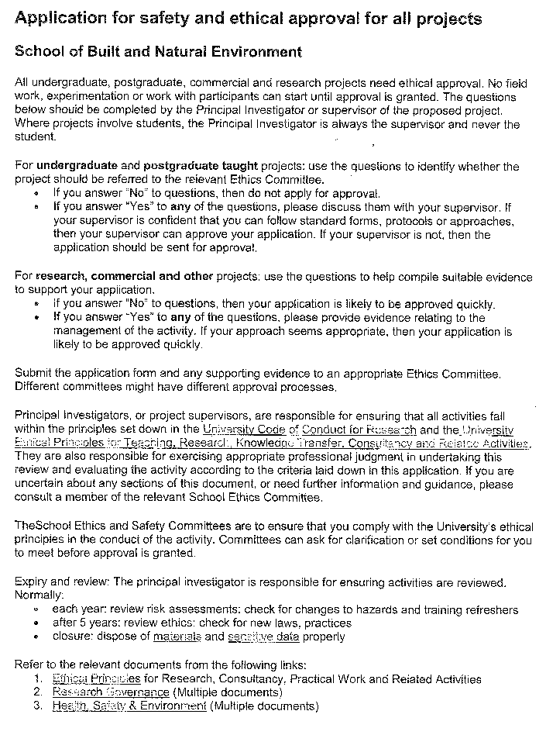

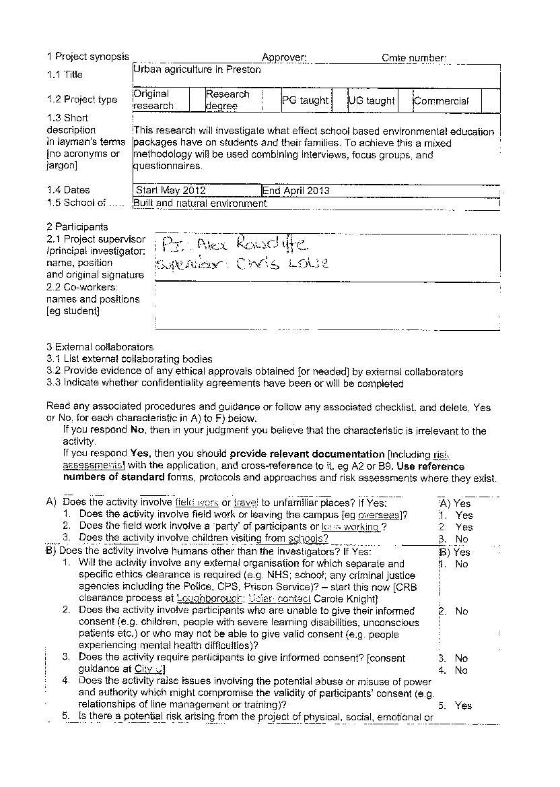

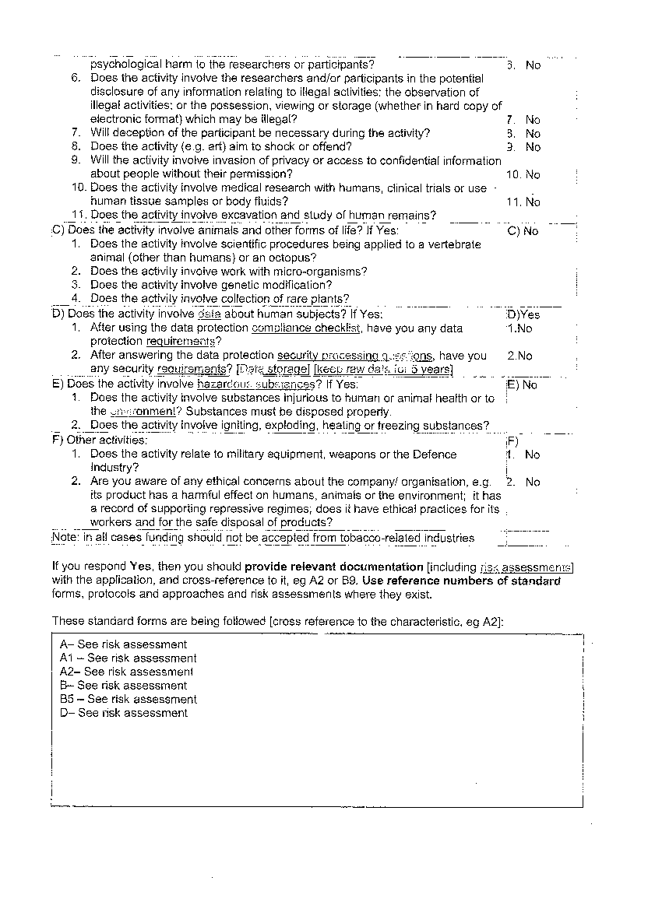

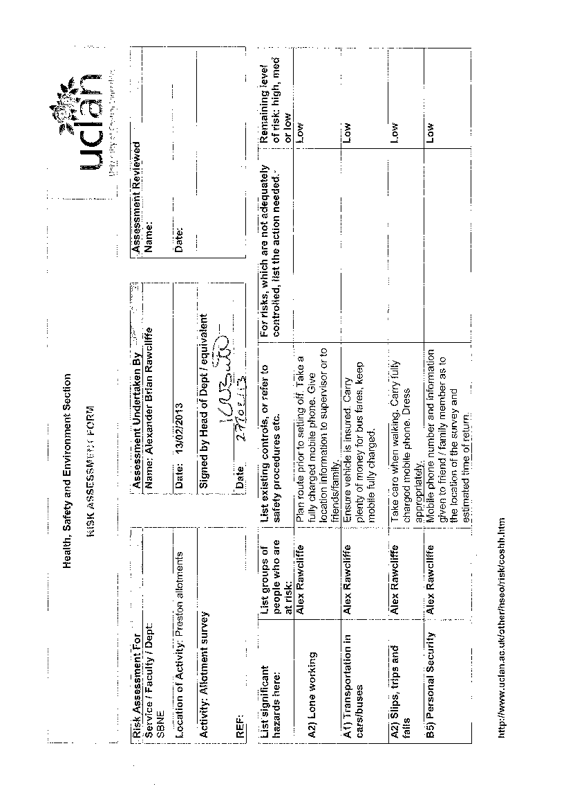

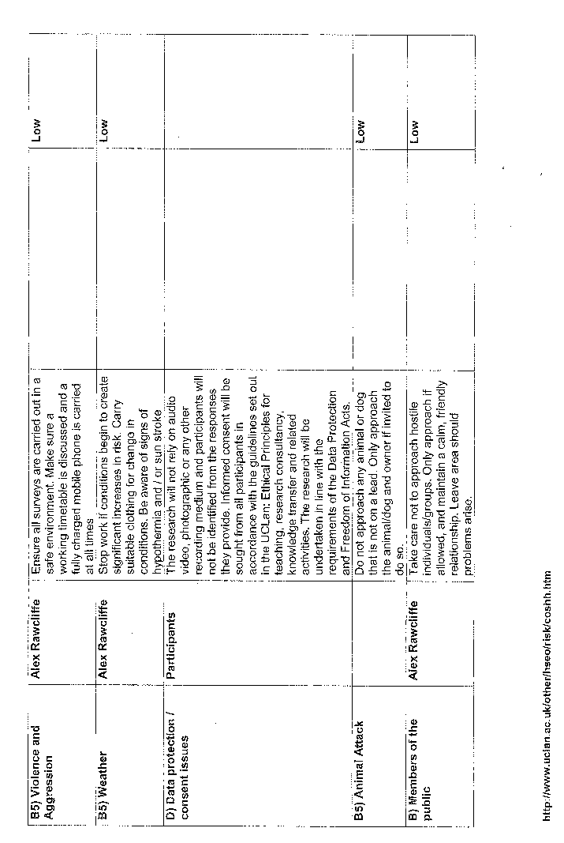
Blank questionnaire template
Questionnaire – No confidential information need be obtained or given. Nothing will be used that may identify you in any way.
1) How old are you?
18-25 56-65

26- 35 66-75
36-45 75+
46-55
2) How long have you had your allotment?
0-3 years 7-9 years
4-6 years 10 years +
3) Why do you rent your allotment?
For economic reasons
Because you enjoy gardening
For social reasons – (to meet other people)
Other reasons:

4) What crop/plant do you grow most at present?
Potatoes

5) Has the economic downturn affected what you choose to grow? i.e. Have you changed from growing flowers to growing fruit and vegetables in recent years to supplement your income?
If yes, why? If not why not?:

6) What do you do to support wildlife on your plot, for example do you provide a pond, compost bins, log piles, bird/bug boxes e.t.c?

7) Are you able to grow all the fruit and vegetables you need or do you still buy some from the supermarkets/shops? If not, why not i.e. lack of space?

8) Besides your allotment do you also grow fruit, vegetables and/or flowers where you live? And if so where do you grow them? In your garden, tubs or containers e.t.c

9) Have you noticed any increase in theft or vandalism in the last five years?

Other notes:

Completed Questionnaires
Questionnaire 1 – No confidential information need be obtained or given. Nothing will be used that may identify you in any way.
1) How old are you?
18-25 56-65

26- 35 66-75
36-45 75+
46-55
2) How long have you had your allotment?
0-3 years 7-9 years
4-6 years 10 years +
3) Why do you rent your allotment?
For economic reasons
Because you enjoy gardening
For social reasons – (to meet other people)
Other reasons:
4) What crop/plant do you grow most at present?
Potatoes
5) Has the economic downturn affected what you choose to grow? i.e. Have you changed from growing flowers to growing fruit and vegetables in recent years to supplement your income?
If yes, why? If not why not?:
No. Still works in a well-paid job so no monetary problems. Although allotment rents are going up.
6) What do you do to support wildlife on your plot, for example do you provide a pond, compost bins, log piles, bird/bug boxes e.t.c?
Puts lots of organic matter on the ground. Introducing nettles and putting up a bird box.
7) Are you able to grow all the fruit and vegetables you need or do you still buy some from the supermarkets/shops? If not, why not i.e. lack of space?
No. Cannot grow enough due to time constraints with work.
8) Besides your allotment do you also grow fruit, vegetables and/or flowers where you live? And if so where do you grow them? In your garden, tubs or containers e.t.c
No it is too windy where allotment owner lives, and too much shade due to trees.
9) Have you noticed any increase in theft or vandalism in the last five years?
Improved since new gates were installed, although three years ago it was very bad.
Other notes:
Interviewee says that there has been a change over recent years on the allotments, more young people are getting involved.

Questionnaire 2– No confidential information need be obtained or given. Nothing will be used that may identify you in any way.
1) How old are you?
18-25 56-65

26- 35 66-75
36-45 75+
46-55
2) How long have you had your allotment?
0-3 years 7-9 years
4-6 years 10 years +
3) Why do you rent your allotment?
For economic reasons
Because you enjoy gardening
For social reasons – (to meet other people)
Other reasons:
Stop wife buying more things from the shops
4) What crop/plant do you grow most at present?
Potatoes because they grow best
5) Has the economic downturn affected what you choose to grow? i.e. Have you changed from growing flowers to growing fruit and vegetables in recent years to supplement your income?
If yes, why? If not why not?:
Allotment rents keep going up.
6) What do you do to support wildlife on your plot, for example do you provide a pond, compost bins, log piles, bird/bug boxes e.t.c?
Nothing.
7) Are you able to grow all the fruit and vegetables you need or do you still buy some from the supermarkets/shops? If not, why not i.e. lack of space?
Grows enough potatoes and garlic for year, doesn’t need to buy these.
8) Besides your allotment do you also grow fruit, vegetables and/or flowers where you live? And if so where do you grow them? In your garden, tubs or containers e.t.c
Grows a variety in greenhouse at home.
9) Have you noticed any increase in theft or vandalism in the last five years?
Slight increase.
Questionnaire 3 – No confidential information need be obtained or given. Nothing will be used that may identify you in any way.
1) How old are you?
18-25 56-65

26- 35 66-75
36-45 75+
46-55
2) How long have you had your allotment?
0-3 years 7-9 years
4-6 years 10 years +
3) Why do you rent your allotment?
For economic reasons
Because you enjoy gardening
For social reasons – (to meet other people)
Other reasons:
Is ill so it is something to keep him fit.
4) What crop/plant do you grow most at present?
Onions
5) Has the economic downturn affected what you choose to grow? i.e. Have you changed from growing flowers to growing fruit and vegetables in recent years to supplement your income?
If yes, why? If not why not?:
No. Used to work in horticulture so it is all purely for pleasure
6) What do you do to support wildlife on your plot, for example do you provide a pond, compost bins, log piles, bird/bug boxes e.t.c?
Bird tables/feed
7) Are you able to grow all the fruit and vegetables you need or do you still buy some from the supermarkets/shops? If not, why not i.e. lack of space?
No, allotment is not large enough
8) Besides your allotment do you also grow fruit, vegetables and/or flowers where you live? And if so where do you grow them? In your garden, tubs or containers e.t.c
No. Cannot due to too many rats.
9) Have you noticed any increase in theft or vandalism in the last five years?
Not been here that long, but has noticed a slight increase in vandalism.
Questionnaire 4 – No confidential information need be obtained or given. Nothing will be used that may identify you in any way.
1) How old are you?
18-25 56-65

26- 35 66-75
36-45 75+
46-55
2) How long have you had your allotment?
0-3 years 7-9 years
4-6 years 10 years +
3) Why do you rent your allotment?
For economic reasons
Because you enjoy gardening
For social reasons – (to meet other people)
Other reasons:
No economic reasons, just something to do. Plus exercise and fresh air.
4) What crop/plant do you grow most at present?
Beans
5) Has the economic downturn affected what you choose to grow? i.e. Have you changed from growing flowers to growing fruit and vegetables in recent years to supplement your income?
If yes, why? If not why not?:
No. It is purely for leisure, trying out growing new varieties of plants and crops.
6) What do you do to support wildlife on your plot, for example do you provide a pond, compost bins, log piles, bird/bug boxes e.t.c?
Bird nest boxes, also wildlife usually takes some of the crops anyway.
7) Are you able to grow all the fruit and vegetables you need or do you still buy some from the supermarkets/shops? If not, why not i.e. lack of space?
No, seasons restrict him to what can grow and when.
8) Besides your allotment do you also grow fruit, vegetables and/or flowers where you live? And if so where do you grow them? In your garden, tubs or containers e.t.c
Yes grows in containers at home and in the ground.
9) Have you noticed any increase in theft or vandalism in the last five years?
There has been an increase until last year when security was improved. Also, increased awareness of vandalism has meant a slight reduction on allotments. People leave less valuables lying around.
Questionnaire 5 – No confidential information need be obtained or given. Nothing will be used that may identify you in any way.
1) How old are you?
18-25 56-65

26- 35 66-75
36-45 75+
46-55
2) How long have you had your allotment?
0-3 years 7-9 years
4-6 years 10 years +
3) Why do you rent your allotment?
For economic reasons
Because you enjoy gardening
For social reasons – (to meet other people)
Other reasons:
Retired so gardening helps to keep fit.
4) What crop/plant do you grow most at present?
Beans
5) Has the economic downturn affected what you choose to grow? i.e. Have you changed from growing flowers to growing fruit and vegetables in recent years to supplement your income?
If yes, why? If not why not?:
No. Not here economically, mainly for leisure.
6) What do you do to support wildlife on your plot, for example do you provide a pond, compost bins, log piles, bird/bug boxes e.t.c?
Grows organically, provides bird feed in the winter, keeps bees and grows wildflowers.
7) Are you able to grow all the fruit and vegetables you need or do you still buy some from the supermarkets/shops? If not, why not i.e. lack of space?
Yes, freezes beans and other produce so it keeps longer.
8) Besides your allotment do you also grow fruit, vegetables and/or flowers where you live? And if so where do you grow them? In your garden, tubs or containers e.t.c
A little bit in the ground soil and containers
9) Have you noticed any increase in theft or vandalism in the last five years?
Big decrease this year, but has been worse in the past.
Questionnaire 6 – No confidential information need be obtained or given. Nothing will be used that may identify you in any way.
1) How old are you?
18-25 56-65

26- 35 66-75
36-45 75+
46-55
2) How long have you had your allotment?
0-3 years 7-9 years
4-6 years 10 years +
3) Why do you rent your allotment?
For economic reasons
Because you enjoy gardening
For social reasons – (to meet other people)
Other reasons:
Supply of fresh food, and retired so gives something to do.

4) What crop/plant do you grow most at present?
Potatoes
5) Has the economic downturn affected what you choose to grow? i.e. Have you changed from growing flowers to growing fruit and vegetables in recent years to supplement your income?
If yes, why? If not why not?:
Yes, rents keep going up and have had some financial support taken off them
6) What do you do to support wildlife on your plot, for example do you provide a pond, compost bins, log piles, bird/bug boxes e.t.c?
Bird tables, wildlife corridor on boundary
7) Are you able to grow all the fruit and vegetables you need or do you still buy some from the supermarkets/shops? If not, why not i.e. lack of space?
Yes, freeze all fruit and vegetables for the winter, occasionally might have to buy some things.
8) Besides your allotment do you also grow fruit, vegetables and/or flowers where you live? And if so where do you grow them? In your garden, tubs or containers e.t.c
Grow in a greenhouse
9) Have you noticed any increase in theft or vandalism in the last five years?
Yes until new fence was put up a year ago, but had been getting worse.
Other notes:
Makes own jam from produce.
Questionnaire 7 – No confidential information need be obtained or given. Nothing will be used that may identify you in any way.
1) How old are you?
18-25 56-65

26- 35 66-75
36-45 75+
46-55
2) How long have you had your allotment?
0-3 years 7-9 years
4-6 years 10 years +
3) Why do you rent your allotment?
For economic reasons
Because you enjoy gardening
For social reasons – (to meet other people)
Other reasons:
Definitely not economic apparently
4) What crop/plant do you grow most at present?
Beans
5) Has the economic downturn affected what you choose to grow? i.e. Have you changed from growing flowers to growing fruit and vegetables in recent years to supplement your income?
If yes, why? If not why not?:
No. Retired and has not affected growing methods in any way.
6) What do you do to support wildlife on your plot, for example do you provide a pond, compost bins, log piles, bird/bug boxes e.t.c?
Bughouse, grows organically, and practices companion planting.
7) Are you able to grow all the fruit and vegetables you need or do you still buy some from the supermarkets/shops? If not, why not i.e. lack of space?
No, not enough space
8) Besides your allotment do you also grow fruit, vegetables and/or flowers where you live? And if so where do you grow them? In your garden, tubs or containers e.t.c
Grows in the soil at home
9) Have you noticed any increase in theft or vandalism in the last five years?
New security has improved situation, but it has always been intermittent spates of vandalism and theft, particularly five years ago.
Questionnaire 8 – No confidential information need be obtained or given. Nothing will be used that may identify you in any way.
1) How old are you?
18-25 56-65

26- 35 66-75
36-45 75+
46-55
2) How long have you had your allotment?
0-3 years 7-9 years
4-6 years 10 years +
3) Why do you rent your allotment?
For economic reasons
Because you enjoy gardening
For social reasons – (to meet other people)
Other reasons:
4) What crop/plant do you grow most at present?
Potatoes
5) Has the economic downturn affected what you choose to grow? i.e. Have you changed from growing flowers to growing fruit and vegetables in recent years to supplement your income?
If yes, why? If not why not?:
No. Always grown crops for pleasure.
6) What do you do to support wildlife on your plot, for example do you provide a pond, compost bins, log piles, bird/bug boxes e.t.c?
Bird table.
7) Are you able to grow all the fruit and vegetables you need or do you still buy some from the supermarkets/shops? If not, why not i.e. lack of space?
Most of the time, depends on weather and disease (such as potato blight). Also soil on allotment not very good so it restricts how much you can grow.
8) Besides your allotment do you also grow fruit, vegetables and/or flowers where you live? And if so where do you grow them? In your garden, tubs or containers e.t.c
No.
9) Have you noticed any increase in theft or vandalism in the last five years?
No change.
Questionnaire 9 – No confidential information need be obtained or given. Nothing will be used that may identify you in any way.
1) How old are you?
18-25 56-65

26- 35 66-75
36-45 75+
46-55
2) How long have you had your allotment?
0-3 years 7-9 years
4-6 years 10 years +
3) Why do you rent your allotment?
For economic reasons
Because you enjoy gardening
For social reasons – (to meet other people)
Other reasons:
4) What crop/plant do you grow most at present?
Strawberries
5) Has the economic downturn affected what you choose to grow? i.e. Have you changed from growing flowers to growing fruit and vegetables in recent years to supplement your income?
If yes, why? If not why not?:
Yes. The tighter budget has meant that the owner has stopped buying organic seeds, only uses regular seeds now.
6) What do you do to support wildlife on your plot, for example do you provide a pond, compost bins, log piles, bird/bug boxes e.t.c?
Companion planting, plants Teasel to provide food for birds. Also has a hedgehog box and a pond.
7) Are you able to grow all the fruit and vegetables you need or do you still buy some from the supermarkets/shops? If not, why not i.e. lack of space?
Could potentially do so, but does not have enough time to cultivate allotment properly,
8) Besides your allotment do you also grow fruit, vegetables and/or flowers where you live? And if so where do you grow them? In your garden, tubs or containers e.t.c
Yes in the soil at home.
9) Have you noticed any increase in theft or vandalism in the last five years?
Says it has decreased, but then again the allotment is situated in one of the more secure areas.
Other notes:
The shed is fitted with gutters connected to a storage tank, evidence of recycling rainwater.
Questionnaire 10 – No confidential information need be obtained or given. Nothing will be used that may identify you in any way.
1) How old are you?
18-25 56-65

26- 35 66-75
36-45 75+
46-55
2) How long have you had your allotment?
0-3 years 7-9 years
4-6 years 10 years +
3) Why do you rent your allotment?
For economic reasons
Because you enjoy gardening
For social reasons – (to meet other people)
Other reasons:
4) What crop/plant do you grow most at present?
Garlic
5) Has the economic downturn affected what you choose to grow? i.e. Have you changed from growing flowers to growing fruit and vegetables in recent years to supplement your income?
If yes, why? If not why not?:
No. Own allotment primarily for pleasure.
6) What do you do to support wildlife on your plot, for example do you provide a pond, compost bins, log piles, bird/bug boxes e.t.c?
Plant wildflower seeds, also swap plants with other allotment owners.
7) Are you able to grow all the fruit and vegetables you need or do you still buy some from the supermarkets/shops? If not, why not i.e. lack of space?
No, there is not enough space. Halving of plots makes it difficult.
8) Besides your allotment do you also grow fruit, vegetables and/or flowers where you live? And if so where do you grow them? In your garden, tubs or containers e.t.c
No, lives in rented accommodation with no garden.
9) Have you noticed any increase in theft or vandalism in the last five years?
Recent increased security having some effect in past year, but sites used to be damaged regularly by vagrants.
Other notes:
Potatoes are actually cheaper to buy in the shop, so not much point in growing them.
Questionnaire 11– No confidential information need be obtained or given. Nothing will be used that may identify you in any way.
1) How old are you?
18-25 56-65

26- 35 66-75
36-45 75+
46-55
2) How long have you had your allotment?
0-3 years 7-9 years
4-6 years 10 years +
3) Why do you rent your allotment?
For economic reasons
Because you enjoy gardening
For social reasons – (to meet other people)
Other reasons:
4) What crop/plant do you grow most at present?
Onions
5) Has the economic downturn affected what you choose to grow? i.e. Have you changed from growing flowers to growing fruit and vegetables in recent years to supplement your income?
If yes, why? If not why not?:
No. Owns allotment as a hobby.
6) What do you do to support wildlife on your plot, for example do you provide a pond, compost bins, log piles, bird/bug boxes e.t.c?
Nesting birds on his plot
7) Are you able to grow all the fruit and vegetables you need or do you still buy some from the supermarkets/shops? If not, why not i.e. lack of space?
Depends on weather, but usually can sustain himself.
8) Besides your allotment do you also grow fruit, vegetables and/or flowers where you live? And if so where do you grow them? In your garden, tubs or containers e.t.c
No.
9) Have you noticed any increase in theft or vandalism in the last five years?
Not directly, but has seen it on other allotments.
Questionnaire 12– No confidential information need be obtained or given. Nothing will be used that may identify you in any way.
1) How old are you?
18-25 56-65

26- 35 66-75
36-45 75+
46-55
2) How long have you had your allotment?
0-3 years 7-9 years
4-6 years 10 years +
3) Why do you rent your allotment?
For economic reasons
Because you enjoy gardening
For social reasons – (to meet other people)
Other reasons:
To teach children about farming
4) What crop/plant do you grow most at present?
Potatoes
5) Has the economic downturn affected what you choose to grow? i.e. Have you changed from growing flowers to growing fruit and vegetables in recent years to supplement your income?
If yes, why? If not why not?:
Yes. Money inputs into allotment very high, due to cost of rent, seed and fencing. Has meant cutbacks on some things.
6) What do you do to support wildlife on your plot, for example do you provide a pond, compost bins, log piles, bird/bug boxes e.t.c?
Wildflowers
7) Are you able to grow all the fruit and vegetables you need or do you still buy some from the supermarkets/shops? If not, why not i.e. lack of space?
No, not enough time
8) Besides your allotment do you also grow fruit, vegetables and/or flowers where you live? And if so where do you grow them? In your garden, tubs or containers e.t.c
No, does not have a garden
9) Have you noticed any increase in theft or vandalism in the last five years?
No, not been here long enough to see.
Questionnaire 13 – No confidential information need be obtained or given. Nothing will be used that may identify you in any way.
1) How old are you?
18-25 56-65

26- 35 66-75
36-45 75+
46-55
2) How long have you had your allotment?
0-3 years 7-9 years
4-6 years 10 years +
3) Why do you rent your allotment?
For economic reasons
Because you enjoy gardening
For social reasons – (to meet other people)
Other reasons:
4) What crop/plant do you grow most at present?
Potatoes
5) Has the economic downturn affected what you choose to grow? i.e. Have you changed from growing flowers to growing fruit and vegetables in recent years to supplement your income?
If yes, why? If not why not?:
Yes, can no longer afford to go on holiday, so bought allotment instead as a hobby.
6) What do you do to support wildlife on your plot, for example do you provide a pond, compost bins, log piles, bird/bug boxes e.t.c?
Nothing.
7) Are you able to grow all the fruit and vegetables you need or do you still buy some from the supermarkets/shops? If not, why not i.e. lack of space?
Usually, but occasionally needs to buy some still.
8) Besides your allotment do you also grow fruit, vegetables and/or flowers where you live? And if so where do you grow them? In your garden, tubs or containers e.t.c
No, not enough room.
9) Have you noticed any increase in theft or vandalism in the last five years?
No.
Questionnaire 14 – No confidential information need be obtained or given. Nothing will be used that may identify you in any way.
1) How old are you?
18-25 56-65

26- 35 66-75
36-45 75+
46-55
2) How long have you had your allotment?
0-3 years 7-9 years
4-6 years 10 years +
3) Why do you rent your allotment?
For economic reasons
Because you enjoy gardening
For social reasons – (to meet other people)
Other reasons:
Likes to grow for pleasure but also to save money.
4) What crop/plant do you grow most at present?
Potatoes
5) Has the economic downturn affected what you choose to grow? i.e. Have you changed from growing flowers to growing fruit and vegetables in recent years to supplement your income?
If yes, why? If not why not?:
Yes, it has made him grow more to save more.
6) What do you do to support wildlife on your plot, for example do you provide a pond, compost bins, log piles, bird/bug boxes e.t.c?
Leaves some crops behind.
7) Are you able to grow all the fruit and vegetables you need or do you still buy some from the supermarkets/shops? If not, why not i.e. lack of space?
Yes, has enough potatoes to last him all year.
8) Besides your allotment do you also grow fruit, vegetables and/or flowers where you live? And if so where do you grow them? In your garden, tubs or containers e.t.c
Grows tomatoes at home in greenhouse.
9) Have you noticed any increase in theft or vandalism in the last five years?
Has decreased, especially since new security.
Questionnaire 15– No confidential information need be obtained or given. Nothing will be used that may identify you in any way.
1) How old are you?
18-25 56-65

26- 35 66-75
36-45 75+
46-55
2) How long have you had your allotment?
0-3 years 7-9 years
4-6 years 10 years +
3) Why do you rent your allotment?
For economic reasons
Because you enjoy gardening
For social reasons – (to meet other people)
Other reasons:
Wanted to grow own produce
4) What crop/plant do you grow most at present?
Potatoes
5) Has the economic downturn affected what you choose to grow? i.e. Have you changed from growing flowers to growing fruit and vegetables in recent years to supplement your income?
If yes, why? If not why not?:
No. Grows purely for pleasure
6) What do you do to support wildlife on your plot, for example do you provide a pond, compost bins, log piles, bird/bug boxes e.t.c?
Provides leftovers organic matter, bird boxes, and uses organic methods. Also plants wildflowers for bees
7) Are you able to grow all the fruit and vegetables you need or do you still buy some from the supermarkets/shops? If not, why not i.e. lack of space?
Yes
8) Besides your allotment do you also grow fruit, vegetables and/or flowers where you live? And if so where do you grow them? In your garden, tubs or containers e.t.c
Grows a variety of things at home as well in poly-tunnels.
9) Have you noticed any increase in theft or vandalism in the last five years?
No.
Questionnaire 16– No confidential information need be obtained or given. Nothing will be used that may identify you in any way.
1) How old are you?
18-25 56-65

26- 35 66-75
36-45 75+
46-55
2) How long have you had your allotment?
0-3 years 7-9 years
4-6 years 10 years +
3) Why do you rent your allotment?
For economic reasons
Because you enjoy gardening
For social reasons – (to meet other people)
Other reasons:
Like the taste of fresh produce
4) What crop/plant do you grow most at present?
Strawberries
5) Has the economic downturn affected what you choose to grow? i.e. Have you changed from growing flowers to growing fruit and vegetables in recent years to supplement your income?
If yes, why? If not why not?:
No, grow all their produce from the seed of previous harvests so don’t need to buy
6) What do you do to support wildlife on your plot, for example do you provide a pond, compost bins, log piles, bird/bug boxes e.t.c?
Pond, bird and bat boxes.
7) Are you able to grow all the fruit and vegetables you need or do you still buy some from the supermarkets/shops? If not, why not i.e. lack of space?
Yes. Turn strawberries into jam
8) Besides your allotment do you also grow fruit, vegetables and/or flowers where you live? And if so where do you grow them? In your garden, tubs or containers e.t.c
Grow a little at home using raised beds.
9) Have you noticed any increase in theft or vandalism in the last five years?
No, since the new fence was installed. Also don’t keep a lock on shed as a sign that there are no valuables.
Questionnaire 17– No confidential information need be obtained or given. Nothing will be used that may identify you in any way.
1) How old are you?
18-25 56-65

26- 35 66-75
36-45 75+
46-55
2) How long have you had your allotment?
0-3 years 7-9 years
4-6 years 10 years +
3) Why do you rent your allotment?
For economic reasons
Because you enjoy gardening
For social reasons – (to meet other people)
Other reasons:
Used to study horticulture so it is now a hobby
4) What crop/plant do you grow most at present?
Potatoes
5) Has the economic downturn affected what you choose to grow? i.e. Have you changed from growing flowers to growing fruit and vegetables in recent years to supplement your income?
If yes, why? If not why not?:
No. Has become more self-sufficient, but mainly due to environmental issues rather than economical.
6) What do you do to support wildlife on your plot, for example do you provide a pond, compost bins, log piles, bird/bug boxes e.t.c?
Totally organic. Also has a pond, wildflowers, wildlife corridor, bird, bat and hedgehog boxes.
7) Are you able to grow all the fruit and vegetables you need or do you still buy some from the supermarkets/shops? If not, why not i.e. lack of space?
No, cannot store produce for long enough to last all year.
8) Besides your allotment do you also grow fruit, vegetables and/or flowers where you live? And if so where do you grow them? In your garden, tubs or containers e.t.c
Grow a few herbs in the soil and starts some seedlings off at home, then brings them to the allotment.
9) Have you noticed any increase in theft or vandalism in the last five years?
Has decreased, although is still intermittent.
Questionnaire 18– No confidential information need be obtained or given. Nothing will be used that may identify you in any way.
1) How old are you?
18-25 56-65

26- 35 66-75
36-45 75+
46-55
2) How long have you had your allotment?
0-3 years 7-9 years
4-6 years 10 years +
3) Why do you rent your allotment?
For economic reasons
Because you enjoy gardening
For social reasons – (to meet other people)
Other reasons:
Keeps active through farming
4) What crop/plant do you grow most at present?
Onions and potatoes
5) Has the economic downturn affected what you choose to grow? i.e. Have you changed from growing flowers to growing fruit and vegetables in recent years to supplement your income?
If yes, why? If not why not?:
No. Owned an allotment for a long time so is experienced in cost-cutting already.
6) What do you do to support wildlife on your plot, for example do you provide a pond, compost bins, log piles, bird/bug boxes e.t.c?
Wildflowers and allows birds to roost on allotment.
7) Are you able to grow all the fruit and vegetables you need or do you still buy some from the supermarkets/shops? If not, why not i.e. lack of space?
Usually grows all that is needed. Keeps some for seed for next year as well.
8) Besides your allotment do you also grow fruit, vegetables and/or flowers where you live? And if so where do you grow them? In your garden, tubs or containers e.t.c
Flowers in the soil at home, also starts some plants off there before moving them to the allotment.
9) Have you noticed any increase in theft or vandalism in the last five years?
Yes. Allotment shed recently vandalised in fact.
Other notes:
Has owned an allotment for 45 years.
Questionnaire 19 – No confidential information need be obtained or given. Nothing will be used that may identify you in any way.
1) How old are you?
18-25 56-65

26- 35 66-75
36-45 75+
46-55
2) How long have you had your allotment?
0-3 years 7-9 years
4-6 years 10 years +
3) Why do you rent your allotment?
For economic reasons
Because you enjoy gardening
For social reasons – (to meet other people)
Other reasons:
For healthy eating and exercise
4) What crop/plant do you grow most at present?
Cabbages
5) Has the economic downturn affected what you choose to grow? i.e. Have you changed from growing flowers to growing fruit and vegetables in recent years to supplement your income?
If yes, why? If not why not?:
Grows more edible crops now than used to. Bought allotment during the last recession.
6) What do you do to support wildlife on your plot, for example do you provide a pond, compost bins, log piles, bird/bug boxes e.t.c?
Uses an old bathtub as a pond, as well as growing organically, planting wildflowers and feeds birds.
7) Are you able to grow all the fruit and vegetables you need or do you still buy some from the supermarkets/shops? If not, why not i.e. lack of space?
Depends on weather, but usually can grow enough potatoes and onions to last all year round.
Greens don’t tend to keep for long enough.
8) Besides your allotment do you also grow fruit, vegetables and/or flowers where you live? And if so where do you grow them? In your garden, tubs or containers e.t.c
Yes, grows raspberries, peas and other salads in containers. Also starts off some plants at home before bringing to the allotment.
9) Have you noticed any increase in theft or vandalism in the last five years?
No. It constantly occurs, although improved security could reduce it.

Questionnaire – 20 No confidential information need be obtained or given. Nothing will be used that may identify you in any way.
1) How old are you?
18-25 56-65

26- 35 66-75
36-45 75+
46-55
2) How long have you had your allotment?
0-3 years 7-9 years
4-6 years 10 years +
3) Why do you rent your allotment?
For economic reasons
Because you enjoy gardening
For social reasons – (to meet other people)
Other reasons:
Likes organic vegetables
4) What crop/plant do you grow most at present?
Beans
5) Has the economic downturn affected what you choose to grow? i.e. Have you changed from growing flowers to growing fruit and vegetables in recent years to supplement your income?
If yes, why? If not why not?:
Yes. Current increasing rents are making her think twice about having an allotment.
6) What do you do to support wildlife on your plot, for example do you provide a pond, compost bins, log piles, bird/bug boxes e.t.c?
Leaves the land to rest sometimes, also leaves some crops behind.
7) Are you able to grow all the fruit and vegetables you need or do you still buy some from the supermarkets/shops? If not, why not i.e. lack of space?
Yes, rarely needs to buy soft fruit.
8) Besides your allotment do you also grow fruit, vegetables and/or flowers where you live? And if so where do you grow them? In your garden, tubs or containers e.t.c
Grows flowers in the soil
9) Have you noticed any increase in theft or vandalism in the last five years?
Yes, more petty vandalism.

Questionnaire 21 – No confidential information need be obtained or given. Nothing will be used that may identify you in any way.
1) How old are you?
18-25 56-65

26- 35 66-75
36-45 75+
46-55
2) How long have you had your allotment?
0-3 years 7-9 years
4-6 years 10 years +
3) Why do you rent your allotment?
For economic reasons
Because you enjoy gardening
For social reasons – (to meet other people)
Other reasons:
Likes growing fresh vegetables
4) What crop/plant do you grow most at present?
Onions
5) Has the economic downturn affected what you choose to grow? i.e. Have you changed from growing flowers to growing fruit and vegetables in recent years to supplement your income?
If yes, why? If not why not?:
No. Grows purely for taste of food.
6) What do you do to support wildlife on your plot, for example do you provide a pond, compost bins, log piles, bird/bug boxes e.t.c?
Organic methods
7) Are you able to grow all the fruit and vegetables you need or do you still buy some from the supermarkets/shops? If not, why not i.e. lack of space?
Still needs to buy from shops as it is not sustainable, only in summer yields are good enough.
8) Besides your allotment do you also grow fruit, vegetables and/or flowers where you live? And if so where do you grow them? In your garden, tubs or containers e.t.c
Grows peas at home in containers
9) Have you noticed any increase in theft or vandalism in the last five years?
Not on current allotment but previous allotment at Deepdale was very bad in last five years.
Other notes:
Used to own an allotment near Deepdale but flooding problems forced him to move.
Questionnaire 22– No confidential information need be obtained or given. Nothing will be used that may identify you in any way.
1) How old are you?
18-25 56-65

26- 35 66-75
36-45 75+
46-55
2) How long have you had your allotment?
0-3 years 7-9 years
4-6 years 10 years +
3) Why do you rent your allotment?
For economic reasons
Because you enjoy gardening
For social reasons – (to meet other people)
Other reasons:
Just a hobby
4) What crop/plant do you grow most at present?
Potatoes
5) Has the economic downturn affected what you choose to grow? i.e. Have you changed from growing flowers to growing fruit and vegetables in recent years to supplement your income?
If yes, why? If not why not?:
No. Purely just a hobby.
6) What do you do to support wildlife on your plot, for example do you provide a pond, compost bins, log piles, bird/bug boxes e.t.c?
Leave some crops behind
7) Are you able to grow all the fruit and vegetables you need or do you still buy some from the supermarkets/shops? If not, why not i.e. lack of space?
No. Doesn’t last him all year round, not enough room and climate variable.
8) Besides your allotment do you also grow fruit, vegetables and/or flowers where you live? And if so where do you grow them? In your garden, tubs or containers e.t.c
No
9) Have you noticed any increase in theft or vandalism in the last five years?
Yes, has gone up.
Questionnaire 23 – No confidential information need be obtained or given. Nothing will be used that may identify you in any way.
1) How old are you?
18-25 56-65

26- 35 66-75
36-45 75+
46-55
2) How long have you had your allotment?
0-3 years 7-9 years
4-6 years 10 years +
3) Why do you rent your allotment?
For economic reasons
Because you enjoy gardening
For social reasons – (to meet other people)
Other reasons:
Into organic farming
4) What crop/plant do you grow most at present?
Potatoes
5) Has the economic downturn affected what you choose to grow? i.e. Have you changed from growing flowers to growing fruit and vegetables in recent years to supplement your income?
If yes, why? If not why not?:
No. Purely wants to grow organic food
6) What do you do to support wildlife on your plot, for example do you provide a pond, compost bins, log piles, bird/bug boxes e.t.c?
Bee boxes, also organic methods, and a pond.
7) Are you able to grow all the fruit and vegetables you need or do you still buy some from the supermarkets/shops? If not, why not i.e. lack of space?
Usually but depends on the weather.
8) Besides your allotment do you also grow fruit, vegetables and/or flowers where you live? And if so where do you grow them? In your garden, tubs or containers e.t.c
No
9) Have you noticed any increase in theft or vandalism in the last five years?
Yes, some shed break ins in the last year in particular.
Questionnaire 24– No confidential information need be obtained or given. Nothing will be used that may identify you in any way.
1) How old are you?
18-25 56-65

26- 35 66-75
36-45 75+
46-55
2) How long have you had your allotment?
0-3 years 7-9 years
4-6 years 10 years +
3) Why do you rent your allotment?
For economic reasons
Because you enjoy gardening
For social reasons – (to meet other people)
Other reasons:
4) What crop/plant do you grow most at present?
Potatoes
5) Has the economic downturn affected what you choose to grow? i.e. Have you changed from growing flowers to growing fruit and vegetables in recent years to supplement your income?
If yes, why? If not why not?:
No, grows only for fresh produce
6) What do you do to support wildlife on your plot, for example do you provide a pond, compost bins, log piles, bird/bug boxes e.t.c?
Leaves leftovers.
7) Are you able to grow all the fruit and vegetables you need or do you still buy some from the supermarkets/shops? If not, why not i.e. lack of space?
Yes, but only through the summer
8) Besides your allotment do you also grow fruit, vegetables and/or flowers where you live? And if so where do you grow them? In your garden, tubs or containers e.t.c
Yes, grows peas and beans at home
9) Have you noticed any increase in theft or vandalism in the last five years?
Yes.

Questionnaire 25 – No confidential information need be obtained or given. Nothing will be used that may identify you in any way.
1) How old are you?
18-25 56-65

26- 35 66-75
36-45 75+
46-55
2) How long have you had your allotment?
0-3 years 7-9 years
4-6 years 10 years +
3) Why do you rent your allotment?
For economic reasons
Because you enjoy gardening
For social reasons – (to meet other people)
Other reasons:
4) What crop/plant do you grow most at present?
Potatoes
5) Has the economic downturn affected what you choose to grow? i.e. Have you changed from growing flowers to growing fruit and vegetables in recent years to supplement your income?
If yes, why? If not why not?:
Yes, spend more time on allotment now because lost job a while ago.
6) What do you do to support wildlife on your plot, for example do you provide a pond, compost bins, log piles, bird/bug boxes e.t.c?
Bird baths and feed
7) Are you able to grow all the fruit and vegetables you need or do you still buy some from the supermarkets/shops? If not, why not i.e. lack of space?
Yes
8) Besides your allotment do you also grow fruit, vegetables and/or flowers where you live? And if so where do you grow them? In your garden, tubs or containers e.t.c
Yes, grow onions in soil
9) Have you noticed any increase in theft or vandalism in the last five years?
Yes
Questionnaire 26 – No confidential information need be obtained or given. Nothing will be used that may identify you in any way.
1) How old are you?
18-25 56-65

26- 35 66-75
36-45 75+
46-55
2) How long have you had your allotment?
0-3 years 7-9 years
4-6 years 10 years +
3) Why do you rent your allotment?
For economic reasons
Because you enjoy gardening
For social reasons – (to meet other people)
Other reasons:
4) What crop/plant do you grow most at present?
Strawberries
5) Has the economic downturn affected what you choose to grow? i.e. Have you changed from growing flowers to growing fruit and vegetables in recent years to supplement your income?
If yes, why? If not why not?:
Yes, buy less organic seeds now.
6) What do you do to support wildlife on your plot, for example do you provide a pond, compost bins, log piles, bird/bug boxes e.t.c?
Leave some crops and organic matter on soil.
7) Are you able to grow all the fruit and vegetables you need or do you still buy some from the supermarkets/shops? If not, why not i.e. lack of space?
No, lack of time and space
8) Besides your allotment do you also grow fruit, vegetables and/or flowers where you live? And if so where do you grow them? In your garden, tubs or containers e.t.c
Yes grow flowers in the soil.
9) Have you noticed any increase in theft or vandalism in the last five years?
Yes
Questionnaire 27 – No confidential information need be obtained or given. Nothing will be used that may identify you in any way.
1) How old are you?
18-25 56-65

26- 35 66-75
36-45 75+
46-55
2) How long have you had your allotment?
0-3 years 7-9 years
4-6 years 10 years +
3) Why do you rent your allotment?
For economic reasons
Because you enjoy gardening
For social reasons – (to meet other people)
Other reasons:
4) What crop/plant do you grow most at present?
Potatoes
5) Has the economic downturn affected what you choose to grow? i.e. Have you changed from growing flowers to growing fruit and vegetables in recent years to supplement your income?
If yes, why? If not why not?:
Yes. Started growing more potatoes so no need to buy them.
6) What do you do to support wildlife on your plot, for example do you provide a pond, compost bins, log piles, bird/bug boxes e.t.c?
Compost leftovers, leave some for the birds
7) Are you able to grow all the fruit and vegetables you need or do you still buy some from the supermarkets/shops? If not, why not i.e. lack of space?
Yes, most of the time.
8) Besides your allotment do you also grow fruit, vegetables and/or flowers where you live? And if so where do you grow them? In your garden, tubs or containers e.t.c
No.
9) Have you noticed any increase in theft or vandalism in the last five years?
No
Questionnaire 28 – No confidential information need be obtained or given. Nothing will be used that may identify you in any way.
1) How old are you?
18-25 56-65

26- 35 66-75
36-45 75+
46-55
2) How long have you had your allotment?
0-3 years 7-9 years
4-6 years 10 years +
3) Why do you rent your allotment?
For economic reasons
Because you enjoy gardening
For social reasons – (to meet other people)
Other reasons:
4) What crop/plant do you grow most at present?
Onions
5) Has the economic downturn affected what you choose to grow? i.e. Have you changed from growing flowers to growing fruit and vegetables in recent years to supplement your income?
If yes, why? If not why not?:
No. Grow a variety of things to keep active and keep a hobby.
6) What do you do to support wildlife on your plot, for example do you provide a pond, compost bins, log piles, bird/bug boxes e.t.c?
Leave corridors for wildlife at edges of allotment
7) Are you able to grow all the fruit and vegetables you need or do you still buy some from the supermarkets/shops? If not, why not i.e. lack of space?
No, not enough room
8) Besides your allotment do you also grow fruit, vegetables and/or flowers where you live? And if so where do you grow them? In your garden, tubs or containers e.t.c
No
9) Have you noticed any increase in theft or vandalism in the last five years?
Yes
Questionnaire 29 – No confidential information need be obtained or given. Nothing will be used that may identify you in any way.
1) How old are you?
18-25 56-65

26- 35 66-75
36-45 75+
46-55
2) How long have you had your allotment?
0-3 years 7-9 years
4-6 years 10 years +
3) Why do you rent your allotment?
For economic reasons
Because you enjoy gardening
For social reasons – (to meet other people)
Other reasons:
4) What crop/plant do you grow most at present?
Doesn’t grow. Keeps chickens on allotment plot instead, producing eggs.
5) Has the economic downturn affected what you choose to grow? i.e. Have you changed from growing flowers to growing fruit and vegetables in recent years to supplement your income?
If yes, why? If not why not?:
No. Chickens keep him in supply of eggs all year round.
6) What do you do to support wildlife on your plot, for example do you provide a pond, compost bins, log piles, bird/bug boxes e.t.c?
Leftover bird feed goes to wild birds.
7) Are you able to grow all the fruit and vegetables you need or do you still buy some from the supermarkets/shops? If not, why not i.e. lack of space?
Has enough eggs usually, so no need to buy.
8) Besides your allotment do you also grow fruit, vegetables and/or flowers where you live? And if so where do you grow them? In your garden, tubs or containers e.t.c
No
9) Have you noticed any increase in theft or vandalism in the last five years?
Yes. Installed new fencing to protect chickens, with secure hutch at night.
Questionnaire 30– No confidential information need be obtained or given. Nothing will be used that may identify you in any way.
1) How old are you?
18-25 56-65

26- 35 66-75
36-45 75+
46-55
2) How long have you had your allotment?
0-3 years 7-9 years
4-6 years 10 years +
3) Why do you rent your allotment?
For economic reasons
Because you enjoy gardening
For social reasons – (to meet other people)
Other reasons:
4) What crop/plant do you grow most at present?
Potatoes
5) Has the economic downturn affected what you choose to grow? i.e. Have you changed from growing flowers to growing fruit and vegetables in recent years to supplement your income?
If yes, why? If not why not?:
Yes. Increasing prices and environmental awareness made owner want to grow more sustainably.
6) What do you do to support wildlife on your plot, for example do you provide a pond, compost bins, log piles, bird/bug boxes e.t.c?
Bird table, log piles for hedgehogs
7) Are you able to grow all the fruit and vegetables you need or do you still buy some from the supermarkets/shops? If not, why not i.e. lack of space?
Yes
8) Besides your allotment do you also grow fruit, vegetables and/or flowers where you live? And if so where do you grow them? In your garden, tubs or containers e.t.c
No not enough room.
9) Have you noticed any increase in theft or vandalism in the last five years?
Yes

Results tables
Question 1 results table
Table 1 (Authors own)
Age range | Total
18-25 | 0
26-35 | 4
36-45 | 5
46-55 | 5
56-65 | 2
66-75 | 8
75 + | 6

Question 2 results table
Table 2 (Authors own)
No. of years | No. of people
0-3 years | 11
4-6 years | 4
7-9 years | 7
10 + years | 8

Question 3 results table
Table 3 (Authors own)
Reason | No. of categories selected
Economic reasons | 10
Horticultural recreation reasons | 29
Social reasons | 11

Question 4 results table
Table 4 (Authors own)
Crop/produce | No. chosen
Potato | 16
Onion | 5
Garlic | 1
Bean | 4
Cabbage | 1
Strawberry | 3
Chicken egg | 1
Question 5 results table
Table 5 (Authors own)
Yes | No
13 | 17

Question 6 results table
Table 6 (Authors own)
Option | No. of times selected
Bird amenities | 16
Pond | 4
Wildflowers | 8
Companion planting | 2
Bat boxes | 2
Hedgehog log piles/ boxes | 3
Bughouse/bee hives | 3
Organic methods | 7
Leave leftover crops | 10
Recycle waste | 2
Leave land fallow | 1
Nothing at all | 2

Question 7 results table
Table 7 (Authors own)
Yes | No
18 | 12

Question 8 results table
Table 8 (Authors own)
Yes | No
17 | 13

Question 9 results table
Table 9 (Authors own)
Yes | No
20 | 10

