A Geomorphologic report to highlight the impacts of kayaking on the River Irwell

Sophie Townsend
Bsc (Hons) Geography
2013
Student Number: 20471907

I declare that this dissertation consists of no more than ________ words and it is all my own work

………………………………………………………………
Sophie Townsend

Abstract
The implication of kayaking on rivers has never been greatly looked into, so a dissertation into the impacts that maybe faced following the continual use of a single river can be seen to fill this gap. To do this a geomorphologic survey has been completed in order to complete this research, such will combine fieldwork aspects as well as laboratory work in order to demonstrate the impacts that kayaking are having on rivers. The report is completed following 4 visits to the specific location over a year period. The location was visited on a number of occasions, June, September (2012) January and March (2013) The visits will show the changes that have occurred over the year in hope to see at what levels kayaking can be seen to impacted on such an environment. The location that has been chosen is due to the change of the use of the area, from an industrial background to that based on recreational activities. Over the time period that was provided only a small impact can be seen to have taken place, although prolonged use over many more years will seen a wider impact. This research can be used by many other parties in order to compare and contrast changes that can be seen to be occurring in other areas which are being impacted by the over use of others rivers. The aim of the study is to demonstrate what needs to be done, if anything in order to protect the River Irwell and other rivers from the impact of kayaking.

Acknowledgments
Firstly, I would like to thank my dissertation supervisor and lecturer Dr Jo Dawson for all her support and guidance through the completion of dissertation.

Secondly, I would like to thank my dad, Chris Townsend for suffering multiple visits to the River Irwell in order for me to complete my research! As well, as my friends and family who have showed me support over the past year.

And finally, TEAM! Who have made the last three years at university the best, even if it meant I was suffering with a hangover most days. WORTH IT!

Table of Tables
Table 1 table to show international grading system of rivers, International Grading System, Cited in Berry, 2002……………………………………………………………………………………………………………………………………10
Table 2 an example of the table that will be used on field visits…………………………………………………….26
Table 3 example of the table used in the first laboratory session………………………………………………….27

Table of Figures
Figure 1 Map to show the section of the river being studied and the length of the river, situated in Burrs Country Park, Bury 4
Figure 2 a map to show the locations of the sites on the river 5
Figure 3 Collection 1 suspended sediment (mg/L) 20
Figure 4 Collection 2 suspended sediment (mg/L) 21
Figure 5 Collection 3 suspended sediment (mg/L) 21
Figure 6 Collection 4 suspended sediment (mg/L) 22
Figure 7 Graph showing the how velocity changes moving downstream after all 4 collections 23
Figure 8 Graph to show the comparison between velocity and discharge at each site on each collection 23
Figure 9 is a table to show the locations where kayakers were present on each collection 24
Figure 10 graph showing comparison of the depth and average width moving downstream on all 4 collections at all sites 24
Figure 11 Average hydraulic radius and velocity on all 4 collecitons 25
Figure 12 Hydraulic Radius at each site on each collection 25

List of Appendices
Appendix Number | Title given to Appendix | Page Number
Appendix 1 | Raw Data collected from collection 1 (June, 2012)………………… | 48
Appendix 2 | Raw Data collected from collection 2 (September, 2012)……… | 52
Appendix 3 | Raw Data collected from collection 3 (January, 2013)……………. | 56
Appendix 4 | Raw Data collected from collection 4 (March, 2013)……………… | 60
Appendix 5 | Total suspended sediment and average………………………………… | 64
Appendix 6 | Changes in widths………………………………………………………………….. | 66
Appendix 7 | Velocity and discharge…………………………………………………………… | 68
Appendix 8 | Width and Depth at each visit ……………………………………………….. | 70
Appendix 9 | Hydraulic Radius and Velocity………………………………………………… | 72
Appendix 10 | Terminology glossary……………………………………………………………… | 74
Appendix 11 | Photographs of each site at each visit …………………………………… | 76
Appendix 12 | Application for safety and ethical approval for all projects form | 87
Appendix 13 | Risk Assessment Forms …………………………………………………………. | 91
Appendix 14 | Remaining photographs ………………………………………… | 95

Table of Contents
Chapter One Introduction
  - Aims and Objectives.............. ..........................................................................................................1
  - Background to site...........................................................................................................................1
  - Site location.....................................................................................................................................2
  - 1.4 Reasons for the choice of site....................................................................................................4
Chapter Two: Literature Review
2.1 Introduction.................................................................................................................................5
2.2 Importance of Rivers...................................................................................................................6
2.3 Rivers and their uses...................................................................................................................7
2.3.1 Rivers and sanitation..................................................................................................7
2.3.2 Rivers and Agriculture..............................................................................................8
2.3.3 Rivers and Navigational uses...................................................................................8
2.2.4 Rivers and Industry.....................................................................................................8
2.3 Rivers and Recreational Activities .............................................................................................9
2.3.1 Water Quality for recreation ........................................................................................11
2.3.2 How recreational activity can lead to changes within river courses............................11
2.3.3 How rivers can be changed.......................................................................................12
2.4.1 Water sports and leisure......................................................................................................12
2.4.2 Negative issues of water sports............................................................................13
2.4.3 Impacts of Canoeing ..............................................................................................14
3. Conclusion ..............................................................................................................................14
Chapter Three: Methodology
3.1 Introduction .......................................................................................................................15
3.1.1 Reasons for collection.........................................................................................15
3.1.1.1 Water samples................................................................................................16
3.1.1.2 Width and Depth ..............................................................................................16
3.1.1.3 Velocity................................................................................................................17
3.1.1.4 Whether or not kayakers were present on the day of the visit ................................17
3.1.1.5 River Gradient ....................................................................................................18
3.1.1.6 Cross sectional areas............................................................................................18
3.1.1.7 Discharge ........................................................................................................18
3.1.1.8 Hydraulic radius................................................................................................19
3.2 Collecting of the field data and measurements....................................................................19
3.2.1 Advantages of collecting primary data .........................................................19
3.2.2 The “reccy” Visit................................................................................................20
3.2.3 Collecting of water samples for testing in the laboratory for suspended sediment ....21
3.2.4 Collecting Data about the formation of the river – Width, depth and flow..................21
3.2.3 Visiting the lake while kayakers are present……………………………………………………………….21
3.2.4 Issues which may arise in field...............................................................................22
3.2.4 Laboratory Sessions ...................................................................................................... 22
3.2.5.1 Filtering of the samples ...................................................................................22
3.2.5.2 Weighing of the samples..................................................................................23
3.2.6 Method Development ........................................................................................23
3.3 Examples of tables ...............................................................................................25
3.3.1 Example of the table that will be used on site visits ………………………………………25
3.3.2 Example of the table that will be used in the first laboratory session ...........................26

Chapter Four: Results
4.1 Introduction .................................................................................................................27
4.2 Sediment per litre travelling downstream at sites................................................................27
4.2.1 Collection 1 – Suspended Sediment mg/L............................................................27
4.2.2 Collection 2 – Suspended Sediment mg/L.............................................................28
4.2.3 Collection 3 – suspended Sediment mg/L...............................................................29
4.2.4 Collection 4 – Suspended Sediment mg/L................................................................30
4.2.5 Sediment per litre overall at all 4 visits ................................................................31
4.3 Velocity of river at all sites................................................................................................31
4.4 Velocity compared to discharge at each location on each collection ............................................32
4.5 Whether or not kayakers were present at each site on each collection........................................33
4.6 Comparison of the changes in width and depth upon the movement downstream......................34
4.7 Average velocity of 4 visits against average Hydraulic radius.......................................................35
4.8 Changes in widths moving downstream at all sites at all 4 collections ........................................36
4.9 Hydraulic Radius to show the efficiency of the river....................................................................37

Chapter Five: Discussion
5.1 Discussion .....................................................................................................................................38
5.2 Limitations .................................................................................................................................... 41
5.3 Conclusions / recommendations and Future studies...................................................................41
References .........................................................................................................43
Appendix ...........................................................................................................46

Chapter One
Introduction
1.1 Aims and Objectives
The main aim of this dissertation is to complete research into whether kayaking can be seen to impact on rivers, focussing specifically on the River Irwell, Burrs Park in turn seeing what level of impact such action has on the river. Such aims will be reached by completing a Geomorphologic survey of the river to see whether kayaking can be seen to have an impact upon the river, such a survey can be completed to see whether the river has been changed as whole as a result of kayakers being present. The overall objective following the completion of the dissertation is to propose a number of recommendations that could be put into action to help preserve the river from impacts kayaking, be able to see the velocities and discharges that are present along the stretch of the river and finally whether the weir that is present has an impact on the river, as this is the main attraction to the river and can be seen to change the rivers dynamics as a whole, as well as seeing the change that has occurred from the industrial revolution to being used as a recreational aspect.
1.2 Background to site
Mant et al (2009) in conjunction with the Environmental Agency gives a detailed description of the background of the River Irwell, stating that the river is sourced from Deerplay Moor, Cliviger; from this location it runs South, travelling through Bacup, Rawtenstall, Ramsbottom, Bury and Kearsley finally joining the Manchester Ship Canal in Salford. Mant et al, (2009) further highlights the aspects that are seen to surround the area where the river travels through, stating what is in the surrounding areas, and “the upper region is largely rural and fairly steep whereas the lower region is mostly urban and less steep”. These are important factors to consider when deciding which area to look into when completing the research as they may influence the visitors to different sections of river. Mant et al. (2009) further concludes that more than 30% of the catchment surrounding the river is urban, including Manchester, Salford, Oldham in the South, and most importantly Bury, as this can show the use of the river when the area was largely influenced by the cotton trade. Furthermore the article highlights how the river has been seen to have face many changes which were originally linked to industrial revolution, including things such as; realignment, culverting (pipe to remove water), widening, dredging, straightening and most important to this study, the construction of weirs. Mant et al. (2009) discusses the impact of such artificial structures added to a natural course, as they can cause obstructions to flow as well as accumulation of sediment which in turn will impact on the river as a whole.
There have been many aspects that can be related to rivers and their uses; these include industrial uses and recreation. Due to the changing of times the River Irwell at this site has seen a change in the way area is moving from a solely industrial use to one in which recreation can take place. Due to the weir being seen as benefit to the industrial aspect such a feature is still popular with kayakers seeking the river as a recreational gold mine. So much so the river has actually been changed and altered over the years to improve the recreational benefits that can be noted from such an area. These are main reasons as to why such a site has been considered for the completion of the research project, as there has been a change in the use over the past years. The influence that the site has been such greatly discussed as a good place to visit.
1.3 Site location
The river that has been selected to have the research conducted is the River Irwell, focusing solely on the section located at Burrs Country Park in Bury. The stretch of the river which will be studied ranges from the grid reference SD 79653 13072 To SD 79976 12632. The starting point of research will be conducted from just above the weir at the location. See Figure 1 which represents a map highlighting the stretch of the river which will be researched throughout the dissertation, the pink dotted line shows the route which has been taken. Figure 1 also represents the total length that has been studied through the use of Edina, the length being 948m.
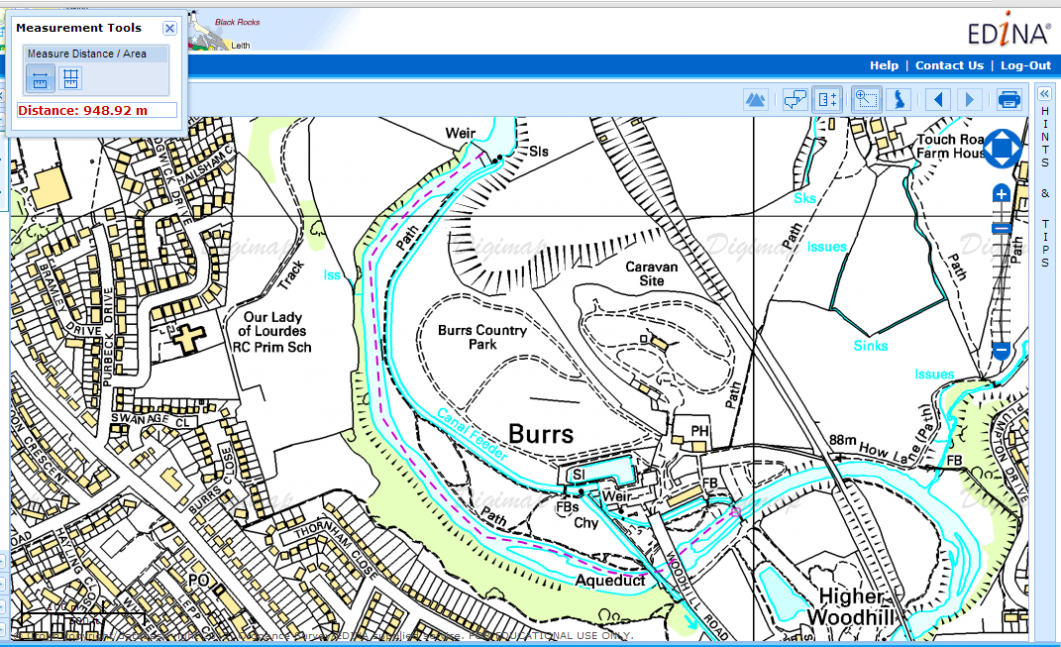
Figure 1 Map to show the section of the river being studied and the length of the river, situated in Burrs Country Park, Bury
Figure 2 has been used to represent the locations at which the sites are situated, beginning at the weir (marked with a star at the top of the map) down the foot bridge (also marked with a star at the bottom).
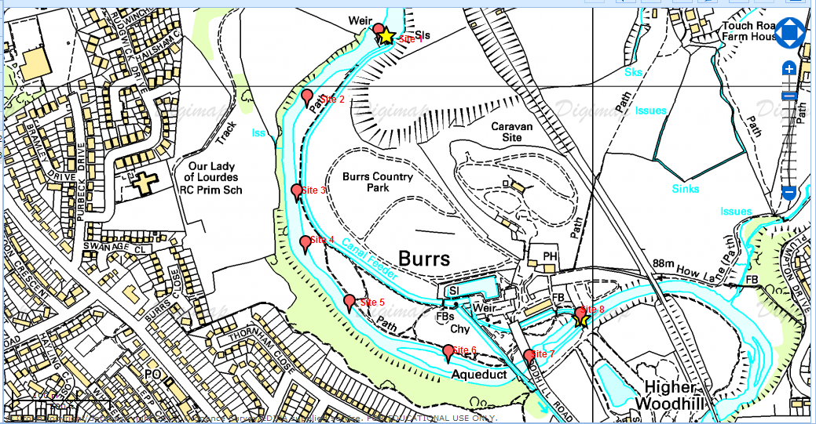
Figure 2 a map to show the locations of the sites on the river
1.4 Reasons for the choice of site
Due to the parameters of the investigation that has taken place this location has been chosen. The main aspect of the research is to try and see whether kayaking can be seen to have an impact on the functionality of the river, and surrounding areas. This location has been chosen for a number of reasons as being a prime area to conduct such a study. Previously the area has been linked to the industrial revolution where the river will have played a key role in the development of the surrounding areas; the river was once used by the cotton industry and was key assist to this development. The introduction of the weir was to change the flow of the river so that the cotton mills could be seen to benefit more greatly from the power that the river water was able to provide. Following the slowing down of the cotton trade the area which is now seen as the park was seen to become downgraded and thus resulting in degradation and has been recently transformed to a country park. (Burrs Country Park, 2008)
Due to these changes that have taken place in relation to the move from an industrial aspect to that of recreation such would make this area once of interest in seeing what changes have been seen to occur over the years. Also the popularity of the site to both novice and experienced kayakers would be beneficial in seeing if such has altered the aspects of the rivers in anyway. The river sees many kayakers travel down the river on a regular occurrence this is due to the wide range of the ‘eddies’ that are created by the river as it travels through the landscape.
There have been a number of changes that have been noted to have been changed over the years following the increased interest in of using this location as prime area for kayaking; these have included changes to the flow of the river. Some examples that can be noted when looking into this river are that of deepening of the channel to encourage there to be an increased level of water within the channel as this would allow for larger volumes of water to be able to travel the course.

Chapter Two
Literature Review
2.1 Introduction
Research will be completed at the location to see whether kayaking can be seen to cause an impact on rivers through the completion of a geomorphologic report. This report will be used to demonstrate whether or not a recreational sport can change the dynamics of a river. Then can be used to highlight any changes or advice that can be offered to reduce the amount of damage, if any that such a use can cause.
2.2 Importance of Rivers
There have been a number of ways in which rivers have been used over the years, these range from transportation and recreation to merely being cleaned and used for human consumption. Such are the reasons as to why rivers are seen as a major resource on earth. Due to the wide range of uses of the rivers can demonstrate the importance of rivers around the world.
“Rivers are a much-cherished feature of the natural world. They perform countless vital functions in both societal and ecosystem terms, health and sanitation need agricultural, navigational, and industrial use...and recreational associations.” (Brierley and Fryirs, 2005) This emphasises the wide range of uses that rivers have, highlighting that even those areas that may not have been initially considered are seen as an important aspect to human life, for example using the river water in industry emphasises the importance still even following the revolution. The way in which rivers have been used over the years for example cleaning of the water can successfully demonstrate how important rivers actually are. Due care and attention should be paid to rivers to ensure that such important features of the natural world are able to remain, rivers have been seen to be a focus for a millennia highlighting the need to protect such parts of the planet. (Centre for Research in Water Recourses, n.d.)
2.3 Rivers and their uses
Over many Years Rivers have become increasingly important in the way of human life, these will be further discussed in the following sub-sections.
2.3.1 Rivers and sanitation
The term sanitation is a complex term which needs to be defined in order to understand the importance of such rivers in such an area. Briefly the term sanitation is linked to the safe management and disposal of human excrement (Parkinson et al, 2008).
Due to the complexity of the term sanitation it can be seen that such care should be taken to ensure that the use of rivers are not overly degraded when using rivers for such an action. Sanitation is such an important aspect of life and can then influence the reasoning for the protection of rivers as they are needed to keep people healthy especially on the basis of the less economically developed countries as they are seen to use rivers a lot more as this is the only access to water that much areas are able to use. The term of sanitation is extremely important in the less developed countries as such do not have the resources to protect against such issues, as oppose to the UK who are not suffering as much from such issues.
Although the UK doesn’t suffer greatly from issues in relation to sanitation such is an important factor when looking into the healthiness of a river. in large numbers of middle and lower class income countries wastewater is released directly into seas or rivers without any treatment. (United Nations, 2013) This release of untreated waste water can be seen to cause havoc as it shifts the issue that needs to be cured upstream merely downstream. (United Nations, 2013) There is a need for the improvement of water sanitation in these harshly impacted areas as with the increased levels of urbanisation the issue can be seen to continually increase causing issues for many countries as such development is the main source of the issue of poor sanitation. (United Nations, 2013)

2.3.2 Rivers and Agriculture
Another very important area that can be seen to be seen to use rivers largely linked to the use of river and water in agriculture. There are seen to be a number of which rivers and water are used in agriculture such as irrigation and the watering of livestock. Many companies and stakeholders have realised that river and agriculture are extremely important and have thus taken care in developing ways in which to preserve such water. Unilever (2013) states that half of the water that is used is used in relation to agriculture so that it is important that water use is managed, and has taken action in arranging ways in which water may not be wasted due to the way in which water is continuing used. These findings can help to reinforce the need to protect the water and rivers that are associated with agriculture. Due to the need to preserve water it can be seen to reinforce the need to preserve the water on earth increasing the need to show the importance of rivers for everyone.
2.3.3 Rivers and Navigational uses
Using rivers for navigational uses is that based on the use of using rivers to navigate around an area, such as being able to follow a route for example to travel from one place to another, in large using rivers as a transportation factor. This term can be seen to represent the use of rivers as the transportation of people or good along the river as oppose to the river being able to transport material within the channel. This distinction is important due to the relation of the human use of rivers. Looking at the history of the term ‘navigational’ it can be overviewed that such is upon the use of kayaks or canoes on the river as a form of transportation.
2.2.4 Rivers and Industry
There are many ways in which river water has been used in industry for many years, with the majority of water on the planet being sourced from rivers it’s no wonder they are seen as so important. Throughout industry rivers have been used for many reasons ranging from power stations using the water from the river, e.g. the River Thames to cool the towers and then are returned to the river. Not only are rivers used to cool the towers they are used in order to produce electricity by a number of processes, the main renewable process is the use of rivers to turn turbines from the flow of river known widely as hydro power. An older method at which rivers have been used is due to the heating of water within a power plant through the use of coal and the stream produced causes the turbines to turn resulting in energy to be produced. Industries can also be seen to reply on rivers and channels in the fact they can be coupled with navigational aspects as they may use the rivers to transport products around the country. There are a number of impacts that can occur sue to the use of rivers in industry, for example there are issues linked to deliberate dumping of waste in river which can lead to pollution, change in temperature of the water or eutrophication, caused by fertilisers, which is a natural process of nutrient accumulation which can be seen to lead to aquatic growth, in large cases fertilisers can cause there to be algal blooms. The final influential impact on river due to industry is that of accidental spillage of hazardous materials, which can cause damage to both the rivers and the surrounding areas. (Rivers of Western Australia, n.d.)
2.3 Rivers and Recreational Activities
The final aspect which can be related to river use and apparent to the research aspect of this project is that of using rivers in the form of recreational activities, there are seen to be a numerous amounts of activities that can be achieved when looking at the aspects that rivers offer. There are a number of recreational activities that can take place near to or on the river, these include: fishing, swimming, kayaking, boating, picnicking, dog-walking, bird-watching and finally wild-life spotting. (Rivers of Western Australia, n.d.)
There are a number of factors that have to be considered before a river can be accessed as a recreational area, such is the grading of the river, such is used to demonstrate the features of each river and difficulties which may be faced before entering a river. The grading of a river is important as it can be very influential as to who can access such a river. The international grading system that is applied widely is featured below. The terms that have been used in this table have been included in a glossary found in the appendix. Figure 3 shows a visual of the different classes that are used to describe the severity of rivers (Whiting and Varette, 2008), showing well what is expected from a grading shown table 1.
Table 1 table to show international grading system of rivers, International Grading System , Cited in Berry, 2002
Grade 1 | Grade 2 | Grade 3 | Grade 4 | Grade 5 | Grade 6
Regular stream  Regular waves  Small Rapids | Passage free  Irregular stream  Irregular waves  Medium rapids, small stopper, eddies, whirlpools and pressure areas | Route recognisable  High irregular waves  Larger rapids  Stoppers, eddies, whirlpools and pressure areas | Route not always recognisable  Inspection mostly necessary  Heavy continuous rapids  Heavy stoppers  Whirlpools and pressure areas | Inspection essential  Extreme rapids  Stoppers, whirlpools and pressure areas | General speaking impossible  Possibly navigable at particular water levels
Simple obstructions | Simple obstructions in flow  Small drops | Isolated boulders, small drops, and many obstructions in stream |  | Narrow passages, steep gradients and drops with difficult access and landing | High risk
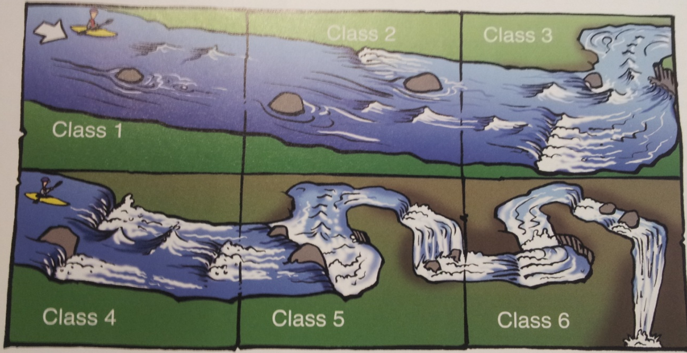
Figure 3 a visual to show the different grading in kayaking (Whiting and Varette, 2008)

2.3.1 Water Quality for recreation
The water quality of an area is seen as important factor when considering a site for recreational use, there have been standards that have been set which need to be reached in order to allow such areas to be used. Kay and Fawell (2007) discuss the need for bathing water to have a standard as they are recognised as carry potential links for decades. There are many risks linked to the water quality of a body of water, such issues include the pollution of recreational water caused by micro-organisms present in faeces. (Kay and Fawell, 2007) There has been research undertaken to demonstrate the need for standards of water to be considered for recreational and bathing standards, from which the World Health Organisation (WHO) produced guidelines from such practical research in order to develop “Guidelines for Safe Recreational Water Environments, published in 2003. Chemicals that are present in water are generally not seen to cause issues for health in recreational water although a small number that are produced by algae can cause some issues which are concerning to recreational water bodies. (Kay and Fawell, 2007) Furthermore, the main issue faced by water quality and recreation is through direct or indirect introduction of faecal matter, from animals or man which both contains pathogens of concerns to human health. (Kay and Fawell, 2007) The chemical contaminants are seen to be present from a consequence of discharge from industrial areas. (Kay and Fawell, 2007)
2.3.2 How recreational activity can lead to changes within river courses
There are a number of ways in which rivers are seen to have been changed following through the introduction to the site, Berry (2002) discusses the use of artificial and dam release sites. Such sites are used to provide a reliable source of white water, and can be excellent places to practice white water skills. Such artificial sites show how areas can be changed and developed to increase the use of the river. Artificial are seen to be made of smooth concrete, in turn water a can be seen to behave differently to those faced in a natural river environment, such areas are seem to resemble the river being flooded.
2.3.3 How rivers can be changed
There have been a number of changes that can be made to rivers in order to increase the potential use, especially for those who will use such areas for recreational uses. One example that has been at a selection of locations is that of the deepening of the channel as this can be seen to increase the level of water that is present in the channel following a period of rain. However, the Environmental Agency (2013) discusses the issues that can be seen to arise when such action is undertaken due to the affect that it can have on the surrounding areas, such as the weakening of the banks, which will in turn be seen lead to an increased level of erosion showing how kayaking could impact on that of the river environment.
Another example that can be seen when considering how rivers can be changed in order to benefit those who wish to use the area as a recreational is the introduction of foreign objects that can be seen to change the dynamics of the river. Such an example could be the addition of rocks to ensure that the river is able to produce a selection of rapids which in turn will be used at an increased level when those who are using the area benefit from. There have been changes made to rivers such as adding hand holds to sections of the river to allow people to hold on to as they are travelling along the course of the river, these changes have been seen at the location of the River Irwell at Burrs Park.
2.4.1 Water sports and leisure
Goodhead and Johnson (1996) defines the term of water sports as a leisure activity as they have citied Mintel (1992) as being that between three and four million people are involved in water sport within the United Kingdom. Goodhead and Johnson (1996) are also seen to discuss in this section of the book on the basis that water sports are seen to have both a positive and negative impact on the maritime environment. The impacts of the water sport that is felt by the maritime environment are seen to be both “an enormously complex and powerful phenomenon” and “ubiquitous and complicated” (Miller and Ditton, 1986). The impacts that such sports can be seen to have on an area can be seen to be “assessed by the number of people who are involved, types and nature of activities…the potential for conflict” (Goodhead and Johnson, 1996) as these can be seen to influential due to the levels of people who are actively using the area for water sports. Leisure has been seen to become increasingly important to those who live in Britain, and is seen as a right with this it has been noted that more and more people are becoming highly interested in the idea of becoming involved in such a leisure activity. (Goodman and Johnson, 1996)
2.4.2 Negative issues of water sports
Although there are seen to be a number of positive impacts due to the increased level of waters sports as a leisure activity these should not overlook those issues that may arise following a site becoming a ‘Honey pot site’ which can see a large influx of people to any one site. These issues have been somewhat addressed by McCormack (1994). Overcrowding is seen to be one of the major issues in relation to the aspect of waters sports on any one location, as such can cause issues which have been outline by McCormack (1994) these include issues such as over capacity of the site due to the knowledge such a site can provide high levels of leisure. These can be seen to snowball into a selection of other issues that at first may have been overlooked. The influx of people to such a ‘honey pot site’ can cause issues due to access available to the site, due to park cars filling roads.
Another issue that can be seen to be faced by many of the areas that have seen an influx of activity following the increase in people seeking such recreation is that of overcrowding. Many areas can be seen to be suffering from the increased volume of people requiring access to such sites and can cause for there to be developments to be made in order for areas to deal with the increased level of people wishing to gain access to the site, these can include developments of car parks to reduce the restriction of parked cars blocking roads.
Finally impacts that can be made to the river as a whole are important, spilled fuel and oil from the boats that could be used for recreational uses can be seen to affect the water quality of the river, which in turn can potentially cause harm and damage to plants and animals that need to rely on clean water. The boats that are being used on the rivers can be caused to cause bank erosion and sedimentation as the waves that are created stirs up the water and carves into the river bank. (Rivers of Western Australia, n.d)
2.4.3 Impacts of Canoeing
Canoeing on its own is seen to be environmentally friendly, as such a sport is able to utilise a number of water resources, including swimming pools, the sea, canals, and rivers. And although such a sport is environmentally friendly issues have arisen sue to the increased pressures on the limited resources and conflict is seem n to have occurred between anglers and canoeist. (McCormack, 1994)
3. Conclusion
After looking in detail at the aspects that need to be considered before the completion of the research it can be seen the need to complete such work, as nothing has been completed in the past to inform people about the impacts of kayaking on rivers.

Chapter Three
Methodology
3.1 Introduction
In order to complete the research there will be a number of visits that need to be made to location of Interest, previously outlined in as the River Irwell focussing on the location as it travels through Bury, accessible at Burs Country Park. Upon these visits a number of results will be collected using various methods these will include: -
- Water samples to find out the suspended sediment levels
- Width
- Depth
- Velocity
- Whether or not kayakers were present on the day of the visit
- Angel of slopes
- Cross sectional areas
- Discharge
- Hydraulic radius (see appendices for formulas used for each of these calculation)
Before any collections could take place both the application for safety and ethical approval and health and safety forms had to be completed and signed off, copies of these can be found in appendix 13 and 14.
3.1.1 Reasons for collection
Each of the parameters that will be collected will be needed in order to structure the geomorphologic report. The information which is provided by each measurement will be used in some way within the results and then further discussed within the discussion element of this report.
3.1.1.1 Water samples
There will be 3 water samples collected at each of the 8 sites along the course of the river beginning above the weir and finishing below the footbridge downstream, totalling 24 per visit. The water samples will be taken across the width of the river, facing upstream one will be taken on the near side bank, the middle and the far side bank. The samples will be collected in sample bottles, in 142ml and 148 ml bottles. The samples will be collected along this section of the river as this is the area at which kayakers are present.
There will be 4 visits to Burrs Country Park to collect the samples so there will be a final total of 96 samples which will need to be tested in the laboratory for the levels of suspended sediment. Suspended sediment has been defined by Terrio (1996) as the sediment that moves in suspension in water and is maintained in suspension by the upward components of turbulent currents or colloidal suspension. Such is important in the completion of this report as it will demonstrate whether the changes that have occurred following the movement downstream can affect the levels. Such is needed to be collected as recreational activities could cause sedimentation within the river. (Rivers of Western Australia, 2009)
3.1.1.2 Width and Depth
The width will be measured at each of the sites where the water in sampled in order for them to be used within the geomorphologic report. This data can be used to compare the changes of the river as the river moves downstream as it will be possible to monitor and comment on changes that occur throughout the stretch of the study. These comparisons that can be made on the whole stretch of the river can be seen to be used in comparison between each separate visit to the site. The width will be used in calculations, for example, cross sectional area, which will be used to produce cross sectional area maps? These then can in turn be used to compare the changes both as the river moves downstream through the sites as well as comparison to the 4 visits to the location.
Similar to measurement of the width the depth will also be assessed however, there will be three measurements taken across the width of the river, facing upstream one will be taken on the near side bank, the middle and the far side bank, similar to locations as to where the water samples will be collected from. The depths that have been measured will then be used later during calculations for example, calculating the average of the depths as this will be used in order to calculate the level of discharge which is present in the river, at each site as well as comparing over the 4 visits.
3.1.1.3 Velocity
The velocity will be collected using the flow rotational flow metre while at the river and then will be converted using the equation so that such data can be used within the results as merely the rotations can be not used. The velocity of the river will be used to compare to the changes that can be seen to occurring as the river moves downstream through the sites as well as the comparisons that can be made with the other visits. These can be used to the changes that have occurred in relation to other aspects such as whether increased velocity can be seen to occur around the locations where the river have been changed by manmade actions.
3.1.1.4 Whether or not kayakers were present on the day of the visit
The knowledge of knowing whether kayakers are present at each of the sites along the bank will need to be noted as there maybe changes that have occurred at these sites that can be linked to presence of the kayakers. The presence of kayakers can be used to show the popularity of the site to kayakers, highlighting that some areas can see a greater use than other. For example, areas which have been deepened or even modified to increase the attraction of the site may cause changes to results as well as demonstrating the impact that such a recreational sport has had on such a location following its drastic move from industry to recreational attraction.

3.1.1.5 River Gradient
The angel of the river needs to be collected to complete the report as such is needed to see what changes have occurred following the changing of the banks or channel, in such ways kayakers have developed or changed areas so that they are able to have beneficial aspects. The measurements will also be used to see the changes that have occurred following the movement downstream. The gradient of channel is calculated by the proportion of the volume of sediment load and is inversely proportional to the water volume. (Matsuda, 2004) As the gradient become steeper, there is an increase in the diameter of sediment load; resulting in the channel profile to concave upward in a general manner. (Matsuda, 2004) The gradient is seen to become steeper toward the upper sections of the river channel. (Matsuda, 2004) The gradient of the river becomes progressively gentler as the erosion of the river proceeds in turn the energy of running water is seen to decrease. (Matsuda, 2004)
3.1.1.6 Cross sectional areas
These will be calculated following the visits using the appropriate data that has been measured; from this comparisons can be made following the construction of cross sectional area graphs. The graphs will be used in the results chapter to show the changes that can be seen to occur in relation to the movement downstream through each site as well as comparisons that can be made between each separate visit to the location of interest.
3.1.1.7 Discharge
The discharge of the river will be calculated upon the return from the field, such data is important as it demonstrates the amount of water that is currently present in the river. The importance of knowing of the level of discharge present can be compared to all the sites down the river as well as the comparisons that can be made to each of the other visits to the selected location. Discharge is defined by Manning (1997) as being the unit volume of water flowing in the stream per unit of time,
3.1.1.8 Hydraulic radius
These will all be collected as primary data upon visits to the location from these results calculations will be completed using a spread sheet programme from which tables and graphs will be able to be constructed. These results will be represented in the results chapter and fully explained in the discussion chapter. The hydraulic radius is used as a method of measuring the efficiency of the river channel in question, the higher the level of hydraulic radius the more effective the river can be seen to be. This can be useful in the completion of this dissertation as the data will show whether kayakers could have actually impacted on the river.
3.2 Collecting of the field data and measurements
Collecting data from the field will ensure that such data that is collected is primary data; such is important due to the reliance on such results. Collecting the data primarily will decrease the level of influence other humans have been seen to influence such data. Having collected such data it can be assured that all data is correct, as such has been collected following a standard methodology. Also, once the primary data has been collected secondary data can be used to compare and contrast the data that has been collected primarily from the location. The main aspect that such data needs to be collected primarily from the selected site is due to the way in which no other research like this has been undertaken in the questioning site.
3.2.1 Advantages of collecting primary data
There are a number of advantages that can be seen from collecting data directly from the field as the data will be primary data. The first and main advantage is the intimate knowledge which the researcher has with the data, ensuring that all data in correct to a level of accuracy. (Pearsons and Knight, 2005) Another major advantage of primary data is that the researcher can collect the exact data that is required for the research being undertaken. This is seen as an advantage to secondary data due to the way in which secondary data may not relate specifically to the question the researcher is looking to complete. Highlighting that such field research should be undertaken by the researcher to ensure that all the data that needs to be collected is done so. (Pearsons and Knight,2005)
3.2.2 The “reccy” Visit
The “reccy” visit to the selected location is important as it allows decisions to be made about the location, for example deciding whether such a location can be seen to have all the aspects that are needed to complete the research. The issues that can be resolved on visiting the location before actual research is taking place is that to decide where each of the sites will be situated as access will need to be monitored in order to ensure that most of the data collection can be completed on each visit. The “reccy” visit will also allow for precautions to be made, for example; creating a water catching device that will be used if the river is seen as potentially dangerous and can therefore not be accessed. As well as deciding to wear a dry suit while accessing the river as the water maybe too deep and cold to access in just waders.
3.2.3 Collecting of water samples for testing in the laboratory for suspended sediment
Along the stretch of the river at 8 different locations 3 samples of water will be collected, one from either bank and one from the middle. These will then be tested later in the laboratory for the level of suspended sediment in each, once the samples have been collected they do however not need to be kept in at a certain temperature so the samples collected over the summer months will be able to be analysed once returning to university in the autumn.
Upon collecting the samples due care and attention must be applied due to the accessing of the river therefore a buoyancy aid must be worn on entering the river as well as rescue line which the other member of the team will be holding on the bank in case of an incident.
Following the “reccy” visit to the site which has been studied it was noted that action will need to be taken if the access of the river will not always be possible, due to the temperature of the water or the flow. Following this a device was constructed so that that the collector is able to stand on the near side bank and collect the samples from the opposing bank. Such has been constructed by modifying a fish angling pole so that a small container can be attached to the end and dipped into the water to collect the sample, which will then be placed in to the pre-cleaned water sample bottles that have been previously used. This will allow for those samples that may have been missed due to both dangerous levels of water increasing the flow of the river as well as the danger due to hyperthermia as to accessing the river in conditions that may not have been previously anticipated. Following the collection made in the summer months it was realised that extra equipment will be required to ensure safety when accessing the river in the winter months these include:
- Dry suit
- Water catcher which has been developed over lay period
- Measuring jug – to allow easier pouring into the water samples bottles
3.2.4 Collecting data about the formation of the river – Width, Depth and Flow
As well as completing the water samples other results will need to be collected on each visit to the river too, such as the width, depth and flow of the river. These will allow for a detailed documentation to be made about the river as a whole. As mentioned earlier the results that have been collected upon the visit will later be analysed to see the changes that have occurred over the time the research has taken place. As above, following the first visit to the site extra equipment shall be required for the next visit:
- Dry suit
3.2.3 Visiting the lake while kayakers are present
To ensure the correlation between recreation and the river can be seen there will be need to have a visit to the river during peak seasons for kayakers as these will be needed to monitor the levels of visitors which can be seen to impacting on the river.
3.2.4 Issues which may arise in field
As project will be completed the a whole year there maybe difficulty accessing the river due to the flow being too fast and strong due to the high levels of precipitation that has fallen in the recent time scale. In these cases second hand data will have to be used in order to complete the results which were collected. This form of second hand data will be received from the environmental agency as they are seen to monitor many rivers, including section of the one which this project is discussing.
3.2.4 Laboratory Sessions
There will be a number of laboratory sessions in order to complete the tasting of the samples that have been collected through the research.
3.2.5.1 Filtering of the samples
During the session filter papers will need to be weighed, in turn and then labelled to match the water samples bottles that were used in the field to collect samples. An example of this labelling would be C1 S1 S1 which represents that the filter paper shows the sediment collected from Collection 1, Site 1 Sample 1.
Following the labelling of the filter paper each will in turn be used to filter the samples that are passed through a suction pump. The sample paper is placed in the Buchner funnel which is used to filter the water, the filter paper catching the sediment. The water will then be collected in a flask underneath.
Once all the samples have been filtered the papers will be placed on a tray to be to left to dry until the following week. The samples do not need to dried in any particular way, the samples can be left in the laboratory on trays until the following week.

3.2.5.2 Weighing of the samples
In the following session a week later each of the sample papers will be reweighed to see whether or not there is in an increase in weight compared to sample papers before filtering the water samples. The weight of the suspended sediment will be calculated by deducting the weight of the filter paper which was weighed in the previous session from the weight of the filter paper when weighed in the second session. This will leave the weight of the suspended sediment at each of the sites along the stretch of the river, at each of the points across the width of the river. In order to calculate the weight and amount of sediment is present a number of calculations need to be completed in order to find mg per litre of sediment.
Mg Total Solids/ L = $\frac{\left(A-B\right)X 100}{mL Sample}$
Where A = weight of filter paper and residue, B= weight of filter paper (Hydrology project, 1999)
3.2.6 Method Development
There were a number of ways in which it was considered how to complete this research to ensure that all the data that was needed to be collected was sourced. Research was undertaken to see what should be collected in order to complete a full geomorphologic survey highlighting which of the measurements will need to be collected on site to then be used to complete the surveys.
The other methods that were considered during the development of the project were that of talking to those who were present at the rivers upon my visits to see what people think about the use of the river, however these interviews were not undertaken due to the chances that they may not be able to provide enough representative data that could allow proof of the impacts of kayaking. As there may not have been enough people to question when visiting the location, so such information about the impacts of kayaking will be founded through reading and secondary data.
The benefit of completing the primary collection of data is important as such data can allow for predictions to be made on the account of whether or not kayaking can be seen to have made an impact on recreational areas, focussing on the data that has been found at the selected site, River Irwell located at Burrs Park Bury.

3.3 Examples of tables
This section will show examples of the tables which will be completed during both the field and laboratory sessions.
3.3.1 Example of the table that will be used on site visits
As there will be primary data that will be collected through the research a table must be developed so that it can be used during the field work completion.
Visit 1
Sites | 1 |  |  | 2 |  |  | 3 |  |  | 4 |  |  | 5 |  |  | 6 |  |  | 7 |  |  | 8
Width (m)
Depth (m)
Wetted Perimeter (m)
Velocity (count)
Were there Kayakers present?
Angle of Slopes
Table 2 an example of the table that will be used on field visits

3.3.2 Example of the table that will be used in the first laboratory session
During the laboratory session a tale like this will be present in the first session, which will feature the weight of the filter paper prior to filtering of the samples, there will be a table for each collection that was made. A similar table will be used in the second session to note the new weights as well as noting which size bottle has been used for each of the water sample collections.
Collection 1
 | Sample 1 | Sample 2 | Sample 3
Site 1
Site 2
Site 3
Site 4
Site 5
Site 6
Site 7
Site 8
Table 3 example of the table used in the first laboratory session

Chapter Four
Results
4.1 Introduction
This chapter will contain the results that have been found in relation to the geomorphologic report that has been completed on the site. The appendix located in this report contains the entire primary data that has been collected and sorted into this chapter. See appendix 15 for photographs and captions in relation to this section.
4.2 Sediment per litre travelling downstream at sites
From the 4 collections that have been taken and tested will be looked at individually in the 4 following sections on the basis of the suspended sediment. See appendix 1 – 4 for raw data that has been analysed for the following subsections.
4.2.1 Collection 1 – Suspended Sediment mg/L

Figure 4 Collection 1 suspended sediment (mg/L)
Figure 4 represents the levels of suspended sediment that have been collected and sampled within the laboratory, documenting the mg/L of suspended sediment at each site from the three samples. The peaks that have been seen to occur at site 7, on the second and third sample, the middle and the far bank. The other samples that have been graphed do not show a great difference across the board as they are grouped together near the near the bottom of the scale. The results show how the changes are seen to occur as the samples are collected near the end of the location that has been studied. From the results that are located in appendix 1 there can be seen to be a drastic increase at site 7 at both the middle (6.704 mg/L) and far side bank (12.810 gm/L), compared to a low sample for example at sample 1 of site 1 (0.014 mg/L) which can be seen as a result of the speed of the moving water. Overall the samples seem to show a high level of consistency, as there are only a couple of extreme outliers which are seen to impact on the results.
4.2.2 Collection 2 – Suspended Sediment mg/L

Figure 5 Collection 2 suspended sediment (mg/L)
Figure 5 represents the data that was collected at the 2nd collection to the location at each site; these results have demonstrated a greater influx and change throughout the collection of the samples. Although there are groupings of data one peak that can be seen is that at site 8 from the first sample that was collected, the near side bank. There can be seen a gradual increase from site 5 to site 8 following the slow decrease that can be seen from all three samples that were collected at site 1, above the weir. There seems to be a much more range in the data collected on the second day of sampling there are also not any samples that are seen to have an extreme increase unlike those that were graphed in figure 1. The largest sample that has been collected is from the second samples collected from the centre of the channel at site 1 (0.09459 mg/L) it is obvious looking directly at the table situated in appendix 2 that overall on the second sampling day the suspended sediment is lower mg/L across the table, due to the lower mg/L present in each sample.
4.2.3 Collection 3 – suspended Sediment mg/L

Figure 6 Collection 3 suspended sediment (mg/L)
Figure 6 represents the data from the samples that have been collected from the third collection to the specific site location. The samples that have been collected at the third sample have again seen a large change in the movement downstream, there are seen to be a number of peaks and troughs demonstrating the changes that occur through the movement downstream. A low sample collected from the third visit is from the third collection on the far bank at site 8 (0.0067567 mg/L) which is actually the same found at site 7, in the similar position showing the slowing down of the river as approaching this section. The highest sample that was collected from site 1 from the first sample on the near side bank (0.040540541 mg/L) compared to the highest value being seen at site 8 sample 3 (0.00675676 mg/L) which is the far side bank showing the river is not able to carry the suspended sediment at this section of the river.
4.2.4 Collection 4 – Suspended Sediment mg/L

Figure 7 Collection 4 suspended sediment (mg/L)
Figure 7 shows the suspended sediment levels that were collected on the fourth visit to the site; the graph shows a general correlation between all the samples at each site with only a peak form the first sample collected from site 5, the near side bank, the second peak located at site 8 from the second sample collected, the middle of the channel. This correlation can be seen to show how the river has managed to carry the same amount of suspended sediment around the whole river sampled with an a drastic increase at site 5 showing that there is an increased amount of suspended sediment present in this section of the river.

4.2.5 Sediment per litre overall at all 4 visits
Collection | Total suspended sediment | Average
1 | 19.986 | 0.833
2 | 0.519223449 | 0.021634
3 | 0.358108108 | 0.014921
4 | 3.529691663 | 0.14707
Table 5 the average and total weight of the suspended sediment from all collections mg/L
Table 5 shows the total of the suspended sediment that is present throughout the whole distance of the river. There can be seen to be a drastic increase between these highest levels of suspended sediment and the lowest suspended sediment found on the third collection. The total shows that on the first collection day is seen to be the most affective at carrying sediment downstream. The raw data that has been collected and analysed to complete Figure 7 can be found in appendix 5.
4.3 Velocity of river at all sites

Figure 8 Graph showing the how velocity changes moving downstream after all 4 collections
Figure 8 shows the data that has been collected over the 4 collections that took place and how the velocity has been seen to change while travelling downstream through the various sites. Figure 3 shows a drastic increase in the velocity on the final visit to the selected study site, such a graph is important in order to see the changes that can be seen to occur through the movement through the rivers course. The velocity has a large peak at site 2 on collection 4 and again at site 8. The peak of velocity is located at site 2 on the second collection and the velocity is 0.4804160000 which is the highest value that can be seen as the minimum value present, the lowest calculation of velocity is also found on the fourth collection at site 4 0.0525620000 which can show this collection is the seen to have the widest range of data. The three other collections are seen to be closely grouped together making showing that there was not much change between these collections. The raw data that has been analysed to complete figure 8 is found in appendix 6.
4.4 Velocity compared to discharge at each location on each collection

Figure 9 Graph to show the comparison between velocity and discharge at each site on each collection
Figure 9 shows a graph that demonstrates a comparison between discharge and velocity found at each site upon each collection. There can be seen a general correlation between the levels of velocity that has been seen collected. The relation between the velocity and discharge are linked as with the increase or decrease of water within a river channel can seen the change in the velocity. The fourth collection seen the greatest increase in both the velocity and the discharge, there are peaks noted at site 2, site 7 and finally site 8. However, at site 6 there is an increase in the velocity that, however the discharge does not increase at the same rate as seen in the other site areas but also against the discharge. The raw data that has been analysed to produce figure 9 can be found in appendix 7. The highest points of velocity and discharge are both found at site 8 on the fourth collection, velocity was rated at 0.56780867 at the site compared to the discharge at 5.25967514.
4.5 Whether or not kayakers were present at each site on each collection
Table 6 is a table to show the locations where kayakers were present on each collection
Site | Collection 1 | Collection 2 | Collection 3 | Collection 4
1 | No | Yes | Yes | Yes
2 | No | Yes | Yes | Yes
3 | No | No | Yes | Yes
4 | No | No | Yes | Yes
5 | No | Yes | Yes | Yes
6 | No | Yes | Yes | Yes
7 | No | No | Yes | Yes
8 | No | No | No | No

Figure 10 a map to show the site locations
Table 6 shows a table produced to show where along the course of the river kayakers are seen to be present and on the collection that they were present; such a table has been produced to see whether or not kayakers are seen to impact on the river as a whole. The overuse of the river by the use of kayakers could have caused there to be a change in the river overall. On the first collection there were not kayakers present in the river, this could have caused the differing results that were collected on this occasion. Collection 2 saw kayakers to present at 4 of the sites, located at site 1 and 2, and 5 and 6. The third collection saw the presence of kayakers at all the sites except for site 8, the fourth and final collection saw again kayakers present at all of the sites, except for again site 8. From this it can be concluded that site 8 is not impacted by kayakers as they exit the river between site 7 and 8. Figure 10 is used as a visual tool to highlight the places in which kayakers are seen to be present through the visit to the location.
4.6 Comparison of the changes in width and depth upon the movement downstream

Figure 11 graph showing comparison of the depth and average width moving downstream on all 4 collections at all sites
Figure 11 is a graph comparing the depth and the average width of each of the sites located at the river, used to show the links between the depth and width within the river channel. There are similarities between the changing in widths and depths. Site 6 sees a drop in both the width and depth followed by site 7 having a drastic increase in the width with a less drastic increase in the depth. Not only can changes be seen in the changes that have occurred over the river channel but also changes that have occurred on the numerous visits to the sites. Site 4 can be seen to show a drastic decrease from collection 1 to collection 4, such could be seen by eye upon the visit to the river losing its excess water from the winter. The raw data that has been analysed to produce figure 11 can be found in Appendix 8.
4.7 Average velocity of 4 visits against average Hydraulic radius

Figure 12 Average hydraulic radius and velocity on all 4 collections
Figure 12 shows a comparison between the hydraulic radius and velocity; together they show the effectiveness of river as it moves downstream. The graph shows how the increase of the hydraulic radius can be used to show an increase in the efficiency of the river. The raw data that has been analysed to produce figure 12 can be found in appendix 9.
4.8 Hydraulic Radius to show the efficiency of the river
Figure 13 Hydraulic Radius at each site on each collection
Figure 13 shows the hydraulic radius of the river at each of the sites, going into greater depth than figure 12, general correlation can be seen throughout all of the collections that have been made at the designated location generally showing that on each visit each have been similar. However, there could be noted at site 5 on the fourth collection that can be seen to be lower than all the other results that have been collected previously. There has also been an increased and sudden drop from overall the data at site 6, such has occurred on all four of the collections and seen to rise steadily together towards site 7 and then all increasing in a group to site 8. The raw data that has been used to produce figure 13 can be found in appendix 10.

4.9 Changes in widths moving downstream at all sites at all 4 collections

Figure 14 Changes in widths moving downstream at each site on 4 collections
Figure 14 is used to show the changes in widths that can be seen to occur travelling downstream there are changes that can be seen to occur in such parameter, the widths can be seen to change on both site to site as well as the collection days. Collection 4 saw changes of drastic changes at site 5 and 6. On a general term the width of the river stays about the same with some fluctuation between site 1 and 5, then there is a drastic drop towards 6 then greatly increases to 7 and stays similar to site 8.
Chapter Five
Discussion
5.1 Discussion
In this chapter the results that were found in previous chapter Results will be discussed in detail, explaining what all the results mean. As well as discussing the results that have been found the limitations that have been faced have been faced throughout the completion of the dissertation. There are a number of findings that have been found in order to support the hypothesis originally outlined is correct.
The main aim of the report was to discover whether kayaking has been seen to impact on the specific section of the River Irwell, at Burrs Park. There has been an increased amount of use on the river due to the development and modification of the river through the building of the weir; Charlton (2008) following the reduction of importance of the weir the river was seen to become largely impacted by an increased use of the area as a recreational activity area. The building of the weir was seen to be an industrial development whereas now it has become largely recreation based.
The ability for a river to work is largely based on its ability to pick up and transport its sediment; this is largely based upon the energy of the river, Morisawa (1986) shows that 95 to 97% of the energy of a river is lost through conversion to heat. Such conversion is made through the inner turbulence as well as friction on its channel walls and bed, such action results in the energy being lost. Following this loss of energy only a small part is left which can be used by the river to transport the sediment load; however this process is seen as one of most important process within the river. Looking solely at the suspended sediment present in the river Irwell can be used to show the efficiency of the river, the suspended load is defined by Morisawa (1986) as being composed of finer particles than the bed load and the grains supported by the fluid and carried above the layer of laminar flow. Laminar flow refers to the flow of water as it moves along a constant path, referred to in many cases as the current.
The gradient of the river can be seen to impact on this flow which is why the sediment that is transported can be seen to be impacted in the lower sections of the river. (Whiting and Varette, 2008) Such sediment once it has entered the flow can be carried by the current with less velocity than the critical velocity needed to erode the bed. Finally, the suspended load decreases the inner turbulence of the water; resulting in the reduction of frictional losses of energy this makes the river more efficient. From this, the findings which were made based on the River Irwell, from the figures in Chapter 4: Results show how the efficiency of the river can be seen to change over the 4 collection of samples that took place, figures 3 to 6 show how fluctuations can be seen to occur throughout the whole case study. Showing in detail that changes can occur moving downstream, from these figures a positive correlation can be noted to show that the river can be seen to be efficient on the basis of suspended sediment. Looking at the river as a whole on all 4 collections it can be seen that the rivers efficiency can be seen to change over the 4 collections that were made, the most efficient time for the river was that of the first collection made completed in the summer month of July, this can be seen by the increased level of suspended sediment present in the samples that are collected over the 4 collections.
The hydraulic radius of the river is used to see how efficient the river is, the higher the result the more efficient the river actually is there a number of effects that an increased level of hydraulic radius has on a river for example, it has more energy to move downstream, in turn as the hydraulic radius increases in turn the velocity of the river increases. Such changes can cause for there to be an increased amount of load that the river can carry resulting in both the competence and capacity increases. Looking specifically at the upper sections of the water course there is an increase of erosion, the increased hydraulic radius results in an increase in vertical erosion so this can in turn cause an increase in the gradient in this section of the river. Furthermore as the river moves downstream and there is an increase in the hydraulic radius there can be seen an increase in the lateral erosion as the water is seen to be closer to the base level.
From the research that has been completed there is seen to be a minimal impact overall that has been caused by the site being used as a recreational purpose, Scottish Sport Council (1997) supports such a conclusion as in most water sport users act responsibly, such act with consideration for others and the countryside resulting in there being a minimal amount of damage to be made to an area, reducing the overall impact of recreation on such an area. Finally, Scottish Sports Council concludes that natural causes, water extraction and other non-recreational activities tend to cause more damage to bank erosion within rivers than water sports actually do. These can be due to the way in which overuse can occur in only a small section of rivers, and the time at which the intense use of rivers is a short time, so the river is seen to be able to recover in the lay period.
Weirs are used to allow the river to loose gradient, which in turn results in the energy of river to be reduced in one go. (Matt Berry, 2002) Such an action results in the reduction in the erosive power of the river, such can result in the in the slowing down of the river this in turn can create sections of deep water for the river traffic. With all this in mind such action could have been undertaken at the location to change the dynamic of the river. With the weir being introduced to the location the gradient is dramatically decreased quickly which in turn may be the reason as to why such gradient does not change dramatically further downstream so in turn has impacted greatly on the way in which the river has developed over the years.
Before the completion of the hypothesis a prediction was made that there would be an increased level of suspended sediment present at site 1 due to the high access of kayakers in this section due to the kayakers accessing the river at this location. Such would have been caused by the way in which kayakers are seen to access the river; such is done due to the way in which they access the river through ‘seal diving’. This form of accessing the river can be seen to cause damage similar to footpath erosion due to the repetitive erosion of the banks due to the dragging of kayaks over the land. Photos have been taken to show these impacts on the river.
5.2 Limitations
Although care has been taken to complete this report to the best of the ability possible a number of limitations can be seen. One of the limitations that should be considered of time constraints and the limited visits that were made to the selected location, to improve this increased number of visits will be made to the selected location to collect even more data about the site. This extra data can be used to compare to the data found in this report to see whether impacts have been made over a wider range of dates. For example a completion of a similar report in the future may see a number of changes that can be seen to impact on the river.
As well as longer time to complete the research another limitations is the issue that only one site was considered, being able to compare this report to another one completed on a similar recreational impacted location could show the overall impacts that kayaking can have on a location.
5.3 Conclusions / recommendations and Future studies
From the completion of the report there are a number of conclusions that can be made; although major changes to have been made in the future such actions may cause damage over the years. The increased use of the water ways and the changing of the use from an industrial and trade benefactor to that of a recreational area since being landscaped and developed into a park like area have changed the views that people have of an area.
There a number of changes that could be made to protect the area surrounding the river channel to ensure that kayaking is not seen to impact on the area in future years such as developing access areas that are protected against kayakers ‘seal diving’ off the bank into the river above the weir. Extra precautions can be made to such an area to increase the bank stability and protection as the areas have been seen to be damaged over the over use of the river. There are a number of ways in which such areas could be protected fir example the introduction of a concrete slip way, however such would cause there to be damages to the boats that access the river and may even cause more damage to the river due to the additions of foreign objects such as plastic which in turn could cause an increased level of damage as oppose to the bank being added to the river’s discharge.
From the research that has been completed there have been minimal changes that can be seen to have occurred, so future studies could help to develop the research that has been completed over the year, these studies could be completed over either a longer period of time, for example two years to see the changes that have occurred over the time span or a lay period could be left between each yearly research to see any drastic changes that have occurred at the one location, as long as the same methods are followed and a similar report is completed to see any changes that have been seen to occur over the years. The testing could either be completed at the same location of River Irwell, Burrs Country Park or at a location that has a similar influx of people to a location for a similar recreational activity; again a similar report would need to be produced following the same methodologies and data collections to be able to compare and contrast any changes.
Scotland has provided areas for recreational sports such as kayaking to place, (Scottish Sports Council, 1997) such are areas provided to the public from public areas. The local authorities use such areas to provide country parks for people to use, in the similar way in which Burrs Park has been developed following the decrease of industrial use for cotton. However, Scotland has taken such areas and authorities to take such areas and provide a number of facilities, such as loch access points, boat launching facilities, car parks and a number of other amenities. (Scottish Sports Council, 1997) Such action could be taken in England and on them location at Burrs Park to reduce the damage that could be made to the location due to the overuse of the site, as this is the main way in which recreational activities are seen to impact on those key areas.

References
Berry, M. 2002 British Canoe and Kayak Handbook. 3rd Chapter 22: Reading White Water p288 – 289
Berry, M. 2002 British Canoe and Kayak Handbook. 3rd Chapter 22: Reading White Water p 291
Centre for Research in Water Resource. (n.d) Channel 5 River Channels CRWR: Austin Accessed on: http://www.crwr.utexas.edu/gis/gishydro00/ArcGIS/chapter5.pdf Last accessed: 22/2/2013
Devesa, F., Comas, J., Turon, C., Carrasco, F. and Poch, M. 2009. Scenario analysis for the role of sanitation infrastructures in integrated wastewater management. Environmental Modelling and Software [online] 24 (3) Available through http://www.sciencedirect.com/science/article/pii/S1364815208001473 [22/3/2013]
Environmental Agency. (2010). Watercourse maintenance frequently asked questions. Available: http://www.environmentagency.gov.uk/static/documents/Research/WatercourseMaintenanceFAQsFINAL.pdf. Last accessed 14/02/2013.
Goodhead, T. and Johnson, D. 1996. Suffolk: E & FN Spon
http://trca.on.ca/dotAsset/55395.pdf
http://www.un.org/waterforlifedecade/swm_cities_zaragoza_2010/pdf/01_water_quality_and_sanitation.pdf Last Accessed: 15/3/2013
Hydrology Project 1999 New Delhi http://cwc.gov.in/main/HP/download/10%20How%20to%20measure%20solids.pdf
Jones J.A.A. 1997 Global Hydrology Processes, Resources and Environmental management Addison Wesley Longman Limited: Essex
Kay, D. & Fawell, J. 2007 Standards of Recreational Water Quality. An FWR Guide. Marlow Foundation for Water Research
Manning, J.C. 1997 Applied Principles of Hydrology. 3rd. Prentice Hall: New Jersey P.183
Mant, J., Pryce, A. and Holloway, J., 2009 River Irwell, North Manchester Restoration Project, Restoration and Enhancement. Cranfield. The Rivers Restoration Centre Available at http://www.bury.gov.uk/CHttpHandler.ashx?id=7836&p=0 Last Accessed: 25/2/2013
Matsuda,I. , (2004), RIVER MORPHOLOGY AND CHANNEL PROCESSES, in Fresh Surface Water, [Ed. James C.I. Dooge], in Encyclopedia of Life Support Systems (EOLSS), Developed under the Auspices of the UNESCO, Eolss Publishers, Oxford ,UK, [http://www.eolss.net]
McCormack, F. 1994. Water Based Recreation managing water resources for leisure. Suffolk: ELM Publications
Miller, M. and Ditton, R.D.(1986) Travel, tourism and marine affairs, Coastal Zone Management Journal, 14 (1/2)
Mintel (1992) Water sports Leisure Intelligence, Vol.4.
Morisawa, M. 1968. Streams their dynamics and morphology. McGraw-Hill Book Company: London 41
Morisawa, M. 1968. Streams their dynamics and morphology. McGraw-Hill Book Company: London p 61
Newson, M. 1994 Hydrology and the River Environment. Clarendon: Oxford
Pearons, T. & Knight, P.G. 2005 How to do your dissertation in Geography and related disciplines 2nd Oxon: Routledge
Peter Scott Planning Services. 1997. Calmer Waters: Guidelines for Planning and Managing Watersport on Inland Waters in Scotland. Scottish Sports Council: Edinburgh
Rivers of Western Australia (n.d) http://www.rowa.org.au/pr_uor_farming.php last Accessed 22/3/2012
Rivers of Western Australia, (n.d) Uses of Rivers: Industry Available on: http://www.rowa.org.au/pr_uor_industry.php . Last accessed 22/3/2012
Rivers of Western Australia, (n.d) Uses of Rivers: recreation Available on: http://www.rowa.org.au/pr_uor_recreation.php . Last Accessed: 22/3/2013
Rivers of Western Australia,(n.d) Uses of Rivers: Farming Available on:
UN Water Decade Programme. Water Quality and Sanitation. UN-Water Decade Programme on Advocacy and Communication Available at:
United Nations 2013 Water Quality and Sanitation: Media Brief Available from
United States Environmental Protection Agency (2003) Bacterial Water Quality Standards for Recrational Waters (Freshwater and Marine water) Available at : http://water.epa.gov/type/oceb/beaches/local_index.cfm Last Accessed: 25/3/2013
Ward, R.C. and Robinson, M. 2000 4th ed. Principles of Hydrology McGraw Hill: London
Whiting, K. And Varette, K. 2008. 2nd. White Water Kayaking: The Ultimate Guide. P263 The Heliconia Press: Ontario
Whiting, K. And Varette, K. 2008. 2nd. White Water Kayaking: The Ultimate Guide. P 97The Heliconia Press: Ontario
Whiting, K. And Varette, K. 2008. 2nd. White Water Kayaking: The Ultimate Guide. P94 The Heliconia Press: Ontario

Appendix 1

Collection 1
Sites | 1 |  |  | 2 |  |  | 3 |  |  | 4 |  |  | 5 |  |  | 6 |  |  | 7 |  |  | 8
Width (m) | 12 |  |  | 11 |  |  | 15 |  |  | 11 |  |  | 15 |  |  | 5 |  |  | 18 |  |  | 20
Depth (m) | 0.12 | 1.13 | 0.75 | 0.35 | 0.75 | 0.5 | 0.1 | 0.65 | 0.14 | 0.14 | 0.65 | 0.45 | 0.3 | 0.85 | 0.45 | 0.13 | 0.45 | 0.25 | 0.15 | 0.55 | 0.2 | 0.3 | 0.8 | 0.24
Depth (m) Average | 0.666666667 |  |  | 0.533333333 |  |  | 0.296666667 |  |  | 0.413333333 |  |  | 0.533333333 |  |  | 0.276666667 |  |  | 0.3 |  |  | 0.446666667
Wetted Perimeter (m) | 25 |  |  | 22 |  |  | 21 |  |  | 24 |  |  | 26 |  |  | 23 |  |  | 28 |  |  | 29
Velocity (count) | 10 | 15 | 12 | 12 | 17 | 12 | 11 | 23 | 9 | 12 | 33 | 14 | 9 | 22 | 8 | 8 | 33 | 7 | 7 | 22 | 5 | 4 | 25 | 7
Velocity (count) Average | 12.33333333 |  |  | 13.66666667 |  |  | 14.33333333 |  |  | 19.66666667 |  |  | 13 |  |  | 16 |  |  | 11.33333333 |  |  | 12
Velocity | 0.060421667 |  |  | 0.061548333 |  |  | 0.062111667 |  |  | 0.066618333 |  |  | 0.060985 |  |  | 0.06352 |  |  | 0.059576667 |  |  | 0.06014
Were there Kayakers present? | No |  |  | No |  |  | No |  |  | No |  |  | No |  |  | No |  |  | No |  |  | No
Angel of Slopes | 2 |  |  | 2 |  |  | 3 |  |  | 5 |  |  | 4 |  |  | 4 |  |  | 5 |  |  | 4
Cross sectional Area | 8 |  |  | 5.866666667 |  |  | 4.45 |  |  | 4.546666667 |  |  | 8 |  |  | 1.383333333 |  |  | 5.4 |  |  | 8.933333333
Discharge | 0.483373333 |  |  | 0.361083556 |  |  | 0.276396917 |  |  | 0.302891356 |  |  | 0.48788 |  |  | 0.087869333 |  |  | 0.321714 |  |  | 0.537250667
Hydraulic Radius | 0.32 |  |  | 0.266666667 |  |  | 0.211904762 |  |  | 0.189444444 |  |  | 0.307692308 |  |  | 0.060144928 |  |  | 0.192857143 |  |  | 0.308045977
Table 7 the completed table following the 1st visit to the river (June 2012)

Table 8 weight of filter paper in g prior to filtering, collection 1
Collection 1
 | Sample 1 | Sample 2 | Sample 3
Site 1 | 0.195 | 0.203 | 0.199
Site 2 | 0.204 | 0.197 | 0.200
Site 3 | 0.200 | 0.203 | 0.203
Site 4 | 0.203 | 0.199 | 0.203
Site 5 | 0.203 | 0.206 | 0.200
Site 6 | 0.203 | 0.199 | 0.203
Site 7 | 0.202 | 0.207 | 0.200
Site 8 | 0.195 | 0.198 | 0.198

Table 9 the codes for the bottles to distinguish between the two sizes, collection 1
Collection 1
 | Sample 1 | Sample 2 | Sample 3
Site 1 | 1 | 1 | 1
Site 2 | 1 | 1 | 1
Site 3 | 1 | 1 | 1
Site 4 | 1 | 1 | 1
Site 5 | 1 | 1 | 1
Site 6 | 1 | 1 | 1
Site 7 | 1 | 1 | 1
Site 8 | 1 | 1 | 1

Table 10 weight of the filter paper post filtering and drying, in g, collection 1
Collection 1
 | Sample 1 | Sample 2 | Sample 3
Site 1 | 0.197 | 0.203 | 0.212
Site 2 | 0.206 | 0.199 | 0.213
Site 3 | 0.203 | 0.204 | 0.207
Site 4 | 0.204 | 0.202 | 0.205
Site 5 | 0.203 | 0.208 | 0.201
Site 6 | 0.205 | 0.200 | 0.205
Site 7 | 0.203 | 1.159 | 2.019
Site 8 | 0.201 | 0.200 | 0.202

Table 11 conversion from g to mg, collection 1
Collection 1
 | Sample 1 | Sample 2 | Sample 3
Site 1 | 197 | 203 | 212
Site 2 | 206 | 199 | 213
Site 3 | 203 | 204 | 207
Site 4 | 204 | 202 | 205
Site 5 | 203 | 208 | 201
Site 6 | 205 | 200 | 205
Site 7 | 203 | 1159 | 2019
Site 8 | 201 | 200 | 202

Table 12 final results of suspended sediment per litre, collection 1
Collection 1
 | Sample 1 | Sample 2 | Sample 3
Site 1 | 0.014 | 0.000 | 0.092
Site 2 | 0.014 | 0.014 | 0.092
Site 3 | 0.021 | 0.007 | 0.028
Site 4 | 0.007 | 0.021 | 0.014
Site 5 | 0.000 | 0.014 | 0.007
Site 6 | 0.014 | 0.007 | 0.014
Site 7 | 0.007 | 6.704 | 12.810
Site 8 | 0.042 | 0.014 | 0.028

Appendix 2

Collection 2
Sites | 1 |  |  | 2 |  |  | 3 |  |  | 4 |  |  | 5 |  |  | 6 |  |  | 7 |  |  | 8
Width (m) | 12.5 |  |  | 11.6 |  |  | 15.7 |  |  | 11.6 |  |  | 16 |  |  | 5.3 |  |  | 18.2 |  |  | 20.5
Depth (m) | 0.2 | 1.13 | 1 | 0.55 | 0.87 | 0.7 | 0.14 | 0.7 | 0.3 | 0.2 | 0.71 | 0.51 | 0.43 | 0.9 | 0.5 | 0.2 | 0.55 | 0.3 | 0.21 | 0.59 | 0.25 | 0.33 | 0.9 | 0.3
Depth (m) Average | 0.776666667 |  |  | 0.706666667 |  |  | 0.38 |  |  | 0.473333333 |  |  | 0.61 |  |  | 0.35 |  |  | 0.35 |  |  | 0.51
Wetted Perimeter (m) | 25 |  |  | 22 |  |  | 21 |  |  | 24 |  |  | 26 |  |  | 23 |  |  | 28 |  |  | 29
Velocity (count) | 14 | 55 | 12 | 13 | 22 | 15 | 12 | 34 | 12 | 15 | 45 | 13 | 7 | 33 | 9 | 6 | 55 | 5 | 9 | 32 | 7 | 4 | 46 | 9
Velocity (count) Average | 27 |  |  | 16.66666667 |  |  | 19.33333333 |  |  | 24.33333333 |  |  | 16.33333333 |  |  | 22 |  |  | 16 |  |  | 19.66666667
Velocity | 0.072815 |  |  | 0.064083333 |  |  | 0.066336667 |  |  | 0.070561667 |  |  | 0.063801667 |  |  | 0.06859 |  |  | 0.06352 |  |  | 0.066618333
Kayakers present? | Yes |  |  | Yes |  |  | No |  |  | No |  |  | Yes |  |  | Yes |  |  | No |  |  | No
Angel of Slopes | 2 |  |  | 2 |  |  | 3 |  |  | 5 |  |  | 4 |  |  | 4 |  |  | 5 |  |  | 4
Cross sectional Area | 9.708333333 |  |  | 8.197333333 |  |  | 5.966 |  |  | 5.490666667 |  |  | 9.76 |  |  | 1.855 |  |  | 6.37 |  |  | 10.455
Discharge | 0.706912292 |  |  | 0.525312444 |  |  | 0.395764553 |  |  | 0.387430591 |  |  | 0.622704267 |  |  | 0.12723445 |  |  | 0.4046224 |  |  | 0.696494675
Hydraulic Radius | 0.388333333 |  |  | 0.372606061 |  |  | 0.284095238 |  |  | 0.228777778 |  |  | 0.375384615 |  |  | 0.080652174 |  |  | 0.2275 |  |  | 0.360517241
Table 13 the completed table following the second visit to the river (September 2012)

Table 14 weight of filter paper in g prior to filtering, collection 2

Collection 2
 | Sample 1 | Sample 2 | Sample 3
Site 1 | 0.206 | 0.202 | 0.207
Site 2 | 0.203 | 0.209 | 0.206
Site 3 | 0.199 | 0.202 | 0.202
Site 4 | 0.197 | 0.204 | 0.204
Site 5 | 0.200 | 0.207 | 0.203
Site 6 | 0.206 | 0.199 | 0.204
Site 7 | 0.196 | 0.204 | 0.202
Site 8 | 0.205 | 0.203 | 0.201

Table 15 the codes for the bottles to distinguish between the two sizes, collection 2
Collection 2
 | Sample 1 | Sample 2 | Sample 3
Site 1 | 2 | 2 | 2
Site 2 | 2 | 2 | 2
Site 3 | 2 | 2 | 2
Site 4 | 2 | 2 | 2
Site 5 | 2 | 2 | 2
Site 6 | 2 | 2 | 2
Site 7 | 1 | 1 | 1
Site 8 | 1 | 1 | 1

Table 16 weight of filter paper post filtering in g collection 2
Collection 2
 | Sample 1 | Sample 2 | Sample 3
Site 1 | 0.205 | 0.216 | 0.210
Site 2 | 0.204 | 0.207 | 0.204
Site 3 | 0.200 | 0.207 | 0.205
Site 4 | 0.205 | 0.205 | 0.204
Site 5 | 0.202 | 0.204 | 0.206
Site 6 | 0.209 | 0.203 | 0.205
Site 7 | 0.197 | 0.205 | 0.203
Site 8 | 0.215 | 0.204 | 0.207

Table 17 conversion from g to mg, collection 2
Collection 2
 | Sample 1 | Sample 2 | Sample 3
Site 1 | 205 | 216 | 210
Site 2 | 204 | 207 | 204
Site 3 | 200 | 207 | 205
Site 4 | 205 | 205 | 204
Site 5 | 202 | 204 | 206
Site 6 | 209 | 203 | 205
Site 7 | 197 | 205 | 203
Site 8 | 215 | 204 | 207

Table 18 final results of suspended sediment per litre, collection 2
Collection 2
 | Sample 1 | Sample 2 | Sample 3
Site 1 | 0.006756757 | 0.094595 | 0.02027027
Site 2 | 0.006756757 | 0.006757 | 0.006756757
Site 3 | 0.006756757 | 0.033784 | 0.02027027
Site 4 | 0.054054054 | 0.006757 | 0.013513514
Site 5 | 0.013513514 | 0.013514 | 0.02027027
Site 6 | 0.02027027 | 0.027027 | 0.006756757
Site 7 | 0.007042254 | 0.007042 | 0.007042254
Site 8 | 0.070422535 | 0.007042 | 0.042253521

Appendix 3

Collection 3
Sites | 1 |  |  | 2 |  |  | 3 |  |  | 4 |  |  | 5 |  |  | 6 |  |  | 7 |  |  | 8
Width (m) | 12.5 |  |  | 11.6 |  |  | 15.7 |  |  | 11.6 |  |  | 16 |  |  | 5.3 |  |  | 18.2 |  |  | 20.5
Depth (m) | 0.15 | 0.63 | 0.41 | 0.35 | 0.73 | 0.3 | 0.01 | 0.45 | 0.2 | 0.15 | 0.55 | 0.34 | 0.25 | 0.74 | 0.3 | 0.1 | 0.42 | 0.22 | 0.12 | 0.7 | 0.13 | 0.23 | 0.78 | 0.4
Depth (m) Average | 0.396666667 |  |  | 0.46 |  |  | 0.22 |  |  | 0.346666667 |  |  | 0.43 |  |  | 0.246666667 |  |  | 0.316666667 |  |  | 0.47
Wetted Perimeter (m) | 25 |  |  | 22 |  |  | 21 |  |  | 24 |  |  | 26 |  |  | 23 |  |  | 28 |  |  | 29
Velocity (count) | 7 | 33 | 6 | 5 | 28 | 12 | 10 | 30 | 8 | 9 | 36 | 6 | 4 | 27 | 8 | 8 | 53 | 4 | 7 | 34 | 8 | 5 | 40 | 7
Velocity (count) Average | 15.33333333 |  |  | 15 |  |  | 16 |  |  | 17 |  |  | 13 |  |  | 21.66666667 |  |  | 16.33333333 |  |  | 17.33333333
Velocity | 0.062956667 |  |  | 0.062675 |  |  | 0.06352 |  |  | 0.064365 |  |  | 0.060985 |  |  | 0.068308333 |  |  | 0.063801667 |  |  | 0.064646667
Were there Kayakers present? | Yes |  |  | Yes |  |  | Yes |  |  | Yes |  |  | Yes |  |  | Yes |  |  | Yes |  |  | No
Angel of Slopes | 2 |  |  | 2 |  |  | 3 |  |  | 5 |  |  | 4 |  |  | 4 |  |  | 5 |  |  | 4
Cross sectional Area | 4.958333333 |  |  | 5.336 |  |  | 3.454 |  |  | 4.021333333 |  |  | 6.88 |  |  | 1.307333333 |  |  | 5.763333333 |  |  | 9.635
Discharge | 0.312160139 |  |  | 0.3344338 |  |  | 0.21939808 |  |  | 0.25883312 |  |  | 0.4195768 |  |  | 0.089301761 |  |  | 0.367710272 |  |  | 0.622870633
Hydraulic Radius | 0.198333333 |  |  | 0.242545455 |  |  | 0.16447619 |  |  | 0.167555556 |  |  | 0.264615385 |  |  | 0.05684058 |  |  | 0.205833333 |  |  | 0.332241379
Table 19 the completed table following the 3rd visit to the river (January, 2013)

Table 20 weight of filter paper in g prior to filtering, collection 3
Collection 3
 | Sample 1 | Sample 2 | Sample 3
Site 1 | 0.202 | 0.201 | 0.199
Site 2 | 0.204 | 0.205 | 0.204
Site 3 | 0.203 | 0.200 | 0.211
Site 4 | 0.201 | 0.199 | 0.211
Site 5 | 0.197 | 0.197 | 0.207
Site 6 | 0.203 | 0.203 | 0.198
Site 7 | 0.200 | 0.205 | 0.197
Site 8 | 0.190 | 0.202 | 0.201

Table 21 the codes for the bottles to distinguish between the two sizes, collection 3
Collection 3
 | Sample 1 | Sample 2 | Sample 3
Site 1 | 2 | 2 | 2
Site 2 | 2 | 2 | 2
Site 3 | 2 | 2 | 2
Site 4 | 2 | 2 | 2
Site 5 | 2 | 2 | 2
Site 6 | 2 | 2 | 2
Site 7 | 2 | 2 | 2
Site 8 | 2 | 2 | 2

Table 22 weight of the filter paper post filtering and drying, in g, collection 3
Collection 3
 | Sample 1 | Sample 2 | Sample 3
Site 1 | 0.208 | 0.203 | 0.201
site 2 | 0.207 | 0.206 | 0.205
Site 3 | 0.204 | 0.202 | 0.201
Site 4 | 0.202 | 0.197 | 0.213
Site 5 | 0.197 | 0.200 | 0.207
Site 6 | 0.205 | 0.205 | 0.200
Site 7 | 0.204 | 0.208 | 0.197
Site 8 | 0.196 | 0.203 | 0.202

Table 23 conversion from g to mg, collection 3
Collection 3
 | Sample 1 | Sample 2 | Sample 3
Site 1 | 208 | 203 | 201
Site 2 | 207 | 206 | 205
Site 3 | 204 | 202 | 201
Site 4 | 202 | 197 | 213
Site 5 | 197 | 200 | 207
Site 6 | 205 | 205 | 200
Site 7 | 204 | 208 | 197
Site 8 | 196 | 203 | 202

Table 24 final results of suspended sediment per litre, collection 3
Collection 3
 | Sample 1 | Sample 2 | Sample 3
Site 1 | 0.040540541 | 0.013514 | 0.013513514
Site 2 | 0.02027027 | 0.006757 | 0.006756757
Site 3 | 0.006756757 | 0.013514 | 0.02027027
Site 4 | 0.006756757 | 0.006757 | 0.013513514
Site 5 | 0.013513514 | 0.02027 | 0.006756757
Site 6 | 0.013513514 | 0.013514 | 0.013513514
Site 7 | 0.027027027 | 0.02027 | 0.006756757
Site 8 | 0.040540541 | 0.006757 | 0.006756757

Appendix 4

Collection 4
Sites | 1 |  |  | 2 |  |  | 3 |  |  | 4 |  |  | 5 |  |  | 6 |  |  | 7 |  |  | 8
Width (m) | 12.5 |  |  | 14.5 |  |  | 10.7 |  |  | 7 |  |  | 7.76 |  |  | 4 |  |  | 17.8 |  |  | 19.9
Depth (m) | 0.15 | 0.63 | 0.41 | 0.35 | 0.73 | 0.3 | 0.01 | 0.9 | 0.15 | 0.15 | 0.55 | 0.34 | 0.25 | 0.74 | 0.3 | 0.1 | 0.42 | 0.22 | 0.12 | 0.7 | 0.13 | 0.23 | 0.78 | 0.4
Depth (m) Average | 0.396666667 |  |  | 0.46 |  |  | 0.353333333 |  |  | 0.346666667 |  |  | 0.43 |  |  | 0.246666667 |  |  | 0.316666667 |  |  | 0.47
Wetted Perimeter (m) | 25 |  |  | 22 |  |  | 21 |  |  | 24 |  |  | 26 |  |  | 23 |  |  | 28 |  |  | 29
Velocity (count) | 4 | 12 | 6 | 960 | 279 | 273 | 4 | 291 | 24 | 1 | 3 | 5 | 2 | 132 | 4 | 4 | 463 | 198 | 255 | 677 | 3 | 397 | 829 | 593
Velocity (count) Average | 7.333333333 |  |  | 504 |  |  | 106.3333333 |  |  | 3 |  |  | 46 |  |  | 221.6666667 |  |  | 311.6666667 |  |  | 606.3333333
Velocity | 0.056196667 |  |  | 0.47588 |  |  | 0.139851667 |  |  | 0.052535 |  |  | 0.08887 |  |  | 0.237308333 |  |  | 0.313358333 |  |  | 0.562351667
Were there Kayakers present? | Yes |  |  | Yes |  |  | Yes |  |  | Yes |  |  | Yes |  |  | Yes |  |  | Yes |  |  | No
Angel of Slopes | 2 |  |  | 2 |  |  | 3 |  |  | 5 |  |  | 4 |  |  | 4 |  |  | 5 |  |  | 4
Cross sectional Area | 4.958333333 |  |  | 6.67 |  |  | 3.780666667 |  |  | 2.426666667 |  |  | 3.3368 |  |  | 0.986666667 |  |  | 5.636666667 |  |  | 9.353
Discharge | 0.278641806 |  |  | 3.1741196 |  |  | 0.528732534 |  |  | 0.127484933 |  |  | 0.296541416 |  |  | 0.234144222 |  |  | 1.766296472 |  |  | 5.259675138
Hydraulic Radius | 0.198333333 |  |  | 0.303181818 |  |  | 0.180031746 |  |  | 0.101111111 |  |  | 0.128338462 |  |  | 0.042898551 |  |  | 0.201309524 |  |  | 0.322517241
Table 25 the completed table following the 4th and final visit to the river (March, 2013)

Table 26 weight of filter paper in g prior to filtering, collection 4
Collection 4
 | Sample 1 | Sample 2 | Sample 3
Site 1 | 0.204 | 0.205 | 0.200
Site 2 | 0.205 | 0.196 | 0.197
Site 3 | 0.202 | 0.203 | 0.200
Site 4 | 0.201 | 0.204 | 0.203
Site 5 | 0.202 | 0.198 | 0.195
Site 6 | 0.205 | 0.203 | 0.195
Site 7 | 0.194 | 0.203 | 0.193
Site 8 | 0.206 | 0.201 | 0.199

Table 27 the codes for the bottles to distinguish between the two sizes, collection 4
Collection 4
 | Sample 1 | Sample 2 | Sample 3
Site 1 | 2 | 2 | 2
Site 2 | 2 | 2 | 2
Site 3 | 2 | 2 | 2
Site 4 | 2 | 2 | 2
Site 5 | 2 | 2 | 2
Site 6 | 1 | 1 | 1
Site 7 | 1 | 1 | 1
Site 8 | 1 | 1 | 1

Table 28 weight of the filter paper post filtering and drying, in g, collection 4
Collection 4
 | Sample 1 | Sample 2 | Sample 3
Site 1 | 0.210 | 0.214 | 0.203
Site 2 | 0.206 | 0.202 | 0.203
Site 3 | 0.207 | 0.206 | 0.199
Site 4 | 0.202 | 0.204 | 0.205
Site 5 | 0.490 | 0.197 | 0.199
Site 6 | 0.201 | 0.205 | 0.200
Site 7 | 0.200 | 0.206 | 0.193
Site 8 | 0.206 | 0.350 | 0.203

Table 29 conversion from g to mg, collection 4
Collection 4
 | Sample 1 | Sample 2 | Sample 3
Site 1 | 210 | 214 | 203
Site 2 | 206 | 202 | 203
Site 3 | 207 | 206 | 199
Site 4 | 202 | 204 | 205
Site 5 | 490 | 197 | 199
Site 6 | 201 | 205 | 200
Site 7 | 200 | 206 | 193
Site 8 | 206 | 350 | 203

Table 30 final results of suspended sediment per litre, collection 4
Collection 4
 | Sample 1 | Sample 2 | Sample 3
Site 1 | 0.040540541 | 0.060811 | 0.02027027
Site 2 | 0.006756757 | 0.040541 | 0.040540541
Site 3 | 0.033783784 | 0.02027 | 0.013513514
Site 4 | 0.006756757 | 0.006757 | 0.013513514
Site 5 | 1.952702703 | 0.013514 | 0.027027027
Site 6 | 0.014084507 | 0.014085 | 0.035211268
Site 7 | 0.042253521 | 0.021127 | 0.014084507
Site 8 | 0.014084507 | 1.049296 | 0.028169014

Appendix 5

Appendix 7 Total suspended Sediment against average
 |  | Total | Average
Collection 1 |  | 52450.704 | 2185.446
Collection 2 |  | 33675.77 | 1403.157
Collection 3 |  | 32925.68 | 1371.903
Collection 4 |  | 36503.81 | 1520.992
Table 31 Total suspended sediment and average

Appendix 6

Appendix 8 Changes in widths
Changing in widths
Site | Collection 1 | Collection 2 | Collection 3 | Collection 4
1 | 12 | 12.5 | 12.5 | 12.5
2 | 11 | 11.6 | 11.6 | 14.5
3 | 15 | 15.7 | 15.7 | 10.7
4 | 11 | 11.6 | 11.6 | 7
5 | 15 | 16 | 16 | 7.76
6 | 5 | 5.3 | 5.3 | 4
7 | 18 | 18.2 | 18.2 | 17.8
8 | 20 | 20.5 | 20.5 | 19.9
Table 32 Changes in Widths progressing downstream at all 4 collections

Appendix 7

Velocity and discharge
Sites | Collection 1 |  | Collection 2 |  | Collection 3 |  | Collection 4
 | Velocity C1 | Discharge C1 | Velocity C2 | Discharge C2 | Velocity C3 | Discharge C3 | Velocity C4 | Discharge C4
1 | 0.063238333 | 0.505906667 | 0.072815 | 0.706912292 | 0.062956667 | 0.312160139 | 0.056196667 | 0.278641806
2 | 0.061548333 | 0.361083556 | 0.064083333 | 0.525312444 | 0.062675 | 0.3344338 | 0.47588 | 3.1741196
3 | 0.062111667 | 0.276396917 | 0.066336667 | 0.395764553 | 0.06352 | 0.21939808 | 0.139851667 | 0.528732534
4 | 0.066618333 | 0.302891356 | 0.070561667 | 0.387430591 | 0.064365 | 0.25883312 | 0.052535 | 0.127484933
5 | 0.060985 | 0.48788 | 0.063801667 | 0.622704267 | 0.060985 | 0.4195768 | 0.08887 | 0.296541416
6 | 0.06352 | 0.087869333 | 0.06859 | 0.12723445 | 0.068308333 | 0.089301761 | 0.237308333 | 0.234144222
7 | 0.059576667 | 0.321714 | 0.06352 | 0.4046224 | 0.063801667 | 0.367710272 | 0.313358333 | 1.766296472
8 | 0.06014 | 0.537250667 | 0.066618333 | 0.696494675 | 0.064646667 | 0.622870633 | 0.562351667 | 5.259675138
Table 33 velocity and discharge table from each collection at each site

Appendix 8

Sites | Collection 1 |  | Collection 2 |  | Collection 3 |  | Collection 4
 | Width C1 | Depth C1 | Width C2 | Depth C2 | Width C3 | Depth C3 | Width C4 | Depth C4
1 | 12 | 0.666666667 | 12.5 | 0.776666667 | 12.5 | 0.396666667 | 12.5 | 0.396666667
2 | 11 | 0.533333333 | 11.6 | 0.706666667 | 11.6 | 0.46 | 14.5 | 0.46
3 | 15 | 0.296666667 | 15.7 | 0.38 | 15.7 | 0.22 | 10.7 | 0.353333333
4 | 11 | 0.413333333 | 11.6 | 0.473333333 | 11.6 | 0.346666667 | 7 | 0.346666667
5 | 15 | 0.533333333 | 16 | 0.61 | 16 | 0.43 | 7.76 | 0.43
6 | 5 | 0.276666667 | 5.3 | 0.35 | 5.3 | 0.246666667 | 4 | 0.246666667
7 | 18 | 0.3 | 18.2 | 0.35 | 18.2 | 0.316666667 | 17.8 | 0.316666667
8 | 20 | 0.446666667 | 20.5 | 0.51 | 20.5 | 0.47 | 19.9 | 0.47
Table 34 Width and average depth table from all sites and all collections

Appendix 9
 | Site | Collection 1 |  | Collection 2 |  | Collection 3 |  | Collection 4
 |  | Hydraulic Radius C1 | Velocity C1 | Hydraulic Radius C2 | Velocity C2 | Hydraulic Radius C3 | Velocity C3 | Hydraulic Radius C4 | Velocity C4
 | 1 | 0.32 | 0.063238333 | 0.388333333 | 0.072815 | 0.198333333 | 0.062956667 | 0.198333333 | 0.056196667
 | 2 | 0.266666667 | 0.061548333 | 0.372606061 | 0.064083333 | 0.242545455 | 0.062675 | 0.303181818 | 0.47588
 | 3 | 0.211904762 | 0.062111667 | 0.284095238 | 0.066336667 | 0.16447619 | 0.06352 | 0.180031746 | 0.139851667
 | 4 | 0.189444444 | 0.066618333 | 0.228777778 | 0.070561667 | 0.167555556 | 0.064365 | 0.101111111 | 0.052535
 | 5 | 0.307692308 | 0.060985 | 0.375384615 | 0.063801667 | 0.264615385 | 0.060985 | 0.128338462 | 0.08887
 | 6 | 0.060144928 | 0.06352 | 0.080652174 | 0.06859 | 0.05684058 | 0.068308333 | 0.042898551 | 0.237308333
 | 7 | 0.192857143 | 0.059576667 | 0.2275 | 0.06352 | 0.205833333 | 0.063801667 | 0.201309524 | 0.313358333
 | 8 | 0.308045977 | 0.06014 | 0.360517241 | 0.066618333 | 0.332241379 | 0.064646667 | 0.322517241 | 0.562351667
Average |  | 0.232094529 | 0.062217292 | 0.289733305 | 0.067040833 | 0.204055151 | 0.063907292 | 0.184715223 | 0.240793958
Table 35 Hydraulic Radius and Velocity table including average

Appendix 10

Eddies – flow in the opposite direction to the main flow, but are seen to be relatively weak in comparison.
Pressure areas
Rapids –
Stoppers used to play in by paddlers
Surface stoppers – strong outflows of water is flushing below the water
Whirlpools- section of downward spiralling current forms where opposing flows collide

(Whiting and Varette, 2008)

Appendix 11

These photographs that have been taken on the 4 collections that were taken, with information about what they each mean, all photographs are taken by researcher.
Site 1
Collection 1 | Collection 2 | Collection 3 | Collection 4
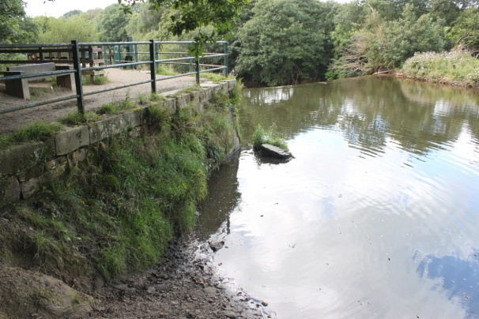 | 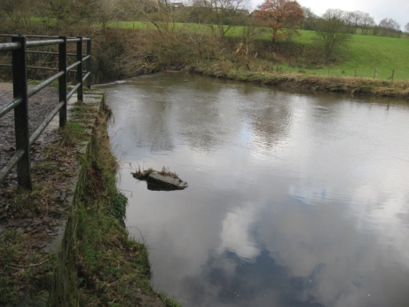 | 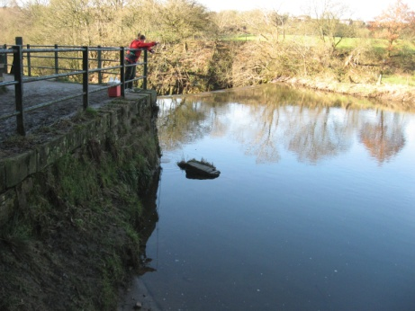 | 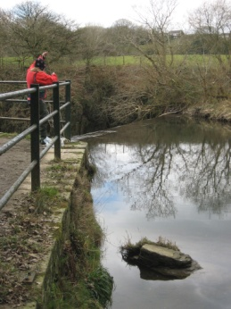
These photographs show the changes that have occurred over the year at which the collections were completed; such changes can be seen to have impacted on the bank showing the changes that has been seen to occur in the area. The photographs are also useful to demonstrate the way in which the river has been seen to change over the 4 collections. There is evidence that the water levels can be seen to change slightly upon the numerous visits to the location, the rock situated in the picture can be used to show the rise and fall of the water level. This can be recognised as the rock in collection 4 is a lot more viable than the other visits showing the water levels have decreased on this visit.

Weir
Collection 1 | Collection 2 | Collection 3 | Collection 4
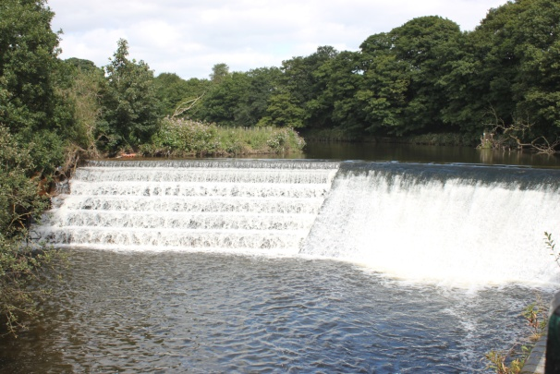 | 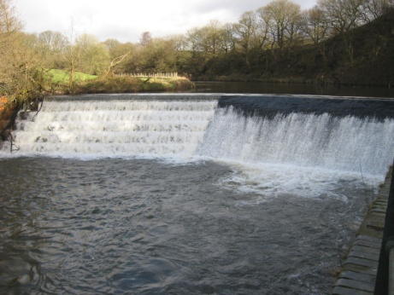 | 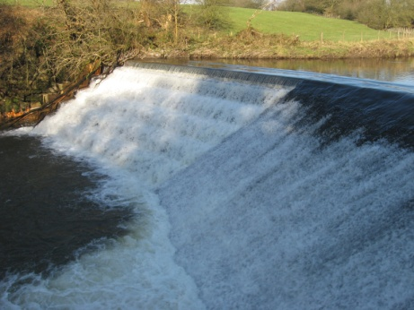 | 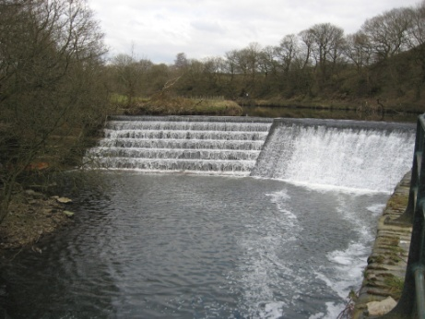
These are the photographs that have been taken looking at the weir to show the changes that have occurred over the 4 collections. These are used to demonstrate the way in which the weir has seen to change the way in which the water can be seen to have an increased level on the 2nd and 3rd visit as the steps are not been able to be seen showing the increased level of water in the river. As it is difficult and dangerous to actually measure the velocity of the weir as accessing such an area could be dangerous, so the images show the fullness of the weir, the fuller the weir the faster the velocity travelling down as well as the increased water levels. On the left hand side there are steps, if you are unable to see the outline of the steps you are able to paddle down this section, (almost in the figure in collection 3 as there is so much water present.

Site 2
Collection 1 | Collection 2 | Collection 3 | Collection 4
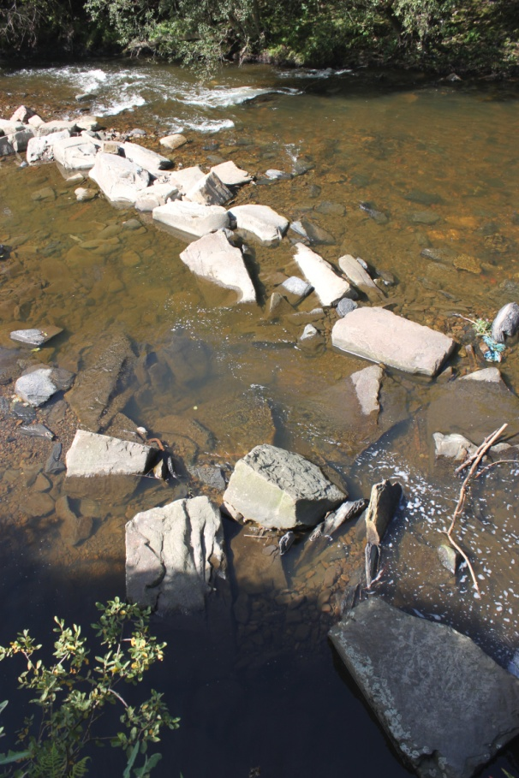 | 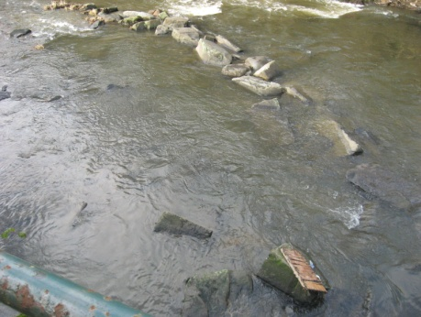 | 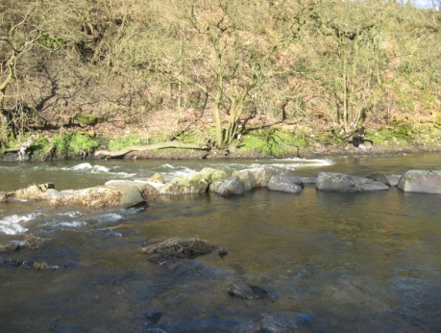 | 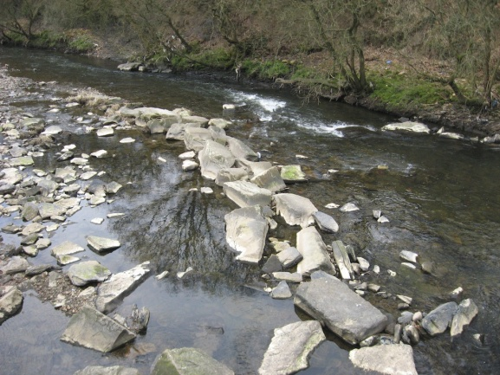
These photographs show the second location where the information was collected from showing the increased level of water that is present in the river on a couple of the collections showing the way the increased level of water can be seen to be impacting on the river as a whole. The disappearing of the rocks that is noticeable upon collection 2 demonstrates the increased level of water that is in the river, compared to levels that are visible in the other figures. Collection 4 shows the lowest level of water that can be judged by eye due to the increased amount of rocks and debris that is present in the figure, showing there will have been a decrease in water levels upon this collection.

Site 3
Collection 1 | Collection 2 | Collection 3 | Collection 4
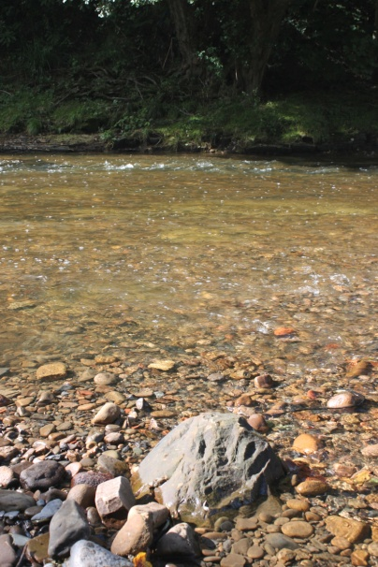 | 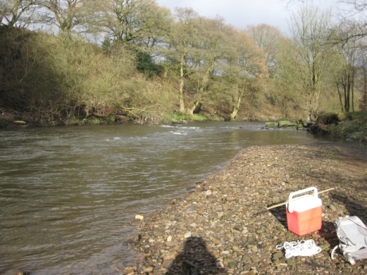 | 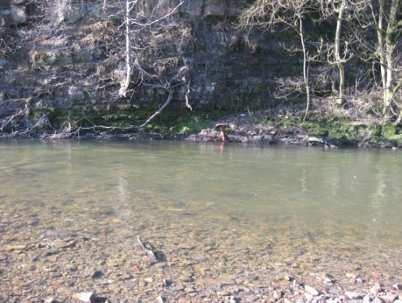 | 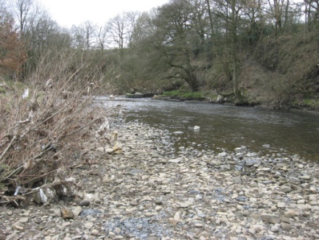
The photographs taken at this location show a number of changes that can be seen to have changed over the year of visits to this location, there can be seen to be another increase in water level demonstrating the increases that have been seen to occur in such areas there can be seen to be debris present in the trees to show the way in which the river has been seen to rise and cause such damage to these areas. The increased level of the river can be seen to have carried large amounts of debris through this section leaving such debris in the trees showing how high the river was in between collection 3 and 4.

Site 4
Collection 1 | Collection 2 | Collection 3 | Collection 4
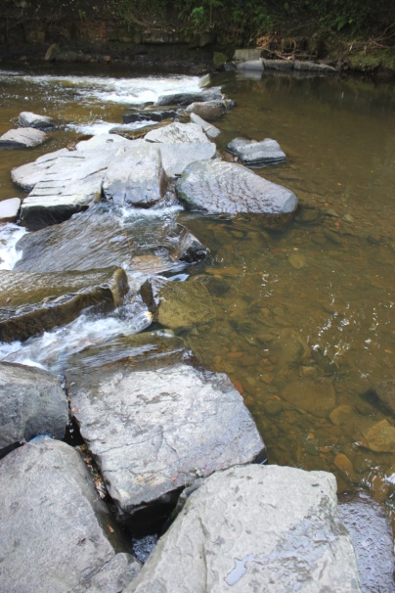 | 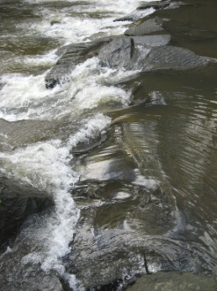 | 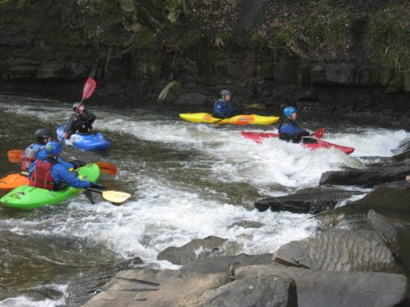 | 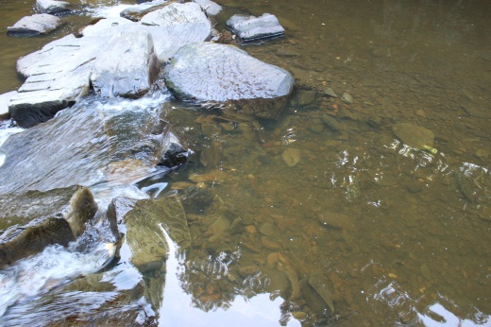
This location demonstrates the way in which the areas has been developed and changed in order for kayakers to benefit greatly from the river, the introduction of the larger rocks shows the way in which rivers are seen to change causing there to increased white water and areas that are have developed eddies for the kayakers to use. As well as showing the way in which the river has been adapted and changed these figures again can be sued to show the rise and fall of the river. Collection 2 shows how the rocks have nearly completely disappeared in comparison between other figures. Such has shown the increase of water in this section of the river.

Site 5
Collection 1 | Collection 2 | Collection 3 | Collection 4
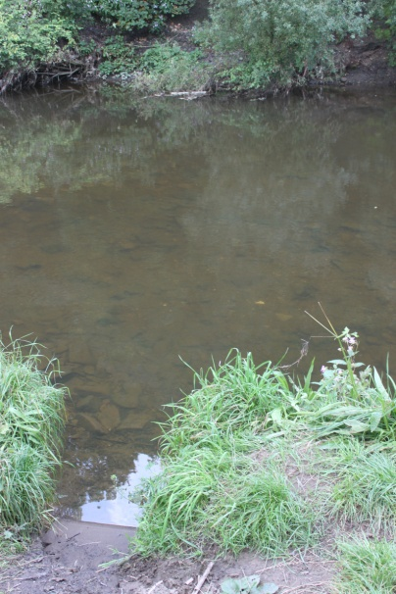 | 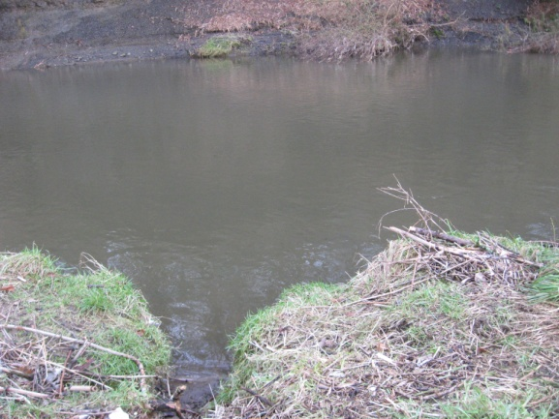 | 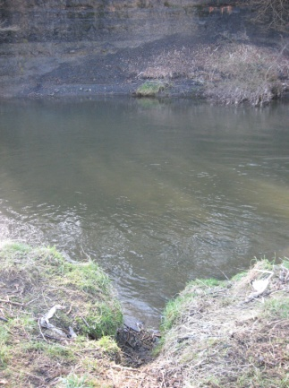 | 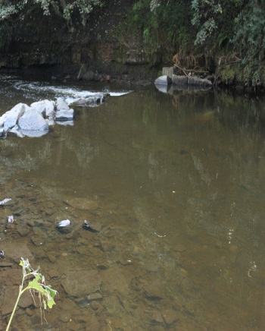
This section of the river is the deepest section of the river that has been accessed over the 4 collections, even when the majority of the other sections were seen as low this section has always seemed to remain relatively high. As such again photographs have been taken in order to show the changes that have occurred over the numerous visits. This section of the river has been developed and changed in order to be protected against erosion that could have been seen to have affected other sections of the river.

Handle bar
Collection 1 | Collection 2 | Collection 3 | Collection 4
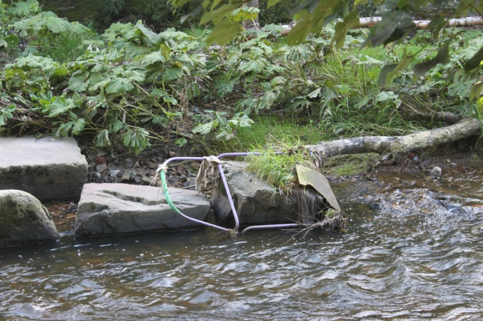 | 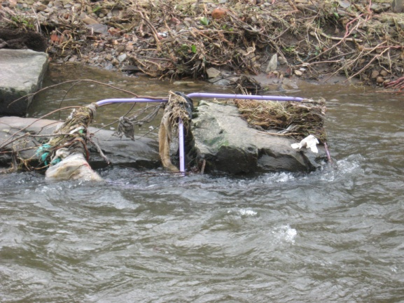 | 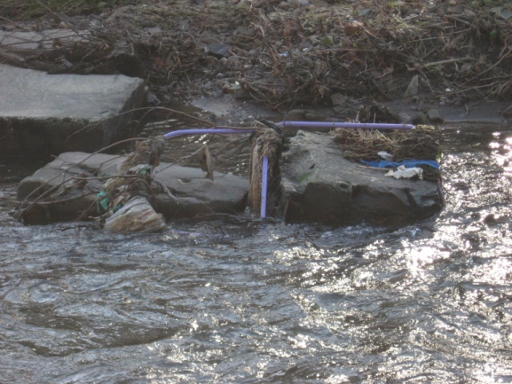 | 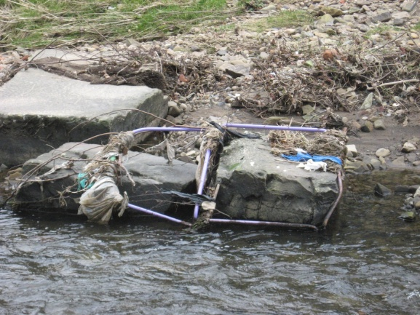
Between site 5 and 6 another modification has been made to the river, such as the introduction of this handlebar. Such has been introduced by kayakers in order to stop before accessing the next section of the river, as the next is one of a small series of waterfalls and rapids which need to be approached with care. There is also a benefit from such an addition to river from a researcher’s point of view as again such a marker can be used to show the increased and decreased water levels that are present within the river channel over the 4 collections. Such is another example of how the river has been changed in order to be more beneficial to kayakers who are seen to access the area.

Site 6
Collection 1 | Collection 2 | Collection 3 | Collection 4
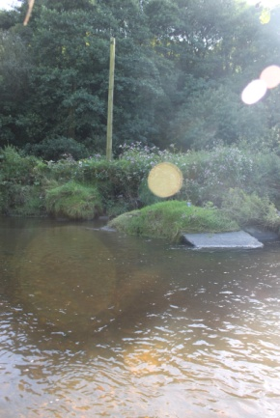 | 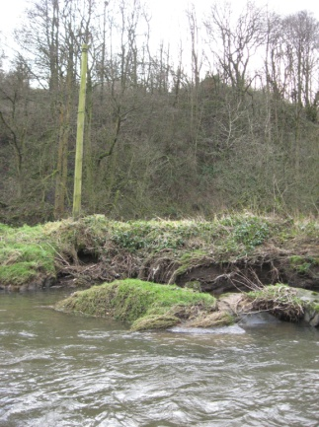 | 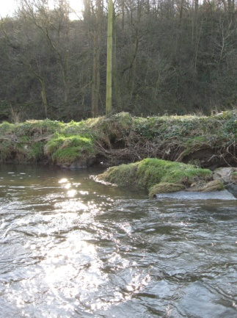 | 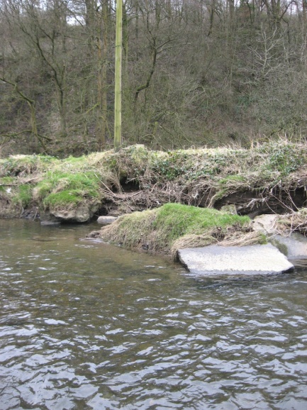
The section of the river can be seen to show the changes that have occurred through the progression of the research again the depth can be seen to be changing through the numerous visits to the location. These changes are noted due to way in which deepening of the water has seen there to be an increase in the way in which the water levels have risen. The figure from collection 4 shows all of the rock present being exposed whereas at the second collection the rock is seen to have completely been covered by water showing again an increase in the level of water present in the river.

Site 7
Collection 1 | Collection 2 | Collection 3 | Collection 4
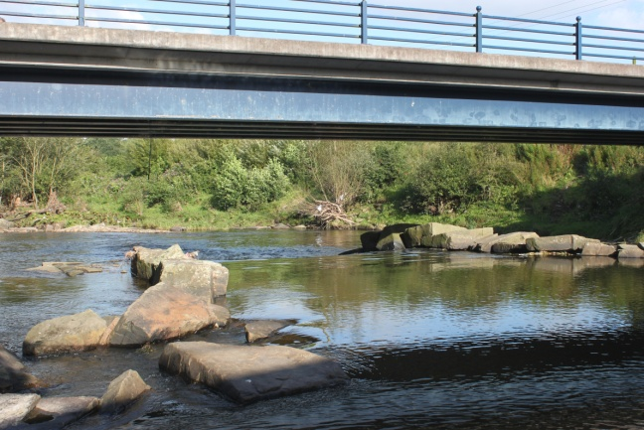 | 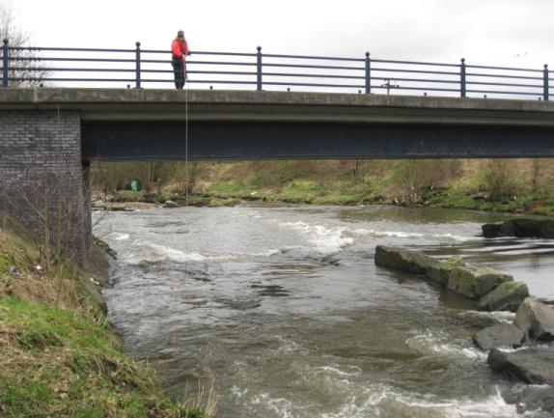 | 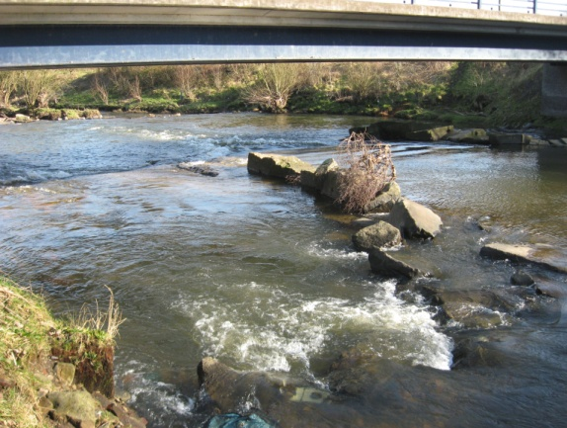 | 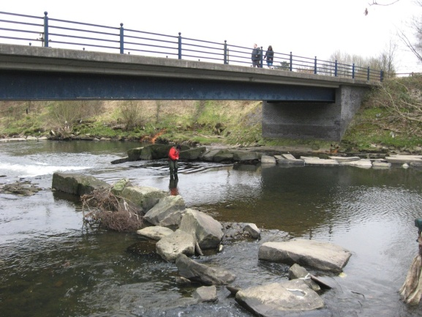
This shows the section of the river that has again shown the changes with the increased of level of water allowing for changes to be noted such can be used to show how the samples were collected as well as showing the way in which such ways the data was collected. When looking at the figure from collection 3 there is an increased level of white water showing that the velocity of the river is at an increased rate which will in turn result in forming more white water, thus showing that such as area will have an increased velocity and water level.

Site 8
Collection 1 | Collection 2 | Collection 3 | Collection 4
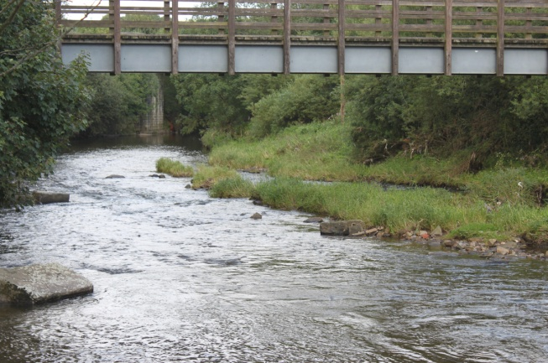 | 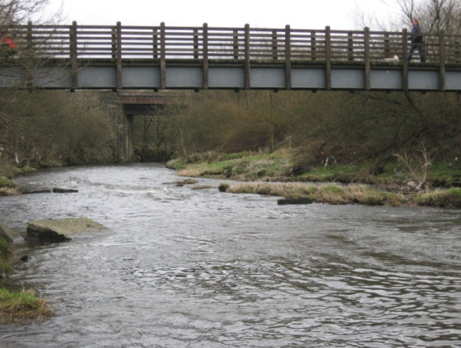 | 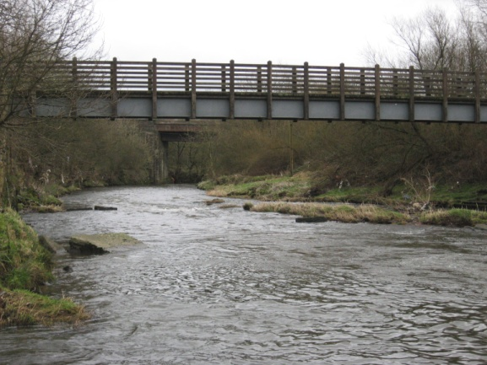 | 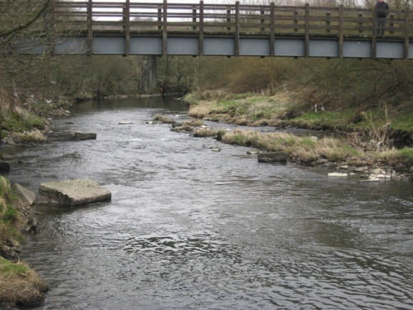
Show the changes that have occurred over the 4 visits to the location, showing the changes that have again occurred at this site in order to show the way in which the river has again changed at this site, changes that have occurred can show the changes that have occurred in the 4 visits to the location. On the 4th collection the rock that is present again shows the changes in the water level, this rock shows that on the final visit the water level has been seen to have dropped from the previous visits.

Appendix 12

Appendix 13

Appendix 13

Appendix 14

