Practical and Ethical Concerns in Usability Testing with Children

Executive Summary
It is common practice to evaluate interactive technology with users. In industry, usability companies typically carry out these evaluations, and the participants in the evaluation are usually adults. In research studies, researchers who do not do this sort of work on a daily basis, typically perform the evaluation. Complexity can be increased if the researcher is also the developer of the software and if the users are children. This case study explores that space, the evaluation of software with researchers / developers with children. The chapter describes the evaluation of an educational game that was designed to teach Spanish to children. The chapter outlines the planning for, and the execution of, a usability study of the game with 25 children aged 7-8 in a school in the UK. The study used two methods to try and discover usability problems; direct observation and retrospective think-aloud, and also gathered user experience data using the Fun Toolkit. The focus in this chapter is less on the results of the evaluation (although these are presented) but more on the practical and ethical concerns of conducting usability evaluations of games with children within a school setting. Those reading the chapter will gather hints and tips from the narrative and will better understand the use of the three methods included in the study. In addition, the researcher / developer role is discussed and it is shown that the methods used here enabled children to make judgments without the ownership of the product being an issue. To make the main points more concrete, the chapter closes with a set of ‘key points’ to consider when doing usability testing with children in schools.

Organization/Institution Background
The study described in this chapter took place in the UK and involved children from a primary school in a semi-rural area of Northern England. The work was carried out by members of the ChiCI (Child Computer Interaction) research group at the University of Central Lancashire (UCLan) - a modern University with over 30,000 students. The ChiCI group was formed in 2002 when a group of four researchers at UCLan came together around a shared interest in designing for, and evaluating with, children. The group has since grown and at the time of writing this article was made up of eight academics, five PhD students and four students on specialist masters courses. ChiCI receives funding from the EU, the UK research councils and industry.
The ChiCI group has a long tradition of working with school children from around the region. The group has a dedicated PlayLab within the University and uses this to hold MESS days (Horton et al. 2012) which are structured events that bring a whole class of children (25 to 30) at a time to the University to rotate through a variety of activities aimed at evaluating and designing technologies for the future. The overarching aim of the ChiCI group is to ‘Develop and test methods that facilitate the design and delivery of highly suitable technologies for children.’ These technologies may be for fun, learning, the benefit of children in communicating with others, or for recording their thoughts or ideas. Innovations to date have included a handwriting recognition system designed for children aged between 5 and 10, a tabletop game for Kindergarten children, a specialized pod for use by teenagers to identify with domestic energy use, and a mobile game for use with children between 5 and 11 with communication difficulties.

Case Study Description
The case study described in this chapter concerns the processes and outcomes around the evaluation, by children, of an educational game. The evaluation took place in a UK primary school and took the form of a usability test that was carried out to identify usability problems and also capture satisfaction metrics. The aim was to improve the design of the game but in the process the research team also sought to investigate several elements of school centred evaluation. The authors developed the game that was used in the study; it took the form of a medium to high fidelity prototype that included all the required functionality and had suitable graphical elements. The game met the appropriate educational objectives for children who would be evaluating the game. The educational merit of the game was not going to be examined in this case study. It is noted however that usability can be examined from a pedagogical perspective focusing on the user interface, design of the learning activities, and the determination of whether learning objectives have been met (Laurillard 2002).
The case study provides the reader with a clear narrative that explains how different tools can be used to capture both usability problems and user experience data from children within a school setting. The use of two different evaluators, one with a personal tie to the game (the developer) and the other looking at the game from an impartial view (the researcher), is also explored to see whether the investment of the evaluator may affect how the children respond to the user study and what they report.
Usability testing with children has been the subject of many academic papers with researchers focusing on the development of, and refinement of, tools and techniques that can help children engage with researchers to evaluate products and systems. Various adult methods have been explored including think aloud, interviews and the use of questionnaires (Markopoulos and Bekker 2003, LeMay et al. 2014 ). Using these, and other methods, it has been shown that children can identify and report usability problems. For example, direct observation has been shown to identify signs of engagement or frustration along with the ability to identify usability problems (Sim, MacFarlane, and Horton 2005, Markopoulos et al. 2008). Think aloud has been used effectively by children to identify usability problems (Donker and Reitsma 2004, Khanum and Trivedi 2013). Hoysniemi et al. (2003) found that children were able to detect usability problems which would aid the design of a physically and vocally interactive computer game for children aged 4-9. However when conducting usability research with children there are still a number of challenges that need to be considered, with one example being the impact of children’s less mature communication skills. Several studies have identified that the younger children are, the less able they are to verbalize problems in activities like think aloud. Despite the apparent success of the think aloud method it still comes under some criticism. There is concern that the think aloud method is quite challenging for children due to its cognitive demands (Donker and Reitsma 2004), especially for younger children (Hanna, Risden, and Alexander 1997) as they could forget to think aloud unless being prompted (Barendregt, Bekker, and Baauw 2008). One study by Donker and Reitsma (2004) , found that out of 70 children only 28 made verbal remarks during a user test – this is a low number and could be considered hardly representative of that group. Where think aloud has been shown to be taxing for children, the use of retrospective methods, where the child describes what happened after the usability test has ended, have shown some promise. Kesteren et al. (2003) found that with retrospective techniques children were able to verbalize their experiences. It has been suggested that children may be less communicative, not because of a lack of skill in communicating but rather as a result of personality traits. Barendregt et al. (2007) showed that personality characteristics influenced the number of problems identified by children in one usability test. Research is still needed to understand usability methods and to identify and catalogue their limitations in order to ascertain which can be reliably used with children. The literature provides guidance on how to perform usability studies in Hanna, Risden, and Alexander (1997) and Barendregt and Bekker (2005) but these are somewhat dated, are restricted to the studies being performed in usability labs, and do not take account of recent research in the field.
For user experience, similar to usability, many methods for children have emerged over the years. These include survey tools (Read 2008, Zaman, Abeele, and De Grooff 2013) and specialized verbalization methods (Barendregt, Bekker, and Baauw 2008) that have typically focused on measuring fun within the context of game play or with children using interactive technology. The survey tools that are widely used with children, including the Fun Toolkit (Read and MacFarlane 2006) and the This or That method (Zaman 2009), capture quantifiable data relating to user experience. Research that has compared the results from the Fun Toolkit and the This or That method has shown that they yielded similar results which can be taken as evidence that they are, when used appropriately, collecting useful data (Sim and Horton 2012, Zaman, Abeele, and De Grooff 2013). Literature on the use of survey methods with children highlights that gathering opinion data is not without difficulties as the younger the children are the more immature they are at understanding the question - answer process. Children are generally unused to giving opinions in this sort of context and this gives rise to problems including suggestibility and satisficing (Read and Fine 2005). These two problems are related but come from two sides – suggestibility is seen where a question might be phrased a certain way in order that the child is ‘more minded’ to answer a particular way. An example might be a question like ‘Do you like this game more than that hopeless one you just played?’ - satisficing is more about answers than questions and is more difficult to deal with in survey design as it is really a process problem. Satisficing is where a child seeks to give an answer that he or she thinks the adult wants to hear. It is born out of the imbalance in the relationship between the child and the evaluator and is inherent in all evaluation studies.
One of the aims of the case study presented here is to explore satisficing as a known issue within usability and user experience studies with children. Another aim is to consider the effectiveness of three different evaluation methods. The study presents data relating to identified usability problems and reported satisfaction and this is critiqued to understand the limitations of the process and methods and to offer suggestions for further research. The main lessons from the case study are used to generate a set of guidelines for carrying out usability and user experience testing in school settings. These guidelines will follow the same structure as those presented by (Hanna, Risden, and Alexander 1997).

Method
As described earlier, for this study, children were being asked to evaluate the usability and user experience of a medium to high fidelity prototype educational game. Each child would play the game and data would be collected using three different methods; the Fun Toolkit, direct observation and retrospective think aloud. The researchers carrying out the study had experience of carrying out observations and capturing usability problems (Sim, MacFarlane, and Horton 2005) - had this not been the case, video recording might have been considered an option for this work to ensure events were not missed whilst notes were being taken. It is quite feasible that some events may have been missed as a result of not recording the screen, but it they were severe problems or obvious problems it was anticipated that several children would experience this and so it would be captured.
Satisficing was examined at the level of ‘who made the game’. The use two adult evaluators acted as ‘developer’ and ‘researcher’ in order to explore how the children reported on, and talked about, the software that they saw. This presentation was controlled for in a between subjects design so that the ‘developer’ was a different person for half the children than for the other half. The usability study was also controlled with half the children being told extensively about the ethics of their inclusion and the other half getting only a brief explanation before being told afterwards. The case study will focus mainly on the qualitative data that was gathered and will give examples of how children spoke to the two adults and the impact the ethical information had on the results.

The Game Prototype
The study used a game that had been developed to help the children in the school learn Spanish. The children testing the game had recently begun to learn Spanish in school and so the game fitted in well with the school curriculum. The game is shown in Figure 1.
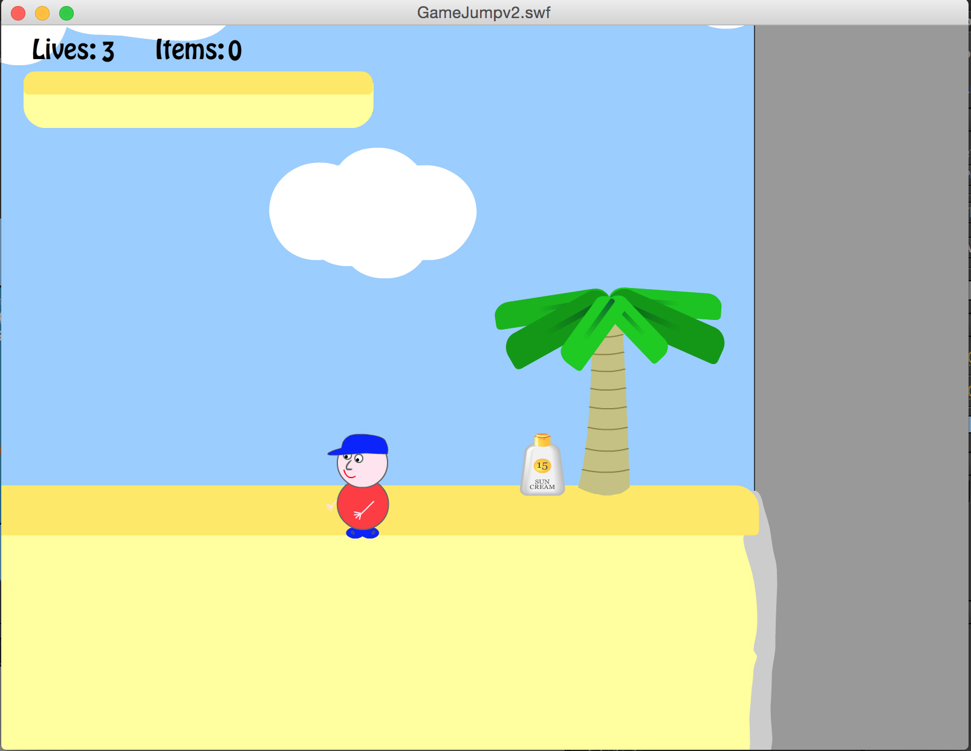
Figure 1. Screen shot of the game
The game was a platform game set in Gibraltar. The storyline featured a pesky Gibraltarian ape stealing a bag from a tourist and then throwing all the contents of the bag off the rock. The (human) player had to retrieve all the items and then return to the top of the rock. Each time an item was found, the game presented a feedback message showing the name of the item in English and Spanish; it also played Spanish audio, speaking out the name of the object, to accompany the message. Whilst navigating around the platforms looking for the missing objects, the pesky apes at the top of the rock threw down bananas that the player had to avoid. Once three bananas had hit the player it was the end of the game. As the game was a prototype, only one level of the game was playable for the purpose of the evaluation. The game was functional but did have some ‘built in’ usability problems, for example, the feedback messages staying on the screen until they were clicked, the lack of instructions on how to control the character and a known problem with the collision detection at the end. The rationale for leaving these problems in was to see whether children would notice them and would talk about them in the retrospective think aloud; this process of deliberatively incorporating usability problems into games has been used in other research (Sim 2012).

Study Design
Usability and user experience were both being measured in this study. There are numerous evaluation methods that could be used for measuring user experiences, however, few have been extensively validated with children, and therefore, for this reason, the Fun Toolkit was selected (Read 2008). This tool has predominantly been used for comparative analysis of technology or games with children and it includes three tools, one of which (the Fun Sorter) is only meaningful in comparative studies. As the study described here was only evaluating a single game that tool, the Fun Sorter was omitted. Thus the Smileyometer and the Again Again tables were used in this study. The Smileyometer, is a visual analogue scale that is coded using a 5 point Likert Scale, with 1 relating to ‘Awful’ and 5 to ‘Brilliant’, see Figure 2.
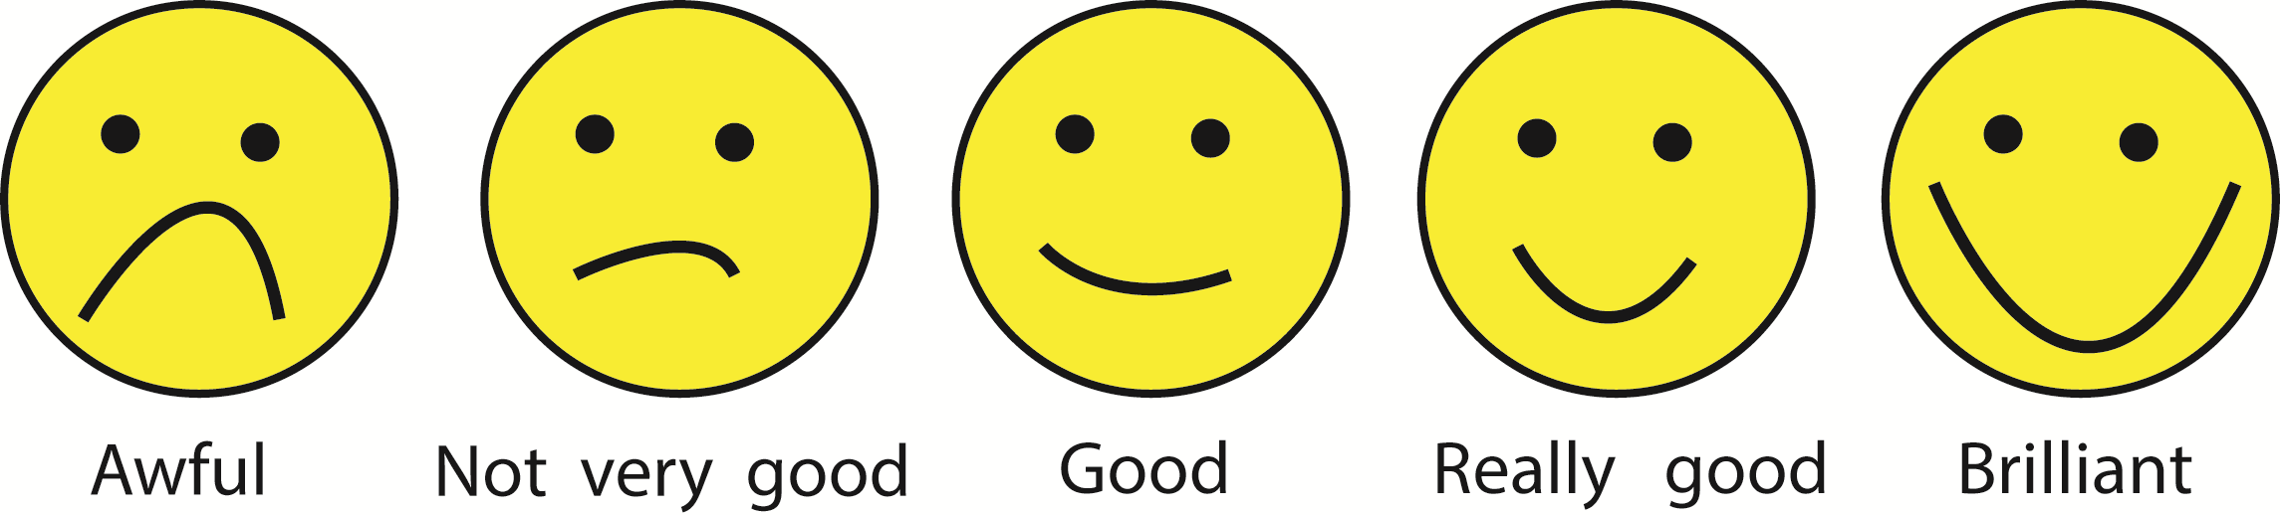
Figure 2. Example of the Smileyometer
The Smileyometer is intended to be used both before and after the children interact with technology. The rationale in using it before is that it can measure a child’s expectations of the product, whilst using it afterwards it is assumed that the child is reporting experienced fun. The Smileyometer has been widely adopted and applied in research studies (Sim and Horton 2012, Read 2012) to measure satisfaction and fun as it is easy to complete and requires no writing by the child. The Again Again table is a table that requires the children to pick ‘yes’, ‘maybe’ or ‘no’ for each activity they have experienced. In this study the children were asked ‘Would you like to play this game again?’ and they had to respond accordingly. A completed Again Again table is shown in Figure 3.
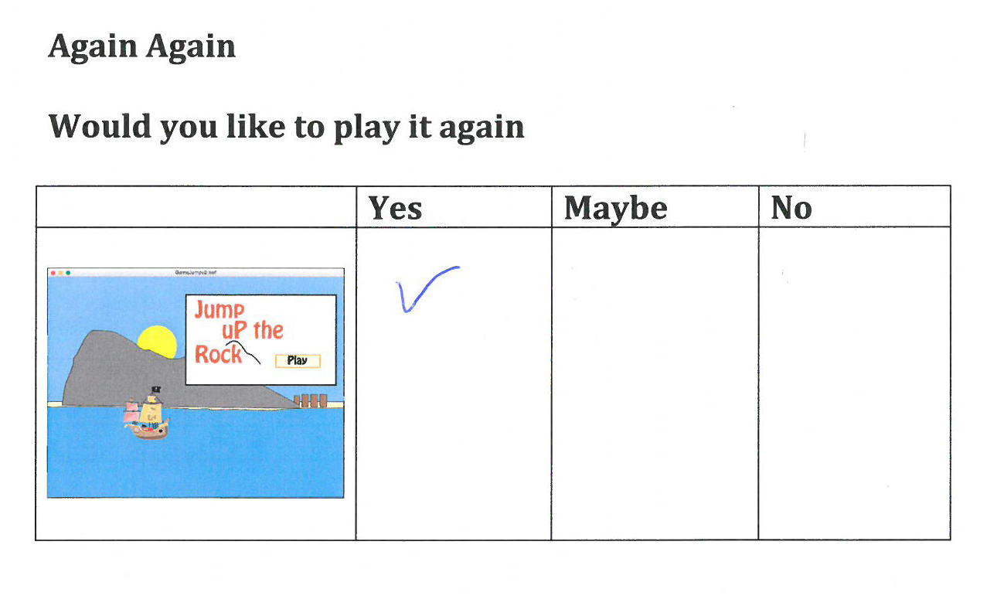
Figure 3. A completed Again Again table
There are many methods available for evaluating the usability of software for children, including think aloud and observations. The decision was made to use direct observation to capture any problems the child had whilst playing the game as this approach has been used effectively in evaluating educational games with children (Diah et al. 2010). The problems observed would be captured on a preformatted sheet documenting both the problem found and the location in the game where it occurred - see figure 4.
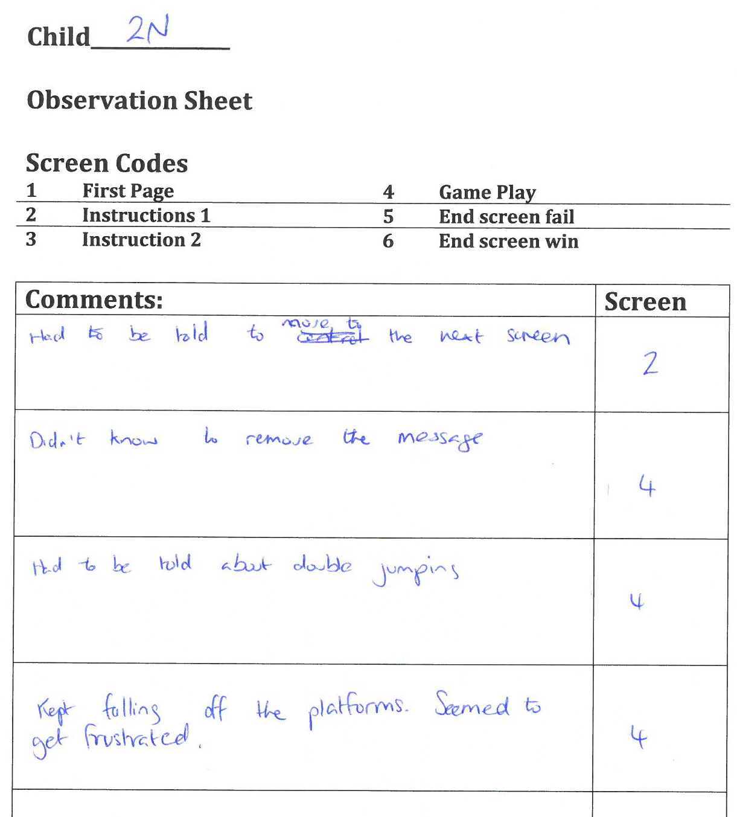
Figure 4. Completed observation form
To ensure the child remained anonymous, as there was no need to record names, each child was given a unique code. In this instance this was child 2 and the N referred to the fact that the role taken by the evaluator in this instance was that of ‘not’ the developer.
In addition to direct observation a decision was made to use an adaptation of retrospective think aloud. On finishing the game, each child was shown screen shots of the various pages and asked to recall any problems he or she had experienced within that part of the game. These problems were then recorded on a separate data capture form similar to the one used for the observation. The screens are shown in figure 5 below; when these were presented to the child each screen was printed in colour on a separate sheet of A4 paper to ensure that the child only focused on the screen of interest rather than getting distracted by multiple images. One of the screens that was included in the original study has been removed for illustration purposes as none of the children managed to complete that level and therefore never saw the screen. The screens were presented in the order shown below.
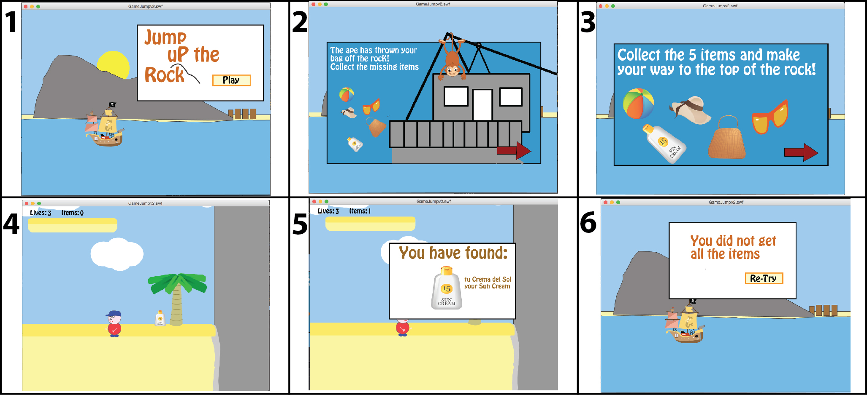
Figure 5. Screen shots of the game
In a traditional retrospective think aloud the player would normally watch a video of himself or herself playing and comment on the interaction. It was felt that this might be difficult for children, time consuming and not very engaging for the child, which is why the decision was made to use just screen shots. This worked in the context of this game as there were not very many different screens but it is acknowledged that had the game had lots of levels or screens then the use of video would possibly be a more practical solution. Using video has many drawbacks especially when it comes to tagging reported problems to a moment in the video and dedicated software may be useful to speed up the process (Kjeldskov, Skov, and Stage 2004).

Ethics
In the view of the ChiCI team, ethics is much more than just obtaining consent for participation in a research study especially as, with children, there are questions about their ability to understand what they are consenting to. Within a school context the teachers typically give consent to involve the children from a class in an ‘out of curriculum’ activity. In that set up it is believed that if a child did not want to take part in the activity then he or she might find it hard to say so as school is not an environment where children pick and choose to do things. Researchers need to be mindful of this and need to explore ways of empowering children to make informed decisions about their participation in evaluation studies. The CHECk tool was developed to facilitate good ethical practice when working on design and evaluation studies with children (Read, Horton, et al. 2013) and has been subsequently used to aid the development of applications to address bullying (Mechelen et al. 2014). The main principle behind the CHECk tool is that it leads the researcher or designer to examine his or her own priorities and beliefs. CHECk consists of two checklists, CHECk1 and CHECk2. The first tool CHECk1 focuses on examining values by asking six questions to be answered prior to any activity. The questions challenge the designer or researcher to consider the appropriateness of both the technical solution and the involvement of children. The aim is to become more explicit about the values that drive the work, pushing designers, developers and researchers to be honest; the six questions and answers from CHECk1, within the context of this study are presented below in Figure 6.
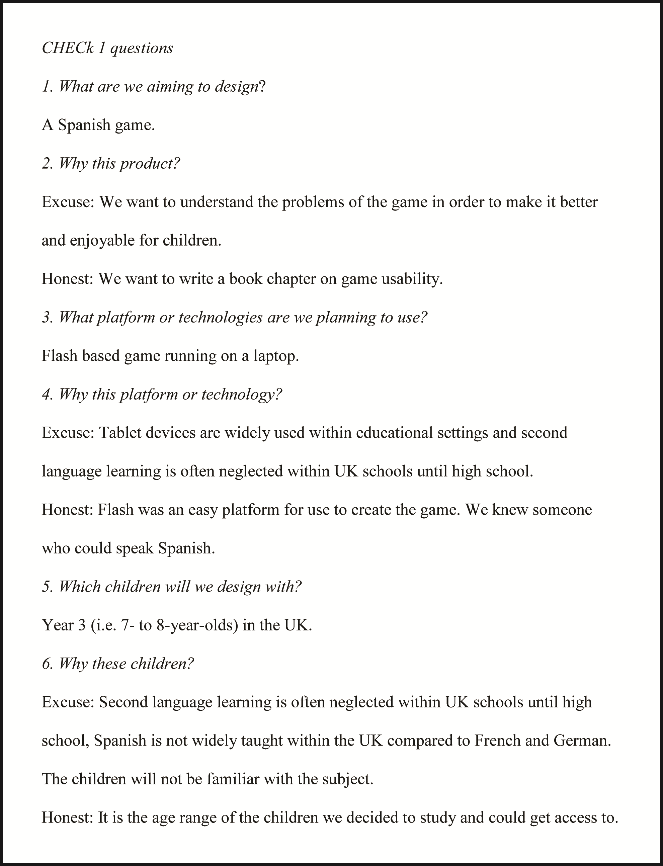
Figure 6. CHECk 1 Questions and Answers
The second tool is referred to as CHECk2, and aims to examine the value of participation to the child. In completing CHECk2 the intention is to look before and beyond the activity in order to better frame, for the children, the landscape of the work in order that they can better consent to participate. The second aspect of information that has to be conveyed to children is about the data the children contribute. CHECk2 provokes discussion about children being informed about what they will be doing, understanding how their contributions will be disseminated and, although difficult, considering who would get credit for any ideas that come out of the activity. The main goal of CHECk2 is achieving ethical symmetry, that is, full consent from the children instead of only consent by adults (Buckingham 2009). The CHECk2 questions are stated in Figure 7.
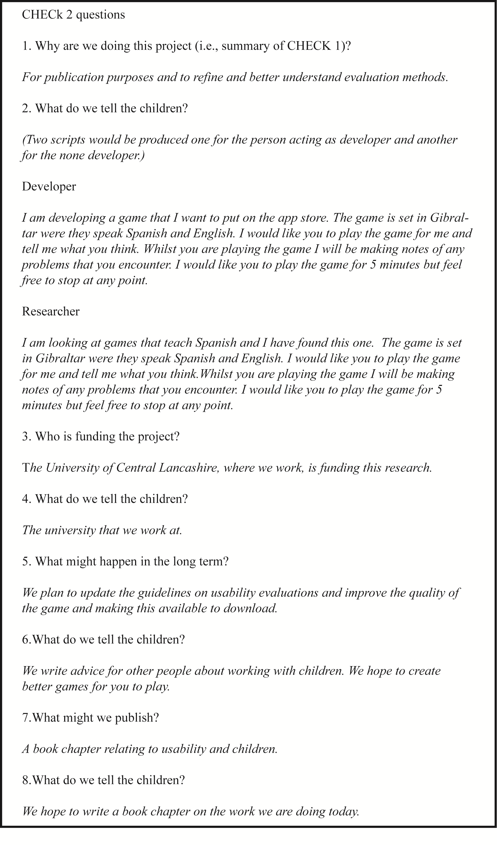
Figure 7. CHECk 2 Completed Questions and Answers
These tools, and the completion of the tools, enabled the researchers in this study to reflect on the process prior to carrying out the evaluation. This helps in being critical of the study design, ensuring that the methods planned for use are suitable. The process also encourages research teams to think about how to explain concepts in a way that children can understand.

Participants
The children who took part in this study were all from a class of year 3 children, aged 7-9 from a UK primary school. On the day, five of the children in the class were absent and so only the remaining 25 children participated in the study. The children who took part did so during their normal school day coming out of regular classes to play the game. Three researchers were involved; all had experience of working, and conducting evaluations, with children of these age groups.

Procedure
The children came to the study in groups of 2 according to selections from the teacher. The study room used was the school library where the researchers used two tables, one at each end of the room; as the children came in, they were asked to go to one of the two tables – they made that decision themselves in terms of which table they went to. Ensuring adequate spacing between participants is required to help ensure that the children do not get distracted by each other or by other equipment. On each of the desks there was a laptop that had the prototype of the game being evaluated preloaded. Each table had an adult evaluator sitting at it. The two evaluators used a script to introduce the activity to ensure that each child received the same information. The evaluators took on the role of developer or researcher, as described above, and they switched these roles half way through the evaluations to reduce bias in the results.
Once the children were settled at one of the two tables, before playing the game, each was shown the first screen of the game, and then asked to complete the first Smileyometer; this was intended to measure expectations of the game before playing. Following this, children played the game for between 5 and10 minutes; but this was flexible to allow children to stop earlier if they were bored or were not enjoying the experience and also to let them continue longer if they were engaged. Whilst each child played the game the evaluator documented any usability problems observed using pre-prepared data capture forms.
Once the child had played the game a number of times or the session had finished, the child was asked to complete the Again Again table and a second Smileyometer. Following this they were then shown each of the main screens within the game and were asked if they recalled any problems or difficulties within each of these sections of the game. The responses were captured on a separate sheet of paper. The children were then thanked for their help and then went to another activity being run by the third researcher attending the day.
This third researcher had two pairs of Google Glasses and showed the children how to interact with these, having them taking photos and videos. They played with the glasses for about 5-10 minutes before returning to the classroom. The rationale for including this activity was the fact that this would be a new technology for the children and it was conjectured that, upon returning to the classroom, the children would talk about the glasses rather than the game, thus minimising chatter about the game in the classroom that could have an effect on the subsequent children’s responses. It is acknowledged, that even with the Google Glass intervention, the children in this study may well have discussed the game with their peers during the day; this is one of the limitations of running a study like this within a school context.

Analysis
All children managed to complete the Smileyometers before and after they played the games. These were coded from 1-5, where 1 represented ‘awful’ and 5 represented ‘brilliant’. In line with other studies using this scale, arithmetic averages have been derived from these scores (Read 2012). The Again and Again table, resulted in a single numeric score with yes being coded as 2, maybe as 1 and no as 0.
During the observation, the problems encountered by the children that were observed by the evaluator, were recorded into an Excel spreadsheet. The problems were then merged, by the two researchers carrying out the work, into a single list of usability problems; this list included the frequency of discovery (in other words a count of the number of children who met that problem). This required each researcher to look at each recorded problem and determine if it was the same as another problem in the list. Problems were treated as separate if they occurred in different locations within the game. In coding problems one approach taken in work with children has been to code the problems based on the behaviour of the child. This was first used by Barendregt and Bekker (2006) who coded problems to identify a number of breakdown indicators. This form of analysis was also used when comparing the usability problems of three prototype games with children (Sim, Cassidy, and Read 2013) and was used in this current study both for the observed problems and also for the comments from the retrospective think aloud. In the think aloud, although the children were meant to be reporting the problems they encountered, several children made generic statements about the game or game elements. For example one of the children stated that he Liked the Monkey and another child, when considering the first screen, simply remarked that it was hard, without any reference to why it was hard. These statements were removed from the list of usability problems and so are not included in the results.

Results
The results will be discussed in three parts, the first relates to the use of the Fun Toolkit to capture the user experience, this is then followed by the results from the two usability methods, direct observation and retrospective think aloud. In each case results are broken up by the role of the evaluator – as developer or researcher as explained earlier in this chapter. This data feeds into discussion about the use of the ethical checklists and about the effect of satisficing.

Use of the Fun Toolkit to Capture User Experience
The results from the Smileyometer are shown in Table 1. Arithmetic averages have been used in line with other studies that have used this tool.
Table 1 Results of the Smileyometer Before and After play
Role | Before |  | After
 | Mean | SD | Mean | SD
Developer | 3.50 | 0.798 | 3.75 | 1.138
Researcher | 3.92 | 0.954 | 3.92 | 0.954
All Children | 3.72 | 0.891 | 3.84 | 1.028

The results from the Smileyometer show that children were not disappointed with the game. Scores were higher after play than before and this indicates that the product was, in the main, a good experience. To determine whether the children satisficed in their responses on account of the role of the evaluator the mean scores were compared, for the none developer when compared to the developer, a Mann-Whitney test revealed no significant difference between the results before Z=-1.156, p=0.320 or after Z=-1.156, p=0.852. This would suggest that the role of the evaluator did not significantly impact on satisficing, it is assumed that the children rated the game highly to please the adults irrespective of their role.
Table 2 shows the difference between the children’s scores from the Smileyometer before they played the game, which captures their expectations and afterwards. In total 9 of the children’s score decreased after they had played the game suggesting that for them, their initial expectations had not been met. The split between the number of children reporting a positive, negative and no change was relatively equal, showing that a third of the children did not enjoy the game.
Table 2 Frequency of change between the After and Before scores of the Smileyometer
 | Difference in rating of the Smileyometer
 | -2 | -1 | 0 | 1 | 2
Developer | 0 | 5 | 2 | 2 | 3
Researcher | 1 | 3 | 6 | 1 | 2
All Children | 1 | 8 | 8 | 3 | 5

The Again Again table that forms part of the Fun Toolkit was also used to establish if the children wished to play the game again and the results for this are shown in table 3 below.
Table 3 Frequency of response to whether the child would play it again
Role | Yes | Maybe | No
Developer | 9 | 2 | 1
Researcher | 9 | 3 | 1

It is clear that the majority of children in both conditions stated that they would like to play the game again, suggesting that they have enjoyed the game. It was interesting to note that the two children who did not want to play again, and three of the five children who said they maybe would, were the last 5 children who participated in the study. These lower scores may have been down to the fact that, for these children, the evaluation was being carried out at the end of the school day, and maybe they were fatigued after a long day, and so did not really enjoy the experience.

Direct Observations
From the direct observation, a total of 112 problems were observed. The fewest observed problems for a single child were two and the highest 8. These problems were aggregated based on the location in which the problem occurred within the game; this left 25 ‘unique’ problems. Seven of the problems in this list were only seen once – i.e. only one child had each of these difficulties, 14 problems were seen by a few children and four problems were encountered by ten or more children. Two problems were observed on the start page, with three children not knowing how to start the game, and another not knowing how to use the mouse pad on the laptop. On the two instruction screens, that followed the start page, 5 problems were observed. The two problems with the highest frequency were that the child didn’t know how to move to the next screen, which was observed 5 times and that children tried to click items that were simply images; this was observed 4 times. The vast majority of the problems were observed within the actual game play, where 18 problems were observed. The five problems with the highest frequency in the gameplay were:
- Didn’t know how to jump or double jump (18 times)
- Unsure how to remove message (18 times)
- Struggled to get onto platforms (12 times)
- Not sure of controls (11 times)
- Tried to collect bananas (10 times)
Although some of these problems appear very similar the decision was made to treat them separately. For example, the problem of the children getting onto platforms was not because they did not know how to jump, it was that they struggled to jump at the correct moment or landed on the platform but immediately fell off. Similarly, not being sure of the controls related to the beginning when they did not know whether to use the keyboard or mouse pad and which buttons to press rather than knowing how to make the man jump.
Within the context of analyzing results from usability tests to make improvements to the game, frequency of discovery should not be the only criteria. The persistence of the problem in regards to whether once it is first encountered whether it can be overcome later could be another factor (Donker and Reitsma 2004). As an example, although 18 children were initially unsure how to remove the message, once informed, only one child struggled with the message after the first play. Another consideration that needs to be taken is on how many children may have progressed to a certain part of the game, in this study two of the unique problems relating to game play were:
- Got to the top, thought they had won and lost, they did not collect all the items
- Go to top and collision detection did not work they fell off the rock and then endlessly fell
Although these two problems had a low frequency it should be noted that these were the only two children who managed to complete the level, which suggests the level was quite hard. These problems might have had a higher frequency if more children had managed to complete the level.
The problems that were ‘built in’ by the developers prior to conducting the evaluation were all encountered but problems such as the children’s inability to get onto platforms was not anticipated. This would provide useful data for the redesign of the level, simplifying the game mechanics and enabling an understanding of how to make the progression through levels challenging.
Other observations, which were not formally documented at the time, relate to the children’s participation in the process. All children appeared to come to the activity with enthusiasm and appeared engaged throughout, however a small number did show signs of frustration during game play.

Retrospective Think Aloud
For the retrospective method the children had to report any problems they recalled for the various sections of the game, as none of the children successfully completed the level no feedback was obtained on this part of the game and this screen was omitted. Of the 25 children, 7 of them claimed to have had no problems, this will be explored further in the next section. Of these 7 children, 3 of them were discussing the game with the developer and 4 of them the none-developer. This would suggest that the role of the facilitator did not impact on their reluctance to talk about problems and satisficing in this form may not have occurred. A further 6 children only reported 1 problem using this method, and the total number of problems found by each child is shown below in table 4.
Table 4 Number of problems found by each child
 | Frequency of problems reported
Problems found | 0 | 1 | 2 | 3 | 4 | 5 | 6
Number of children | 7 | 6 | 5 | 5 | 1 | 0 | 1

In total 47 problems were reported by the children and only 11 of these problems were communicated to the developer. This may suggest that children were reluctant to talk about problems to the developer and felt more comfortable talking to someone impartial. After the problems were aggregated, there remained 24. The number of problems reported by the children for each of the screens is shown in table 5 below.
Table 1 Number of usability problems reported by the children for the various screens.
 | Screens
 | 1  Start | 2 Instruction | 3 Instruction | 4  Game | 5  Feedback | 6  End
Number of problems | 4 | 5 | 1 | 10 | 2 | 2

Of the 24 problems reported, 15 of the problems were unique in that only 1 child reported it as a problem. Similar to the direct observation the majority of problems related to the actual game play, as might have been expected. Only 5 of the children reported a problem understanding how to jump or perform a double jump and 6 stated it was hard to get onto the platforms. Eight children indicated a problem in removing the feedback message once an item had been collected. On the final screen they were asked if they had any problems and knew why the game ended, four of the children after playing the game several times, had not realized that the bananas killed you.

Direct Observation compared to Retrospective Think Aloud
After aggregation there were 25 problems identified via direct observation whilst 24 were reported using the retrospective think aloud method. Figure 8 below shows how many problems were unique to a particular method and how many were identified in both methods.
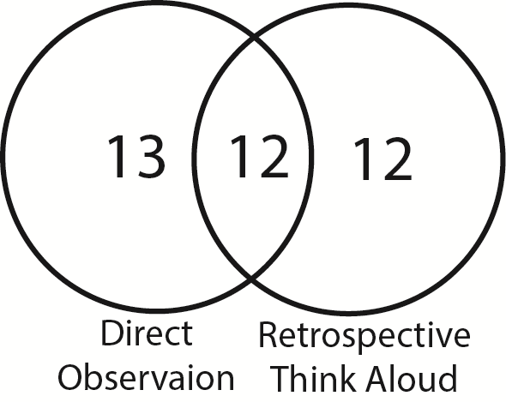
Figure 8. Usability problems in each method
For the retrospective think aloud all the problems that were only seen using this particular method were unique problems in that only 1 child reported each. Below are some of the examples of the unique problems
- Didn’t know there were lives
- Hard to try again
- Didn’t understand the Spanish
For the problem ‘hard to try again’, this was not observed, the child reporting this did not appear to have any difficult when on this screen. It may have been that the facilitator had missed this and if screen capture software had been used this could have been further analyzed. Alternatively, and perhaps more plausible is the suggestion that the child had to ‘think’ of a problem, in order to ‘help’ the evaluator and so came up with this response. This is an example of potential satisficing.
The 5 problems with the highest frequency within the direct observation method were all also identified as problems whilst using retrospective think aloud, but the frequency of verbal report, as opposed to observed activity, was a lot lower. For example, in direct observation, 18 children had been seen to have problems jumping whilst only 5 children reported this problem in retrospective think aloud. Of the 13 problems that were unique to the direct observation all of the 7 problems with a frequency of 1 were unreported via retrospective think aloud. Examples of the problems with a higher frequency that were unique to direct observation include:
- Opened Flash menu (4)
- Tried to click items (4)
- Got stuck inside hill (2)
In both methods the problems reported by a single child were unique to that method, it would appear that the more obvious and potentially severe problems are identifiable within both methods. These conflicts across the methods are interesting as they show that the two methods are collecting different stories. It could be that some of the observed problems, like the Flash menu opening, were indeed problems but were such that the children could not explain them. These might have been the more implementationally focused problems.

Challenges
In carrying out usability evaluations with children there are a number of challenges that researchers and practitioners face. As well as the practical side of carrying out evaluations with children there is the challenge of obtaining useful data.

Methodological Challenges
It has been shown with adults and children that different evaluation methods yield different results (Desurvire, Kondziela, and Atwood 1992, Markopoulos and Bekker 2003). Within this case study the two usability methods yielded different results. Although a comparison was made between the two usability methods presented in this case study, this mainly focused on the reported problems. Other metrics for comparing usability methods have been established, for example (Markopoulos and Bekker 2003) identified three criteria:
- Will they be able to apply a particular usability testing method for their problem (robustness)?
- How good results does the usability testing produce (effectiveness)?
- How expensive it is to apply a usability testing method in terms of time or other resources (efficiency)?
Robustness was concerned with the feasibility of applying the method in different contexts and highlighted the importance of understanding the suitability of the methods at different stages of the life cycle and use in different locations. Within this case study the evaluations methods were only used in one location and for one game but the results can be used to offer further evidence to the robustness of these methods within a school context.
To determine the effectiveness of an evaluation, Hartson et al. (2003) proposed quantified criteria based upon the work of Sears (1997). This looks at three criteria, thoroughness, validity and effectiveness where success is defined as the extent to which actual problems are found. This approach is problematic as it requires there to be a known set of problems that can be listed as otherwise a number which is simply a total has no meaning. In this case study the practical aspects of carrying out the evaluations was the main concern and thus the decision was made not to calculate this value.
For the final criteria efficiency, this can be a simple measure of the resources required to perform the evaluation; the time to complete the study and analyze the data. Mathematical models have also been used to determine the efficiency of a method based upon the number of participants (Nielsen and Landauer 1993). There may well be conflict between these three criteria, for example video analysis can be time consuming, meaning it may be less efficient than the use of other methods such as the retrospective think aloud as used in this case study. However there may be a trade off in the fact it is inefficient but is more effective and researchers need to establish the priority before selecting a suitable method.
The results of the retrospective think aloud method within this case study, showed that of the 25 children used, 7 of the children claimed to have no issues. However, all the children were observed having problems. These children may have been reluctant to talk about the problems with an adult which might imply satisficing occurred, that they just wanted to go back to class, or genuinely could not remember any problems. For example, child 3 in this study stated that they had no problems within the retrospective method but the following problems were observed:
- Kept pressing shift key by mistake
- Struggled to remove message
- Showed signs of frustration
- Struggled to get to the platforms
Child 9 also stated no problems but the following were observed:
- Flash menu appeared
- Not sure how to remove message
- Right clicked menu to try and remove it instead of just left click
- Character appeared in the middle of the mound and they struggled to move it
If relying on this method alone then the selection of the children may be important as in this case 28% of the children did not report any problems and there may be a need to recruit more children to overcome these difficulties.
The variability of evaluator performance has also been highlighted in studies with adults (Hertzum and Jacobsen 2001). In both the direct observation and retrospective think aloud methods there were a large number of unique problems. It is clear that the different usability evaluation methods used within this case study yielded slightly different results, and this is inline with other studies examining usability methods with children (Als, Jensen, and Skov 2005, Markopoulos and Bekker 2003). It is unlikely that all the problems within a game would be captured through a single usability study, inevitability a number of problems may go undetected.
In this case study gender was not considered although this has also shown to effect results when performing usability studies with children (Markopoulos and Bekker 2003). Further research is still required to fully understand the effect gender has on the results of usability studies.
This case study has highlighted a number of challenges faced performing usability evaluations with children yet there are still a vast amount of unanswered questions and limitations. For example, in this study only one game was tested and this was a platform game. This is true of many other studies where only a limited number of games, or game genres, are evaluated (Edwards and Benedyk 2007). It is unclear whether a particular method is more suited to one genre of game over another.
Further work is needed to understand how usability and user experience change over time. Within this game only 1 level was examined, if there had been multiple levels then it would not have been possible to evaluate the entire game in the time available. New methods and techniques are thus needed to understand the persistence of problems throughout a game and to capture longitudinal user experience. Vissers et al. (2013) proposed the MemoLine, which is a tool for capturing long-term user experience of a game and help facilitate interviews about game experience. This type of data would be useful to assist in the prioritization of the most severe problems as part of a redesign of a game.
The usability studies performed in this case study were carried out by academics and more input is needed from industry to enable methods to be created that are useful for development teams to make informed decisions about the usability of a game. The actual hardware the game is running on may also affect the suitability of the method. Within this case study the game was running on a laptop and therefore the interaction could easily be observed. If the children were using a mobile device such as a phone then observing the game play may not be feasible. With the advancement of technology methods may need to be established or existing methods analyzed to determine their effectiveness within new contexts such as games developed for the Oculus Rift (Dufour et al. 2014).

Challenges of conducting evaluation studies with children
There are many practical challenges that are faced when conducting usability studies with children. Children’s lives are predominantly situated in two locations; the home, and school. These provide a child with a sense of safety and comfort, which is almost impossible to replicate within the context of a usability laboratory. Taking children out of their natural environment will have an effect on their emotions and perceptions, and therefore could affect their participation in an evaluation study. The effect may not necessarily be negative and may differ for each individual child; where one child is excited about coming to a research laboratory and therefore very positive in their contribution, another may be scared or nervous about the unfamiliar surroundings. There is a strong focus on the use of field studies in child research with the apparent need to keep children in a natural environment evident (Jensen and Skov 2005) but as yet very little in the way of guidance in working with children outside of the laboratory setting. If an evaluation has to be carried out outside of a natural environment such as in a research lab, making the lab more child-friendly can help put the children at ease. However, any such interventions do need to be designed in such a way as to not cause too much distraction from the task at hand (Hanna, Risden, & Alexander, 1997). The case study presented here offers guidance on performing usability evaluation studies within the field.
Due to the natural unequal power relationship between adults and children, researchers themselves can unintentionally affect an evaluation study (Read & MacFarlane, 2006) due to:
- Increased possibilities of researcher bias.
- Children trying to please, or not to upset, the researcher.
- Not building up a relationship with the child participants.

Children spend the majority of their time with adults who are in a position of power over them. Spending most of their time at home and at school, it is the children’s parents and teachers who they interact with the most and these are the adults who children have become accustomed to; taking instruction from and being disciplined by. This is why the presence of parents and teachers during evaluation studies is questioned. The power imbalance can be minimized when only a researcher is present as the relationship has not already been formed. However there is some evidence to suggest that the influence of a teacher has little impact on the results of the evaluation (Pardo, Vetere, and Howard 2006).

Researcher bias is where the views and opinions of the researcher can affect the answers given by a child in variety of ways these include; the biased wording of a question, positive or negative wording or gestures towards a specific answer and probing answers for more information that gives off the perception that the researcher does, or does not, agree with the answer of the child. Children in their very nature want to please adults making it important that the researcher shows neutrality towards any answers given and thinks carefully about the wording of questions so as not to lead a child to a particular answer. If a child is of the belief that a researcher wants him or her to answer a specific way, or feels the researcher is not happy with the answer that has been given, then there is a tendency for the child to answer in a manner in which will be designed to please the researcher. It is to this point that we decided to see if the perceived investment by the evaluator, with the two distinct roles (developer vs researcher), would have an effect on the children’s responses. In this case study there seemed to be very little difference between the two roles on the children’s responses to both the survey and usability methods.

Relationship building is a vital role to reduce issues associated with satisficing, as the more comfortable children are with an evaluator the more likely they are to provide opinions and useful feedback. Different approaches have been used to try and break down unequal power balances such as getting to know the children well before the study by working with them on non-research related activities (Alderson 2001), engaging in small talk (Hanna, Risden, and Alexander 1997), playing games, team building activities (Druin 2002), all of which are designed to get the children used to being around the adults and allow the researchers the opportunity to prove that they are not teachers and to build up a rapport with the children talking to them on their own level about their own interests. Punch (2002) notes that researchers also need to build up a rapport with the adult gatekeepers of the children and not just the children themselves.

In a study considering participatory design with children, Kam et al. (2006) found children to be extremely nervous having their class teachers present, to the extent that this hindered the different relationship the researchers were trying to build with the children. Their solution was to, politely, ask the teachers to leave the room where the study was being conducted. This issue could also be prevalent when conducting usability studies with children. However, when evaluating the involvement of teachers in usability testing, Pardo, Vetere, and Howard (2006) found that teachers’ involvement, as an obstacle in this regard, was not critical and did not inhibit children’s participation. Teachers, and parents, are more likely to introduce their own biases into a study through interventions such as assisting the children to answer questions, rather than affect the relationship between the children and the researcher. It is important to ensure that it is not the views and ideas of the adult that are being recorded through child. In the case study here the decision was made to use a quiet room within the school to minimize external influences that might bias the results.

Language skills are an important challenge, particularly when working with younger children and when carrying out evaluation studies with children of different ages. Children develop their reading and writing skills at different speeds therefore the abilities of children of the same age group could differ significantly (Markopoulos & Bekker, 2003; Read & MacFarlane, 2006). Researchers need to ensure the language used in an evaluation is age appropriate and if necessary provide instructions in more than one format to assist and support the children as much as possible. When working with children of different age groups the gulf in ability may be sufficient to require different language and different methods to be used even though the researcher is trying to gather the same information from both. Children use language differently to adults, they use slang words and terminology that may have different meanings to adults. Listening to children interacting with each other and discussing language, and methods, with the children and their gatekeepers, can help researchers choose the right techniques to ensure children have the best chance of participating properly and provide more valid and reliable data.

When carrying out any research with children it is important for the researchers to be flexible and creative in the methods used. Children are still developing their capacity to concentrate and therefore tasks of different size and complexity should be used with children of different age groups (Markopoulos & Bekker, 2003). There is an agreement that research studies involving children should not last too long but not on what this length of time should be. Hanna et al. (1997) state that activities should last around 30 minutes, which is in line with Barendregt, Bekker, and Baauw's (2007) recommendation they should be less than one hour, but ultimately not the same. There may also be instances where parts of a study require adapting or changing due to unforeseen circumstances or unexpected responses (Darbyshire, MacDougall, & Schiller, 2005). With children, particularly when working with (school) classes or groups, the right to participate can be equally important. It may be the case that a study requires a certain number, or sample, of children but the opportunity to take part should be given to all, even if the results from some children are not actually used. Children are used to inclusion and the exclusion of some in a group can lead to undue stress on children who are not even participating in the study. This is discussed in more detail in the next section.

Ethical Challenges
Ethical challenges are widely regarded as one of the major differences and most important factors of doing research with children as opposed to research with adults (Punch 2002). There are three major ethical factors that should be taken into account when carrying out research with children, these being informed consent, confidentially/privacy and vulnerability although in this research it is informed consent that we have focused on.

Informed Consent
Informed consent is a much-debated area of ethics with children. In essence it is an agreement by the child, or suitable parent/carer that they are happy to take part in a research study and that this consent has been given freely. This involves the subject, or person responsible for giving the consent, receiving as much information about the research that is taking place to be able to make an informed decision as to whether they wish to take part.
The choice to participate in a research study is quite often not down to the child themselves but comes from an adult gatekeeper (parent, teacher etc.) who is responsible for the child at the time the research is being conducted (Mauthner 1997). Often it is not that the child has not been given the right to choose, more that the child feels they do not have the right to refuse. At school, children are used to following instructions given by their teacher and participating in activities as a group and also at home they are used to obeying the directions of their parents (Backett-Milburn and McKie 1999).
Whether or not a child should receive the right to give their own consent often comes down to the beliefs of the researchers involved in a study with some believing that children are the property of their parents and therefore devoid of any right to choose (Morrow and Richards 1996) or not competent enough to give their consent and this must be sought by a more competent adult (Fargas-Malet et al. 2010). This view is not supported by all with more and more researchers beginning to understand the importance of giving each child the choice to take part in their research whether consent has been sought from an adult gatekeeper or not (Horton and Read 2008).
The ability to retract this consent at any time during the study should be seen as equally important as the concerns over gaining consent in the first place but is often not considered by researchers. A child should have the right to withdraw from a research study at any time whether it is because they are uncomfortable with the study or simply uninterested in continuing with it. Even if it was an adult that gave consent in the first place, the child should be able to revoke it. Often young children are uncomfortable withdrawing their consent and, particularly with younger children, it is the job of the researcher to identify when a child may wish to withdraw. Cree, Kay, and Tisdall (2002) note that when carrying out research with young children, it is possible to identify whether or not they wish to take part in the research as they are capable of showing it in different ways such as crying or refusing to engage with the research. In this case study signs of frustration and anxiety were looked out for by the facilitator and if any signs of distress were shown then intervention would occur.
Whatever method is chosen to obtain informed consent it is the quality of the information given about the study that is most important. All involved should receive simple and concise information about the study, the participation level required, how the outcomes of the research will be used along with information about privacy and data security. It may be a case of this information being created more than once to cater for different audiences (Fargas-Malet et al. 2010). More often than not, consent gained is not ‘informed’ appropriately, particularly with the children participating compared to their adult gatekeepers. It is for this reason that we use, and recommend, the CHECk tool (Read, Horton, et al. 2013) to ensure the important issues are considered and answered truthfully. This will help address some of the many issues that can arise when conducting usability studies with children.

Solutions and Recommendations
For inexperienced researchers and practitioners guidelines for carrying out usability evaluations with children have been studied and several publications offer ideas including the CHECk tool (Read, Horton, et al. 2013), the book on evaluation by Markopoulos et al. (2008) and papers that include direct reference to school situations like MESS days (Horton et al. 2012). Adding to this literature and using the experience gained in conducting the studies here, evidence from previous studies, and knowledge from the literature, the following modifications to the guidelines found in Hanna, Risden, and Alexander (1997), are proposed with the aim of helping researchers and developers carry out effective evaluations in schools.

Set-up and planning
- It is important to know the school day, when are the scheduled break times, and any other scheduled activities that may impact on the study. This will prevent children needing to stop part way through the evaluation for a scheduled break, or an in class test for example. In the case study presented here we had to work around a class test. This enabled us to determine the duration for each session and when children would be available during the day. It is also important to plan for the unexpected and be flexible with the schedule as there are occasional unforeseen events that will occur within the school day.
- Hanna, Risden, and Alexander (1997) recommended to use laboratory equipment as effectively yet unobtrusively as possible and this is still important within a school. However, the equipment has been less obtrusive with cameras and mp3 dictaphones becoming smaller. Within a school setting, it is important to consider the placement of equipment as access to power sockets, for example, could lead to trip hazards with cables needing to cross busy classroom floors. It is up to the researcher to ensure the equipment is safe and not hazardous to the children.
- It is important to know the physical location that the evaluation will take place within the school. This will have an impact on the study design and whether it is feasible to use recording equipment. In this case study, the study was conducted in the library and occasionally throughout the day children would come in and out to get books. If video equipment was being used, other children may be accidently captured and this may have ethical implications, as they have not consented. People coming in and out of the room may also influence the behavior of the child during the session, distracting them, so it is important to try and minimize any disruptions.
- In the original guidelines it is recommended that the duration of the session is 1 hour and for preschoolers this should be reduced to 30 minutes. The times should be influenced by the school day and in our study here and previous studies (Horton et al. 2012) we tried to keep activities to about 20 minutes, although other research studies have been slightly longer (Vermeeren et al. 2007). Taking children out of the class for 1 hour at time may be difficult and would require the researchers to be in school over a number of days if the whole class is to be used, which is good practice. It is unfair if only a subset of the class get to play on the game or take part in the evaluation. There may not be a requirement to use the results from everyone but it is important the children do not feel excluded from the activity, unless of course they opt out.
- If a number of tasks are being performed then it is important the order of these is counterbalanced to avoid fatigue and any possible ordering effect (Markopoulos et al. 2008). It is also important that the tasks are in different locations in order not to distract the children, especially if one task is perceived to be more interesting or engaging than the other. In this case study the decision was made to use Google Glass as another activity after they had performed the main study and this was conducted in a separate location.
- Most children within western schools will have some experience of computers, for example a European Commission report found that there are between 3 and 7 children for every computer within a school and 9 out of 10 children are within schools with broadband (European Commission 2013), so screening for computer experience may not always be necessary. It may be important to screen children in certain situations, for example if they had played a particular game before as this could influence the results (Sim and Cassidy 2013). Screening may also help identify which children are likely to verbalize problems (Barendregt et al. 2007). Children should not be omitted from a study due to their expertise, or lack of it, unless the study specifically requires it.
- Checklist can be used to ensure that you take all the equipment that is required to the school, including data capture forms and pens (Markopoulos et al. 2008). It is sensible to have backup or spare kit just in case the laptop breaks or runs out of power for example. Within this study we were reliant on the battery of one of the laptops and the Google Glasses. When the equipment is not in use for a period such as school breaks, then the equipment should be charged.
- The CHECk tool could be used to help consider any ethical implications for the study and how this could be communicated to the children. This should be completed at the planning stage.

Introduction
- It may be easier to explain the ethics, any confidentiality agreements, and consent before the session starts to the whole class (Read, Sim, et al. 2013), however, this is not always possible. In the study presented here this was our original intension but was not feasible on the day therefore the discussion took place on a one to one basis.
- It is important to establish a relationship with the child when you first meet, asking them their name and having some small talk is recommended as a good way to put them at ease (Hanna, Risden, and Alexander 1997).
- Having a script to introduce the children to the evaluation process is important to ensure all the children are getting the same information. It is not possible to account for all the possible questions that children may ask, but it is important to answer these ensuring that the child understands and is comfortable taking part in the study. It has been recommended not to refer too strictly to the protocol (Barendregt and Bekker 2005) to ensure you sound natural.
- Try and motivate the child and highlight their importance in this process (Hanna, Risden, and Alexander 1997). Younger children are often highly motivated because they are doing something new, and in the context of this study they get to play games, which is usually a motivational factor (Habgood and Ainsworth 2011).
- If any equipment is being used to record audio or video, children should be informed of this and be told how the data will be used (Read, Sim, et al. 2013). These devices can sometimes be embedded within the equipment, for example, a laptop with a webcam could be used to capture the children during an evaluation. It is important that the children are made aware of this prior to the study.
- It is usually good practice to have a facilitator present to explain the purpose of the study, help the children if they have any difficulties with the technology or software irrespective of their age or experience (Markopoulos et al. 2008). For example, in this study a number of children accidentally opened the Flash menu and needed assistance. Having a facilitator present to fix and explain this type of issue would help alleviate any anxieties or fears of breaking the game or technology.

During the test
- If the child really does not know to what to do it is useful to intervene. This will alleviate any stress or anxiety and enable them to continue playing the game. In this study a number of children struggled on the first screen and also did not know how to double jump. They were told the actions by the facilitator to enable them to play the game, it is important that the child has a positive experience and if they are showing signs of confusion then you should ask them if they are ok. These problems can be recorded through observation so there effects on a study can be documented.
- If children can’t understand the information on the screen, or read the, words then it is advisable to read them out or rephrase if asked. In the guidelines proposed by Barendregt and Bekker (2005) they suggest that children should be encouraged to try and read the instructions, other researchers suggest that the facilitator should read out all the instructions (Edwards and Benedyk 2007).
- Hanna, Risden, and Alexander (1997) suggested that you should not ask the children if they want to play the game again as this presents them with an opportunity to say no. Saying no is should be a perfectly acceptable response. If a task is enjoyable to the child they will want to do it again, they should not be forced or feel pressured to participate in the study. In this case the last child struggled to play the game and it was apparent after the second try that they were not enjoying the game and they wanted to stop, so at this point the facilitator ended the session having confirmed with the child that they wanted to stop.
- Try and encourage the child to remain on task if they are looking around or appear distracted. It is important to take into account the fact they might be looking around due to anxiety and want to stop participating in the task or study. It is the facilitator’s job to recognize the reasons for a distracted child and deal with in the appropriate manner.

Finishing Up
- Once the child has finished participating in a study then you should present them with any survey questions (Hanna, Risden, and Alexander 1997). For young children it might be useful to read out the questions and complete the forms for them. In this study the questions and information were read out to the children, a method that has proved useful in other studies (Sim, Cassidy, and Read 2013).
- Once complete you should thank the child for their help, explain to the child what the data collected will be used for and reconfirm that they are happy for you to use it (Markopoulos et al. 2008). The children may have given consent at the beginning before they understood the process and therefore it is good practice to ask again at the end.
- Once the activity is complete you can escort the child back to the classroom or to another activity. Once the session has finished and all the children have completed the evaluation you should go into the classroom to thank all the children again for their assistance and thank the teachers.
- When possible you should share the findings of the study with the children so they understand how their input has helped in the design of the game or product (Read, Horton, et al. 2013). It might be that you go back to the school at a later date with a new version of the game for the children to play.

Conclusions
The case study aimed to examine the usability of an educational game. A variety of methods were used to explore whether satisficing was an issue dependent upon the role of the facilitator and understand ethical issues. In total 25 children took part in the study over the course of a day. Direct observation was used along with an adaptation of the retrospective think aloud method were used to capture usability problems within a game. A similar number of usability problems were documented in both methods but approximately 50% of the problems were unique to a single method, suggesting that multiple evaluation methods may be necessary to capture all the problems. However, a large number of the problems that were unique to a specific method were only observed or reported by one child. Using the Fun Toolkit to capture satisfaction metrics the children reported a positive experience of playing the game despite the observed problems. It is unclear whether the children were being overly generous in their scores, given the fact that all of the children experienced some difficulty in playing the game and no one actually completed the level. From our experience of conducting usability evaluations within a school context guidelines were produced that complement and update the existing guidelines present in literature. Researchers or practitioners could use these guidelines to help plan and carry out usability evaluation studies within a school context.

References
Alderson, P. 2001. Research by children. International journal of social research methodology 4 (2):139-153.
Als, BS., JJ. Jensen, and MB. Skov. 2005. Comparison of think-aloud and constructive interaction in usability testing with children. Proceedings of the 2005 conference on Interaction design and children, Boulder, Colorado.
Backett-Milburn, K, and L. McKie. 1999. A critical appraisal of the draw and write technique. Health Education Research 14 (3):387-398.
Barendregt, W., M. Bekker, and E. Baauw. 2008. Development and evaluation of the problem identification picture cards method. Cognition, Technology and Work 10 (2):95-105.
Barendregt, W., M. Bekker, DG. Bouwhuis, and E Baauw. 2007. Predicting effectiveness of children participants in user testing based on personality charactersitics. Behaviour & Information Technology 26 (2):133-147.
Barendregt, W, and MM Bekker. 2005. Extended guidelines for usability (and fun) testing with children. Proceedings of SIGCHI Conference.
Barendregt, W, and MM Bekker. 2006. Developing a coding scheme for detecting usability and fun problems in computer games for young children. Behavior research methods 38 (3):382-389.
Buckingham, D. 2009. Creative' visual methods in media research: possibilities, problems and proposals. Media, Culture & Society 31 (4):633-652.
Commission, European. 2013. Survey of Schools: ICT in education. Belguim.
Cree, VE, H. Kay, and K.Tisdall. 2002. Research with children: sharing the dilemmas. Child & family social work 7 (1):47-56.
Desurvire, H., J. Kondziela, and M. Atwood. 1992. What is gained or lost when using evaluation methods other than empirical testing. Proceedings of CHI, Monterey.
Diah, N.M., M. Ismail, S. Ahmad, and M.K.M. Dahari. 2010. Usability testing for educational computer game using observation method. Information Retrieval & Knowledge Management, Shah Alam, Selangor.
Donker, A., and P. Reitsma. 2004. Usability Testing with Children. Interacton Design and Children, Maryland.
Druin, A. 2002. The role of children in the design of new technology. Behaviour & Information Technology 21 (1):1-25.
Dufour, T, V. Pellarrey, P.Chagnon, A. Majdoubi, T.Torregrossa, V.Nachbaur, C. Li, R. I. Cortes, J. Clermont, and F. Dumas. 2014. ASCENT: a first person mountain climbing game on the oculus rift. Proceedings of the first ACM SIGCHI annual symposium on Computer-human interaction in play.
Edwards, H., and R. Benedyk. 2007. A comparison of usability evaluation methods for child participants in a school setting. International Conference on Interaction Design and Children.
Fargas-Malet, M., D. McSherry, E. Larkin, and C.Robinson. 2010. Research with children: Methodological issues and innovative techniques. Journal of Early Childhood Research 8 (2):175-192.
Habgood, MPJ, and SE Ainsworth. 2011. Motivating children to learn effectively: Exploring the value of intrinsic integration in educational games. The Journal of the Learning Sciences 20 (2):169-206.
Hanna, L., K. Risden, and K.J. Alexander. 1997. Guidelines for usability testing with children. Interactions 4 (5):9-14.
Hartson, H.R., T.S. Andre, and R.C. Williges. 2003. Criteria for Evaluating Usability Evaluation Methods. International Journal Human Computer Interaction 15 (1):145-181.
Hertzum, M., and N.E. Jacobsen. 2001. The evaluator effect: A chilling fact about usability evaluation methods. International Journal of Human-Computer Interaction 13 (4):421-443.
Horton, M., and J.C. Read. 2008. Interactive Whiteboards in the Living Room? - Asking Children about their Technologies. 22nd British HCI Conference, Liverpool.
Horton, M., J.C. Read, E. Mazzone, G. Sim, and D. Fitton. 2012. School friendly participatory research activities with children. CHI 12 Extend Abstracts, Austin Texas.
Hoysniemi, J., P. Hamalainen, and L. Turkki. 2003. Using peer tutoring in evaluating the usability of a physically interactive computer game with children. Interacting with Computers 15 (2):203-225.
Jensen, JJ, and MB Skov. 2005. A review of research methods in children's technology design. Proceedings of the 2005 conference on Interaction design and children.
Kam, M, D. Ramachandran, A. Raghavan, J. Chiu, U. Sahni, and J. Canny. 2006. Practical considerations for participatory design with rural school children in underdeveloped regions: early reflections from the field. Proceedings of the 2006 conference on Interaction design and children.
Kesteren, I. E. H. van, MM. Bekker, A. P. O. S. Vermeeren, and P. A. Lloyd. 2003. Assessing usability evaluation methods on their effectiveness to elicit verbal comments from children subjects. Proceedings of the 2003 conference on Interaction design and children, Preston, England.
Khanum, M. A., & Trivedi, M. C. (2013). Comparison of Testing Environments with Children for Usability Problem Identification. International Journal of Engineering and Technology, 5(3), 2048-2053.
Kjeldskov, Jesper, Mikael B. Skov, and Jan Stage. 2004. "Instant data analysis: conducting usability evaluations in a day." Proceedings of the third Nordic conference on Human-computer interaction, Tampere, Finland.
Laurillard, D. 2002. Rethinking University Teaching: A conversational framework for the effective use of learning technologies. Edited by 2nd Edition. London and New York: Routledge.
LeMay, S., Costantino, T., O'Connor, S., & ContePitcher, E. (2014). "Screen time for children." Proceedings of the 2014 conference on Interaction design and children, Proceedings of the 2014 conference on Interaction design and children, Aarhus, Denmark.
Markopoulos, P, and M. Bekker. 2003. "On assessment of usability testing methods for children." Interacting with Computers 15:227-243.
Markopoulos, P, J.C. Read, S. MacFarlane, and J. Hoysniemi. 2008. Evaluating Children's Interactive Products: Principles and Practices for Interaction Designers. San Francisco: Morgan Kaufmann.
Mauthner, Melanie. 1997. "Methodological aspects of collecting data from children: Lessons from three research projects." Children & Society 11 (1):16-28.
Mechelen, Maarten Van, Gavin Sim, Bieke Zaman, Peggy Gregory, Karin Slegers, and Matthew Horton. 2014. "Applying the CHECk tool to participatory design sessions with children." Proceedings of the 2014 conference on Interaction design and children, Aarhus, Denmark.
Morrow, V., and Martin R.. 1996. The ethics of social research with children: An overview. Children & society 10 (2):90-105.
Nielsen, J., and T.K. Landauer. 1993. A mathematical model of the finding of usability problems. In Proceedings of the SIGCHI conference on Human factors in computing systems, 206-213. Amsterdam, The Netherlands: ACM Press.
Pardo, S, F. Vetere, and S. Howard. 2006. Teachers' involvement in usability testing with children. Proceedings of the 2006 conference on Interaction design and children.
Punch, S. 2002. RESEARCH WITH CHILDREN The same or different from research with adults? Childhood 9 (3):321-341.
Read, J.C. 2008. Validating the Fun Toolkit: an instrument for measuring children's opinion of technology. Cognition, Technology and Work 10 (2):119-128.
Read, J.C. 2012. Evaluating artefacts with children: age and technology effects in the reporting of expected and experienced fun. 14th ACM International Conference on Multimodal Interaction, Santa Monica.
Read, J.C., and K. Fine. 2005. Using Survey Methods for Design and Evaluation in Child Computer Interaction. Interact 2005, Rome.
Read, J.C., and S. MacFarlane. 2006. Using the Fun Toolkit and Other Survey Methods to Gather Opinions in Child Computer Interaction. Interaction Design and Children, Tampere.
Read, J.C., G. Sim, P. Gregory, D. Xu, and J.B. Ode. 2013. Children Designing Serious Games. EAI Endorese Trancsactions on Serious Games 13 (1):e5.
Read, J. C., M. Horton, G. Sim, P. Gregory, D. Fitton, and B. Cassidy. 2013. CHECk: a tool to inform and encourage ethical practice in participatory design with children. CHI '13 Extended Abstracts on Human Factors in Computing Systems, Paris, France.
Sears, A. 1997. Heuristic Walkthroughs: Finding the problems without the noise. International Journal Human Computer Interaction 9:213-234.
Sim, G. 2012. Designing the anti-heuristic game: a game which violates heuristics. 11th International Conference on Interaction Design and Children, Bremen, Germany.
Sim, G., B. Cassidy, and J.C. Read. 2013. Understanding the Fidelity Effect when Evaluating Games with children. Interaction Design and Children, New York.
Sim, G., and M. Horton. 2012. Investigating children's opinions of games: Fun Toolkit vs This or That. Interaction Design and Children, Bremen, Germany.
Sim, G., S. MacFarlane, and M. Horton. 2005. Evaluating usability, fun and learning in educational software for children. World Conference on Educational Multimedia, Hypermedia and Telecommunications, Montreal.
Sim, G., and B. Cassidy. 2013. Investigating the fidelity effect when evaluating game prototypes with children. Proceedings of the 27th International BCS Human Computer Interaction Conference, London, UK.
Vermeeren, A., M. M. Bekker, I. E. H. van Kesteren, and H. de Ridder. 2007. Experiences with structured interviewing of children during usability tests. Proceedings of the 21st British HCI Group Annual Conference on People and Computers: HCI...but not as we know it - Volume 1, University of Lancaster, United Kingdom.
Vissers, J., L. De Bot, and B. Zaman. 2013. MemoLine: evaluating long-term UX with children. Proceedings of the 12th International Conference on Interaction Design and Children, New York, New York.
Zaman, B. 2009. Introduction and validation of a pairwise comparison scale for UX evaluations and benchmarking with preschoolers. Interact, Uppsala.
Zaman, B., V.V. Abeele, and D. De Grooff. 2013. Measuring product liking in preschool children: An evaluation of the Smileyometer and This or That methods. International Journal of Child-Computer interaction 1 (2):61-70.

List of Additional Sources
Resource | Links
Journal of Children Computer Interaction | http://www.journals.elsevier.com/international-journal-of-child-computer-interaction/
Online Resource: IFIP Working Group on Interaction Design and Children | http://www.idc-sig.org/
Book: Evaluating Children's Interactive Products | https://www.elsevier.com/books/evaluating-childrens-interactive-products/markopoulos/978-0-12-374111-0
Online Resource: Interaction Design Foundation | https://www.interaction-design.org
Video: Guidelines for Successful Online Resource: Mobile Interactive Apps for Children | http://www.gdcvault.com/play/1015634/Guidelines-for-Successful-Mobile-Interactive
Online Resource: Guidelines for Usability Testing with Kids and Teens | http://www.usability.gov/get-involved/blog/2015/02/working-with-kids-and-teens.html
Book: Game Usability | https://www.crcpress.com/product/isbn/9780123744470
Book: Designing Games for Children Developmental, Usability, and Design Considerations for Making Games for Kids | http://www.tandf.net/books/details/9781315851259/
Online Resource: ChiCI Group | http://www.chici.org/
Online Resource: Testing by Teaching: Peer Tutoring, a Usability Evaluation Method for Children | http://uxpamagazine.org/testing-by-teaching/

Biographical Sketch
Dr. Gavin Sim is a Senior Lecturer in Human Computer Interaction at the University of Central Lancashire. His research interests are in the board area of human–computer interaction and child-computer interaction where he is a member of the ChiCI group. His main research areas are in usability, user experience, and interaction design with over 50 peer reviewed publication in this area. He is secretary of the British Computer Society Interaction Group, was co-chair for the British HCI Conference in 2014 and will be co-chair of the 2016 Interaction Design and Children Conference. He actively reviews for a wide range of journals and conferences relating to HCI and Educational Technology.
Prof. Janet C Read is a Professor of Child Computer Interaction (CCI) at the ChiCI group at the University of Central Lancashire in Preston, UK. She has a general research interest in understanding how best to design and evaluate interactive technologies for children and has authored the textbook ‘Evaluating Interactive Technologies for and with Children’ as well as organized a series of courses and master classes across the globe on doing research, design and evaluation with children. She is editor in chief of the International Journal for Child Computer Interaction and is the Chair of the IFIP TC13 Working Group on Interaction Design and Children. Her most cited work is work relating to measuring fun and the associated ‘Fun Toolkit’ is the single most used evaluation tool in CCI.
Dr. Matthew Horton is a Lecturer in Computing at the University of Central Lancashire. He specializes in organizing and carrying out design sessions with children and in gathering information about technology use from children in a way that is robust and reliable. He is a member of the Child Computer Interaction Group (ChiCI Group), secretary of the TC13-IFIP Working Group on Interaction Design and Children and co-chair of the 2016 Interaction Design and Children Conference. Matt has over 50 peer reviewed publications in CCI and HCI and is a regular reviewer for leading conferences and journals in this field.

Key Terms and Definitions
Child-Computer Interaction: Child–Computer Interaction (CCI) is an area of scientific investigation that concerns the phenomena surrounding the interaction between children and computational and communication technologies.
Usability: ISO 9241 defines usability as the: “Extent to which a product can be used by specified users to achieve specified goals with effectiveness, efficiency and satisfaction in a specified context of use.”
User Experience: ISO 9241-210 defines user experience, or UX, as “a person’s perceptions and responses that result from the use or anticipated use of a product, system or service”.
Ethics: has many definitions and interpretations. Ethics is associated with ensuring protocols and process are in place to protect participants, researchers and their affiliations.
Retrospective Think Aloud: In a retrospective thinking aloud test, is an adaption to the think aloud method where you ask test participants to use the system while continuously thinking out loud. Whilst the retrospective think aloud asks the participants to recall their thoughts whilst watching a video or viewing the system after the interaction.
Direct Observation: relies on an individual observing and documenting a user interacting with a system or product.
Fun Toolkit: Is a set of child appropriate survey tools designed to measure the construct of Fun. This consist of three tools the Smileyometer, Again Again table and the Fun Sorter

