IAC-20-E5.2.2

Public Value in the Space Sector : ESA Case

Dr. Gianluigi Baldesiª*, Dr. Rick Wylie^{b}, Miss Estelle Godard^{c}

ª Department of Strategy, European Space Agency, 24 rue du Général Bertrand, 75007 Paris, France Gianluigi.baldesi@esa.int
^{b} Samuel Lindow Foundation, School of Engineering, University of Central Lancashire, United Kingdom, RWylie@uclan.ac.uk
ª Department of Strategy, European Space Agency, 24 rue du Général Bertrand, 75007 Paris, France Estelle.godard@esa.int
* Corresponding Author

Abstract

Space is an enabler for growth and innovation, the results and applications deriving from its use, have macro and micro benefits worldwide. It is spanning so many areas that it is difficult to find the one single value for space and while most of the space community is aware of the benefits generated, it might be less obvious to the general public. A public value approach to an assessment of an organisation raises new questions about its performance and brings voice and values, of the public into the policy process. Hence, this collaborative research project under the auspices of ESA LAB at UCLan sought to provide a comprehensive analysis and framework for the measurement of wider perceived public value of space agencies likes the European Space Agency (ESA).
Keywords: Public Value, Performance, Intangible, Policy

Acronyms/Abbreviations
Applied Policy Science Unit (APSU)
European Space Agency (ESA)
International Space Station (ISS)
Science,Technology,Engineering,Mathematics (STEM)
World Health Organization (WHO)
Existence, Relatedness and Growth (ERG)

- Introduction
In the frame of ESA_LAB@UCLan, UCLan’s Applied Policy Science Unit (APSU) is collaborating with the European Space Agency (ESA) to develop and implement an innovative, operationally robust and defensible measure of the public value of ESA. Building on different case studies in energy and education sectors, this project will ultimately extend to the organisational implications and imperatives for working with public value. The present report focuses upon the public value profile of ESA.

  - Aim of this project
The aim of this project is to assess the public value of ESA and make appropriate recommendations for its optimisation. The foundation of public value is human values. This project is based upon a distinctive synthesis of tested theories, models and frameworks of public value, and human values and needs. The approach used centres upon the perception of an organisation by reasonable, informed citizens assessed against a comprehensive and inclusive set of human value categories. An empirical study of this type, based on original data, is rare in public value research and this project is breaking new ground in the acquisition and analysis of human values in the public value management process.
Today, values beyond financial efficiency, especially democratic values, are becoming more appreciated among public, policy makers and politicians [1] and these are at the heart of public value. These democratic participatory values may be at the heart of Space 4.0 as it “…innovates, inspires, informs and interacts for the benefit of the European citizen, society and economy.” according to Jan Woerner, ESA Director General. In the context of Space 4.0, public value is a key issue for ESA, as it is increasingly required to address issues of its effectiveness as well as its financial efficiency [2]. Moreover, with space becoming closer to consumers and society [3] a public view of activities is important as citizens become involved in the co-creation of outcomes and outputs from space technologies through their use of space-derived data and information.

  - Conversation in context with ESA employees
In the spring of 2018 APSU, under the auspices of ESA_LAB@UCLan undertook a series of “conversations in context” in ESA’s Paris HQ, which focussed upon the public value environment, internally and externally, of ESA. These interviews explored the awareness of public value and existence of shared public values among ESA employees surveyed, and the public value implications of the context within which ESA was operating within Space 4.0. These exchanges set the scene for the subsequent public value profile research. The conversations in context stage is located in the wider project in Fig. 1.

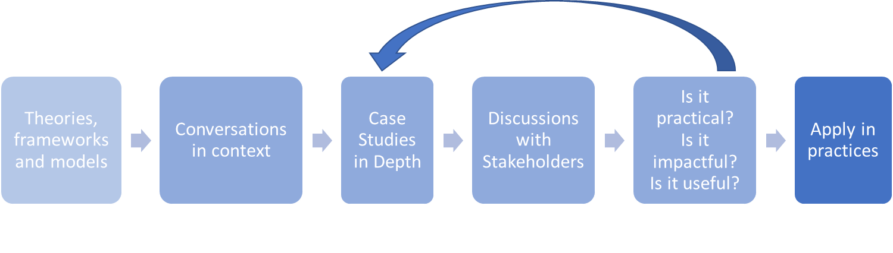
Fig. 1. APSU's Approach

The conversations in context revealed an appreciation of the importance of public value to ESA and its key role in the future of the organisation. It was generally considered among respondents that it is important to promote the public value among Member States who fund and control the organisation. However, it was generally felt that the strategic situation within which ESA is positioned makes it to a certain extent invisible in the public sphere compared with national space agencies. Recognising ESA’s dependence on funding from Member States it was felt that there was a clear need for engagement and dialogue with the public, especially at a time of fiscal challenge in public finances. Moreover, it was felt that accountability to citizens, and a profile, would give an enhanced legitimacy and mandate to ESA.

From these interviews a consensus on categories of wider public value associated with ESA’s operation among some of those interviewed emerged. These were,
• prestige;
• aspiration;
• elements of the Space for Earth programme serving member states’ citizens especially in respect of agriculture, transportation, imaging and communication.

From these interviews and conversations, it was very clear that the importance of public value to ESA in the New Space Economy was recognised among ESA staff. It was also clear that ESA makes a very significant public value contribution which goes unappreciated both by the public and even by the Agency’s own staff.

  - Surveying reasonable, informed citizens
The second part of this project, which was informed by the earlier interviews in Paris, involved surveys with two groups of reasonable, informed citizens, specifically selected in settings in which respondents could act as proxies for the public aware of the contribution of ESA to the public sphere. The first survey was undertaken at the Paris Air Show using a questionnaire developed by UCLan’s APSU in collaboration with ESA and administered by a team from ESA. An identical questionnaire was used at the New Space Economy Forum in Rome in December 2019 implemented by APSU. The analysis reported in this document has been undertaken by APSU in collaboration with the Corporate Development Office ESA Strategy Department. It gives an overview of the breadth and depth of ESA’s public value contribution as perceived by two groups of reasonable, informed citizens. Demographic details of the samples are given in the appendix.
It must be stressed that these surveys were not intended to constitute a representative sample of the national populations.
These groups were used for the survey, within the methodological framework of our public value management project, as groups of citizens who would have some knowledge of the space sector and the work of ESA. This meant they were able to give an assessment of the contribution of ESA as a perception of its value to the public sphere/society within the totality of human value categories. What is striking in the results is that the profiles of responses were very similar from the two independent surveys in different countries undertaken by different researchers. In the NSE Forum in Rome, it was stressed to respondents that the survey was designed, implemented and framed by the completely independent (and unremunerated) Applied Policy Science unit of the University of Central Lancashire. Again, the similarity of profiles should be noted.

- Theoretical approach to Public Value

  - What is Public Value?
Today, Governments are increasingly focusing upon wider than economic value in their evaluation policies and the justification of spending, upon ‘softer’ outcomes rather than ‘hard’ outputs. After decades of policy shaped by neo-liberal ideology foregrounding financial targets which was driven by the commercialisation, competition and contractorisation of the public sector (in which economic efficiency and financial targets were key drivers) there is today a turn to public value management. Now, a new view of value is coming to the fore, one that recognises the impact organisations have in the wider public sphere as well as the positive implications public value realisation has upon an organisation’s mandate, and one which requires new modes and methods of strategic management to respond.

As a mode of governing, public value foregrounds values beyond economic efficiency and effectiveness [1] and dialogue with the public.

As a mode of management it requires an appreciation of the wider consequences of soft ‘outputs’ rather than hard ‘outcomes’ and a contribution-orientation which brings into focus the everyday lives of ordinary people and how an organisation, policy, project or programme contributes to the things they value in their lives.

Public value is essentially mundane, it is about the commonplace, the everyday, experienced in homes, neighbourhoods, at the workplace and seen on TV and the ‘web. To experience public value is to achieve things we seek to realise in our daily lives, things which motivate us and to which we aspire to as we develop our biographies and for an organisation, it is how its policies, projects products or programmes facilitate this. Public value is about individuals acquiring things that matter to them and which motivate them – it is everywhere and percolates into every corner of their lives. Public value is often indirect, and ultimately democratic. For an organisation public value may be thought of as ‘positive externalities’ and for the public as something they perceive as valuable.
An important element of a public value approach is the concept of the public sphere - the wider contribution public value makes to the scope, structure and substance of socio-political space. To benefit from value produced by ESA, for example, you do not have to work for it, or be a supplier or travel into space. As we shall see, ESA produces public value, to a greater or lesser extent, across the board in all categories of human value. An overarching definition of the public value contribution of an organisation is, simply put, its contribution to the public sphere.
The overarching approach we use in this report is informed by the work of Mark Moore (e.g. [4]) whose approach to strategic public value management comprises three elements, the realisation of actual public value outcomes (to which we turn to next); the authorising environment of an organisation in which public value may be seen as a mandate-relevant resource; and operational capacity reflecting the importance of operational processes, policies and controls and the polycentric nature of the public policy environment in which relationships between organisations, publics and politics are key. Following Moore, these three elements form a system encompassing a strategic management approach for achieving public value. Moore’s approach may be drawn up as follows in Fig. 2Error: Reference source not found and for an organisation public value is optimised when these three elements are aligned.
Firstly, it must create something publicly valuable; secondly, it must be legitimate and sustainable politically; and thirdly, it must be achievable within the capacity and capability of the organisation – and its collaborators. In this report for ESA, we focus upon the first of these three elements, and for public value simply put; something is valuable if it is perceived to be so by individual citizens.

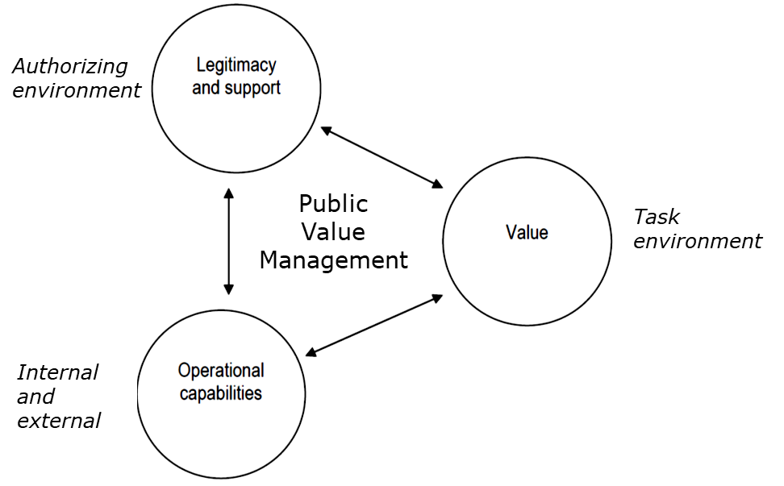
Fig. 2. The 'Strategic Triangle'of Public Value Management [5]

  - APSU’s Approach

    - Public Value 360’
The public value 360 approach we have developed in ESA_LAB@UCLan with ESA and separately with other collaborators in real-world case studies is essentially in two parts. Firstly, it is about defining and measuring public value, what Moore refers to as value in the task environment in the diagram above. This is based upon external assessments of the value perceived to be produced by an organisation and, following Meynhardt [6], this is based upon assessments of value made by ordinary citizens.
The second public value management element of our approach gives an appreciation of the dynamics of public value as an asset for an organisation within its policy environment, and an appreciation of public value as a currency in the political economies within the authorising environments in which organisations exist. It also focuses upon how an organisation must act, interact and react to optimise its value as perceived by the public. This second element of the ‘360’ approach covers the organisational implications of working with and within public value both at a strategic and an operational level. This takes into account the realities of networks and collaborations in the delivery of outputs and the realisation of outcomes, and the sometimes vital role a public value profile plays in the defence of an organisation’s mandate in its authorising environment.
The term ‘public value’ requires some clarification. Essentially, we take it to mean the realisation of value by individual citizens seen through the lens of their needs and motivations. Fundamentally, public value is about the realisation of value in the public sphere, in people’s everyday lives, their families, neighbourhoods and places – that is all it is.
Turning to the ‘public’ in public value reveals the breadth of the concept. Following Ostrom ET. al. [7] the ‘public’ may be envisaged as those who are touched by the indirect, positive, consequences of an organisation’s outputs. Today, the public sphere may, in this era of globalisation, satellite communications and the World Wide Web be very broad indeed and the public effect of an organisation, as if ESA may be equally expansive. In a globalised, interconnected world, the boundaries of an organisation, and its impact, can extend well beyond territorial jurisdictions and commercial and contractual relationships. At the same time, the impact of an organisation extends to a wider public affected by the indirect consequence of its outputs and outcomes in ways which may be unforeseen and unappreciated.
Thinking of organisational implications of the ‘public’, a public value perspective brings into view the boundary issue of an organisation. There are two elements to this. Firstly, the hybrid nature of public policy and projects results in collaborations between organisations and across sectors; and secondly the engagement of citizens, communities and collaborators in the co-production and co-design of public facing outcomes.
The fundamental issue with public value for any organisation is to appreciate the impact its impact upon the public sphere [4][6]. To achieve this, we focus upon evaluations by individual citizens to acquire their perceptions of an organisation, policy, project, product or programme to the public sphere, to the daily lives of ordinary citizens. We draw upon a psychological approach to public value to create a profile based upon an assessment by members of the public of the value they associate with an organisations activities.

This approach is based upon a proven, tested framework of human values and the needs and motivations underlying them. In it we use two leading approaches [8] to value measurement and interpretation, those of Shalom Schwartz [9][10] and Ronald Inglehart [11][12][13][14] which together give a robust assessment of public value outcomes based upon human needs, values and underpinning motivations together with an analytic framework for its interpretation.

    - Measuring Public Value
The approach we have developed through this project into how the public perceive value in a policy, project or programme is based upon an original synthesis of extant, proven theories, models and approaches in public value management and human values and valuations.
For the measurement of public value, we draw upon a psychological approach to public value Meynhardt [6][15][16] which we enhance and unpack using two leading approaches [8] to understanding human values, their motivations [10][17][18][11][12][14][19] and the impact of context upon them. We also draw upon theories from Alderfer [20] and Maslow [21] to incorporate the concept of human needs in a dynamic framework which gives the foundation of value 19associated with this public value investigation in detail we use these proven theories of human values as a fundamental underpinning for the acquisition and interpretation of value data underpinning public value. In this, the relationship between an organisation (in this case ESA) and the public sphere is the essential focus of investigation, as Meynhardt suggests,

“Public value is value for the public. Value for the public is a result of evaluations about how basic needs of individuals, groups and the society as a whole are influenced in relationships involving the public. Public value then is also value from the public, i.e. ‘drawn’ from the experience of the public... Any impact on shared experience about the quality of the relationship between the individual and society can be described as public value creation.” [16]

From a functional perspective, human values perform two primary functions. Firstly, they are cognitive expressions of needs (Inglehart, Alderfer) and secondly, they guide actions. As Kluckhohn argued,

“(a) value is a conception, explicit or implicit, distinctive of an individual or characteristic of a group, of the desirable that influences the selection from available modes, means, and ends of actions”. [23]

‘Values’ as cognitive constructs, invisible yet influential, are expressions of underlying motives and motivations which individuals use to shape their activities and inform their relations and dialogue with and within society. Values make a difference [24] they give meaning to action, and to attitudes [25]– and underpin the justification for actions or attitudes. Human values may be conceived as desirability’s, as trans-situational goals varying in importance, that serve as guiding principles in people's lives. Relatively enduring (though not immutable), they shape, singly or in combination, individuals’ attitudes and behaviour. Invisible yet impactful, values give individuals stability, and predictability, across social settings. Essentially, they are cognitive maps, which help us navigate the broad ocean of complexity we encounter in our daily lives and are at the heart of most of the things we do as human beings.
Values are, of course, a conceptual construct. Located between our existential needs as human beings, and the influence of context they are essentially between our eternal past, which shapes us, the perpetual present in which we live and our aspirations for an uncertain future. They are deep-seated principles, which we, as humans, use to make judgments and decisions. Essentially, public value is created by something if it is perceived to have a positive impact in the public sphere as assessed by members of the public against their individual values.

    - The Dynamics of Public Value
Perhaps the defining feature of public value is its foundation upon the achievement of value by members of the public assessed against their needs and motivations. In this section, we look at three related theories of human values which suggest a dynamic structure within the overall set of human values, and which further reveal the breadth of contribution by ESA to the public sphere.

The value circle
Earlier, we focused upon the work of Meynhardt (who drew upon Epstein, [27]) and Schwartz [10] whose value circle is one of the most widely used representations of human values. Shown as a circle in diagrammatic form [10] the values circle shows a relational perspective on human values when seen as an overall set in which related values lie adjacent to one another and values which conflict (such as self-interest and benevolence) are located on opposite sides of the diagram.

Fig. 3. The Value Circle

We subsequently used the ultimate Schwartz categorisation of 19 value categories in the acquisition of data relating to ESA’s public value profile and the results of that form the basis of this report. From a public value standpoint, a key observation is that, following Schwartz [10] all humans hold the same overall set of value categories, but the strength and priority of their personal value set is determined by biography and context. Values are on the one hand what give individuals a degree of stability and certainty, but on the other hand, they can be what differentiates individuals and groups of humans. Different people will hold the same value set but in a different (sometimes very different) order of priority.

Hierarchy of needs (Maslow) [21][22]
In the 1940’s Abraham Maslow deduced a set of human motivations based upon basic human needs, which embraced physical, relational and cognitive needs, and motivations, which he arranged as a hierarchy. Today, the ‘Hierarchy of needs’ remains an influential, heuristic approach to human needs and motivations which continues to prove influential over 7 decades since its first introduction (Maslow 1943). Broadly speaking the ‘Hierarchy of Needs’ gives a dynamic, sequential approach to understanding the relationship between value categories. Essentially, Maslow posited a hierarchical relationship between originally five and ultimately eight categories in which individuals look for fulfilment of ‘basic needs’ or deficiency needs before prioritising the so-called ‘higher order’ or growth needs associated with relationships, self-realisation, discovery and achievement. These are shown on Fig. 4 in the triangular form usually used to represent his hierarchical model. Essentially, individuals are motivated by the ‘pull’ of the next unsatisfied value or need in the hierarchy so once an individual and this dynamic has been proven in many studies over the years.

The enhanced Maslow hierarchy of needs is especially useful in a public value context in that it provides the basis of a dynamic interpretation of values data - the arrangement of value categories. What is especially interesting are the revisions he made to the original five-category hierarchy. Essentially, he unpacked and expanded the higher order self-actualisation category into four values, which Alderfer would include, in his ‘growth’ category, the so-called ‘being needs’ associated with self-fulfilment.

Existence, Relatedness and Growth (Alderfer)
A less well known theory associated with the Hierarchy of Needs is that of Clayton Alderfer [20] in his ‘existence’, ‘relatedness’ and ‘growth’ (ERG) model, he posited that the Maslovian hierarchy could be usefully summarised into three categories, ‘existence’, ‘relatedness’ and ‘growth’ [28] which he proved empirically and has recently proved instructive in projects as diverse as telecommunications [29] and financial services [30][31].
The three categories of need in the ‘ERG’ model may be described as below:

- Existence Needs: include of all those needs that relate to the existential, physiological and safety aspects of human beings. They are a prerequisite for the survival and include both the physiological and safety needs of Maslow.
- Relatedness Needs: reflect the fact that humans are social creatures. They relate to social needs, those with whom an individual seeks to establish relationships with, those for whom they care and with whom they value interaction. These needs cover Maslow’s social needs and esteem needs derived from individuals’ relationships with other people.
- Growth Needs: cover Maslow’s self-actualization needs as well as a part of esteem needs, which are internal to the individual, such as a feeling of being unique, personnel growth, etc. Thus, growth needs are those that influence an individual to explore and pursue their maximum potential in the environment they live and seek, including cognitive, aesthetic and wider transcendental needs and ultimately those associated with.

The key differences with the Maslovian model are the summarising of value categories (shown in the diagram below) from eight to three and the observation that values may not be sought or satisfied in an ascending order. Value satisfaction or frustration need not be achieved sequentially or hierarchically. Fundamentally, however, it does not assume that lower level satisfaction will always result in the pursuit of the satisfaction of higher order needs.

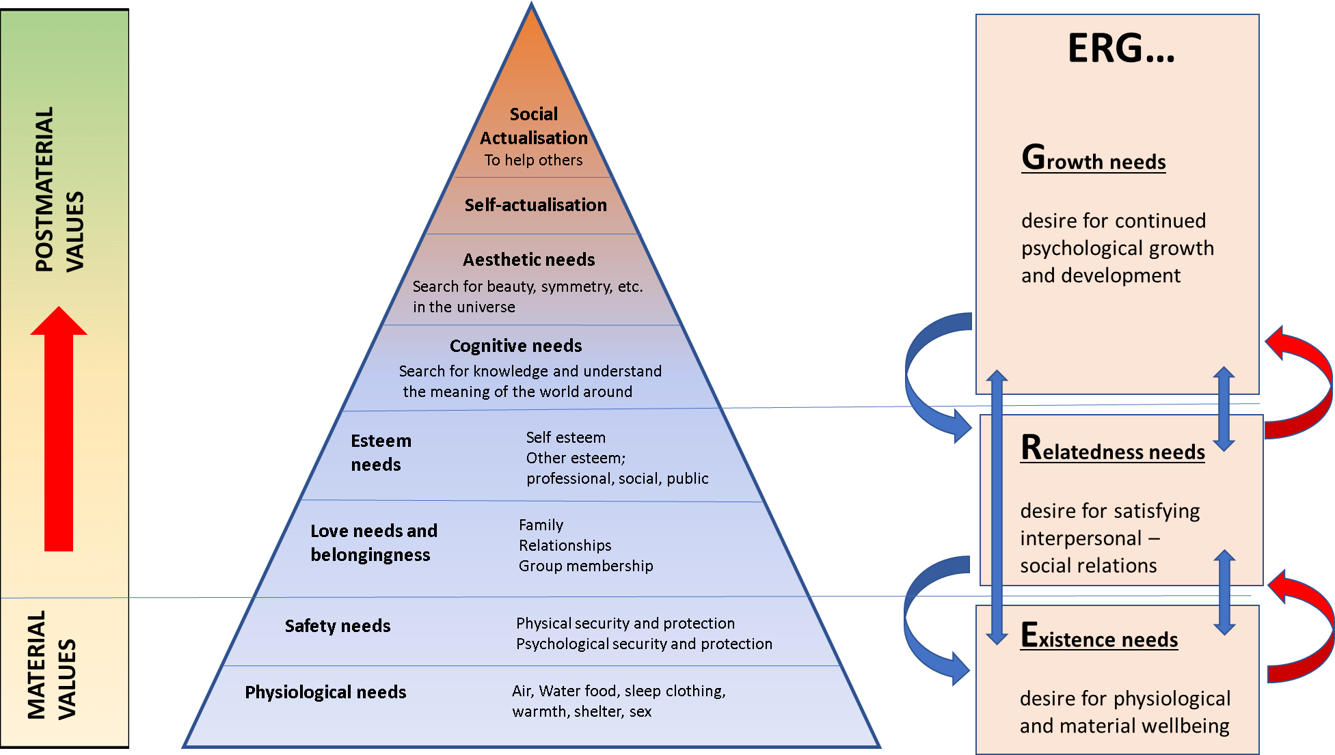
Fig. 4. Relationship between theories of Inglehart (post-materialism), Alderfer (ERG) and Maslow's (hierarchy of needs)

Post materialism theory (Inglehart)
This sequencing and substance of the original Maslow hierarchy informed work by Inglehart in the 1970’s [11] into what has become a widely accepted approach to categorising human value clusters. Following Maslow, Inglehart defining two value groups based upon Maslow’s deficiency and growth motivational needs (which he termed ‘material’ values) with the higher-order growth needs associated with self-actualisation and relationships being termed ‘post material’ values. Inglehart contextualised value prioritisation in terms of socialisation and scarcity (of safety and physiological resources) arguing that the decades in the second half of the C20 had seen unprecedented levels of affluence in Western democracies which had influenced the value priorities of new generations and which had consequently resulted in political change. With their increasing focus upon post-material values which reflected prioritisation of relationships, freedom of expression, participation and the natural environment, ‘post-materialists’ had a significant impact upon politics and policy.

Inglehart synthesised the Maslovian hierarchy into two broad value sets what he termed ‘material’ corresponding essentially with deficiency needs, and Postmaterial, which corresponded with ‘being’ value, associated with Maslow. Relating this to the ERG model in the diagram above we see that existence and relatedness needs/values are related to Postmaterial values.

Inglehart [11] argued that the two underpinning hypotheses, scarcity and socialisation could, in a time of crisis (like COVID-19) cause postmaterialists, those prioritising postmaterial values to revert to material values in a time of scarcity and existential insecurity threat. Inglehart’s work related to value prioritisation again gives a dynamic component to value choice which is especially revealing in respect of giving a short hand view or perspective on the likely appeal of certain activities and the salience of values.

Clearly, the public value expectation of these value-oriented groups in society could have been significantly distinct. However, a of the popular misconceptions about the Inglehart model is that it is a continuum, with pure type postmaterial on one end and pure type material on the other. However, research reveals that this is not actually the case [32]; postmaterial values are built upon a foundation of existential security and this security and resource values are fundamental, they are not discarded in times of affluence and security though they will not be prioritised.

Insights from the Postmaterial thesis reveal the notion of a sequential hierarchy, starting with satisfaction of the basic, physiological needs and then progressing to the satisfaction of higher order Postmaterial values associated with relationships, freedom of expression and actualisation become priorities, requires a careful interpretation. These are not fundamentally different value groups and fundamentally, everyone is a materialist, though some are other things as well. Individual’s value prioritisations begin with their satisfaction of material needs, safety and sufficient resources to exist and as they progress up the value hierarch, they do not. These are the most fundamental needs and motivations and when resources are stressed, they revert to these values representing existential needs – the being values. With increasing levels of security and success (relational and resource) the values that Inglehart termed Postmaterial value or the growth value orientation or category is very diverse.

From theory to implementation
These theories of value choice, components and change give us important insights into working with public value. They reveal the relationship between value categories and suggest an upward dynamic of related, progressive value categories. We have seen how the ERG model may be used as a shorthand for the value contribution of an organisation, the ESA examples being particularly instructive as they address existence, relatedness and growth value categories. Perhaps the most significant finding of the later Maslow work, carried forward in Alderfer’s and Inglehart’s theories, is the transcendental nature of the higher order value orientations, which are associated with the ‘benevolence’ and ‘universalism’ value categories in the Schwartz model we used in this empirical analysis and to which we refer earlier.

These three theories, ERG, Postmaterialism and the Maslovian hierarchy are all useful and relevant to an understanding of the public value profile of an organisation. They each allow a heuristic ‘shorthand’ for understanding and articulating the complexity of value categories. Though these value theories all identified similar categorisations the key is that at any moment in time, individuals focus, to a greater or lesser extent, upon all value categories though fundamentally, individuals give a greater focus upon material, existence or needs values upon which all other ‘higher order’ needs-based motivations are built.

In our interpretation of public value profiling using the Schwartz value circle as an overarching framework which we augment following Wilson [33] in respect of related Inglehart Material-Postmaterial dimensions by overlaying a dynamic based upon Maslow and drawing upon Alderfer and Inglehart which allows a value narrative in which we present and interpret a value profile in the following sections of this report.

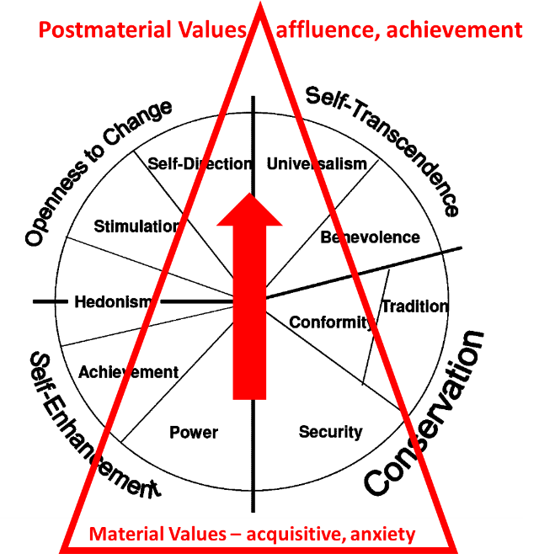
Fig. 5. Maslovian-derived graphic over the Schwartz framework

Schwartz 19 category framework
The analysis in this survey uses the Schwartz 19 category framework in which he unpacked six of the original 10 value categories into further subcategories and added two more value categories. This to give ‘…greater heuristic and explanatory power…’[10] in the use of the data acquired using this value circle framework. The 19-value category model with the underlying motivational components (in brackets) is as follows.

Personally- focused
- Self-direction–thought (Freedom to cultivate one’s own ideas and abilities)
- Self-direction–action (Freedom to determine one’s own actions)
- Stimulation (Excitement, novelty, and change)
- Hedonism (Pleasure and sensuous gratification)
- Achievement (Success according to social standards)
- Power–dominance (Power through exercising control over people)
- Power–resources (Power through control of material and social resources)
- Face (Security and power through maintaining one’s public image and avoiding humiliation)
- Security–personal (Safety in one’s immediate environment)

Socially focussed
- Security–societal (Safety and stability in the wider society)
- Tradition (Maintaining and preserving cultural, family, or religious traditions)
- Conformity–rules (Compliance with rules, laws, and formal obligations)
- Conformity–interpersonal (Avoidance of upsetting or harming other people)
- Humility (Recognizing one’s insignificance in the larger scheme of things)
- Benevolence–dependability (Being a reliable and trustworthy member of the in-group)
- Benevolence–caring (Devotion to the welfare of in-group members)
- Universalism–concern (Commitment to equality, justice, and protection for all people)
- Universalism–nature (Preservation of the natural environment)
- Universalism–tolerance (Acceptance and understanding of those who are different from oneself)

These value categories represent the entire gamut of human values and they are used in the subsequent surveys. The Schwartz value set provides an insight into the foundation of valuation, an ontology for the assessment of perceived value provided by ESA in the public sphere. Together they provide a series of categories representing how individuals interact with the world and the categories of ‘trans-situational goals which guide individuals in their daily lives and are grounded in fundamental aspects of human existence.
In the research with ESA, we create a series of hybrid propositions assessing ESA’s perceived contribution in each of these 19 categories giving a total perspective of all 360 degrees of the Schwartz value circle.

- Public Value in the Space Sector

  - Unearthing value creation

    - Public institutions faced with more pressure
The evolution of generational perspectives on value creation is an important aspect to consider. Baby-boomers saw value creation as the possibility to choose freely. The generation that followed was educated on the choice and valued the depth of the exchange. Nowadays, advances in technologies allow for facilitated communication channels between public institutions and the society reconfiguring civic involvement mechanisms. New generations have more opportunities to participate in the public discourse, but also have a lot more expectations for the environment to account for their complexities. This leads to a situation where international, inter-governmental organisations are strongly encouraged to become more transparent, effective and engage in direct exchanges with the public if they do not want to become unpopular. Measuring value creation using a public value approach allows evaluating trans-utilitarian value relating to elements, which are hard to quantify – such as knowledge, curiosity and culture – but are of particular relevance to the society, and especially about the space sector.

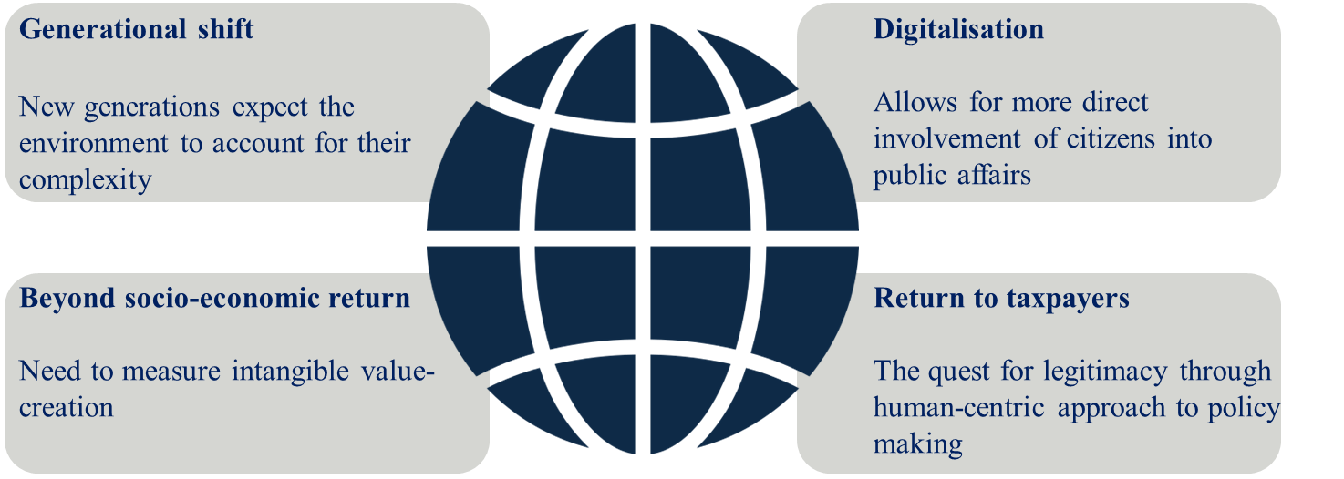
Fig. 6. Evolution in citizen's expectations

    - Assessing intangible value creation in the space sector
Space activities provides much more than simply quantifiable performance indicators. It is spanning so many areas that it is difficult to find the one single value for space. Current econometric assessments are weak in valuing investments in space and do not capture the qualitative/intangible benefits. From human space flight to satellites for various purposes (science navigation, communication and others) or exploration of other planets, the rockets themselves and more, Space provides identity and authenticity, and also fascination and inspiration for young people then going for STEM education. However, as for technology and innovation in general, investments in the space sector are often risky in nature and depend mostly on an expectation of the value return, as returns on investments are long term. Therefore failing to capture the full benefits of space – beyond traditional economic returns – could potentially lead to underinvestment.

    - ESA’s Mission
Ensuring the public’s faith into the spinoff benefits of space and shedding light on the multiplier effect is very important if we want to continue to grasp the full spectrum of possibilities that space has to offer. The European Space Agency is a complex organisation. National member states and the European Union’s contribute to the budget of the agency thanks to the money they receive from their taxpayers and entrust the organisation with the mandate to work on activities for the benefits of the society Fig. 7. To this end, ESA has tried to come up also with a different way of looking at an organisation. Against the usual ex-post methodology: decide, announce, defend - ESA now looks at the ex-ante, and secure the legitimacy of its projects by interacting with the public, proactively and inclusively. In line with its strategy to become a more agile and effective organisation, this approach is a subtle but full frontal assault on the new public management. This assessment will allow the agency to draw from it and make this work in the public sphere for debate and for governmental funding decisions. As explained by Meynardt et al. [34], “The only way to foster legitimacy in a modern democratic society is to engage in dialogue with societal actors and groups over and over again. Such a quest is not arbitrary but a call for systematic outside-in perspective”.

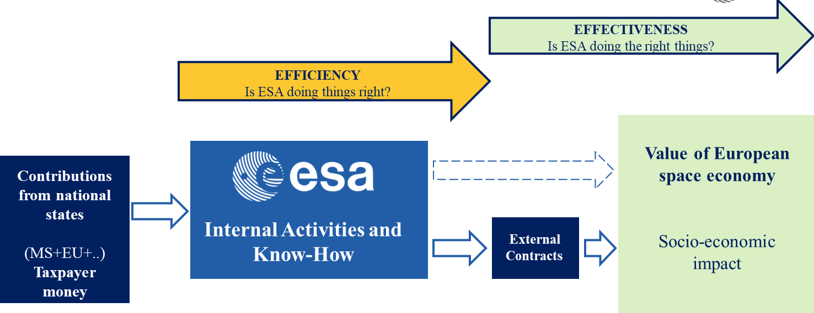
Fig. 7. Assessing the Value of ESA: ESA PV Profile

Table 2 below provides an overview of the human values and how they translate into practical examples for the space sector and for ESA. This translation is an important step to bridge between the different lexicons and establish a common ground for discussion.

  - Space safety, human performance and astronaut’s psychological resilience: a micro-level case study

    - Value of an astronaut
Schwartz’s recognized framework for studying values also applies to space-related research. In a study on Space Safety and Human Performance, Sandal et al. [35] explain how personal values can provide valuable information on individual’s motivations when choosing to pursue certain activities. Furthermore, those values are also as effective measure for the management and counteraction of stress for crewmembers during a spaceflight. The study highlight that motivational goals help understand the sensitivity of crewmembers to various mission stressors and that similar value profiles represent a platform for interpersonal compatibility. Using data from a large sample of studies, they measured the personal value profile of an ISS cosmonaut prior to a 6 months mission as shown on Fig. 8.
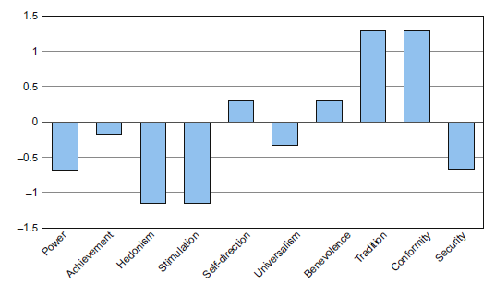
Fig. 8. Personal Value Profile of ISS cosmonaut [35]

The profile overall reveals that the person respects and accepts its customs and cultural norms (traditions), while still conforming to norms and rules (conformity). It also shows the importance of maintaining interpersonal relations (benevolence) while a freedom to think and act (self-direction).

3.2.2 Behavioural insights to performance management
The cognitive dissonance theory [36] posits that as an individual notices differences between his pre-existing value/attitudes and his actions, he will try to eradicate this dissonance. This theory has been particularly used in the field of behavioural economics and can provide valuable insights when assessing human performance at work and motivation. Indeed, the congruence between personal values and the work environment has significant implications for work satisfaction. Studying a space simulation, Sandal et al. [37], show that crewmembers emphasizing hedonism expressed strong discontent with in-flight nutrition and even lost weight before alternative food was offered to them.
Value differences can also affect the overall performance of space missions, and studies have demonstrated that diversity in team can have implications for cohesion and conflict variables in the process. Woehr et al. [38] found that diversity in self-direction, achievement and benevolence notably affected such variables. This was further proved during a space simulation where tensions between crewmembers arose from diversity in those values.
Thus assessing the value profile of an organisation concerning its employees can benefit the overall performance of the organisation. Further analysis can be done at the micro level to provide better team management.

  - A practical example to Public Value creation: Space in response to COVID-19
The World Health Organization (WHO) reported on the 16th of May 2020, that the number of recorded cases was more than 4 248 389 worldwide and 292 046 people have lost their lives. Moreover, the alarming levels of spread and severity has led WHO to characterise the COVID-19 as a pandemic outbreak.
Through its many applications, space as the potential to provide valuable responses to the COVID-19 crisis as presented in the diagram below. Those solutions can further illustrate the ERG model (existence – relatedness – growth) developed in 2.2.3 and Fig. 4Error: Reference source not found.

Satellite Navigation (SatNav) can:
- Enable applications in the VR/AR environment
- Validate the access to training/learning content based on the location of the pupils and on the time when the access is done
- Support epidemiological analysis and cross-certification

Satellite Communications (SatCom) can:
- Provide connectivity where terrestrial communications are insufficient
- Enable remote monitoring through transmission of sensor data
- Be a backup for terrestrial systems

Satellite Earth Observation (SatEO) can:
- Provide contextual situational awareness for epidemiological mapping
- Provide collection of data for production of images and maps, e.g. to provide relevant parameters into the VR/AR environment used for specific courses (e.g. geographical maps, historical sites)

- Results: Assessing ESA Public Value Profile

  - Background

    - ESA citizens’ debate on space for Europe
An illustration of how ESA was able to assess its public value towards the public at large was the experience conducted with the “Citizens’ debate on space for Europe”. In 2016, ESA organised the first informed debate between a space agency and its main stakeholders: the taxpayers, the citizens. Regarding ESA, this debate was conceived to get from citizens, elements of information and of inspiration for drawing up the future of space strategy for Europe. In terms of governance, important to note that this debate although being an illustration of participatory democracy was not meant to interfere with the institutional decision making process of ESA but to nurture, to support it.
More than 1600 citizens dedicated a whole day (10 September 2016) to gather and discuss on space issues after having been given information through magazines and videos. The citizens subsequently answered a questionnaire comprising both closed and opened questions. They also lived and appreciated a creative session giving them the opportunity to build up a space mission for 2036.
When the citizens’ debate took place, the inspirational dimension of space was tangible and the young generation was very much dedicated to the discussions and enthusiastic about the matter. Space represents indeed opportunities in many sectors and hope for the future and this debate demonstrated it. With this citizens’ debate ESA opened up a new chapter of the space adventure.

Two Interactive studies on how passionate and concerned Europeans are about space and its challenges
In 2018 and in 2019, ESA Communication Department organised a survey with Harris interactive in support of the Council at ministerial level Space 19+. Debate: A more substantiated discussion with qualitative elements.
2018 study carried out online with sample of 5,395 Europeans, comprising 5 representative samples of the national population aged 18 or over in each of the following countries:
- Germany: 1,062 people
- France: 1,054 people
- United Kingdom: 1,064 people
- Italy: 1,138 people
- Spain: 1,077 people
At the request of the European Space Agency (ESA), and 9 months after a first survey, Harris Interactive interviewed for the second time the inhabitants of Europe's five most populous countries to better understand the image they have of, and their expectations for, space activities. As last December, representative samples of the major populations living in Germany, France, the United Kingdom, Italy and Spain, with each sample comprising at least 1,000 people, expressed their views on various themes associated with space, this time in September 2019.
If space activities are perceived positively it is also because they are associated with indirect economic benefits, even if this is not a priority
- At the end of 2018, 90% of Europeans had a positive opinion of space activities in general. This positive perception is based on both scientific and tangible factors. Hence, space activities are thought to provide a better understanding of the universe (93%), as well as pave the way for technologies that improve everyday life (especially satellite navigation, 89%).
- The 2019 study identifies more specifically the indirect benefits that Europeans associate with space activities, particularly on an economic level. 79% of Europeans believe that this enables engineers involved in these space projects to improve their expertise, while 70% believe that the data made available by space activities can be used to develop artificial intelligence solutions. More than 7 out of 10 Europeans believe that European space activities have a significant impact in Europe, in several areas: the development of new technology by European businesses, the development of the European economy, and even the daily use of new technology by European citizens.
- Although this was a relatively minor concern compared to identifying the effects of global warming, which was the overriding priority for Europeans, last year the exploration of the solar system was a major priority in the eyes of the general public (84%), and this new survey provides an element of nuance: Europeans believe the robotic exploration mission to Mars is slightly more important (58% said it was important) than sending astronauts to the red planet (53%) or to the Moon (53%).

The challenges related to space security imply a collective responsibility that goes beyond the strict framework of States active in space
- This new survey clarifies the significance Europeans place on a threat that could put the future of humanity at risk: 83% of those questioned believe that European space activities should give priority to developing methods to divert asteroids heading towards Earth. This is a threat that was considered significant by three quarters of Europeans last December.
- Another threat deemed significant by more than 3 out of 4 Europeans last year, space debris, is also the subject of a specific question in this survey. Thus, Europeans expect a joint mobilisation of both public and private authorities to tackle space debris: 73% believe that the major space powers are responsible for cleaning up space debris orbiting Earth, even if it has been created by private space missions; however, 71% of Europeans also think that private companies should be involved in the clean-up.

European cooperation in space activities appears to be a necessary condition for competing against other major powers, an important framework to protect the personal data of European citizens, and an effective means of strengthening links between countries
- In the survey conducted last December, the pooling of European space activities seemed almost taken for granted: 91% think it is important, a vast majority view in all countries, including the United Kingdom (85%), still in the process of Brexit.
- This new survey also helps to explain the reasons that drive Europeans to call for European space cooperation more clearly: Europeans believe that the pooling of space activities on their continent allows Europe to compete with the major space powers (70%). This desire to be competitive is slightly stronger than the desire for independence in principle for the major European powers, which is nevertheless a high expectation for two-thirds of Europeans (64%).
- In fact, the issue of the independence of European space activities is not perceived in a completely consistent way: the argument with the most support for European independence in space matters concerns personal data. As such, 82% of Europeans consider it important for European countries to be able to protect the confidentiality of their citizens' personal data, a slightly more marked requirement than that of having independent access to space via their own space infrastructure (74%).
- So, does European cooperation in space activities pay off? Yes, according to 80% of Europeans, who believe that the development of European space activities has a major impact on cooperation between European countries.

Finally, Europeans still have an unclear idea of how much public funding European space activities receive, but they do not believe that public funding is excessive, quite the contrary
- The survey conducted in December 2018 made it possible to pinpoint the difficulties Europeans have in estimating how much public funding European space activities receive. When asked how much of their taxes went towards space activities each year, the general public provided answers (€245 on average) far removed from the real order of magnitude (less than €10 on average). It must be noted that this difficulty for Europeans to estimate how their taxes are used is probably not specific to space activities, but is probably applicable to all areas of public spending.
- This finding of Europeans' overestimation of the cost of space activities indirectly called their legitimacy into question: do Europeans believe that the continent's space activities receive too much public funding, especially when compared to their main competitors? The answer is clearly no, since only 16% consider that these funds are currently excessive. On the contrary, 1 in 2 Europeans (50%) believe that European space activities receive insufficient public funding compared to other major space powers.

This new survey thus provides a better understanding of the basis of Europeans' positive opinions towards space activities, which a clear majority of the general public mainly associate with concrete economic benefits. The general public is also aware of the issues of collective responsibility in space security and cooperation between European countries. The public funding available for European space activities does not appear to be excessive in light of these many benefits: 1 in 2 Europeans even think that these funds are currently insufficient.

Surveys versus Citizens’ debates cannot give the same type of results: surveys or polls are snapshots at a given moment based on questions and answers compared to more qualitative elements gathered after a longer discussion based on an informed debate for citizens’ debates. The format, methodology, representability are different. In particular, the ESA Citizens’ debate participants were from the 22 ESA Member States (against 5 in the Harris surveys).

Interesting to note however that interests, priorities, hopes or concerns are convergent in both results from Citizens’ debate and surveys.

  - Approach used for assessing ESA Public Value

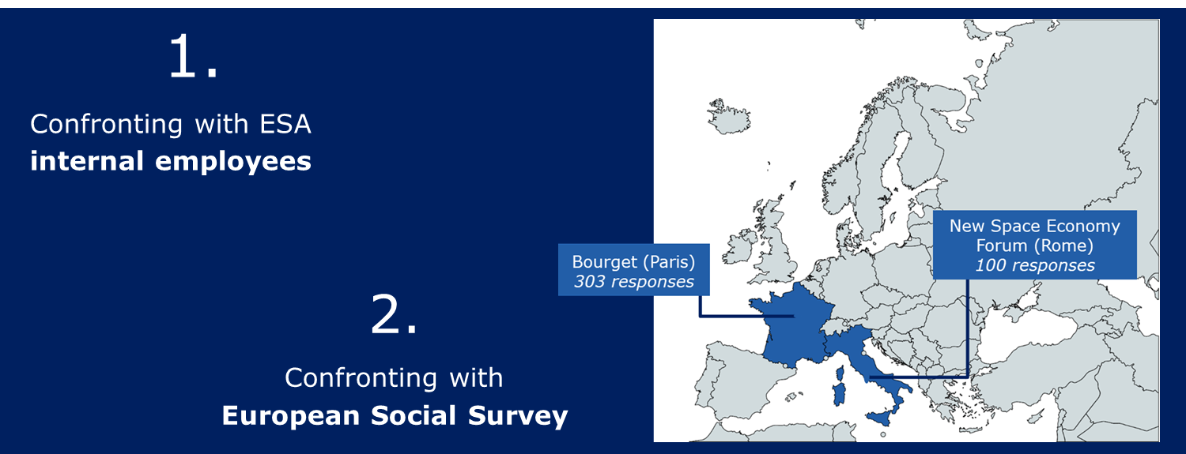
Fig. 9. Overview of the Methodology of Analysis

In order to assess ESA’s Public Value Profile, this study uses a questionnaire with 19 statements related to each one of the 19 Human Values. These statements describe how ESA activities contributes to the specific Human Value, and respondents were asked to assess, on a scale from one to five (strongly disagree, disagree, neither, agree, strongly agree), the contribution of ESA with respect to the Value. These are in a sense public value in that they have a wide, cross-cultural and cross-national relevance. That said, not all are regarded equally. What we are probing are perceptions of value deriving from ESA’s activities. It is stressed that this is not an assessment of ESA’s performance, nor is it an opinion poll. Rather, this project gives appreciation of the Public Value of ESA among reasonable, informed citizens in respect of its contribution by Human Value categories.

The share of respondents answering “agree” and “strongly agree” to each statement/Human Value is used as an indicator of how well ESA performs with respect to each value. This provides an initial Public Value profile of ESA as a first step of the study. The two following steps are a matter of comparison of these initial external results. The first comparison is performed with internal results, collected with the same questionnaires but surveying ESA staff and contractors on the various sites. The second comparison is performed with the European Social Survey, used as an indicator of citizens’ expectations.

  - Analysis of the population (internal and external)
A minimal level of awareness from respondents with respect to ESA’s activities and the space sector in general is necessary in order to obtain not only accurate, but also significant and relevant answers. Therefore, respondents were targeted specifically at the le Bourget and Rome forums because they were not simply the “man on the street” but reasonable and informed citizens, which have the capacity to provide accurate and informed answers to the questionnaire. Indeed, out of the 303 respondents in le Bourget, more than 55% were active in the space and aeronautics sectors and, out of the 100 respondents in Rome, more than 75% were active in the space and scientific research sectors. The samples from each of the areas were quite different. 62.7% of respondents at Le Bourget were French nationals whilst 64.6% at Rome were Italian. Regarding the age of respondents, respondents in Le Bourget were much younger (42% under 24) whilst those in Rome were more widely spread across all working age ranges.
Regardless of the differences between the two cohorts of respondents, the shape of the responses overall was broadly the same, with only a few differences. From a space policy setting standpoint it may be that there are differences in the policy perspectives of the two cohorts at Le Bourget and those in Rome, which was explicitly following the New Space Economy commercial space agenda. On the downside, the number of respondents to our questionnaire is relatively low and could constitute a limit to our study.

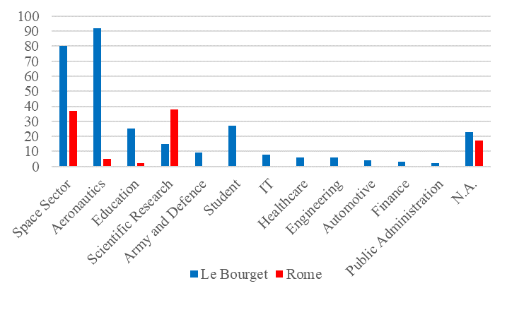
Fig. 10. Sectors of external respondents (Le Bourget and Rome)

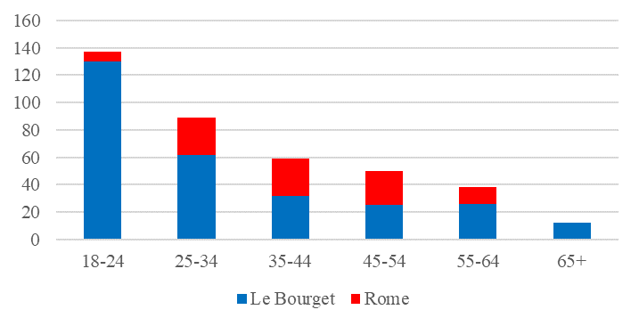
Fig. 11. Ages of external respondents (Le Bourget and Rome)

On the other side, the internal survey collected 80 respondents over various ESA sites and pillars. The most represented are respondents from ESA HQ in Paris, and the administration pillar, but other sites and pillars have a fair representation.

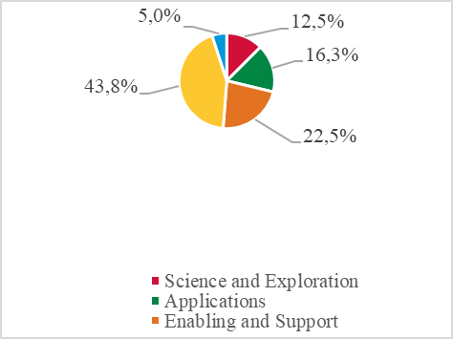
Fig. 12. Distribution of internal respondents across ESA areas

  - Interpretation
The external and results of the study are plotted on the radar diagrams below, first summarised into the four main categories of Human Values and then in the more detailed 19 Human Values.`
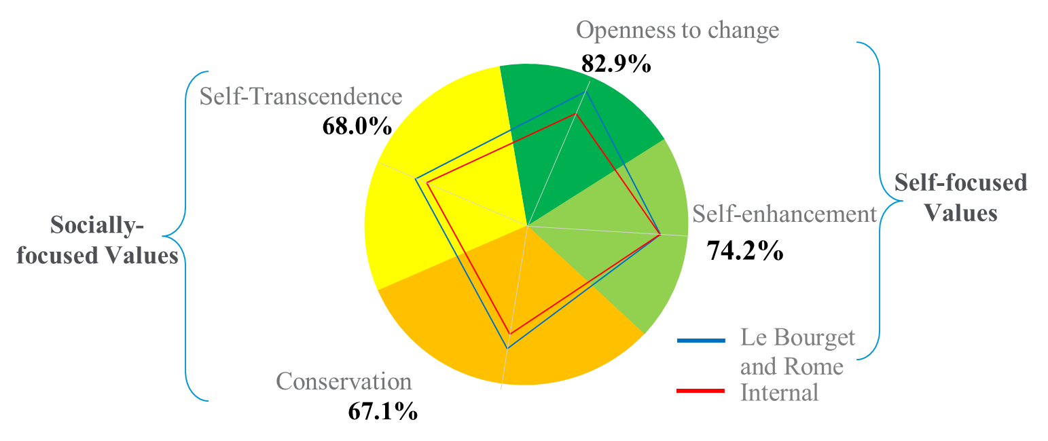
Fig. 13. ESA's Public Value Profile

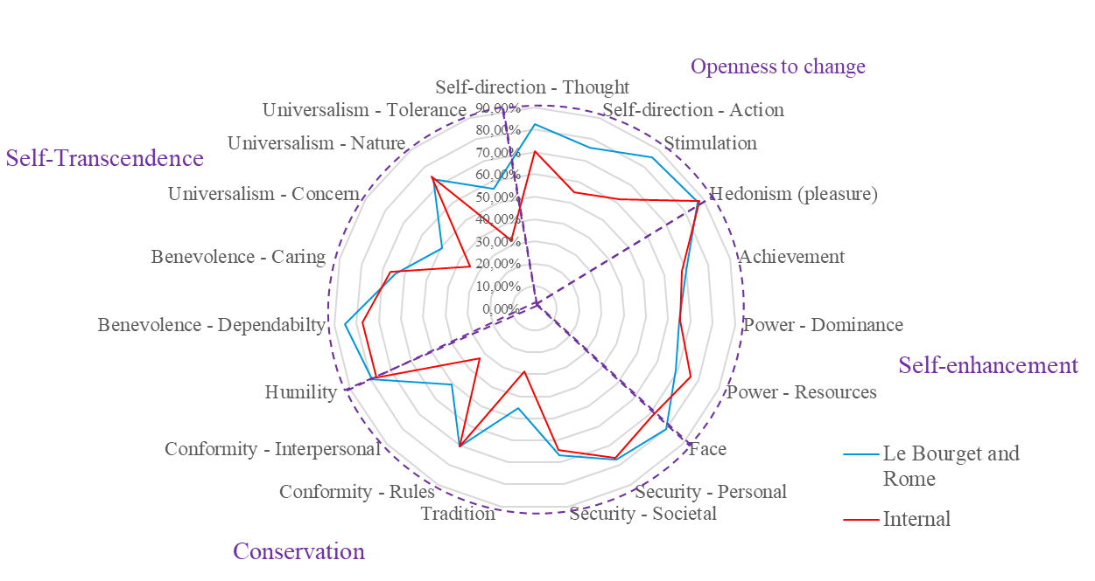
Fig. 14. ESA Public Value Profile across Schwart'z 19 value categories: Internal vs. External views

These graphs reveal overall that ESA has a positive Public Value profile. Perhaps the most striking overview impression is that the shapes of external and internal plots generally follow the same pattern, or trend, with the exception that internal respondents were slightly more critical with regard to ESA’s performance than respondents from Le Bourget and Rome. The shape of the plots is revealing: they show greater value is perceived in self-focused Human Values than in socially focused Human Values.

From these results, we see that ESA is perceived to make a significant contribution to value realisation across all 19 Human Values in the extended Schwartz framework. However, the two categories associated with the focus on one’s self (Self-enhancement and Openness to change) score higher among all respondents across both subsamples. We stress that overall, these are positive results, and it is just that there are significant differences between them.

    - Comparison to the European Social Survey
The European Social Survey (ESS) is a database updated every two years constituted of data collected through surveys regarding attitudes, beliefs and behaviours in every European country. In particular, a section of the ESS includes a 21-item Human Values scale designed by S. Schwartz. Comparing the results of our analysis of ESA’s Public Value profile to the results obtained by the ESS in the countries where our surveys were ran would provide additional interesting insights on ESA’s public value profile.
The next step of the study is a comparison of the ESS data with the data collected through the external surveys. In order to do so, the first step was to turn the 21-item Human Values scale of the ESS into a scale comparable to the 19-item human values scale used in this study. This meant first to find equivalent values from one scale to the other, as they are formulated differently, and then remove two values from the 21-item scale. The values which have been removed are the ones which were too similar to other values in the same scale but not specific enough. The following table details how equivalent Human Values were determined.

Table 1. ESS-Schwartz 19 equivalence
ESS’ expression of the Human Values | Schwartz's 19 values equivalents
Important to be successful and that people recognize achievements | Achievement
Important to help people and care for others’ well-being | Benevolence - Caring
Important to be loyal to friends and devote to people close | Benevolence - Dependability
Important to behave properly | Conformity - Interpersonal
Important to do what is told and follow rules | Conformity - Rules
Important to show abilities and be admired | Face
Important to seek fun and things that give pleasure | Hedonism
Important to be humble and modest, not draw attention | Humility
Important to get respect from others | Power - Dominance
Important to be rich, have money and expensive things | Power - Resources
Important to live in secure and safe surroundings | Security - Personal
Important that government is strong and ensures safety | Security - Societal
Important to make own decisions and be free | Self-direction - Action
Important to think new ideas and being creative | Self-direction - Thought
Important to seek adventures and have an exciting life | Stimulation
Important to follow traditions and customs | Tradition
Important that people are treated equally and have equal opportunities | Universalism - Concern
Important to care for nature and environment | Universalism - Nature
Important to understand different people | Universalism – Tolerance
Important to have a good time | Removed
Important to try new and different things in life | Removed

This conversion from one scale to another allowed us to have data comparable to the data collected through our questionnaires. Using the results of the ESS for France and Italy as an indicator for citizens’ order of preference, and thus expectations, in these countries, and subtracting this data, for each human value, to ESA’s performance measured by our questionnaires, we obtain the data in the graphs below, grouped into the four categories and then in detail for Le Bourget and Rome. More specifically, for each human value, we obtain the difference in percentage points between the share of respondents in France or Italy who, according to the ESS, view a certain human value as important, and the share of respondents of nationality of the two countries, respectively, in Le Bourget or in Rome, who view ESA as performing well with regard to the same value. It is therefore possible to clearly see whether ESA over-performs or under-performs with respect to each value. If, for a certain value, the result is positive, as is the case, for example, for “Stimulation”, ESA is contributing to the Value. On the other hand, if the result is negative, as is the case for “Tradition”, ESA is under-performing.

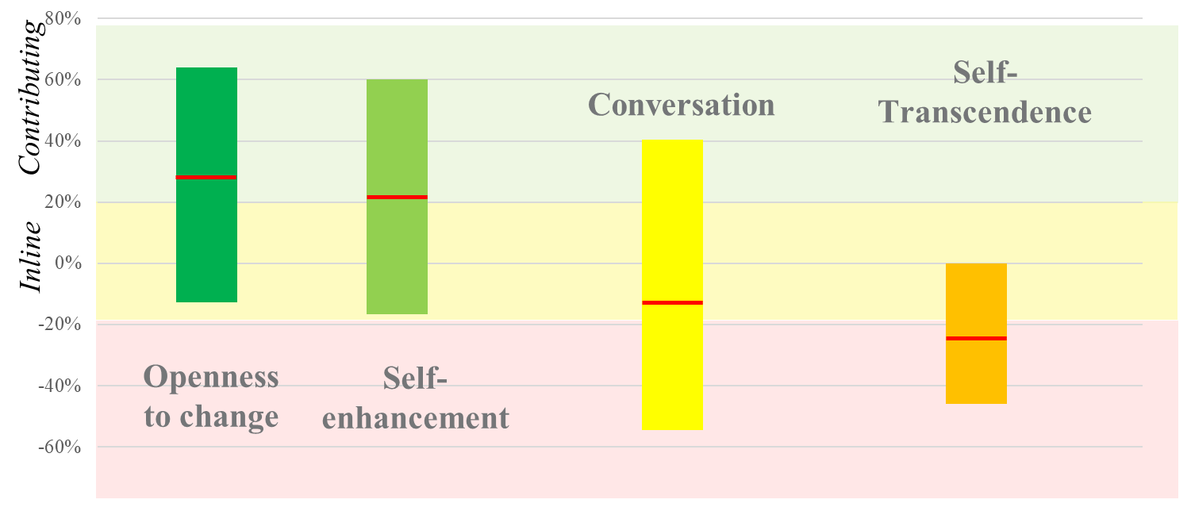
Fig. 15. ESA's performance concerning citizens' expectations in percentage points

ESA to have a positive contribution regarding the values that emphasise Openness to change and Self-enhancement, as expectations of citizens are exceeded. Regarding values that emphasise Conservation, ESA’s Public Value performance is generally in line with citizens’ expectations. However, regarding values that emphasise Self-transcendence, the performance of ESA is slightly below citizens’ expectations.

    - Reflections on the result
This collaborative project under the auspices of ESA_LAB@UCLan has created and implemented a framework for the measurement of the public value contribution of ESA. This approach to public value looks at the contribution an organisation makes to the common good and is based upon an underlying set of proven theories and methods. Using this approach, we have assessed public value using an ontology of values based upon leading theory of human values. We stress that this is not a public opinion poll. Rather, it gives an appreciation of the contribution ESA is perceived make to the common good among respondents who undertook a questionnaire survey. These findings reveal a very significant level of perceived contribution of ESA to the public sphere within the scope of the totality of human value and motivational categories. These values are important in that underpin a contemporary worldview associated with security and affluence.
A public value approach to an assessment of an organisation asks questions about effectiveness not efficiency and about outcomes to the wider public rather than a contribution of outputs to relatively few.
It may be that responses to these propositions reflects the prevailing discourses relating to the space sector. Certainly, the narrative of the New Space Economy does not appear to focus upon public goods and the contributions to daily lives in the public sphere. It may be revealing that responses to our recent public value appraisal of the nuclear industry in West Cumbria are in some respects broadly similar in profile to those relating to ESA. The following radial diagram provides an overlap of ESA’s Public Value profile, simplified in 10 Human Values, and the nuclear facilities in West Cumbria. Similar patterns of performance can be observed. This can be explained by the fact that the space sector and the nuclear sector both involve technologically intensive, large-scale and very “political” projects throughout the collective imagination. On the other hand, differences such as for the Benevolence and Tradition values could be explained by differences in “trendiness”, social acceptability and controversy between both sectors.

    - Potential COVID-19 impacts on the study and the results
Public value focuses upon human values. The set of values is shared among the individual, however the prioritisation differs depending on the time and the setting. In the case of COVID-19, the setting is changing. Therefore, while the overall results on the Value Profile of ESA will not change, rather its performance with regards to the European Social Survey will be changing over time as individual value priorities evolve over time.
At a time of COVID-19 in which wider risk perceptions similar with Beck’s World Risk Society come to dominate the public sphere [39] the commonality of implications of this for daily lives across the world - in different cultures and communities – are revealed as the pandemic sweeps across the globe. This global crisis reveals the categories of human value priorities as the global discourse reverts to existential security and safety and one can see how relational and universal dimensions of human values have increasing salience. In short, the COVID-19 crisis may be interpreted as revealing that, at any time; all human value categories are active as individuals respond, individually or collectively, to complex issues.
As of now, it is too early to say what will be the next value priorities of the citizens worldwide, but ongoing reflections by various actor highlight potential evolutions as to what will be the new words of tomorrow. For instance, a study conducted by CapgeminiInvent highlights the following “new words” for tomorrow: Reset, Risks, Sobriety/Frugality, Labour, Trust, Digital Sovereignty, Reinventing logistic, Synchronisation, Prevent [40]. In this context, it will be relevant and interesting for ESA to reflect upon how both internally and externally, how ESA can respond efficiently to the future priorities of the citizens.

- Conclusions and recommendations

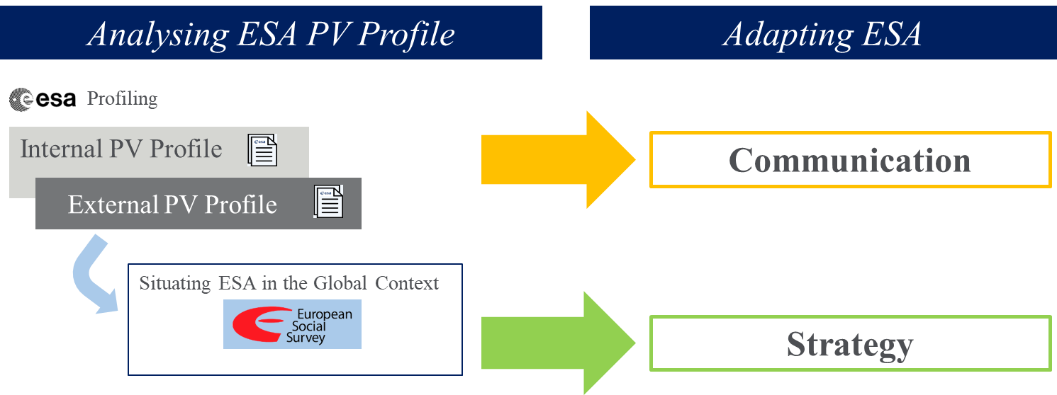
Fig. 16. From measuring to managing Public Value at ESA

There is overall clearly great potential here for ESA. As with most of our public values collaborations to date the public value approach, asking new questions about outcomes and public contribution, reveals outcomes and benefits of value to the public, which the organisation delivers in the public sphere and which go, often unrecorded and frequently unappreciated. The public value profile work gives insights on the relationship between ESA’s output and outcomes in the public sphere assessed by respondents against the universal set of human value categories. The results and the methodology must be seen within these limits. In fact the Applied Policy Science Unit study is the fit between the universal human values ‘set’ and the outputs of ESA as perceived by reasonable, informed citizens in specific aerospace settings. This was not a representative sample of the public. It was never meant to be. This study relies on a degree of awareness and understanding for respondents to make the connection between beliefs about the output of ESA and value categories representing human needs and motivations.

From the evidence of internal interviews with staff, and from a review of the data in this report, the public value of the Space for Earth programmes and wider activities of ESA may be neither appreciated nor communicated. In the following recommendations section we highlight a particular area in which a public value communication focus may give an early advantage in positioning ESA as a public value organisation – which it undoubtedly is.

The results of this study on ESA’s Public Value contribution to society can be interpreted in different ways. On one hand, one can say that an organisation such as ESA should have a positive performance with respect to citizens’ expectations in every single aspect of Public Value. On the other hand, it can also be claimed that a positive performance is required only in some of the Human Values, while others do not matter for an organisation such as ESA. For example, the under-performance of ESA in the value of “Tradition” could be compensated by the fact that it is not the objective of ESA to carry on tradition, but rather to provide a clear break from the past through progress and innovation.

Moreover, there are two aspects of recommendations, which can be formulated considering the conclusions drawn from our results. First, these conclusions could be interpreted as a need for an enhancement in communication and strategy to fill in the gaps identified.

In the context of Space 4.0 and the New Space Economy generally with its commercial and economic focus there appears to be a clear and distinctive role for a public space agency with a democratic, civil mandate in society embedded in the public sphere. From the evidence examined, we suggest, within a wider strategic approach relating to the totality of ESA’s public value outcomes, that particular attention be paid to messaging within the three values categories associated with the category of Universalism, that these be given special emphasis in positioning ESA as a public value institution within the New Space Economy with its focus upon economic benefits.
- Universalism – Concern, relating to motivations associated with commitment to equality, justice, and protection for all people.
- Universalism – Nature, focusing upon technologies and outcomes relating to the preservation of the natural environment.
- Universalism – Tolerance, focusing upon its role in promulgating and facilitating acceptance and understanding of citizens and societies worldwide.
Given the democratic nature of Space for Earth activities, and the importance of the public perception of ESA’s value among funders and stakeholders - especially the public – this activity would give a fuller appreciation of the value of ESA and space activities.

Acknowledgements
This section is not numbered.

References

- Bryson, John M; John M; Crosby, Barbara C and Bloomberg Laura. Public Value Governance: Moving beyond Traditional Public Administration and the New Public Management. Public Administration Review, 2014. Vol. 74, Issue. 4, pp. 445–456.
- Schrogl, Kai-Uwe The Value of Space for Earth: The European Space Agency. In Achieving Public Value, a Policy Network Paper edited by Stephen Haraldsen, 2018. Accessed at https://clok.uclan.ac.uk/24084/
- Mazzuccato, M., & Robinson, D. Market creation and the European space agency (European Space Agency (ESA) Report). Citing a speech to the media on 15 January 2016, made by ESA Director-General Jan Woerner who outlined his vision of Space 4.0 as a key element of ESA’s mission. 2017. See: www.esa.int/spaceinvideos/Videos/2016/01/DG_s_media_brief_replay
- Moore, Mark H. Creating Public Value: Strategic Management in Government. Cambridge, MA: Harvard University Press, 1995.
- Bennington, J. From Private Choice to Public Value: Paper presented to the Public Management and Policy Association. London : PMPA, 2005.
- Meynhardt, T. Public value inside: What is public value creation? International Journal of Public Administration, 32(3–4), 192–219, 2009.
- Ostrom, Vincent; Tiebout Charles M. and Warren, Robert. The Organization of Government in Metropolitan Areas: A Theoretical Inquiry. The American Political Science Review, 1961. Vol. 55, No. 4 pp. 831-842
- Datler, Georg; Jagodzinski, Wolfgang; and Schmidt, Peter Two theories on the test bench: Internal and external validity of the theories of Ronald Inglehart and Shalom Schwartz. Social Science Research 42, 2013. pp 906–925
- Schwartz, S. H., Cieciuch, J., Vecchione, M., Davidov, E., Fischer, R., Beierlein, C., Ramos, A., Verkasalo, M., Lönnqvist, J.-E., Demirutku, K., Dirilen-Gumus, O., & Konty, M. Refining the theory of basic individual values. Journal of Personality and Social Psychology, 103, 2012. pp 663-688.
- Schwartz, S. H. An Overview of the Schwartz Theory of Basic Values. Online Readings in Psychology and Culture, 2012. 2(1).
- Inglehart, R. The Silent Revolution: Changing Values and Political Styles among Western Publics. Princeton University Press, Princeton. 1977.
- Inglehart, R. Post-materialism in an environment of insecurity. The American Political Science Review 75, 1981. Pp 880–900.
- Inglehart, R. Aggregate stability and individual-level flux in mass belief systems: the level of analysis paradox. The American Political Science Review. 79, 1985. Pp 97–116.
- Inglehart, R. Culture Shift in Advanced Industrial Society. Princeton University Press, Princeton. 1990.
- Meynhardt, T. Public value: Turning a conceptual framework into a scorecard. In J. M. Bryson, B. C. Crosby, & L. Bloomberg (Eds.), Public Value and Public Administration (pp. 147–169). Washington, DC: Georgetown University Press. (2015)
- Meynhardt, T., & Bartholomes, S. (De)composing public value: In search of basic dimensions and common ground. International Public Management Journal, 14(3), 2011. Pp 284–308.
- Schwartz, S. H. Are there universal aspects in the content and structure of values? Journal of Social Issues, 50, 1994. pp19-45.
- Schwartz, Shalom & Bilsky, Wolfgang. Toward A Universal Psychological Structure of Human Values. Journal of Personality and Social Psychology. 53, 1987. pp 550-562. https://doi.org/10.1037/0022-3514.53.3.550.
- Inglehart, R. Modernization and Postmodernization. Cultural, Economic, and Political Change in 43 Societies. Princeton University Press, Princeton. (1997)
- Alderfer, Clayton P. An Empirical Test Of A New Theory Of Human Needs . Organizational Behavior And Performance 4, (1969). pp 142-175
- Maslow, A. Motivation and Personality. 3rd ed. Cambridge: Harper & Row Publishers. 1954.
- Maslow, A. A Theory of Human Motivation. Psychology Review, Volume 50(4), 1943. pp.370-396.
- Rohan, M. J. A Rose by Any Name? The Values Construct. Personality and Social Psychology Review, 4(3), 2000. Pp 255–277. https://doi.org/10.1207/S15327957PSPR0403_4
- Williams RM Change and stability in value and value systems: A sociological perspective. In M. Rokeach (Ed.) Understanding Human values New York, Free press (1979)
- Rokeach, M. The Nature of Human Values. 1st ed. New York: Collier-Macmillan. (1973).
- Rokeach, M. Understanding Human Values: Individual and Societal. 1st ed. New York: Free Press. (1979).
- Epstein, S. Cognitive-experiential self-theory of personality, in: Handbook of Psychology 5, Personality and Social Psychology, ed. by Theodore Millon, Melvin L. Lerner and Irving B. Weiner, New York. (2003)
- Alderfer, Clayton P. Existence, Relatedness, and Growth: Human Needs in Organizational Settings. New York: Free Press. (1972)
- Yang, Cheng-Liang; Hwang, Mark; and Chen, Ya-Chien. An empirical study of the existence, relatedness, and growth (ERG) theory in consumer’s selection of mobile value-added services. African Journal of Business Management Vol. 5(19), pp. 7885-7898,9. (2011)
- Botha, A And Venter, J.M.P. The Effect Of Life Stages On Needs Satisfied By Credit Used, According To Alderfer’s Existence Relatedness And Growth Theory. Risk Governance & Control: Financial Markets & Institutions / Volume 6, Issue 4. (2016)
- Venter, J.M.P. and Botha. A Analysing The Financial Needs Addressed By South African consumers When Using Credit Products. Risk Governance & Control: Financial Markets & Institutions Volume 4, Issue 2. (2014)
- R. Wylie. Affluence or Anxiety? Public Opinion Towards the Natural Environment with Particular Reference to Theories of Risk Society and Postmaterialism in relation to the Civil Nuclear Industry. University of Newcastle upon Tyne. Unpublished PhD Thesis. (2011).
- Wilson, Marc Stewart. A Social-Value Analysis of Postmaterialism, The Journal of Social Psychology, 145:2, 209-224, (2005).
- Meynhardt, T. Gomez P. and Schweizer T. M. The Public Value Scorecard: What makes an organization valuable to society?, Performance, Vol 6, Issue 1. (2014).
- Sandal, G.M. Psychological resilience in Space Safety and Human Performance, Editor(s): Tommaso Sgobba, Barbara Kanki, Jean-François Clervoy, Gro Mjeldheim Sandal, Butterworth-Heinemann, 2018. Pages 183-237, ISBN 9780081018699, https://doi.org/10.1016/B978-0-08-101869-9.00006-6. (http://www.sciencedirect.com/science/article/pii/B9780081018699000066)
- Festinger, L. A theory of cognitive dissonance. Stanford, CA: Stanford University Press. (1957).
- Sandal, G.M., Bye, H.H., van de Vijver, F.J.R., Personal values and crew compatibility: results from a 105 days simulated space mission. Acta Astronautica 69 (3–4), 2011. pp 141–149.
- Woehr, D.J., Arciniega, L.M., Poling, T.L., Exploring the effects of value diversity on team effectiveness. J. Bus. Psychol. 28 (1), 2013. Pp 107–121.
- Beck, U. World Risk Society in Pedersen, S. A., Hendricks, V. F., Olsen, J. K. B., & Olsen, J. K. B. A companion to the Philosophy of technology. (2009). Retrieved from http://ebookcentral.proquest.com
- Grass, E. Inventer les mots du jour d’après, CapgeminiInvent, (2020). Retrieved from https://www.capgemini.com/fr-fr/2020/04/inventer-les-mots-du-jour-dapres/

Table 2. Translating human values into Space domain activities
 |  | Human Value |  | General Definition | Practical Application Example (ESA) | Question in the questionnaire
Openness to change |  | Self-direction - Action |  | Freedom to act on its own | Twin roles of Space Situational Awareness and Space Control secure the freedom to act in space | Provides information and opportunities for citizens to explore and achieve new things
 |  | Self-direction - Thought |  | Freedom of to think on its own | Vast amount of data from Copernicus enables decision makers with analysis of climate change variables | Gives citizens inspiration, information and insights which engage their imagination and encourage them to develop new ideas
 |  | Stimulation |  | Excitement, novelty, change | Moon village, Mars exploration | Creates excitement and suggests new and novel challenges
 |  |  | Hedonism | Pleasurable experience | Watching a launch from Kourou or online | Creates appealing and interesting images and information involving space (i.e. Apollo launch)
Self-enhancement |  | Power - Dominance |  | Power through exercising control | Power given to the Member States (resource allocation on projects they want) | Enhances member nations authority and influence over people, policy and politics within space and related domains
 |  | Power - Resources |  | Material and social resources | Control from Member states over the given resources (i.e. geo-return) | Gives member nations control over material, technical and social resources associated within space
 |  | Achievement |  | Pathways to personal success | Reaching Rosetta | Creates opportunities for individual and institutional achievement
 |  |  | Face | Sense of pride and identity | Prestige of sending life in space (i.e. Astronauts, dogs) | Makes an important contribution to European image and identity and the status of member states
Conservation |  | Conformity - Interpersonal |  | Avoiding harming other people | Clean Space Initiative (Space Debris) | Promotes recognition of the integrity and need for balance and harmony in human society
 |  | Conformity - Rules |  | Compliance with rules | ESA-EU partnership, ESA Convention , ESA internal Law: Staff Regulations, Rules and Instructions | Helps ensure compliance with rules, laws, and formal obligations in space
 |  | Security - Personal |  | Safety in immediate environment | Navigation/Telecommunication | Gives us technologies and information for activities in space to make individuals' lives safer and healthier on earth
 |  | Security - Societal |  | Safety from global hazards | ESA's contribution to SDG's – Monitoring natural disasters, Space Safety and Security (SSA), Technology transfer | Gives us technologies and information to make society more stable, secure and sustainable
 |  | Tradition |  | Maintain and preserve cultural, family or religious traditions | ESA is set to act for peaceful purposes and conforms to its mandate | ESA contributes towards stability in daily lives and the preservation of traditional social and political arrangements
 |  |  | Humility | Recognizing one's insignificance in the larger scheme of things | The iconic picture of the Earth from the Moon provides sensibility towards the care for our planet | Makes us aware of humanity's place in the cosmos
Self-transcendence |  | Universalism - Concern |  | Promotion of equality and justice and protection for all | ESA is an enabler for cooperation in the international community (i.e. giving access to data, ISS cooperation, protection of our planet) | Promotes a global view of equality, justice and protection of all people
 |  | Universalism - Nature |  | Protection of the environment | EOP Copernicus programme | Promotes an awareness of the global environment and contributes to its protection
 |  | Universalism - Tolerance |  | Openness to diversity | Promote diversity of fields and competences involved | Promotes global understanding and tolerance for all human society
 |  | Benevolence - Caring |  | Welfare of in-group members | Human resources, Corporate Social Responsibility | Is committed to the welfare of the individuals and institutions with whom it is involved
 |  | Benevolence - Dependability |  | Reliable/trustworthy member of a group | Reliable to stakeholders, the space community, its suppliers | Is a trustworthy organisation embedded in the European family of nations

